Removal of Foreign Body causing Intestinal Obstruction in a Goat

Overview

When an intestinal obstruction is suspected, a right paralumbar fossa approach is taken to locate, isolate, exteriorize and remove it. The muscle layers, which are much thinner than in the cow, are incised sharply in a vertical direction. The Gastrointestinal Tract is also more fragile in small ruminants than cattle, so care should be taken manipulating the intestinal tract. Small ruminants are also more susceptible to peritonitis so caution should be taken to be as clean and atraumatic as possible.

Intra-Operative Procedure

Skin incision
- A vertical skin incision is made starting approximately 10cm ventrally to the transverse processes and extended 30-40 cm ventrally .

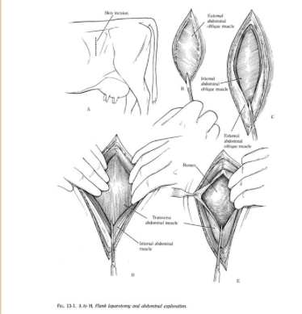
Incision through muscle layers
- Cutaneous, external abdominal oblique, internal abdominal oblique and transverse abdominal muscles will be incised.
- Incision can be by scalpel or once an initial entry point has been made the surgeon may switch to the use of surgical scissors.
  - This reduces the likelihood of cow movements leading to trauma of internal tissues/organs.
- Hemostats should be placed on large vessels or they can be ligated if necessary .
- The peritoneum can be incised with a scalpel and then extended with surgical scissors. Pull the peritoneum towards slightly towards you to reduce risk of incisions into viscera. (Entry into the peritoneum is usually accompanied by the sound of air entering the abdominal space.)
Enterotomy
- The abdominal organs should be inspected thoroughly and systematically.
- Locate and exteriorize the offending portion of intestines.
- pack laparotomy sponges around the intestinal segment to decrease contamination.
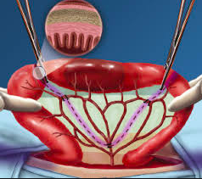
- Gently milk chyme from the lumen of the identified intestinal segment to minimize spillage.
- Occlude the lumen at both ends of the isolated segment by either:
  - Use of a scissor like grip with the index and middle fingers, approximately 4 to 6 cm on each side of site.
  - Use of a Doyen (non-crushing intestinal forceps). (sterile bobby pins have also been used).
- Make an incision into the lumen on the antimesenteric border with a No. 11 scalpel blade. The incision should be made in healthy-appearing tissue distal to the foreign body. Lengthen the incision along the intestine's long axis with Metzenbaum scissors or scalpel as necessary to allow foreign body removal without tearing the intestine.
- Carefully remove the Foreign Body

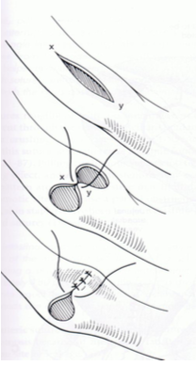
Closure of the Enterotomy site.
- Use a monofilament absorbable suture material on a swaged-on taper needle. 3-0 polydioxanone (PDS) or polyglyconate (Maxon) suture should be used.
- Close the enterotomy with simple interrupted appositional pattern. Everted edges of the mucosa can be cut away to ensure apposition. (Some close the incision longitudinally while other close transversely to increase intestinal lumen diameter.)
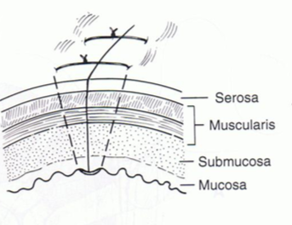
- Sutures should be placed through all layers of the intestinal wall, 2mm from the edge and 2 to 3 mm apart, with extraluminal knots.
- Angle the needle so the serosa is engaged slightly further from the edges than the mucosa to help prevent mucosal evertion.
- Tie each suture carefully with apposition without cutting through the serosa layer of the intestine. Sutures should be tied just tight enough to appose all layers of the intestine.

Leak test
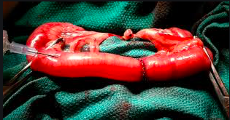
- Before releasing luminal occlusion a leak test should be conducted. Use a 20-22 gauge needle to insert into the lumen of the intestine. Inject sterile saline into the lumen; just enough saline to distend the enterotomy site. If there is leakage place one or two more sutures and retest for leakage.
- Wrap a small amount of omentum around the enterotomy site to help seal the enterotomy site.

Exit

Peritoneal and muscle closure
- Absorbable suture material on a round bodied needle should be used in a continuous pattern.
- Each layer can be closed
  - individually,
  - in pairs (peritoneum and transverse muscle layer; internal and external abdominal obliques) or
  - altogether.
- Ballottement or an enema pump can be used to remove excessive air that entered the cavity when the peritoneum was opened prior to peritoneal closure.

Skin closure
- The skin incision is closed using non-absorbable 5-7 metric nylon on a large cutting needle.
- Appositional suture patterns are preferred
Post-operative cleaning
- The site is washed to removed blood to reduce the risk of attraction flies.
- Anti-myasis treatment can also be used to prevent myasis.
- Topical antibiotic spray or wound healing sprays can be applied to the incision line.

