INFECTIOUS DISEASES/DISORDERS OF THE MAMMARY GLAND
- Pseudocowpox
- Aetiology – Parapoxvirus
- Epidemiology- Worldwide
- Causes mild infection with small red papules on the udder and teats. Can progress to pustules or small vesicles and then rapid scabbing.
- Infections spread slowly amongst herd and cattle can become reinfected in subsequent lactations.
- 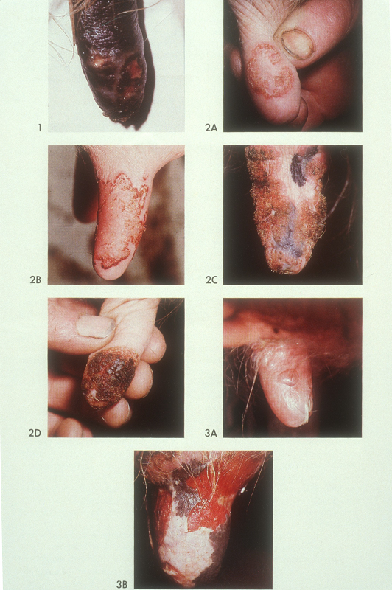

- Bovine Warts
- Aetiology: Bovine Papillomavirus (several strains include: BPV1, BPV5, BPV6, BPV9)
- Clinical Presentation:
- pale, smooth, raised lesions develop frequently on teat skin and may persist indefinitely without causing problems.
- filamentous or frond-like lesions develop at the teat orifice and interfere with milking.
- Transmission: Bovine warts are spread by direct or indirect contact, and bovine papillomavirus DNA has been identified in blood, milk, urine, and other biologic fluids obtained from infected animals.
- Diagnosis - examination of the lesion and exclusion of other causes.
- Treatment of warts is not necessary, but frond-like lesions that interfere with milking may require excision. The use of autogenous vaccines and virucidal teat dips may be recommended in herd outbreaks.
- Bovine Ulcerative Mammilitis
- Aetiology: Bovine herpesvirus II and IV (BHV-II, BHV-IV)
- Clinical Presentation: acute, ulcerative condition of teat and udder skin of dairy cows.
Relatively mild, small plaques of edema to severe ulceration. Lesions often begin as one or more thickened, edematous plaques of varying size on the skin of one or more teats. Vesicles develop and may rapidly rupture, leaving a raw, ulcerated area that becomes covered with a dark-colored scab. The scabs tend to crack and bleed, especially if milking is attempted.
- Epidemiology: BHV-II can occur sporadically or in outbreaks that often have a seasonal association with cold weather
- This diseases may result in reduced milk production and increased susceptibility to bacterial mastitis.
- Diagnosis: based on clinical signs and confirmed by histopathology or by virus isolation from early lesions.
- Treatment: supportive care, because there is no effective therapy for this virus. The use of iodophore-containing teat dips with added emollients may help to inactivate the virus.
- Prevention/Control: The use of separate milking equipment; clean, single-use towels to dry udders; and clean gloves for milking personnel help to prevent spread of the agent to susceptible animals.

- Lymphosarcoma
- Lymphosarcoma is the most common tumor to appear within the gland and associated lymph nodes in dairy cattle. Focal and diffuse infiltration of the gland with lymphosarcoma and rarely adenocarcinoma has been observed (Figure 8-8, A and B). The mammary gland is hardly ever the only site of lymphoma infiltration, however. Usually tumor masses in other target organs or lymph nodes supersede mammary involvement. Affected glands may merely appear edematous rather than firm, and secretions may appear normal. Diffuse lymphocytic infiltration of the udder may appear similar to the diffuse mild edema that develops in hypoproteinemic cattle. The mammary lymph nodes (superficial inguinal) may be enlarged because of lymphosarcoma or chronic inflammation and should routinely be palpated during physical examination.

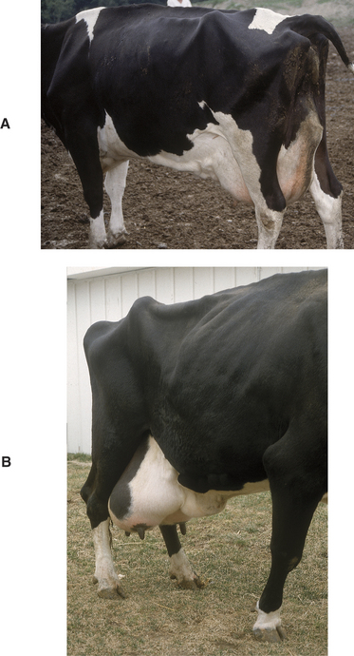
A- mature Holstein affected with lymphosarcoma. The right supramammary lymph node is markedly enlarged and appears as a firm swelling in the dorsal aspect of the right rear mammary gland. The cow also had diffuse infiltration of the mammary gland and cardiac neoplasia. B- A 14-year-old Holstein with mammary gland adenocarcinoma. There was diffuse neoplastic involvement of the gland.

Diagnosis: Biopsy or aspirate of a suspicious mass is essential for diagnosis
Treatment: Excision of juvenile tumours. Cryosurgery may suffice in early stages of the disease, but udder amputation may be required in advanced cases. Treatment for lymphosarcoma is rare and generally of limited success.

