Post operative drugs: These drugs should be given after the procedure has been completed

Active Ingredients | Administration and Dosage | Use | Withdrawal time | Picture
Procaine penicillin G, 200000 IU Dihydrostreptomycin sulphate, 200 mg  Excipients ad, 1ml | -IM  -1.1 mg/kg  -administer before procedure  -administer once daily, for 2 days after procedure | -antibiotic  -narrow spectrum  -bactericidal action against mainly Gram-positive bacteria | Milk: 60 hours  Meat: 23 days | 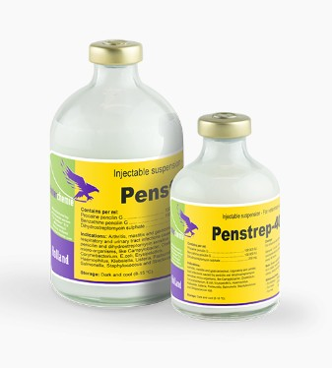
Flunixin meglumine | -IV  -20,000 iu/kg  -administer before procedure  -administer once daily, for 2 days after procedure  -slow infusion | -NSAID  - anti-inflammatory  -anti-pyretic activity  -analgesic  -antitoxic  -given for relief of postoperative pain | Milk: 36 hours  Meat: 4 days pre-slaughter time | 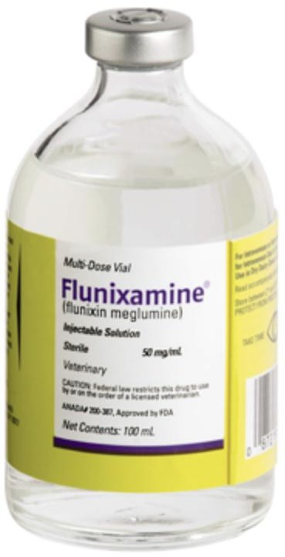

25mg/mL Oxytetracycline hydrochloride  2mg/mL Gentian violet | -applied topically  -administer immediately after procedure  -administer daily after procedure (3 to 5 days) or until wound has healed | -stable bacteriostatic broad spectrum antibiotic  -interferes with the protein synthesis of Gram-ve and Gram+ve bacteria |  | 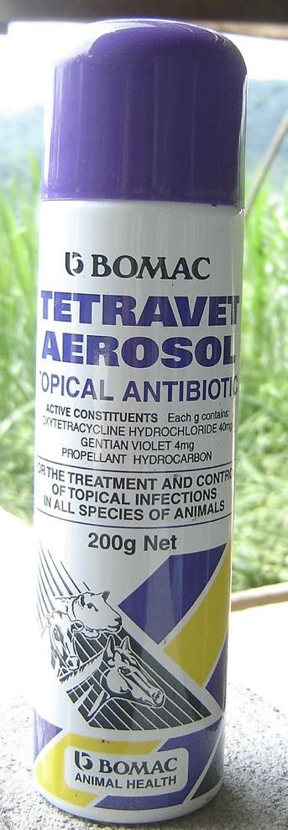
Silver Sulfadiazine 0.1 g Aluminium 5.0 g  DDVP 1.6 g  Cypermethrin 0.4 g | -applied topically  -administer immediately after procedure  -administer daily after procedure, until wound has healed | -antiseptic and antimicrobial properties  -used for interdigital conditions and dermatitis caused by licking  -used for healing, anti-myasic, repellent |  | 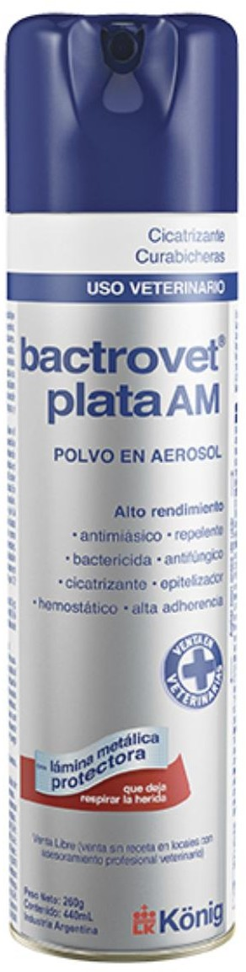
Chlorfenvinphos 0.52g Dichlorvos 0.83g  Gentian violet | -applied topically  -administer immediately after procedure  -administer daily after procedure, until wound has healed | -insecticide  -paralysis of the larvae  -protects, keeps insects away and reinfestation of the wounds |  | 