SPERMATIC CORD NERVE BLOCK
Desensitizes nerve fibers of the spermatic cord.
Location: spermatic cord
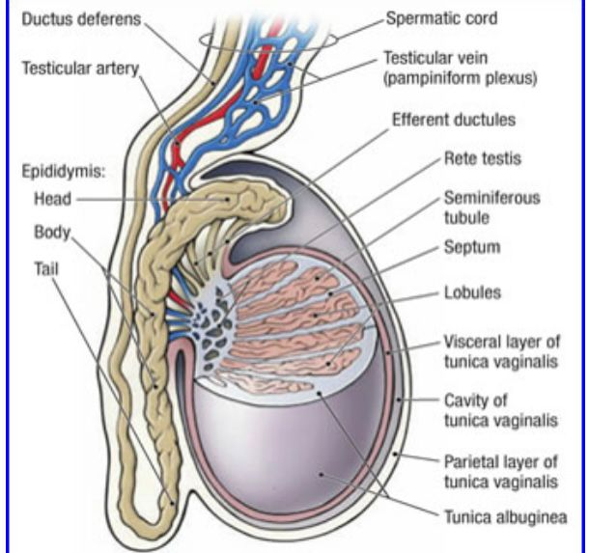
Procedure:
- Palpate the spermatic cord and isolate it laterally,
- Insert needle as proximally as possible in the midline of the cord and inject half the volume of lidocaine.
- Aspirate to ensure the needle is not in any blood vessels before administering.
- Pull out needle slightly from the spermatic cord and into the scrotum and inject the remaining lidocaine into the subcutaneous tissue.
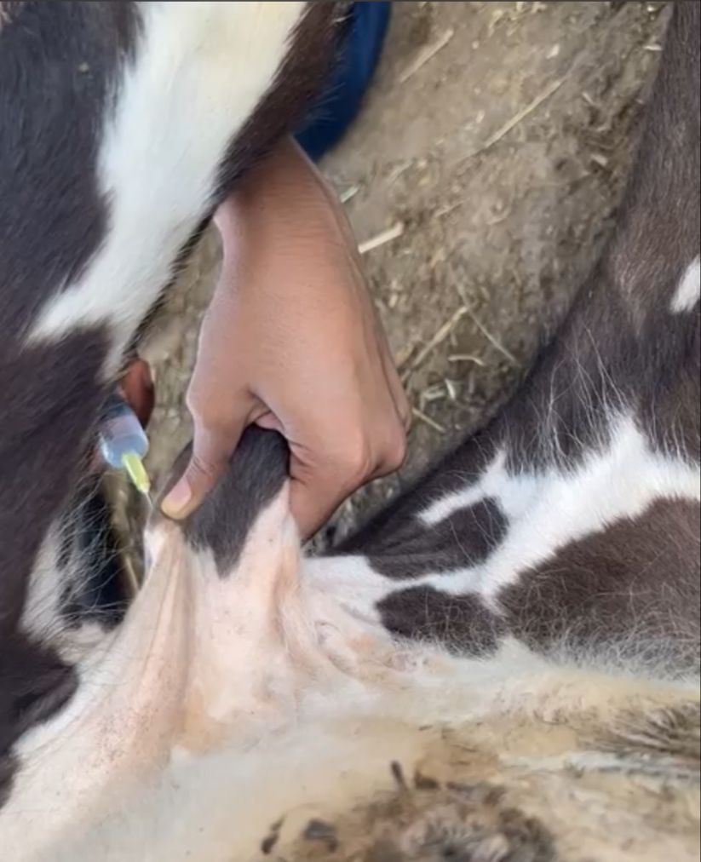 Picture taken from lab showing spermatic cord block being done.

