 | Equipment Name | Description
Manual Hoof Trimming Tools
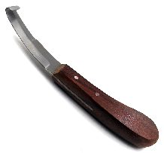 | Hoof Knife | A slightly curved blade used for trimming of hooves and removal of debris. Ensure knife is sharp to prevent injury to user and animal.
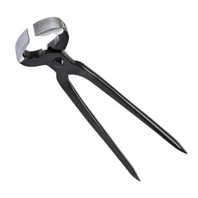 | Hoof Clippers | A physical means of removing hoof material by squeezing the handles together thus closing the bit and removing part of the hoof
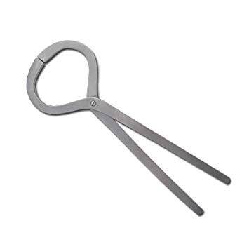 | Hoof Testing pliers | Used to check feet for any indications of pain
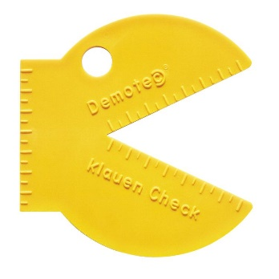 | Measuring tool | An angular tool used to measure the angle of the hoof, a protractor and ruler can be used in place of this.
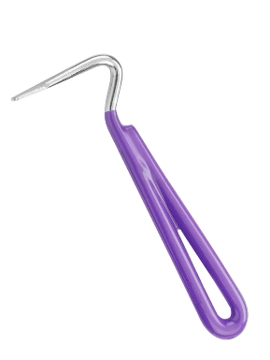 | Hoof pick | Used for removal of debris
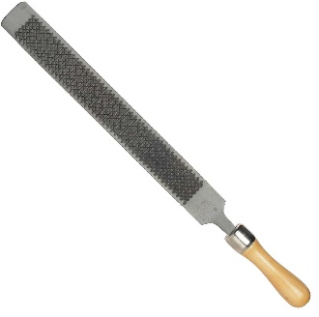 | Hoof Rasp | A hoof rasp is a coarse file used for shaping.It is used to trim and shape the hoof. It is also sometimes referred to as a farrier’s rasp
MOTOR HOOF TRIMMING TOOLS
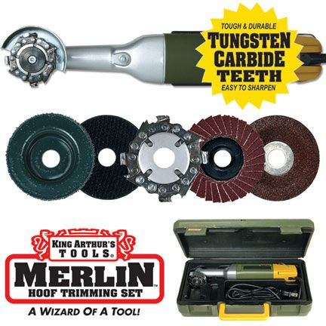 | Merlin Tool | The Merlin-Electric Hoof Knife  can handle are quickly removing excess hoof wall material or over-growth, cleaning pith from the sole area and dress  the flare from the hoof wall. The Merlin can be used for both corrective and routine or maintenance trimming
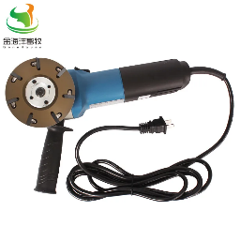 | Electrical Hoof Grinder | An angled electrical grinder used to remove layers of debris and hoof material during hoof trimming.
OTHER EQUIPMENT USED
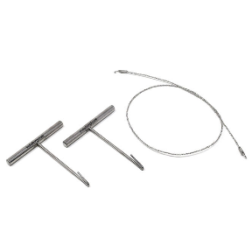 | Gigli wire | A strong wire that is used to saw through the bone.
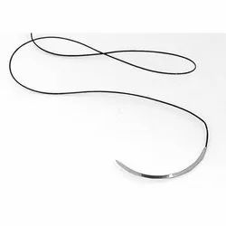 | Nylon sutures | A synthetic, non-absorbable suture material, that needs to be taken out after a duration of time.
 | 22 Scalpel Blade
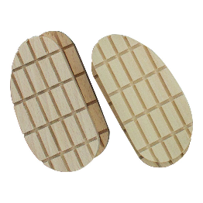 | Hoof Block | Used to elevated a hoof, also used to provide comfort and protection of hooves in lame cattle

