SOCIAL COGNITIVE VIEW
This is a brief summary of the three key assumptions of Bandura’s Social Cognitive approach to learning theory:
- Reciprocal interactions on each other of behaviour, person and environment.
- The ways learning occurs – enactive and vicarious.
- Learning and performance are different.

Triadic Reciprocality Model (reciprocal interactions)
Bandura’s social cognitive believed people were not controlled by external stimuli or by inner forces. Bandura believed that your cognitive and other personal factors, your behaviour and your environmental events all interacted and determined each other. (Schunk, p. 85) In the model below the bold part was originally published by Bandura in his Social Foundations of Thought and Action. The interior descriptors were added by me to give a better understanding of the forces involved.

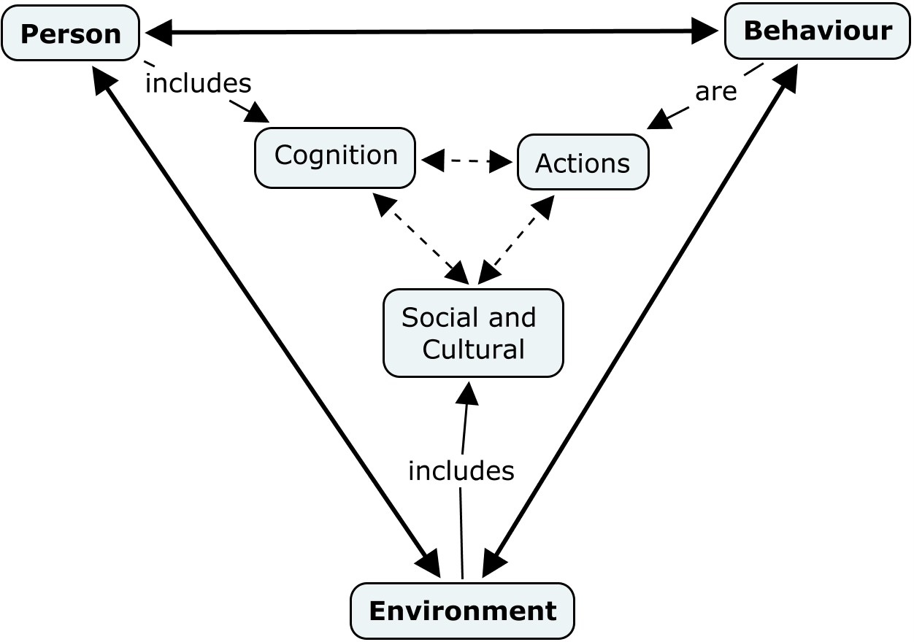
Enactive and Vicarious Learning
Learning is seen as mainly an information processing activity that happens as a result of actual doing (enactive) or by observing (vicariously). The person observes a model of what it is they want to learn. The observations will assist in accelerating learning. Complex skills will require a combination of action and observation (enactive and vicarious). The models observed could be live, symbolic or portrayed electronically. (Schunk, p. 86).

Learning and Performance
Social cognitive theory sees these as two separate functions. Although learning can occur through actions (performance) it is not the only way to learn. Some learning occurs through observation. In 1978, Rosenthal & Zimmerman noted that many students learned the following types of knowledge when they were not performing:
- Declarative knowledge – facts, scripts, organized passages
- Procedural knowledge – concepts, rules, algorithms
- Conditional knowledge – knowing when to employ forms of declarative and procedural knowledge and why it is important to do so
(Schunk, p. 87)

References:
Schunk, D.H. (2004), Learning Theories: An Educational Perspective, pp. 83-112 (Ch. 3). Upper Saddle River, NJ: Pearson

