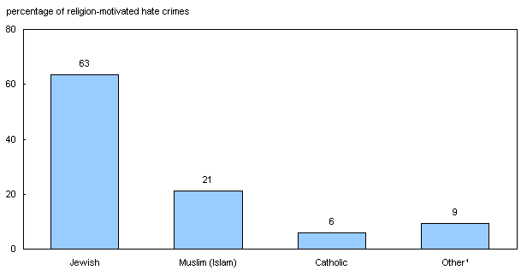
Graph of hate crimes in Canada

