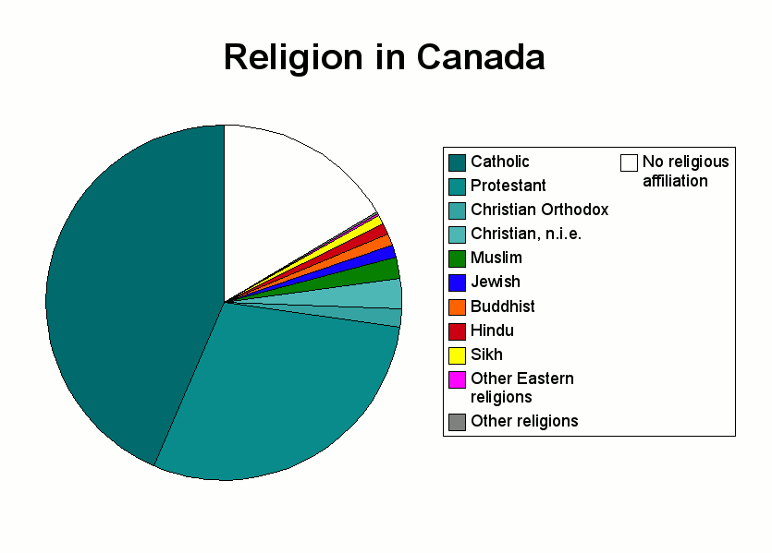
Pie Chart on the Religions in Canada

