Canadian Sport Images

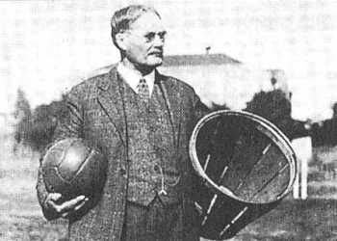
This is a picture of James Naismith

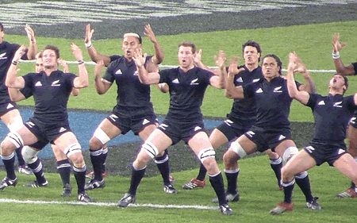

One of the team is the amazing New Zealand.
The warm up in the most toughest http://www.youtube.com/watch?v=z4LNjNXt1yM
this a picture of New Zealand doing there warm up. Every game they do this. For a warm up.


