Subunit on the Maya Civilization
Created and Developed by Nick Neiderhouse
Anthony Wayne Local Schools, Whitehouse, OH

Rationale:
Social Studies students will need to describe the characteristics of the Maya civilization including the location, religion, agriculture, and cultural and scientific contributions. My instructional design will target this curricular issue because the student learning outcomes that I have established at both the subunit and lesson level clearly articulate what my students will learn and be able to do as a result of my instruction. Through engagement in my instruction, students will be informed of my learning outcomes and how they can reach them to increase their achievement. This will provide a sense of direction for both my students and myself. My design will guide learners and instruct them as to where they are going, and how they know when they have reached a certain outcome. New encounters with concepts and skills will be attained and mastered, as content knowledge is taught and then connected to the learner's experiences. Throughout my activities, I will provide examples that are derived from real situations, events, and problems to clearly connect the concepts to student learning. In accordance with my contextualized teaching and learning theory, my assessments will provide closure as students are assessed to ensure authentic retention and transfer of concepts for my instructional design.

Curricular Unit Outcomes:
History

Subunit: Maya Civilization

- Students will describe the location of the Maya civilization.
- Students will identify the physical characteristics of people from the Maya civilization.
- Students will evaluate the religious practices and beliefs of the Maya civilization.
- Students will examine the cultural and scientific contributions of the Maya civilization.
- Students will compare the cultural practices and products of the societies including the daily life, customs, and traditions.
Pre assessment
For my pre assessment strategy, I have chosen to have my students complete a K-W-L chart about the Maya civilization. This will allow me to activate students prior knowledge about this civilization by asking them what they already Know about this topic, and then setting goals about what they Want to learn about this particular civilization. After students have completed this portion of the chart and discuss their thoughts and ideas, I will collect this from them. A discussion will occur before the charts are handed in and students will be asked to tell what they already know about this civilization. Students will be encouraged to not add any other students' ideas to their charts and will not be allowed to have a writing utensil out at this point. Sample general questions may include: Where is the Maya civilization located?, What does a Mayan look like?, How did they survive?, and is this civilization still around today? Through these discussions, I will then be able to determine if students have any misconceptions or if they have background knowledge about the Mayans.
At the end this unit, the students will receive their charts back and complete the; what have I Learned portion to complete the chart. This will be beneficial because I will be able to determine which students utilized and gained higher-order thinking strategies to help them construct meaning from what they have learned and to identify how their learning has progressed throughout the unit.

Maya - KWL Chart

Name:_____________ Date: _____________

What I Know | What I  To Know | What I’ve Learned

Lesson Plan Number One (Day One): The Mayan Experience

Subunit Outcomes:
- Students will describe the location of the Maya civilization.
- Students will identify the physical characteristics of people from the Maya civilization.

Lesson Objectives:
- Students will observe pictures of Mayan architecture and structures and interpret their meanings from the Power Points.
- Students will understand the geographical features on which the Maya lived.
- Students will place countries, cities, and bodies of water on the continent on which Mayans lived.

Materials:
- Overhead video projector
- Overhead projector
- Computer
- PowerPoint software

Procedure:
- The following procedure should last approximately 60 minutes or one class period.
- Personal stories of when I went to Mexico will be shared with the class. In these stories, I will incorporate how the Maya civilization has impacted our society today and how we still use some of their inventions to better our lives. (e.g. calendars, corn, early form of government) (10 minutes)
- Students will view the attached Power Points in the Cmap. These include photos and videos from my Mayan encounters at two Mayan Ruins: Tulum and Coba. (35 minutes)
- Students will be handed the worksheet below titled: The Mayas-Mapping it Out and be instructed to use the maps in the front of their textbooks to correctly locate the places were the Maya civilization was the most dominate. (10 minutes)
- Once every student has attempted to complete the map, the teacher will reveal the correct locations on the overhead projector so the students are able to accurately place the countries, cities, and bodies of water on the continent where the Mayans lived. (5 minutes)

Assessment:
1. Students will be assessed formally and informally for this activity.
2. Formally, I will have a very similar map on the final post-assessment to see if students could accurately located the given locations. This will be graded as apart of the final assessment.
3. Informally, I will ask students' questions at the beginning of the lesson tomorrow to observe if students retained the material from my Power Point presentations.

Summary:
Through actively listening to my presentations, students will gain a better understanding of how the Mayans lived and carried out their daily lives. Students can observe the temples, buildings, water features, cenotes, jungles, wildlife, and plant life that was available for the Mayans to survive. These will help students formulate and conceptualize what resources were available to the Mayans to live and make their buildings or gaming areas.
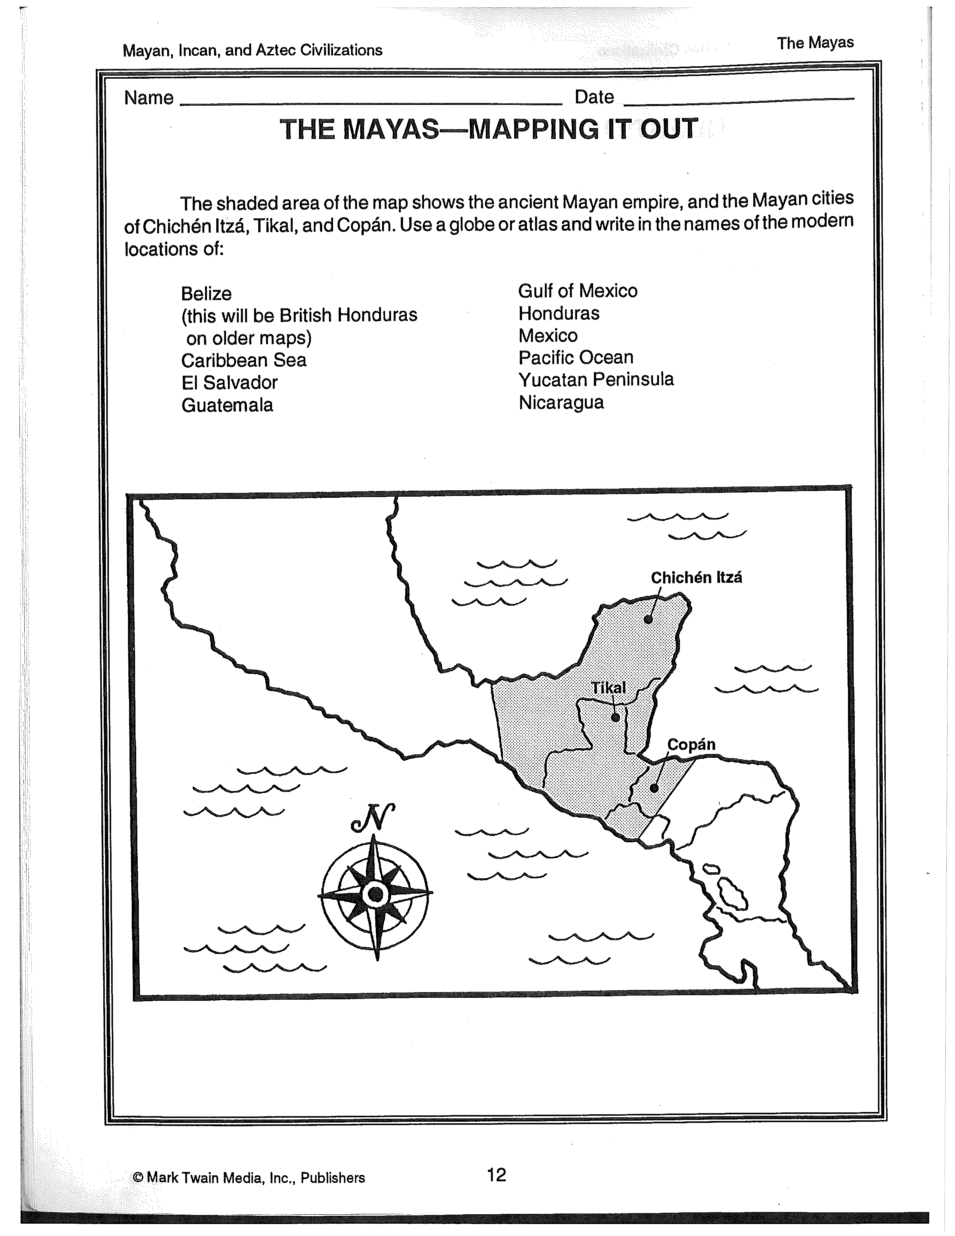
Obtained from: Kramme, M. (1996). Mayan, Incan, Aztec Civilizations. Greensboro, NC: Mark Twain Media, Inc.
Lesson Plan Number Two (Day Two): The Mayan Empire

Subunit Outcomes:
- Students will evaluate the religious practices and beliefs of the Maya civilization.
- Students will examine the cultural and scientific contributions of the Maya civilization.
- Students will compare the cultural practices and products of the societies including the daily life, customs, and traditions.

Lesson Objectives:
- Students will use vocabulary words related to the Mayan empire.
- Students will learn about the arts, inventions, daily life, and religious beliefs of the Maya.
- Students will understand why the Maya are considered among the most advanced of all ancient civilizations.

Materials:
- Internet access for Mayan Kids website (http://www.mayankids.com/mkintro.htm)

Procedures:
- The following procedure should last approximately 60 minutes or one class period.
- Introduce key vocabulary words and provide definitions on board: (10 minutes)
A. Cenote
B. Codex
C. Excavate
D. Hieroglyphs
E. Jade
F. Motif
G. Stele
- Have students work individually or with partners to answer the following questions as they explore Mayan Kids. (30 minutes)
A. People, Places, and Beliefs
Go to Mayan Kids website: http://www.mayankids.com/mkintro.htm and click on the “people,” “places,” and “beliefs” links at the top of the screen to read about the daily life
of the ancient Maya. On a separate piece of paper, create a three-column chart and make notes about each of the important topics that are covered.

B. Advanced Civilization
The following quotation is found on the site:” The Maya were the most advanced of all ancient Mesoamerican cultures.” Explain what this statement means. Support your explanation with facts from the website.
4. Set aside time for students to share and discuss the information they gathered back in their assigned seating groups. These consists of about four to five students for each group. (15 minutes)

Assessment:
- Use the rubric that follows the summary to assess students' understanding of the ancient Mayan Empire.
- The first section of this will be completed as students are working on the activity. The other three sections will be completed once students turn in their chart and answer to the quotation.
Summary:
After the students discuss their answers, students will be probed for recollection of the key vocabulary words that were introduced at the beginning of the lesson. After definitions are understood, students will receive their homework below to reinforce the concepts for the day. (5 minutes)

The Mayan Empire Rubric
4 | Exemplary  Student:  moves around the website without difficulty.  makes thorough and detailed notes about the people, places, and beliefs of the ancient Maya.  accurately interprets the quotation and supports it with multiple facts from the site.  actively participates in a discussion of the Maya.
3 | Competent  Student:  moves around the website with some guidance.  makes notes about the people, places, and beliefs of the ancient Maya.  interprets the quotation and supports it with at least one fact from the site.  participates in a discussion of the Maya.
2 | Developing  Student:  moves around the website with substantial guidance.  makes incomplete notes about the people, places, and beliefs of the ancient Maya.  interprets the quotation but does not support it with facts from the site.  minimally participates in a discussion of the Maya.
1 | Emerging  Student:  is unable to move around the website.  is unable to make notes about the people, places, and beliefs of the ancient Maya.  is unable to interpret the quotation or support it with facts from the site.  does not participate in a discussion of the Maya.
Obtained from: http://www.teachervision.fen.com/mexico/rubrics/4783.html?detoured=1
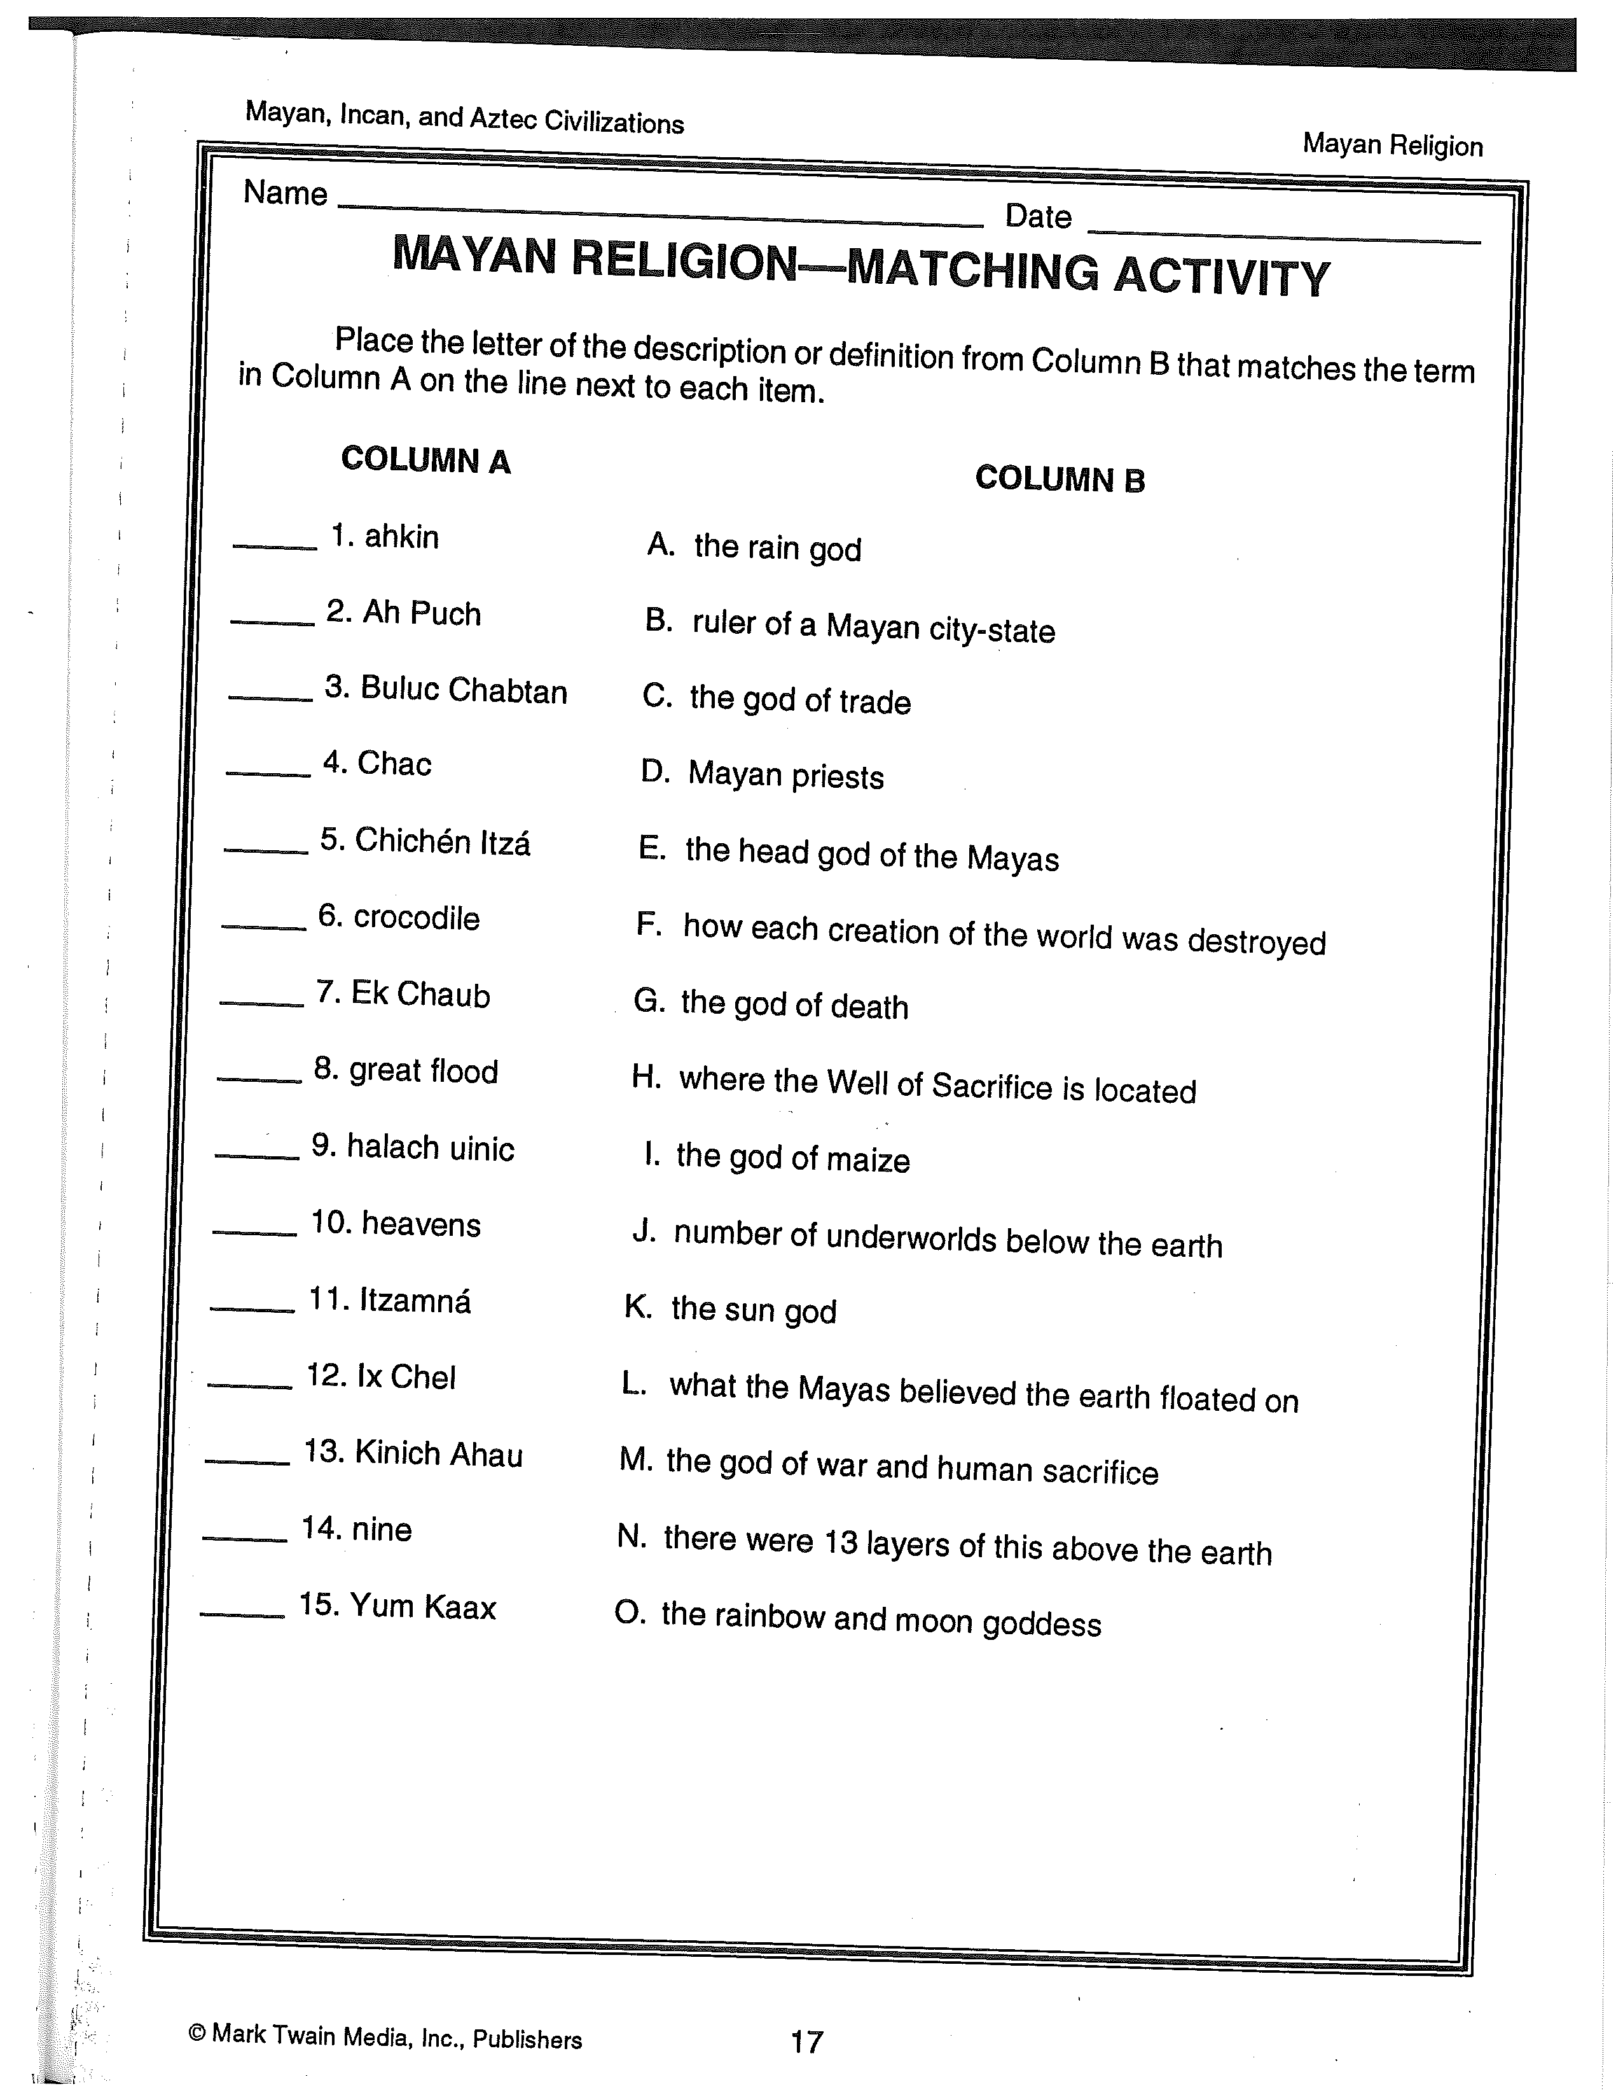
Obtained from: Kramme, M. (1996). Mayan, Incan, Aztec Civilizations. Greensboro, NC: Mark Twain Media, Inc.

Lesson Plan Numbers Three and Four (Days Three and Four): Ancient Maya-Knowledge Through Art

Subunit Outcomes:
- Students will identify the physical characteristics of people from the Maya civilization.
- Students will examine the cultural and scientific contributions of the Maya civilization.
- Students will compare the cultural practices and products of the societies including the daily life, customs, and traditions.

Lesson Objectives:
- Students will analyze pieces of art from Maya exhibit.
- Students will examine glyphs that form the Maya system of writing.
- Students will read about ancient Maya culture and how we have learned about the Maya through their art.
- Students will develop an understanding of Maya daily life through writing and hands-on activities.

Materials:
- Internet access
- Ingredients for Maya chocolate drink. (Unsweetened baking chocolate, boiling water, cinnamon, chili powder. See the procedures in activity number two for complete recipe.)

Procedure (Day Three):
- First of all, collect students' religions matching worksheet that was for homework last night.
- The first activity for this lesson will last 60 minutes or one class period.
- Show the streaming video of the following Online NewsHour transcript: Mayan High Life found at: http://www.pbs.org/newshour/bb/entertainment/jan-june04/mayan_05-13.html
(30 minutes)
4. Then ask students to explore the following Web sites to gather information about the life of the
Mayan people: (10 minutes)
A. Latest archaeological finds:
http://news.nationalgeographic.com/news/2004/05/0504_040505_mayamasks.html
B. Mayan art and artifacts:
http://www.nga.gov/exhibitions/mayainfo.htm
5. Use the websites below to answer the lesson one handout questions.
A. http://www.historylink101.com/1/mayan/ancient_mayan.htm
B. http://www.ancientsites.com/aw/Post/261968
C. http://www.jaguar-sun.com/
D. http://www.mesoweb.com/
6. After examining the web resources, give students the handout below and ask them to answer questions individually or with a partner. (15 minutes)
Procedure (Day Four):
- The second activity for this lesson will last 60 minutes or one class period.
- Pass back graded questions from lesson one handout from yesterday.
- A short review of yesterday's lesson concepts will be presented by the teacher. Refer to lesson one handout and questions for material. (10 minutes)
4. Have student visit the virtual version of the Maya exhibit found at: http://www.nga.gov/exhibitions/2004/maya/lifeatcourt.htm
5. Now that the students have some background knowledge about the Maya, engage them in a discussion in which they answer some or all of the following questions. Have students answer questions in their assigned seated groups. (30 minutes)
A. By looking at the art of the Maya, what seems to be important in their
lives?
B. What does the art tell us about the role of women compared to the roles of
women in our society today?
C. How do the religious symbols and their use in art and daily life compare
with the use of religious symbols and religion today?
D. What roles did maize and cacao play in the religious life of the Maya?
E. What does the figure of the maize god reveal about life in the court?
F. How do the hierarchy and interactions of kings, queens, and courtiers
compare with those of government officials today?
G. Look at the cylinder vase showing Itzamna, the Moon Goddess. Think of
the types of paintings and sculptures that artists create today. Do they
represent the same kinds of things as the art of Maya?
H. What symbols of power are shown in the art of the Maya? What symbols
of power do we have today?
I. Look at the cylinder with the court scene. What evidence is shown on the
cylinder to indicate the wealth and status of the man pictured?
J. What are some of the outward signs of wealth and good living for modern people? K. If corn or maize represented wealth and success to the Maya, what serves
the same purpose for us? How do they compare?
L. Look at the carving of the queen drawing the thorned rope through her
tongue? What did this represent? Do you believe that suffering and sacrifice
must always precede success and good fortune? Why or why not?
M. Why was sacrifice and bloodshed expected of Maya leaders?
N. Look at the pieces of art that show Maya warfare and captive prisoners.
How were the reasons for going to war similar to or different from those
used by modern leaders?
O. What do these pieces of art tell us about Maya warfare?
6. After questions have been answered in the groups, have students reveal answers to the class. This will allow you to add to answers and correct any misconceptions. (10 minutes)
7. As students are answering the above questions in their groups, the teacher ahead of time can have a Maya Chocolate drink ready for everyone to try. The recipe is below. This can be handed out and enjoyed the last ten minutes of class.
Recipe:
- Grate 1 oz. unsweetened baking chocolate into a cup or mug.
- Add a little boiling water and stir until melted.
- Then add a little cinnamon, or, to be authentic, some chili powder.
- Fill the cup with boiling water.
- Using a whisk, stand it upright in the cup and rub the whisk briskly between your
hands to make the chocolate foam.
Assessment:
- Assessment for the first activity will include grading students' to the posed questions on the handout.
- A non-graded assessment will involve gaging students responses to the oral questions that are provided at the end of the class period.
- At the end of day four, have each group turn in their responses to the above set of questions.
- The teacher can review each group's responses for accuracy and to make sure concepts were attained.

Summary:
After students have completed the questions on their handout, have students turn their answers in the tray behind my desk. To conclude day three, ask students two broad questions about the Maya art and civilization: Who held the power in the Maya Civilization? and What goals and values were important to the Maya? If responses are accurate, the lesson for day four will continue. If responses are incorrect, the teacher will need to correct responses and review them again at the beginning of day four. For day four, students will be engaged in answering questions from the provided website. Then through the group interactions and discussions that will take place, students will be learning material and mastering objectives subunit concepts 1-3 and lesson outcomes 1-4.

Ancient Maya: Knowledge through Art (Lesson One Questions) Handout

1. List five great Maya cities, and describe the basic city design.
2. Who are the principal Maya gods?
3. How is the Maize God story connected to the maize crop cycle?
4. What is Popol Vuh?
5. Who were the Hero Twins?
6. What were some of the features of physical beauty for men and women of the Maya
court?
7. What was the "ball game?" How was the "ball game" connected to the Maya religion?
8. What is a glyph? Copy one and explain its meaning if you can.
9. Write your age using the Maya numbering system.
10. What great mathematical discovery are the Maya known for?
11. Why was cacao important to the Maya?

Lesson Plan Number Five (Day Five and Six): A Classical Maya News Report

Subunit Outcomes:
- Students will examine the cultural and scientific contributions of the Maya civilization.
- Students will compare the cultural practices and products of the societies including the daily life, customs, and traditions.

Lesson Objectives:
- Students will determine the relationships between Maya city-states during the classical period.
- Students will discover how archaeologist study and learn from their findings.

Materials:
- Pens, pencils, and markers
- Scissors
- Paper
- Paints, glue, and tape
- Books and magazine articles about the Maya classical period
- Atlas
- Encyclopedias
- Computer with Internet access
- Computer with Pages software (optional)
- Video equipment (optional)

Procedures:
- This activity for the lesson will last at least two sixty minute class periods from the beginning to the end.
2. To introduce the lesson, ask the students the following questions to evoke creativity and to get students motivated to learn and engaged in the activity. (5 minutes)
A. What can artifacts tell us about a civilization like that of the ancient Maya?
B. Why was deciphering the Maya hieroglyphs important to the understanding of their history and culture.
C. What do you think archaeologist will find from our society 2,000 years from now, and what will their findings say about us?
D. What role did astronomy play in ancient Maya civilization?
3. Explain to students that they will explore the ancient civilization of the Maya during the classical period, from A.D. 300 to A. D. 900. This time in Maya civilization was marked by the growth of city-states and by imperial wars between them. Students will then prepare news reports about the major events of this period. (Remainder of the class period today and tomorrow) Events might include a great war planned for a special astronomical date or the capture of a rival king and his city-state.
4. Explain to students that their news reports may be in the form of a magazine article using Pages, with sidebars providing background information; a major newspaper story; or an editorial. Students may also wish to videotape a presentation in the style of a prime-time television news show. Although students are reporting on historical events, they should strive to give their news stories a present-day immediacy.
5. Have students work in small groups. Provide each group with a list of classical period city- states, in Tikal, Clakmul, Piedras Niegras, and Uaxactun. If students are interested in other classical period city-states, allow them to explore these as well. Ensure that each group has chosen a different city-state so that no two groups report on the same event. See reading material below for examples passed out to students.
6. Encourage students to analyze the media format in which they choose to present their reports. Challenge them to include as many features of media as they can, such as headlines, illustrations, news anchors, graphic titles, sidebars, and editorials. Students may even wish to stage interviews with kings of the city-states.
7. Collect encyclopedias and a variety of books and magazines articles about the Maya classical period. (e.g., Breaking the Code, Popol Vuh: A Sacred Book of the Maya)
8. Students may also access the websites below to learn and obtain information:
A. http://www.learner.org/interactives/collapse/
B. http://www2.iath.virginia.edu/med/
9. Allow class time for each group to present its news report. Include a class discussion period so that students can ask any questions they still have.

Assessment:
- Students will be evaluated on their Maya news report using the following the three-point criteria.
Three points: Students present a complete news report about an event from the Maya classical period. The news report utilizes many features of its medium. (e.g., sidebars, interviews, and open-ended pieces), and there it full group participation.
Two points: Students present the basic facts of the event. The news report only only contains a few of the features of its medium, but whole group participates.
One point: Students present a brief report of the event with little background material and few special features. There is not full group participation.
2. There will also be informal assessments provided by the teacher as the teacher facilitates and observes the progress of the working groups.

Summary:
For this lesson, students will learn the objectives through much research and by applying the jigsaw method of learning. Each student in the group will be responsible for a certain section of the news report and then inform the other students of their findings. Then as a result, students will compile their evidence to create an overall project. As groups are presenting their reports, other students will be learning the objectives, such as the classical period characteristics and the culture contributions of the Maya.

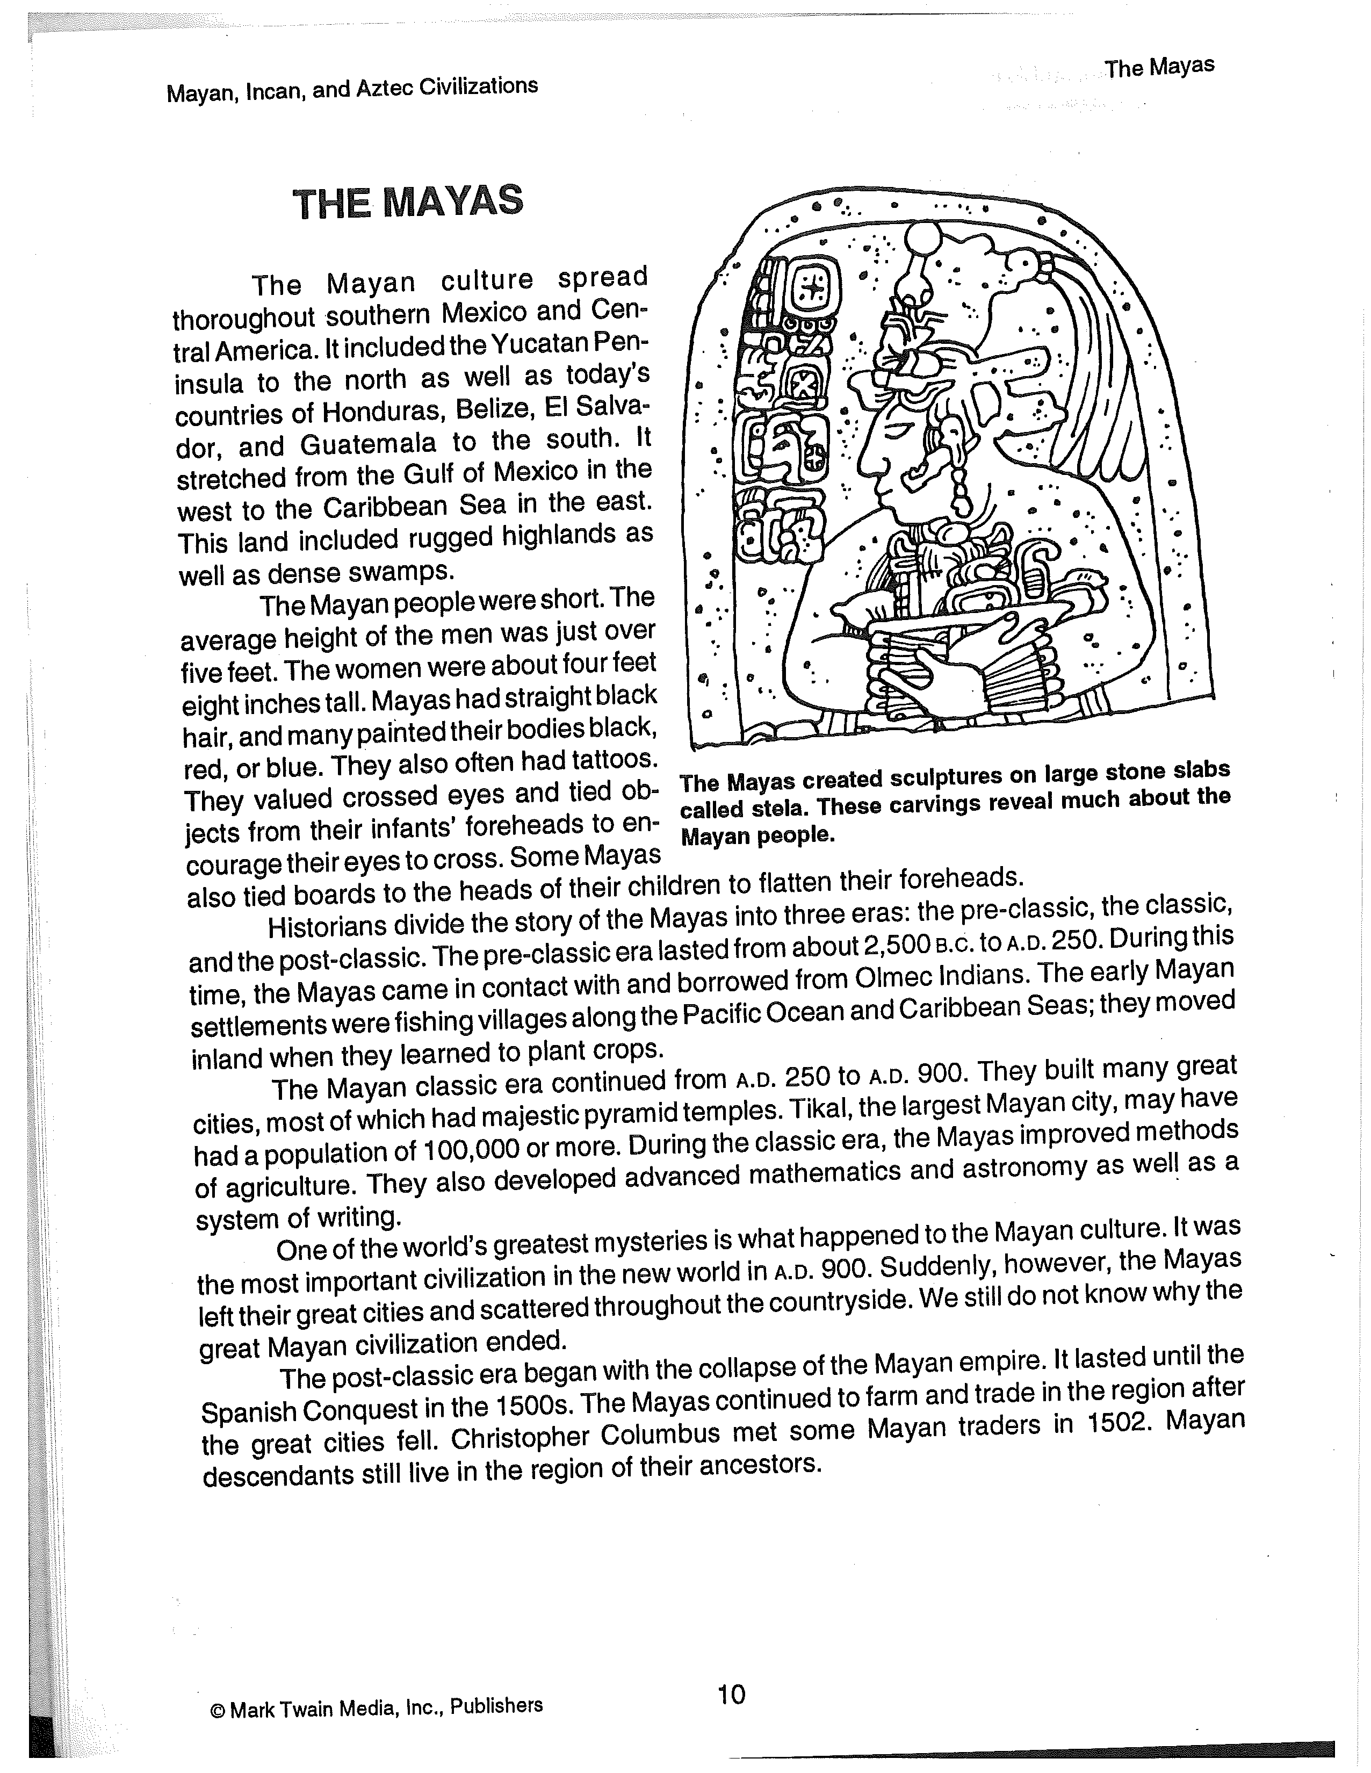
Obtained from: Kramme, M. (1996). Mayan, Incan, Aztec Civilizations. Greensboro, NC: Mark Twain Media, Inc.

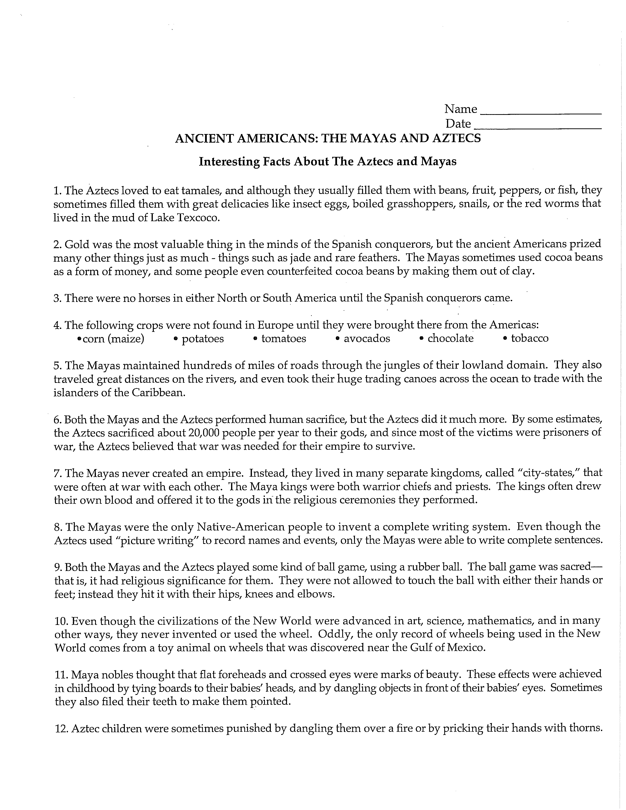
Obtained from: My personal file of facts

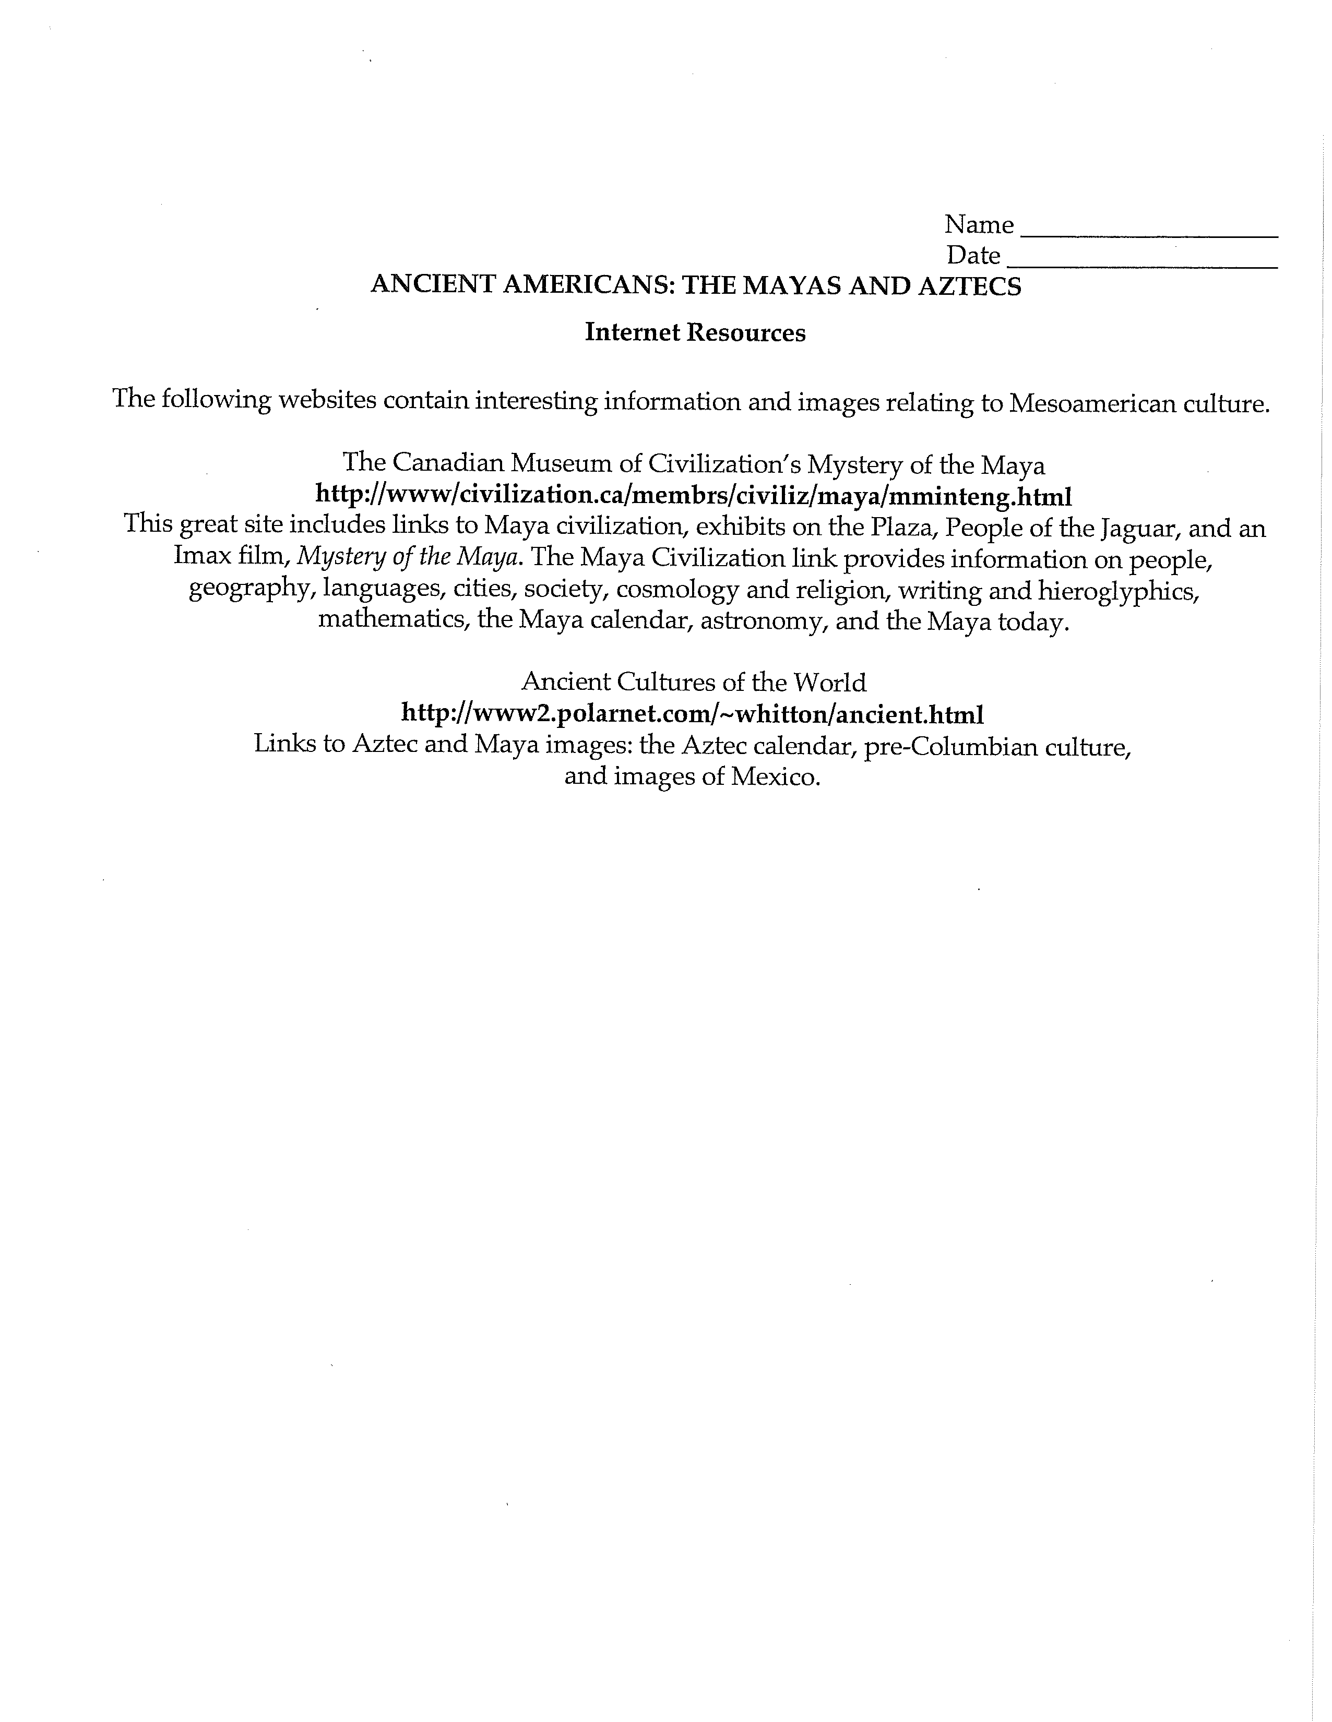
Obtained from: My personal file of facts
Post assessment
Upon completion of lessons one through five, these will be evaluated as a comprehensive
post assessment. The research projects, worksheets, presentations, discussions, and news reports will help to solve my original issue of having students identify the characteristics of the Maya civilization including location, religion, agriculture, cultural and scientific contributions. Through my activities, daily checks for understanding,and incremental homework assignments, the post assessment will provide me with the data that indicates the extent to which students reached unit and lesson objectives and how much of that attainment can be attributed to my instruction. The post assessment below was created before the unit and lesson design to reflect what was being taught, along with what the students were expected to learn.

Maya Civilization Assessment

Section one: Mayan History
Answer the following questions. Each question is worth two points and there are ten points total for this section.

1. What geographical features did the Mayan lands include?

2. Give three examples of what a Maya might have looked like.

3. Provide three examples of what the Mayas developed in the classical era.

4. _________What was the name of the largest Mayan city in the classical
era?
A. Tikal B. Coba
C. Belize D. Tulum

5. What Spanish explorer met the Mayan traders in 1502?

Section two: Mayan Religion
Answer the following questions. Each question is worth two points and there are ten points total for this section.

1. What did they call the ruler of a Mayan city-state?

2. Name the three sacrifice rituals.
_______________________________________________________________________________________________________________________________________________________________________________________
3. This is the name for a Mayan priest.

4. What did the Mayans believe that the world floated on?

5. Why did the Mayan make sacrifices to their gods?

Section three: Mayan Writing, Mathematics, and Astronomy
Answer the following questions. Each question is worth two points and there are ten points total for this section.

1. What type of writing did the Mayas use?

2. Why did the Spanish destroy Mayan books?

3. What did a drawing of a shell represent?

4. Write the numbers “eight” and “twelve” the way the Mayas would have written them. (Must get both correct to receive full credit)

_____________ _______________
eight twelve

5. What did the Mayans build to observe the stars?

Section four: Mayan Agriculture and Trade
Answer the following questions. Each question is worth two points and there are ten points total for this section.

1. How did early Mayas get food?

2. What is one of the oldest methods of farming?

3. What caused Mayan farmers difficulty?

4. How did merchants transport goods by the water?
_____________________________________________________________

5. What was the Mayan trade system called?

Section five: Mayan Mystery and the Spanish
Answer the following questions. Each question is worth two points and there are ten points total for this section.

1. This is what Mayans used to plant their crops.

2. This was the name for Mayan merchants.
A. Ahkin B. Warriors
C. Priests D. Ppolm

3. Name three possible reasons for the Mayan decline.
_____________________________________________________________
_______________________________________________________________________
___________________

4. What were the white Spanish searching for in the Americas?

5. What did the white men bring with them to the Mayans?

Section six: Miscellaneous Mayans
Answer the following questions. Each question is worth two points and there are ten points total for this section.

1. Who was one of the leaders of the Spanish conquest for the Mayans?
A. Alfred Mosley B. Merida
C. Yun Kaax D. Hernando Cortes

2. How many layers did the Mayans believe existed above the earth?
A. 20 B. 13
C. 5 D. 12

3. This is what they believed that the gods created humans from.
A. Chac B. Corn
C. Water D. Ix Chel

4. This is how they grew crops in swampy areas.
A. Steps B. Mounds
C. Terraces D. Slash and burn

5. This is the name for a Mayan book.
A. Ficus B. Tablets
C. Glyphs D. Codex

Section seven: Location
See map. Each location is worth one point and there are ten points total for this section.

Bonus: (2 points each)
- What invention, did the Mayans use to plan religious events?

2. What did the Mayans believed that each creation of the world was destroyed by?

