Rare and Fastidious
Haemophilus aphrophilus
Actinobacillus
Francisella
Rickettsia
Rickettsia rickettsii

Rickettsia akari
Bartonella henselae
Rickettsia prowazeki
Cardiobacterium
Eikenella
Rickettsia typhi
Coxiella burnetti
Alipia felis
Brucella
Kingella
Pasteurella
Capnocytophaga
Orientia (Rickettsia)
Bartonella Quintana
Ehrlichia species
Spirochetes
Leptospira
Borrelia burgdorferi
Borrelia recurrentis
Treponema carateum
Treponema pallidum ssp endemicum
Treponema pallidum ssp pallidum
Treponema pallidum ssp pertenue

Odd Balls
Bordetella parapertussis

Bordetella pertussis
Bordetella bronchiseptia

Legionella pneumophilia

Calymmatobacterium granlomatis
Chlamydia

Chlamydia trachomatis
Chlamydia psittaci
Chlamydia pneumonia
Mycoplasma
Ureaplasma urealyticum
Mycoplasma hominis
Mycoplasma pneumonia
Gram negative bacilli
First in the HACEK group
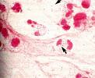

Identification Methods

Catalase Variable
Oxidase Variable
ONPG

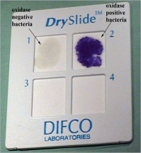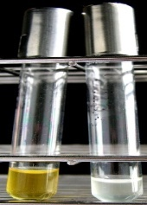

Diseases

Infections of the head and neck following tooth extractions

Septicemia & Endocarditis

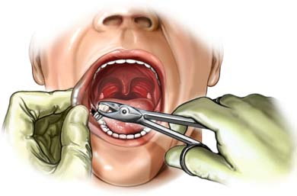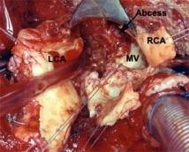

Second in the HACEK group
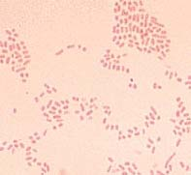

Identification Methods

Oxidase Positive
Indole Negative
Catalase Positive
Nitrite Positive

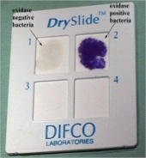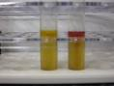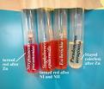
Glucose Fermenter

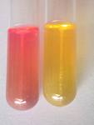

Diseases

Periodontal Disease
Endocarditis
Toxins

Collagenase and Leukotoxin
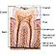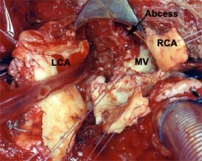
Third in the HACEK group

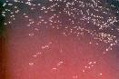

Identification Methods

Spot Indole Negative
Catalase Negative
Indole Positive
Oxidase Positive

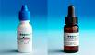

Diseases

Endocarditis exclusively in humans

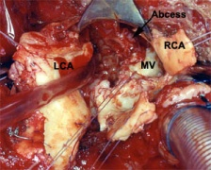
Loves cardiac valves especially aortic

Fourth in the HACEK group
Human bites/Clenched fist syndrome/Chlorox odor

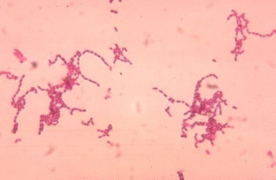

Identification Methods

Indole Negative
Catalase Negative
Nitrite Positive
Oxidase Positive
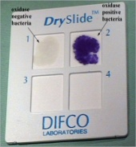
Diseases

Periodontal Disease
Endocarditis
Meningitis

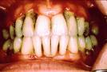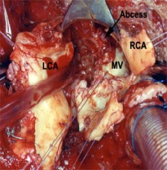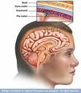
Asaccharolytic

Fifth in the HACEK group

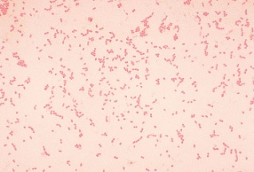

Identification Methods

Oxidase Positive
Indole Negative
Catalase Negative
Nitrite Negative

Sucrose Fermenter
Glucose Fermenter
Diseases

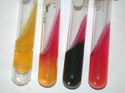

Endocarditis
Infection of the bones and joints in young children

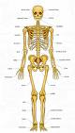

Gram Negative Fusiform Bacilli
Yellow pigment on SBA

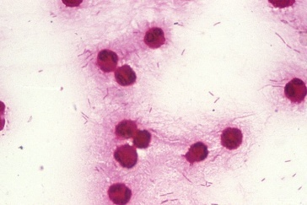

Identification Methods

Oxidase Negative
Nitrite Positive
Indole Variable
Catalase Negative

Glucose Fermenter

Disease

Periodonitis

Gram Negative Coccobacilli
Infected from a bite or scratch

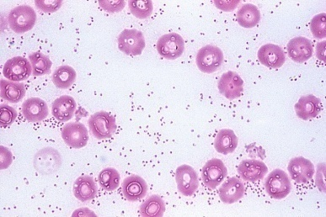

Identification Methods

Oxidase Positive to Variable
Indole Positive
Catalase Positive
Ornithine Positive
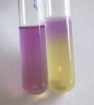
Diseases

Septic Arthritis
Respiratory infection
Cellulite Infection
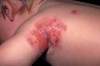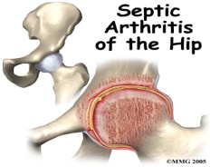

Gram Negative Pleomorphic Coccobacilli
Zoonotic Pathogen

Ability to penetrate skin

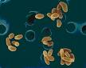

Identification Methods

BYCE
Cysteine Heart Agar
Fluorescent Antibody

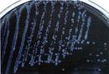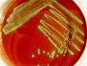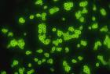
Infections

Bacteremia and Pneumonia
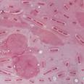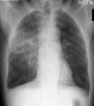

Gram Negative Coccobacilli

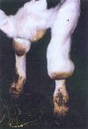

Method Identification

Oxidase Positive
Indole Negative
Urea Positive
Catalase Positive
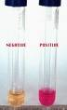
Best Sample for Identification

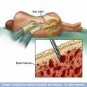
Diseases

Undulant Fever
Malta Fever
Spontaneous abortions in animals

Causes Rocky Mountain Spotted Fever

Vector

The American Dog Tick
Rocky Mountain Wood Tick

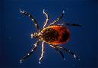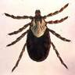

Symptoms

Headache, fever, rash, nausea

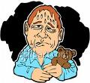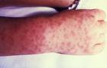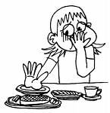

Diagnosis

Weil-Felix test
Direct Fluorescence

Causes Rickettsialpox

Vector

House Mouse Tick

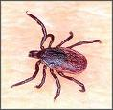

Symptoms

papule at mite bite, fever, chills, headache, rash

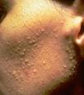

Humans are Accidental Host

Vector

Rat Flea

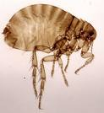

Symptoms

headache, fever, rash, nausea

Louse Borne Typhus
Vector

Human Louse
Squirrel Louse

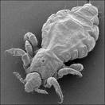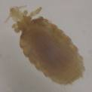

Symptoms

headache, fever, rash, nausea

Scrub Typhus

Vector

Chiggers

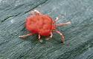

Symptoms

headache, fever, rash, chills

Causes Trench Fever
Vector

Human Body Louse
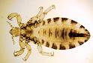

Symptoms

headache, fever, rash, severe pain in joint



Causes Cat Scratch Fever

Vector

Cat Flea
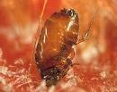

Identification Methods

Brucella Agar With Hemin

BYCE

Causes Query Fever

reservoir for cattle, sheep, goats, and cats

Organism shed in feces, milk, and birth products

Diseases

Pneumonia

Granulomatus hepatitis

Endocarditis

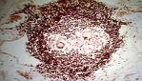

Ehrlichiosis

Vector

Tick
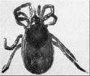

Symptoms

Headache, fever, rash, nausea

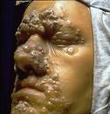
Causes Syphilis

Four Stages

Primary: painless lesion called chancre

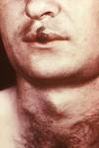
Secondary: fever, rash, ulcers

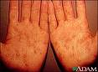
Latent: No symptoms

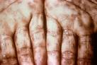
Tertiary: Gumma, Neurosyphilis, cardiovascular syphilis

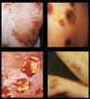

Spirochete 2

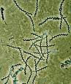

Enters through damaged skin

Produces lesions called Yaws
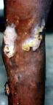
Symptoms

Fever and swollen lymph nodes

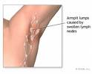

Pinta
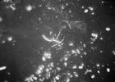
Causes hypo pigmentation and hyper pigmentation

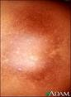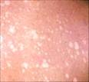
Symptoms

swollen lymph nodes

Bejel

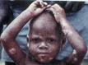
Symptoms

Primary lesion that can progress to gumma of skin, bone, mucus membrane

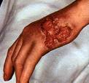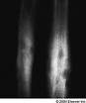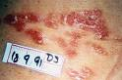
Can cause destruction of bone, skin, and cartilage

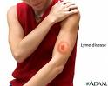
Causes Lyme Disease

Vector

Deer tick

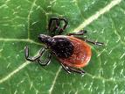
Identification Methods

Direct Observation, IFA, ELISA, PCR, Western Blot
Symptoms

Fever, headache, muscle pain, fatigue, joint pain
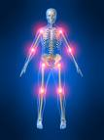
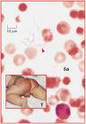
Can be endemic or epidemic

Vectors

Tick or Lice

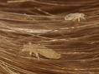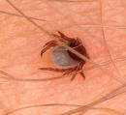
Identification Methods

Brightfield observation from lesions, CSF, blood, Kelly Medium

Causes Leptospira interrogens

Exposure
Urine from an infected animal
Can cause Weil’s Disease

Symptoms

Flu-like symptoms, headache, fever


Identification Methods
Gram stain, Wright stain, Immunofluorescence, Blood, CSF

Causes Whooping Cough
Three Toxins
Hemoagglutinin
Tracheal Cytotoxin
Pertussis Toxin

Identification Methods

Urea Negative
Nitrate Negative
Motility Negative
Catalase Positive
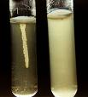
Oxidase Positive

Agarss

Regan-Lowe Medium
BCYE
Bordet-Gengou potato infusion agar

Can Cause Mild Pharyngitis
Identification Methods

Urea Negative
Nitrate Negative
Motility Negative
Catalase Positive
Oxidase Positive

Cause Pneumonia in Animals
Identification Methods

Urea Positive
Nitrate Positive
Motility Positive
Catalase Positive
Oxidase Positive

Obligate Intracellular Organism
Causes donovanosis, granuloma inguinale, granuloma venereum

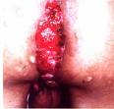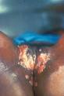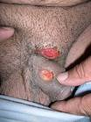

Identification Methods

Geimsa Stain, Wright Stain, Egg Yolk Medium

Facultative Intracellular
Exposure

Aerosol

Can Cause

Legionnaires or Pontiac Fever

Identification Methods

Gram Stain, BCYE, Feeley Gorman media

Can Develop Elementary Body and Reticulate Body
Common Cause of sexually transmitted bacterial pathogen in the U.S.

Vector

Horse Fly

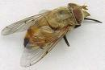

Can also cause :

Prostatitis in men, Pelvic inflammatory disease in women, Newborn conjunctivitis, Pneumonia

Parrot Fever

Cause

Pneumonia and Endocarditis

Bird handlers and Veterinarian are Susceptible

Cause Pneumonia
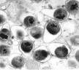

College students are susceptible

Identification Method

Cytology stain is best for diagnosis

Common Acquired Pneumonia

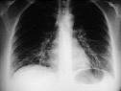
Symptoms

Non-productive cough and autoimmune cold agglutinin

Young adults and school age children are susceptible

Identification Methods

Deine’s methylene blue stain, culture on PPLO broth

Infects the Urogenital Tract

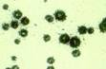

Can Cause

Non-gonococcal urethritis in men, UTI in women, Congenital pneumonia

Causes Urogenital Tract Issues
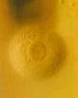

Normally found in healthy individuals

