Instructional Design

4th Grade Plant Unit: Plants’ Interactions with Their Environment

Christy Reker

Bellefontaine City Schools

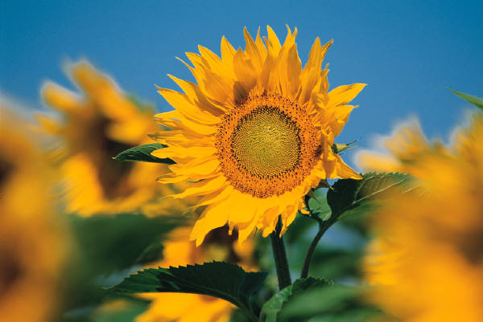

Rationale

The subunit on Plants’ interactions with nature is the last in the entire plant unit. The reason that this subunit is placed last is because of the excessive need for students to apply their prior information and knowledge to analyze how plants interact with different components of nature. If students are unable to identify the purposes of the plant’s parts as well as the different processes that the plant goes through in the life cycle, they will not be able to make the connection to the amazing relationship that plants have with the rest of their environment. I think the first three or four weeks prior to this subunit is laying the foundation to test how well the students are able to gel all of the information together. I think this subunit is also at the end of the entire unit because of its importance. If a student is able to master this final subunit, they have obviously been able to master all the content.
This subunit also is vital for students’ overall understanding of the world. I definitely feel that this area is a life skill that students need to understand. To have a great understanding of how important plants are in our world and how they need to interact with our environment for not only human survival but also the survival of countless living things.
This subunit is a great way to end the unit as well as the school year because of the vast amount of analysis and application that the students are required to do. The manner in which the content is set up allows students to take their prior knowledge and learn these processes through an inquiry-based strategy. There is not a lot of new content in this subunit for students to learn and more an application of what they learned in the unit so far as well as their general knowledge of living things in our environment. Having this unit placed at the end of the year has a great opportunity to see how far your students have matured through their 180 days of school.
This subunit, therefore, is taught with a much more inquiry-based structure. Since the subunit lands at the end of the unit and the material lends itself to be much less content and much more application, the inquiry-based structure fits well with the goals and outcomes.
It is very important to use formative and summative assessments and evaluations throughout the subunit. Again, referring back to the inquiry-based structure; there is a lot of time to observe children to get a better handle on what they understand and what needs further guidance. Even at the end of each lesson, there is a good time to spend a few minutes assessing what the students learned from the day. And then to end the subunit with a summative assessment provides an opportunity for students to use all the information and demonstrate their mastery of the content.
Unit Outcomes

Lesson 1: Why do plants interact with their environment?

- Students will be able to explain why plants need to interact with the environment for their own survival
- Students will be able to identify how the different parts interact with the environment in order to survive.
- Students will understand that different plants are made in different ways in order to use their specific strengths to increase interactions with the environment.
- Students will understand that not all plant interactions with the environment are successful.

Lesson 2: Plants’ Interactions with Insects

- Students will identify what insects interact with plants.
- Students will understand how the plants’ parts are made in order to increase the interaction with the insects, i.e. Bright colors.
- Students will be able to explain how insects interact with plants.
- Students will understand why insects have the need and are drawn to the plants.
- Students will be able to explain how the interaction of plants and insects helps plants survive.

Lesson 3: Plants’ Interaction with Animals.

- Students will apply their understanding of pollination to explain how humans can transfer pollen unintentionally.
- Students will explain how humans intentionally take part in interaction with the plants’ reproduction.
- Students will understand how plant seeds are structured to increase the chances of animals moving them to other locations. (ie: burrs)
- Students will apply their understanding of digestion to understand how animals transport seeds through eating and getting rid of wastes.
- Students will understand that animals and plants have a symbiotic relationship.

Lesson 4: Plants’ Interaction with Weather and Nature

- Students will apply their understanding of wind to analyze how seeds can be transported. (i.e. Dandelion seeds)
- Students will apply their understanding of the movement of water to analyze how seeds can move with rain.
- Students will understand how plants that live in water and around water can reproduce with the help of the moving water.

Lesson 5: Plants’ Unsuccessful Interactions and Assessment

- Students will apply their understanding of why plants produce a lot more seeds than will ever turn into mature plants.
- Students will be able to explain what problems seeds and pollen may encounter during the transportation process.
- Students will be able to demonstrate their understanding of all plants’ interactions with the environment.
- Students will analyze all the different interactions plants have with the environment.
Pre-Assessment

1. List two ways that animals can interact with plants in order to help them reproduce more plants.

________________________________________________________________________

________________________________________________________________________

________________________________________________________________________

________________________________________________________________________

2. Why do plants need to interact with animals and humans?

________________________________________________________________________

________________________________________________________________________

3. What would happen if plants do not interact with the other parts of their environment?

________________________________________________________________________

________________________________________________________________________

4. Which parts of weather help plants move seeds and pollen? (Circle all that apply)

a. Wind

b. Sun

c. Clouds

d. Water

e. Snow
Lesson 1: Why do Plants Interact with Their Environment?

Audience: 4th grade students (50 minutes)

Content: Importance of plants’ interaction with environment

Objectives:
- Students will be able to explain why plants need to interact with the environment for their own survival
- Students will be able to identify how the different parts interact with the environment in order to survive.
- Students will understand that different plants are made in different ways in order to use their specific strengths to increase interactions with the environment.
- Students will understand that not all plant interactions with the environment are successful.

Procedure:

Introduction: (10 minutes)

1. Show a picture on smart board of a tree in a prairie. Ask students how that is possible
if there are no other plants around them?
2. Use answers from students to continue a discussion on why it is necessary for that to
happen.
3. To get some extra thinking, ask students why their sunflowers will probably produce
up to 500 seeds.

Developmental: (30 minutes)

1. Set up five stations. Split students into groups. Explain the task the groups are to
work on at each station: Discuss how these different parts of the environment interact
with plants. (Stations: wind, water, humans, animals, and insects.)
2. After about 3 minutes at each station switch.
3. After all groups have been at each station reconvene to discuss their findings.
4. Based on what students stay either continue the discussion or move students towards
thinking about the reproduction cycle and what needs to happen for that process.
5. Once the students seem to be thinking in the right direction switch to whole class
pictures on smart board.
6. On smart board show two different parts of the environment and how they could
interact to help the plant reproduce. (i.e. bee and flower or burrs and bear)

Essential Questions:
1. Why do seeds need to interact with their environment?
2. What parts of an animal might a seed use to move?
3. Can you think of two ways that humans can take part in this process?
4. Do you think all seeds survive? Why or why not?
Conclusion: (10 minutes)

1. After students have discussed for a bit and they have a good basis, pass out pictures
for students to apply their understanding of the interactions. They are to explain how
the things interact.

Evaluation:

Check worksheet for a general understanding, (just introduction, do not need to master at this point.)

Materials:

1. Smart Board
2. Station pictures
3. Worksheets
Plant Interactions
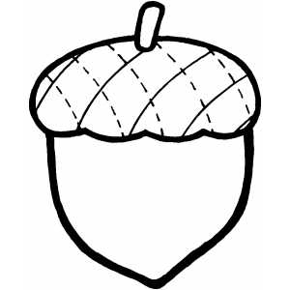
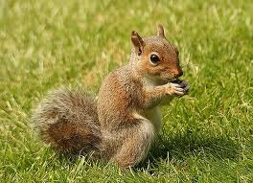
1.

_______________________________________________________________

_______________________________________________________________

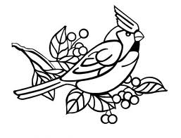
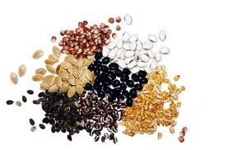
2.

_______________________________________________________________

_______________________________________________________________

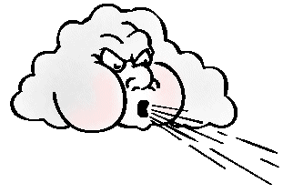
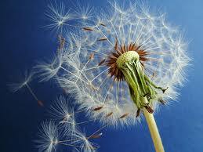
3.

_______________________________________________________________

_______________________________________________________________
Lesson 2: Plants’ Interactions with Insects

Audience: 4th grade students (50 minutes)

Content: How and why do plants interact with insects.

Objectives:

- Students will identify what insects interact with plants.
- Students will understand how the plants’ parts are made in order to increase the interaction with the insects, i.e. Bright colors.
- Students will be able to explain how insects interact with plants.
- Students will understand why insects have the need and are drawn to the plants.
- Students will be able to explain how the interaction of plants and insects helps plants survive.

Procedure:

Introduction: (10 minutes)

1. Begin by asking why do plants gravitate towards plants? Hopefully they will say the
bright colors, if not, steer them that way.
2. So great for the insect because they get nectar, but does the plant get anything out of
the process?
3. Show you tube video of bee pollinating a flower. Discuss when finished.

Developmental: (30 minutes)

1. Students will read the focus curriculum textbooks to understand the process of how
the interaction takes place.
2. Discuss after reading to ensure that students have the general basis of information of
how the interaction takes place.
3. Take the students a step farther and have them analyze what parts a plant has that helps
this process happen, (bright colors, loose/sticky pollen)
4. Now, have students take it another step further and ask them what parts and actions of
the insects help in the process, (light weight, flying ability, need for nectar).
5. Finish with a picture of different steps of the pollination process and label each step
together.

Essential Questions:
1. How do plants and insects work together to survive?
2. How have plants adapted themselves over time to help attract insects?
3. What would happen if insects died off? What plants be able to survive?

Conclusion: (10 minutes)

1. Give students exit ticket on analysis of the relationship with insects and plants.
2. Have students turn in and discuss their findings.

Evaluation:

1. Check exit slips and assess and evaluate for understanding.

Materials:

1. Focus Curriculum books
2. Smart board pictures throughout lesson.
3. Picture for students to label of pollination process
4. Exit slip
Pollination
2.

1.

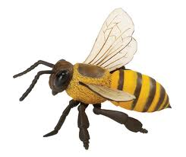

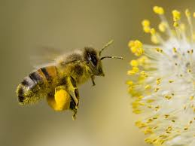
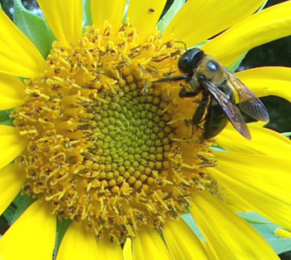

3.
Exit Slip:

1. How does a bee transfer pollen from on flower to another?

________________________________________________________________________

________________________________________________________________________

2. What part of the flower attracts the insect?

________________________________________________________________________

________________________________________________________________________

3. Why is this process important for the survival of plants?

________________________________________________________________________

________________________________________________________________________

Exit Slip:

1. How does a bee transfer pollen from on flower to another?

________________________________________________________________________

________________________________________________________________________

2. What part of the flower attracts the insect?

________________________________________________________________________

________________________________________________________________________

3. Why is this process important for the survival of plants?

________________________________________________________________________

________________________________________________________________________
Lesson 3: Plants’ Interactions with Animals

Audience: 4th grade students (50 minutes)

Content: How plants interact with animals including humans, mammals and birds

Objective:

- Students will apply their understanding of pollination to explain how humans can transfer pollen unintentionally.
- Students will explain how humans intentionally take part in interaction with the plants’ reproduction.
- Students will understand how plant seeds are structured to increase the chances of animals moving them to other locations. (ie: burrs)
- Students will apply their understanding of digestion to understand how animals transport seeds through eating and getting rid of wastes.
- Students will understand that animals and plants have a symbiotic relationship.

Procedure:

Introduction: (10 minutes)

1. Ask students if they could possibly take part in the reproduction process. Since
students will most likely say that they can plant seeds like they did with their
sunflower, ask if they could possibly do it without even knowing?
2. Take a flower and class outside. Ask students if next year there was the same type
of flower on the other side of the playground how could it have gotten there?

Developmental: (30 minutes)

1. Give students each a group of cards to cut out. Have them cut them out.
2. Have students split their cards into colors, (seeds and pollen are on pink paper
and different animals are on white paper)
3. Students split into groups and play a game of name the interaction. Students will
take turns of pulling a white card and a pink card. They need to explain how the
two interact to move the reproductive part. Students do not take score, just discuss
together.
4. Come back together and pull out a white card and a pink card. Have students share
what they discussed with their partner. Do this enough times so that you feel students
have demonstrated enough understanding. Help students as needed.

Conclusion: (10 minutes)

1. Pass out picture worksheet. Have students write how the animal moved the seed or
pollen.

Evaluation:

1. Check the picture worksheets for overall understanding.

Materials:

1. Flower
2. Picture cards
3. Scissors for each student
4. Picture worksheet
Plants and Animals

Explain how the animals help transport the seeds shown.

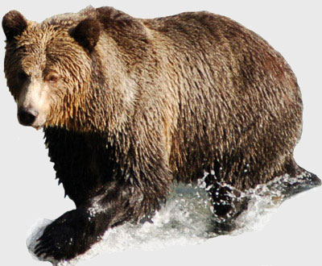
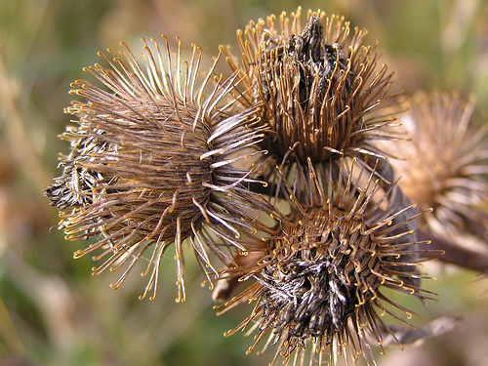
1.

________________________________________________________________________

________________________________________________________________________

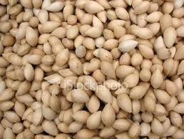
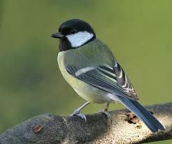
2.

________________________________________________________________________

________________________________________________________________________



3.

________________________________________________________________________

________________________________________________________________________
Lesson 4: Plants’ Interaction with Nature and Weather

Audience: 4th grade students (50 minutes)

Content: Plants’ interaction with wind and water in transporting seeds and pollen.

Objectives:

- Students will apply their understanding of wind to analyze how seeds can be transported. (i.e. Dandelion seeds)
- Students will apply their understanding of the movement of water to analyze how seeds can move with rain.
- Students will understand how plants that live in water and around water can reproduce with the help of the moving water.

Procedure:

Introduction: (10 minutes)

1. Go outside and ask students to pick a dead dandelion of they can find one. If not,
have them pull a live one.
2. Ask students to spread the seeds without their hands. Make sure that students
understand that the dandelions’ seeds are the white fluffy things.
3. Bring students in and discuss what they did to spread the seeds.
4. Hopefully students that had a live dandelion argue, let that happen without answering
because this will encourage the learning in the lesson.

Developmental: (35 minutes)

1. Start with a brief discussion on what made the dandelions’ seeds fly. Ask if there is
another aspect of weather or nature that can help move seeds.
2. Once students come up with water, have them work on identifying the seeds that
travel with either water or wind. Have pictures of various seeds, some that travel
by wind, some by water and some by neither. Students place the seeds in the
right spot of the Venn diagram. (Using scissors and glue sticks).
3. After the students complete their Venn diagram, they need to justify why the seeds
move the way they do. (i.e. helicopter’s structure to flow in the wind)
4. Once this is all finished, have the room split into three areas, water, wind and neither.
5. Put pictures of one seed at a time on the smart board and have students move to the
place where they decided the seed move. Once students are there, ask a few students
to defend their rationale. Go through all the seeds with this.

Conclusion: (5 minutes)

1. Collect the Venn diagrams and do some exit questioning and review.
Evaluation:

1. Venn Diagrams
2. Discussion

Materials:

1. Glue sticks
2. Scissors
3. Smart Board
4. Dandelions
5. Pictures and Venn Diagram
Wind

Water

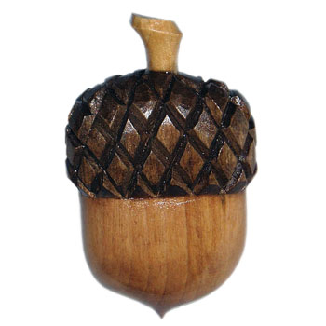
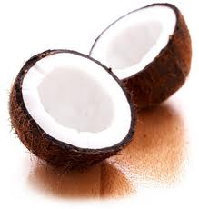
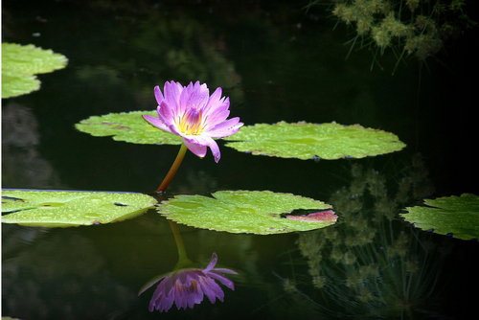

Neither

Cut out the pictures below and glue them in the Venn Diagram based on how their
Seeds travel.

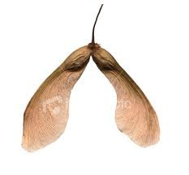
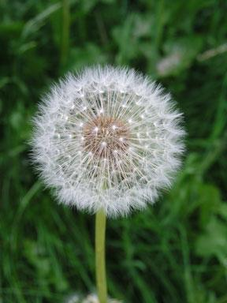

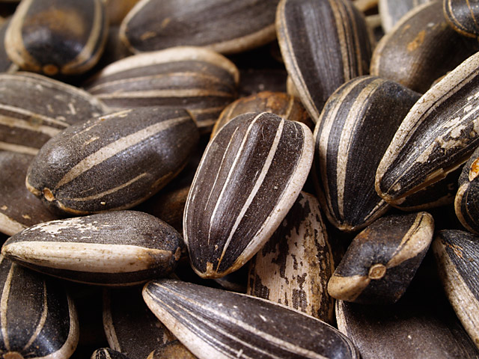
Lesson 5: Plants’ Unsuccessful Interactions and Assessment

Audience: 4th grade students (50 minutes)

Content: Seeds that do not survive and assessment of plants’ interactions with their environment.

Objectives:

- Students will apply their understanding of why plants produce a lot more seeds than will ever turn into mature plants.
- Students will be able to explain what problems seeds and pollen may encounter during the transportation process.
- Students will be able to demonstrate their understanding of all plants’ interactions with the environment.
- Students will analyze all the different interactions plants have with the environment.

Procedure

Introduction: (10 minutes)

1. Go outside a look at the maple tree on the playground. Have students count as many
helicopters/seeds on the ground. If they can, also have them try and count as many
helicopters there are in the tree.
2. Use an estimate of the number of seeds and ask students to make a prediction. “Will
all of those seeds become adult plants?”
3. Have students justify there reasoning.

Developmental: (35 minutes)

1. Have students break into groups of 3 or 4. Have them try and list as many ways that
seeds can die. Give them about 10 minutes.
2. Reconvene and go around to each group and discuss some of their findings. Decide
on which ways are good and which are a stretch.
3. Back into seats and pass out assessment of the subunit.
4. Students finish assessment.

Conclusion: (5 minutes)

1. Quick review and questioning as they prepare to leave.

Evaluation:

1. Assessment
Materials:

1. Maple tree
2. Assessment
Plants’ Interactions with their Environment Quiz

Multiple Choice: Select the best answer.

1. Seeds can travel by all of the following ways except which one?

a. Wind b. Sun c. Animals d. Water

2. Why do not all seeds grow into adult plants?

a. Some seeds walk away

b. Some seeds fly to other locations

c. Some seeds die or land in a place where they cannot survive

d. Some seeds don’t want to become adult plants

3. What animal would be the best for transferring burrs?

a. Birds b. Bees c. Dogs d. Snakes

4. Why do flowers have bright colors?

a. To attract insects to their nectar so they can spread pollen

b. To make them pretty

c. So they can be seen from the sky

d. To make them attract more sunlight

5. How does a bee transfer pollen?

a. It eats the pollen and then gets rid of it as waster

b. It pushes the pollen to another flower

c. It drops the pollen to the ground

d. The pollen sticks to the bee and the bee goes to another flower and leaves the
pollen there
Short Answer: Please provide at least one complete sentence to answer the question.

6. Plants cannot survive without the help of animals, especially humans. Can you explain two ways that humans can help plants survive? (I am not looking for watering, but movement of seeds and pollen)

________________________________________________________________________

________________________________________________________________________

________________________________________________________________________

7. You planted a sunflower in your backyard one summer. You notice that next summer you have five sunflowers growing in your front yard. If you didn’t plant the seeds in their front yard, how did the flowers grow there?

________________________________________________________________________

________________________________________________________________________

________________________________________________________________________

8. We talked about how an animal can eat a seed and get rid of its waste which will lead to a new plant. How is this possible if the animal ate the seed? (Think seed coat).

________________________________________________________________________

________________________________________________________________________

________________________________________________________________________

