Zaragoza (formerly Saragossa in English; Latin Caesaraugusta) is the capital city of the autonomous region and former Kingdom of Aragon in Spain, and is situated on the river Ebro and its tributaries, the Huerva and Gállego, near the centre of the region, in a great valley with a variety of landscapes, ranging from desert (Los Monegros) to thick forest, meadows and mountains.
According to 2006 data from the Zaragoza council [1], the population of the city of Zaragoza was 660.895, ranking fifth in Spain. The population of the metropolitan area was estimated in 2006 at 833.455 inhabitants. The municipality is home to more than 50% of the Aragon population. The city is 199 metres above sea level, and constitutes a crossroads between Madrid, Barcelona, Valencia and Bilbao, all about 300 kilometres (200 miles) from Zaragoza.

History
The city was the Roman colonia of Caesaraugusta, founded under Augustus in Hispania Citerior.
Zaragoza was the scene of two famous martyrdoms: those of Saint Dominguito del Val, a choirboy in the basilica, and Pedro de Arbués, an official of the Spanish Inquisition.
From 1018 to 1118 Zaragoza was one of the taifa kingdoms, independent Muslim states which emerged in the 11th century following the destruction of the Cordoban Caliphate. During the first three decades of this period, 1018–1038, the city was ruled by the Banu Tujibi. In 1038 they were replaced by the Banu Hud, who ruled until they were defeated by the Almoravids in 1110. In 1118, king Alfonso el Batallador reconquered the city for the Christians and made it the capital of the Kingdom of Aragon.
It suffered two famous sieges during the Peninsular War: a first from June to August 1808; and a second from December 1808 to February 1809 (see Agustina de Aragón).
During the Spanish Civil War it was briefly taken by the Durruti Column, led by Buenaventura Durruti.

Economy
In addition to the advantageous geographic situation, a General Motors Opel factory was opened in 1982 in Figueruelas, a small village nearby. The progressive decline of the agrarian economy turned Opel into one of the main pillars of the regional economy, along with: Balay, which manufactures household appliances; Caf (Construcciones y Auxiliar de Ferrocarriles S.A.) which builds railway engines for both the national and international markets; SAICA and Torraspapel in the stationery sector; and various more local companies, such as Pikolin and Lacasa, that are gradually making their ways into the international market.
As of 2006, the city's economy is benefitting from projects like Expo 2008 (the next official World's Fair, with the theme of water and sustainable development, to be held between June 14 and September 13, 2008), [2], Plataforma Logística de Zaragoza (PLAZA), Parque Tecnológico de Reciclado (PTR), as well as being on the route of the AVE high-speed rail route since December 2003, which consolidates the city role as a communications hub.
Zaragoza is home to a Spanish Air Force base, which was (until September 1992) shared with the U.S. Air Force. In English, the base was known as Zaragoza Air Base. The Spanish Air Force maintained an F/A-18 Hornet wing at the base. No American flying wings (with the exception of a few KC-135's) were permanently based here, but it served as a training base for American fighter squadrons across Europe.

Culture
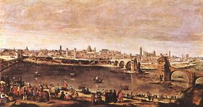
View of Zaragoza by Juan Bautista Martinez del Mazo.
Zaragoza is linked by legend to the beginnings of Christianity in Spain. According to legend, the Virgin Mary appeared miraculously to Saint James the Great in the 1st century, standing on a pillar. This legend is commemorated by a famous Catholic basilica called Nuestra Señora del Pilar ("Our Lady of the Pillar").
The event, called "Las Fiestas del Pilar", is celebrated on October 12, which is a major festival day in Zaragoza. Since it coincided in 1492 with the discovery of the Americas by Christopher Columbus, that day is also celebrated as El Día de la Hispanidad (Columbus Day, literally Hispanic Day) by Spanish-speaking people worldwide.

Sport
Zaragoza is strongly associated with Jaca in its bid for the 2014 Winter Olympics. It would host the Opening and Closing ceremonies (at La Romareda stadium), as well as most of the ice events venues.
Zaragoza's football team, Real Zaragoza, play in the Primera división.

Places of interest
Near the basilica on the banks of the Ebro are located the city hall, the Lonja (old currency exchange), the La Seo Cathedral, and the ruins of the Roman city wall.
Near this area is a tapas zone called El Tubo and a nightclub district called El Casco. Other nightclub districts are La Zona and El Royo. The city is home to a number of popular gay and lesbian establishments as well.
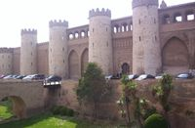
Outside View of the Aljafería
Some distance from the centre of the old city is an expansive Moorish castle or palace called the Aljafería, one of the northernmost important Moorish buildings in Spain and the setting for Giuseppe Verdi's opera Il Trovatore (The Troubadour). The Aragonese parliament currently sits in the building.
Zaragoza is linked by Renfe's AVE high-speed rail service to Madrid and to Lleida in Catalonia.
Demographics
Population growth, in thousands, can be seen here: 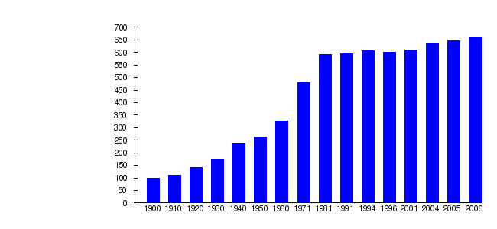
Demographic evolution of Zaragoza between 1991 and 2006
1991 | 1996 | 2001 | 2004 | 2005 | 2006
594 394 | 601 674 | 610 976 | 638 799 | 647 373 | 660 895
- Historical Series of population: National Statistics Institute of Spain (INE)
- Dates 2006 City council of Zaragoza.

