CMAPTOOLS FACILITATES ALIGNMENT OF LOCAL CURRICULUM
WITH STATE STANDARDS: A CASE STUDY

Jane Heinze-Fry, Ph.D. and Fran Ludwig, M.S.

Abstract. Concept maps were used to align the Lexington Public Schools’ local elementary life science benchmarks and interdisciplinary Big Backyard program with the Commonwealth of Massachusetts (MA) Life Science Framework. CmapTools was used to create a template concept map of the MA Life Science Framework. A color-coding system was used to compare life science concepts from the Lexington Elementary Life Science Benchmarks with the state template map. Concepts were color-coded to indicate alignment with the state (green in web version; medium-gray in print version), nonalignment with the state (red in web version; dark gray in print version), and more depth than the state (yellow in web version; light gray in print version). The same method was used to examine how the interdisciplinary Lexington Big Backyard program supports the state’s life science framework. The analysis is useful in that it offers a clear visual indicator of “fit” between the state framework and local benchmarks. Its utility comes primarily in assuring that the district addresses the state framework. This alignment strategy offers insight into recommendations that can easily incorporate “red concepts” into existing instructional activities and objectives. As state science testing becomes more high stakes, such alignment methods increase in value. While other alignment strategies exist, concept mapping offers a particularly robust decision-making tool for a constructivist-based learning community. In addition to providing a visual framework, the concept maps, by demonstrating connections among concepts, can help teachers develop instructional activities in a cohesive manner.

1 Background
In the 1980s, the education community at large was put on alert with the release of a number of reports recommending reform in U.S. Education, including: A Nation at Risk: The Imperative for Education Reform by the National Commission on Excellence in Education. The science education community responded to these criticisms and ‘No Child Left Behind’ legislation with national and state standards and benchmarks. Of particular note to the field of science education are the National Science Education Standards and the Benchmarks for Science Literacy: Project 2061. These publications are the “gold standard” against which many of the state standards and frameworks are judged.

Tremendous efforts have been made to align national-state-local curricula; to align state assessments with the state’s curricula; and to align what happens in the classroom with the various levels of curricula. The mission of one independent, not-for-profit organization, Align to Achieve, is to facilitate the evaluation and improvement of academic standards and student achievement. This organization provides a standards database of grades K-12 content standards and benchmarks from states, national organizations and selected countries. With a broader focus, Science Curriculum Topic Study (SCTS), by Page Keeley, bridges the gap between standards and practice. Keeley offers a “methodical study process and a set of tools and strategies– organized around 147 curriculum topics– designed to help educators improve the teaching and learning of science.” For each science topic, her book references appropriate sections of key resources that identify the adult content knowledge, instructional implications, concepts and specific ideas, research on student learning, coherency and articulation of the topic, and integration with state standards. SCTS facilitates teachers’ efforts to link to the standards and to current research on student learning about different topics.

A variety of “mapping strategies” have been applied to these alignment endeavors. In Mapping the Big Picture: Integrating Curriculum & Assessment K-12, Heidi Hayes describes the use of “curriculum mapping” to encourage teachers at the school and district level to map their classroom time and then collaborate to eliminate gaps and repetitions, judge alignment with standards, identify needs for further collaboration and research, and improve their overall spiral delivery of instruction. Each teacher creates a map identifying content, processes, and assessments over the course of the school year.

“Content mapping,” on the other hand, is a new analytical method described in New Tools for Analyzing Teaching, Curriculum and Standards in Mathematics & Science by Blank, Porter, and Smithson. This very broad study examines links among the intended curriculum, the enacted curriculum, and the learned curriculum (student outcomes). Content maps are used to represent a two-dimensional matrix showing the amount of time spent on the intersection of content topic (at a general level) and level of expectations for student learning (memorize, understand concepts, perform procedures, conduct experiments, analyze information, apply concepts.) Data collected by this project could be applied to queries about alignment of assessment to assessment; assessment to instruction; and instruction to instruction.

More recent, a collection of “strand maps” was introduced in the Atlas of Science Literacy. These maps demonstrate the connections among the national science benchmarks, which are listed sequentially in the Benchmarks for Science Literacy. Clusters of large maps integrating clusters of benchmarks indicate connections of benchmarks from K-2 to 3-5 to 6-8 to 9-12 levels. The Atlas clearly illustrates the importance of prior knowledge upon which each succeeding level of instruction builds as well as the rich fabric of interconnections among different clusters of related maps. The Atlas connects both content knowledge and process knowledge. The goal of the Atlas is that “thinking carefully about the growth of understanding from kindergarten to graduation is an essential part of planning what students can be expected to learn and how best they can be helped to do so.” The mission of integrating sequenced benchmarks into connected understandings touches on the strengths of Novak’s concept mapping process, which is used in this case study.
2 Introduction
In the last few years, the statewide assessment in Massachusetts has emphasized English language and mathematics. Now, as science testing becomes more high stakes (i.e., required for high school graduation in the Class of 2010), schools are working to align their local science curriculum with the state’s science framework. While prior work demonstrates the application of concept mapping to teaching and learning in the sciences [Cañas, et al. (2004); Mintzes, et al. (1997); Novak (1998)], this case study explores the utility of using concept maps to align a local life science curriculum with the state life science framework.

In Massachusetts, the Science and Technology/Engineering Curriculum Framework, was published by the Massachusetts Department of Education in 2001. The Science Framework addresses both science inquiry processes and conceptual content. The Massachusetts Comprehensive Assessment System (MCAS) primarily addresses conceptual content. Framework revisions are currently being incorporated. The full document is available in pdf format at http://www.doe.mass.edu/frameworks/scitech/2001/0501.pdf. State frameworks for all disciplines are available at http://www.doe.mass.edu/frameworks/current.html.

Individual school districts, as is the case with the Lexington Public Schools, often operate from local curriculum guidelines. The Lexington Elementary Science Benchmarks (Lexington Benchmarks) describe the overall goals and objectives of the entire science program. (The Lexington Public Schools curriculum is available at http://lps.lexingtonma.org/curriculum/elementary.html.) These goals include conceptual content from the life sciences, earth sciences, and physical sciences, as well as inquiry skills.

Some of these Lexington Benchmarks are addressed by the interdisciplinary Lexington Big Backyard (BBY) program. This program of seasonal walks on the schoolyard and adjacent conservation lands, led by trained parent volunteers, has developed over the course of a decade. It was designed to address both science and social studies goals. Objectives for the walks address not only appropriate content in the life sciences, earth sciences, physical sciences, and social sciences, but also science inquiry processes, affective goals (such as environmental awareness and attitudes of respect toward the environment and each other) and psychomotor goals (such as the use of appropriate science equipment). Developed before and then simultaneously with the state frameworks, some effort has been made to align the BBY program with the state science and history and social science frameworks.

While a variety of methods to align curricula have been used, concept mapping offers the potential of integrating the concepts into a visual conceptual structure highlighting connections among concepts. This case study limits itself to demonstrating alignment of the district’s life science content specified in both the Lexington Benchmarks and BBY program with the state life science framework. It does not investigate the enactment of the district curriculum in the classroom, the level of student performance expected with the content, or developmental level of the content. However, it has the potential to demonstrate integration and connections among concepts at a more detailed level than was carried out by other alignment studies. It may be relatively easy for a district to incorporate “red concepts” into their benchmarks that address the alignment map’s adjacent “green-coded” concepts. Hence, at a detail level, the connectivity facilitates recommendations for areas of omission that the district may wish to address. It also clarifies areas that the state framework does not address at this point in time. This effort will help further the Lexington Public Schools’ goal of aligning curricula more closely with the state frameworks.
3 Method
Steps taken to examine alignment of curricula with the science framework involved the following transformations:

1. A state concept list, retaining as much of the explicit and implied propositional linkages and hierarchy as possible, was derived from the Massachusetts Elementary Life Science Framework. The Massachusetts science standards are listed in a table format indicating learning standards, ideas for developing investigations and learning experiences, and suggestions for extensions to learning in technology/engineering. The life science framework is divided into conceptual clusters. The clusters of Grades PreK-2 standards (pp.39-40) include characteristics of living things, heredity, evolution and biodiversity, and living things and their environment. The clusters of Grades 3-5 standards (pp. 41-44) include characteristics of plants and animals, plant structures and functions, adaptations of living things, and energy and living things.

2. Using CmapTools, the state concept list was used to create a template framework concept map. The template map includes a core map (Figure 1) and three submaps, which can be viewed by clicking on the attachment icons for three of the concepts: ‘Living Things,’ ‘Food Chains,’ and ‘Plants.’ (http://cursa.ihmc.us:80/servlet/SBReadResourceServlet?rid=1143727786182_1913844725_6339&partName=htmltext) To view the state concept list, one can click the icon at the bottom of the ‘Environment’ concept.

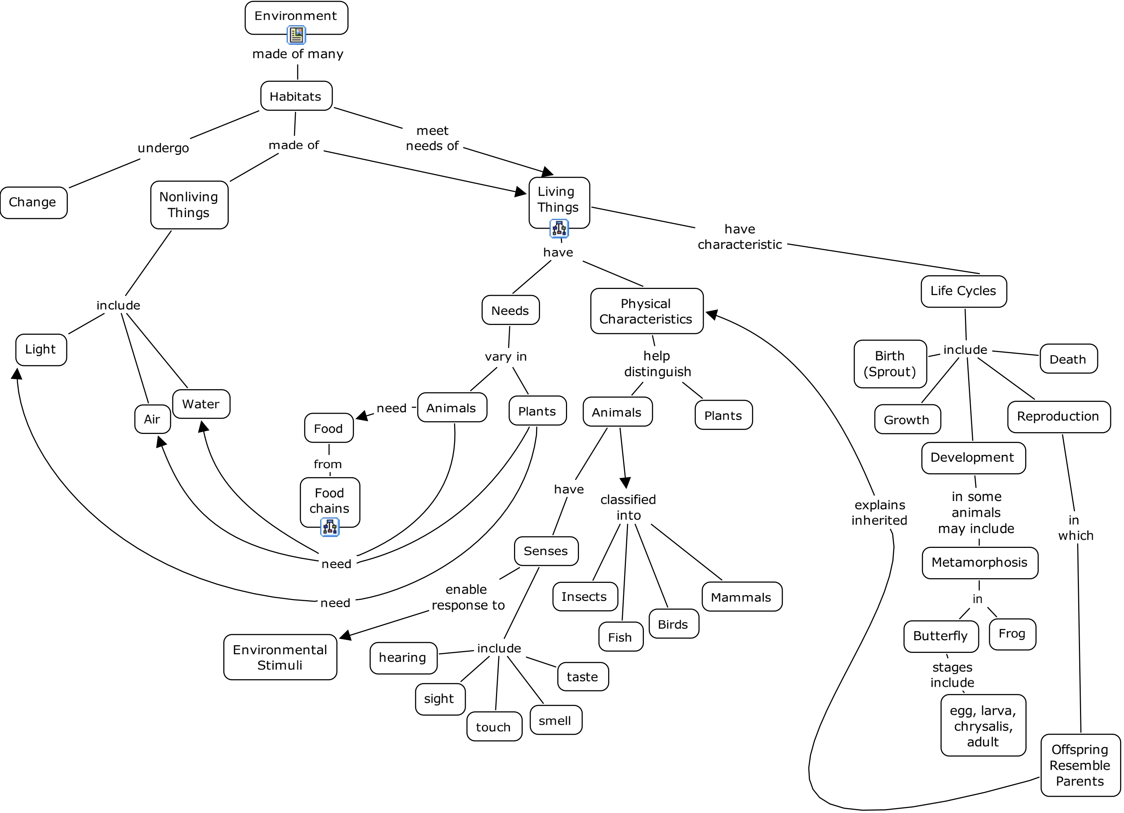
Figure 1. Massachusetts Framework ‘Core’ Concept Map

3. A local curriculum concept list was derived from the Lexington Benchmarks.

4. Concepts on the state template concept map were color-coded: ‘green’ in the web version (medium-gray in the print version) for concepts found in both the framework and the local benchmarks; ‘red’ in the web version (dark-gray in the print version) for concepts found in the framework, but not the local benchmarks; ‘yellow’ in the web version (light-gray in the print version) for concepts found in the local benchmarks, but not in the framework. For the gray tones in the print version of “Core Map”, see Figure 2. This alignment can be viewed in color and with submaps on the web at: http://cursa.ihmc.us:80/servlet/SBReadResourceServlet?rid=1143727786182_1874593061_6336&partName=htmltext. To view the Lexington Benchmarks concept list, one can click the icon at the bottom of the ‘Environment’ concept.

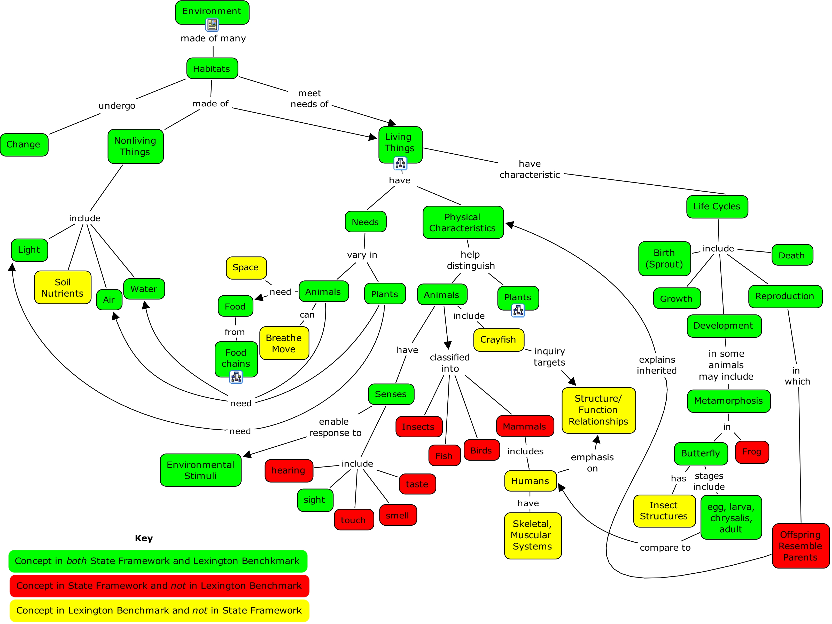
Figure 2. ‘Core’ Concept Map Aligning Lexington Benchmarks with State Framework
5. A Big Backyard concept list was derived from the stated objectives of the original printed handouts of the K-5 walks and the objectives listed in the “Grade Overview” and “Teacher” documents available at the Big Backyard website.

6. Concepts on the state template concept map were color-coded with the same strategy as the Lexington Benchmarks. (See “4” above.) Note, this map has an additional submap located by clicking on the “Habitat” concept. This alignment can be viewed in color and with submaps on the web at: http://cursa.ihmc.us:80/servlet/SBReadResourceServlet?rid=1143727786182_1921903453_6343&partName=htmltext. To view the BBY concept list, one can click the icon at the bottom of the ‘Environment’ concept.

For an alternative route to observe the alignment concept maps on the web, go to [ http://cursa.ihmc.us/ ]. Then open the folder titled " JHFry CMaps, MA" (Scroll down. . . It’s in alphabetical order.) Then open " 1 Elementary School", then "MA Elem Life Sci Framework". Select the concept map titled " Lex Life Science Framework K-5." (Repeat for the Benchmarks and BBY folders.)
4 Results
4.1 State Template Map and General Alignment Results
The core template map created with CmapTools underwent three revisions. With each revision, the map’s focus and the connections among concepts were clarified. The core map is primarily the K-2 concepts. It emphasizes habitats made of both living and nonliving things together with their interactions and life cycles. There is some repetition of concepts going to submaps in order to show some connections among concepts. The “Living Things” submap emphasizes characteristics of living things, both physical and behavioral, which aid in adaptation to the environment and its changes. The “Food Chains” submap covers key ecological concepts related to food. The “Plants” submap addresses plant structure and function.

What do the alignment maps of the Lexington Benchmarks and Big Backyard program tell us about the Lexington elementary life science curriculum? A table summarizing number of concepts offers some insights. Note that the precision of counting numbers of colored concepts can be somewhat skewed. Why? Some concepts are just examples, so are not really as powerful as key concepts themselves. Therefore, they carry a bit too much weight. (This is particularly the case in the “Living Things” submap.) On the other hand, some concepts are clustered together because of map size limitations; therefore, these concepts may carry less weight. (Note “egg, larva, chrysalis, adult” in the core map.) In spite of these caveats, some patterns emerge. Examination of the overall alignment map of the Lexington Benchmarks reveals almost 2/3 alignment to the standards. A closer examination shows that core map with 75% alignment and the food chains submap with 92%, while the other two submaps indicate less than 50% alignment (“Living Things” at 42% and “Plants” at 47%). (See Table 1.) What does closer examination of the maps reveal?

Benchmark  Alignment Map | Number of  Green Concepts (G)  [in state and in local] | Number of  Red Concepts (R)  [in state, not in local] | Number of  Yellow Concepts (Y)  [in local, not in state] | % Alignment  [G/ (G+R)] X 100
Core | 30 | 10 | 9 | 75
Living Things | 13 | 18 | 1 | 42
Food Chains | 12 | 1 | 3 | 92
Plants | 7 | 8 | 5 | 47
Total | 62 | 37 | 18 | 62
Table 1. Analysis of Alignment of Lexington Benchmark Concepts with State Framework Concepts.
4.2 Core Map Alignment Results
Lexington addresses ¾ of the framework concepts: life cycles and the needs of living things being met by habitats in which they live. There are, however, three key “red zones” where the Lexington Benchmarks are missing concepts stated in the standards: the senses, major animal classification groups, and a basic understanding of heredity. Concepts of the “senses” are of little concern because they are implied in the inquiry section of the Lexington Benchmarks and explicit in the Big Backyard objectives. One exception is the sense of “taste,” because elementary students are discouraged from tasting outdoor samples! (See the BBY core alignment map.) “Yellow zones” indicate that Lexington emphasizes relating structure and function in living systems: insect structures in the butterfly life cycle study; skeletal and muscular systems in the human body; crayfish in behavior studies.

While students in the Big Backyard program are exposed to a tremendous variety of organisms in the four indicated habitats, the focus is on discussion of how the organisms are adapted for the habitat in which they are found. Classification of organisms into major animal groups is not explicit in either the Lexington Benchmarks or the Big Backyard program. On the other hand, students in Big Backyard activities do experience identification of common trees, plants in the wetlands, and aquatic organisms of the stream. The framework appears, however, to target student conceptual understanding of how to use dichotomous keys in classifying the major animal groups: insects, fish, birds, and mammals. From the “red zone,” it is clear that the Big Backyard program does not address the life cycle part of the map. However, from the Lexington Benchmarks alignment maps, we can deduce that those concepts are addressed by “inside activities” at Lexington.
4.3 Submap Alignment Results: Living Things, Plants, Food Chains, Habitats
The “red space” on the Lexington Benchmarks ‘Living Things’ submap is glaring: alignment of Lexington’s curriculum with the state standards is only 42%. In addition to the state framework’s strong articulation of “adaptations of behaviors and physical characteristics,” there is an additional subordinate conceptual layer that distinguishes “learned and acquired characteristics” from “inherited characteristics.” This is a “red zone” for Lexington, exacerbated by the number of examples provided in the framework. An examination of the BBY ‘Living Things’ alignment submap indicates an emphasis on the relationship of seasonal adaptations to seasonal changes. BBY, however, does not address the difference between learned behaviors and instincts nor between inherited and environment-influenced physical characteristics.

With only 47% alignment on the ‘Plants’ submap, it is clear that something is missing in the Lexington Benchmarks. An examination of the map offers two insights. The “red zones” indicate that the Lexington Benchmarks address plants’ structures, but not functions. This observation is surprising, since the Lexington Benchmarks are so strong in connecting structure and function in other conceptual areas mentioned previously. On the other hand, “yellow zones” indicate that Lexington’s approach to plants is stronger in viewing plants as part of a larger system. Its strength is in ecologically connecting plants to the nonliving parts of the environment through soil needs and in the role played by worms. The BBY alignment map reinforces the Lexington Benchmarks map in addressing plant structure, but not function. The Lexington curriculum adds “seeds” to plant structure concepts.

With 92% alignment on the ‘Food Chains’ submap, it is clear that Lexington Benchmarks excel in food chain concepts. A closer look indicates that the only missing “concept” is the “label” of photosynthesis. (This label is included in the BBY map). Lexington Benchmarks offer one more superordinate concept (food web) and two more subordinate concepts (primary consumer, secondary consumer) beyond the state standards. Food chains are clearly covered by the BBY program. Again, the linkage of decomposers back to the nonliving components of the ecosystem is a clear connection made in this program. Further, the BBY program so strongly addresses habitats, that an additional ‘Habitats’ submap was created. BBY visits a variety of habitats, including field, forest, wetland, and stream. Structure and function of the wetland are targeted concepts. The stream habitat details identification of living aquatic organisms as well as nonliving qualities of the habitat: pH, color, cloudiness, and odor.
5 Conclusions
Concepts from the state science framework can be transformed into a template concept map. Color-coding of concept maps visually clarifies alignment of school content with the framework. While interpretation of individual concepts and propositional linkages are in some cases subjective, this analysis clarifies larger patterns of alignment areas, nonalignment areas, and extensive depth beyond the state framework. The detailed concept mapping work offers strength in examining the integration of the conceptual content of a subject. When used to examine alignment between district benchmarks and state framework, the connectivity of a concept map suggests where missing elements may easily be added.
6 Recommendations
Based upon these findings, both specific and broad recommendations can be made.
6.1 Specific recommendations
Depending upon school policy, the science coordinator could work to increase alignment of the local curriculum to the state framework. Assuming closer alignment is desired, content areas coded ‘green’ should remain in the local curriculum. In general, educators should consider the green-coded concepts as “core” and strive for high performance by all students in attaining them. The curriculum coordinator should work to incorporate content areas coded ‘red’ into the local benchmarks. Areas that call for more emphasis or clarity include: classification of major animal groups; basic inheritance understanding that offspring resemble their parents and that inheritance gives rise to observable physical characteristics; clarification of learned and acquired adaptations vs instinctual and inherited adaptations; plant adaptations to light and gravity; and sensory systems. The recommendations do not generally call for a redesign of approach. Sometimes this means simply adding content which is already in the enacted curriculum, but has not been emphasized in the Lexington Benchmarks document. Sometimes it means simple alteration of objectives in some of the Big Backyard walks. The concepts coded ‘yellow’ can be considered strengths of the school system and areas of depth or extension. Yellow-coded concepts could be considered “nice to know, but not necessary.” This coding should be of particular significance to special needs teachers working with students who struggle with the amount of material they are expected to learn.

The Massachusetts Department of Education (DOE) might also take note of this analysis. Although ‘seeds’ are implied in an understanding of life cycles, ‘seeds’ might be added to the list of plant structures in the framework. While the framework emphasizes the relationship of structure and function in plants, it does not do so for animals. A problem in the elementary science framework (p. 41) is that some standards relating to animals are listed under the ‘Plant Structures and Functions’ subheading. One way to solve the problem would be to create a new subheading titled ‘Animal Structures and Functions.’ Standard 3 regarding “life cycles of plants and animals” could move to the ‘Characteristics of Plants and Animals’ subheading. Standard 4 relating to metamorphosis in animals could shift to the new ‘Animal Structure and Function’ subheading. Finally, while the state framework emphasizes the “flow of energy through an ecosystem,” the DOE might consider addressing the “cycling of matter,” which is so clearly emphasized in the Lexington curriculum. With many Massachusetts schools involved in recycling projects, this change seems appropriate. Further, “thinking in systems” is crucial to the study of all scientific disciplines.
6.2 Extension of Concept Mapping Alignment Function
Alignment analyses could be extended to more types of concepts, levels of the educational system, school leaders, and disciplines. In addition to content standards, science process concepts could be aligned. Such an analysis would balance the tendency of the state frameworks to emphasize content standards. Alignment maps carried out at the elementary, middle school, and high school levels would inform an entire school system about their alignment with state standards. They would also give teachers at each level insights about the “prior knowledge” of their students upon which they would build. Such a process would move in synchronous steps with the Atlas and SCTS.

Alignment maps could be used in a number of ways by the science coordinator to more fully integrate the educational system. Sharing these alignment maps with teachers and volunteer parents demonstrates how their efforts in individual activities contribute to the development of a larger integrated “whole” for their learners. Linking digitized activities to the alignment maps would facilitate that process, as would indicating grade level for each of the concept areas. Individual teachers could align their particular class with local or state curricula to see how their classroom work supports systemic priorities. This type of work would support efforts by the Survey of the Enacted Curriculum Project.

In addition to life sciences, other sciences and other disciplines could be aligned. Schools that emphasize thematic learning and integrated disciplines might find the more extensive analysis and synthesis to be a useful tool. The field of environmental education emphasizes interdisciplinary relationships. The North American Association for Environmental Education (NAAEE) recently published Guidelines for Excellence K-12. As with the MA life science framework, template concept maps of the conceptual goals for the Guidelines for Excellence could be used by environmental education programs to evaluate their “fit” with the national standards.
6.3 Beyond Curriculum Alignment
As connections among the science concepts become clearer at a curricular level, it makes sense to have students create their own maps as they experience both indoor and outdoor science activities. Individual portfolios can serve as MCAS review at the end of the fifth grade. This is an easy step at Lexington, where students already use Inspiration software.

Concept mapping, based upon Ausubelian learning theory (Ausubel, et al., 1978), offers a clear opportunity for teachers to build upon students’ prior knowledge. When curriculum coordinators offer the vision of linkage between connected conceptual knowledge and classroom instruction and when students construct knowledge while connecting their emerging conceptual structure to their own observations, experiences and research findings, then each succeeding level of education is empowered to offer a truly integrated educational experience.
7 References
Align to Achieve. This organization provides information about content and skill level across the four major disciplines K-12 for all the state frameworks. http://www.aligntoachieve.org/
American Association for the Advancement of Science. (1993). Benchmarks for Science Literacy: Project 2061. Oxford University Press: New York.
Atlas of Science Literacy: Project 2061. (2001). American Association for the Advancement of Science and the National Science Teachers Association: Washington, DC.
Ausubel, D. P., Novak, J. D., & Hanesian, H. (1978). Educational Psychology: A Cognitive View, Second Edition. New York, N. Y.: Holt, Rinehart, and Winston.
Blank, R. K., Porter, A., Smithson, J. (2001). New Tools for Analyzing Teaching, Curriculum and Standards in Mathematics & Science. Results from Survey of Enacted Curriculum Project. Final Report. Council of Chief State School Officers, ATTN: Publications, One Massachusetts Avenue, NW, Suite 700, Washington, DC 20001-1431. (Available in pdf format at http://eric.ed.gov/ERICDocs/data/ericdocs2/content_storage_01/0000000b/80/0d/8c/5a.pdf)
Cañas, A. J., J. D. Novak & F. M. Gonzalez (Eds.). (2004). Concept Maps: Theory, Methodology, Technology, Proceedings of the 1st International Conference on Concept Mapping, Volumes 1 and 2. Pamplona, Spain: Universidad Publica de Navarra.
Cañas, A.J., Hill,G., Carff, R., Suri, N., Lott, J., Eskridge, T., Gomez, G., Arroyo, M., & Carvajal, R. (2004). “CmapTools: A Knowledge Modeling and Sharing Environment.” In A. J. Cañas, J. D. Novak & F. M. Gonzalez (Eds.), Concept Maps: Theory, Methodology, Technology, Proceedings of the 1st International Conference on Concept Mapping. Pamplona, Spain: Universidad Publica de Navarra.
Gardner, David Pierpont. (1983). A Nation at Risk: The Imperative for Educational Reform. A Report to the Nation and the Secretary of Education, United States Department of Education by the National Commission on Excellence in Education. Washington, D.C.
Heinze-Fry, J. A. (2004). “Applications of Concept Mapping to Undergraduate General Education Science Courses.” In A. J. Cañas, J. D. Novak & F. M. Gonzalez (Eds.), Concept Maps: Theory, Methodology, Technology, Proceedings of the 1st International Conference on Concept Mapping. Pamplona, Spain: Universidad Publica de Navarra.
Jacobs, H. H. (1997). Mapping the Big Picture. Integrating Curriculum & Assessment K-12. Association for Supervision and Curriculum Development, 1250 N. Pitt Street, Alexandria, VA 22314-1453.
Keeley, P. (2005). Science Curriculum Topic Study. Corwin Press: Thousand Oaks, CA.
Massachusetts Department of Education. (2001). Massachusetts Science and Technology/Engineering Curriculum Framework. (Available online at www.doe.mass.edu/frameworks/current.html.)
Mintzes, J. J., Wandersee, J. H., & Novak, J. D., eds. (1997). Teaching Science for Understanding: A Human Constructivist View. San Diego, CA: Academic Press.
National Research Council. (1996). National Science Education Standards, Ninth Printing. National Academy Press: 2101 Constitution Avenue NW, Box 285, Washington, DC 20055.
North American Association for Environmental Education. (1999). Excellence in Environmental Education—Guidelines for Learning (K-12). 1825 Connecticut Avenue NW, 8th Floor, Washington, DC 20009-5708
Novak, J. D. & Gowin, D. B. (1984). Learning How to Learn. Cambridge: Cambridge University Press.
Novak, J. D. (1998). Learning, Creating, and Using Knowledge: Concept Maps TM as Facilitative Tools in Schools and Corporations. Mahwah, NJ: Lawrence Erlbaum Associates.

