Patterns

A third grade unit on analyzing and replicating sequence and patterns.

Lisa A. Kaliszewski

March 27, 2009

Instructional Design Rationale
In today’s academic arena, state mandated standards are utilized as a foundation for classroom learning. Educators focus on state standards and benchmarks to gear learning and expected outcomes to guide their lessons to ensure coverage and mastery of these benchmarks which are identified by core concepts aligned by the state. These academic content standards describe the knowledge and skills that students should reach. In essence, the standards are an indicator of what students should know and be able to do. Teachers can utilize the standards to develop instruction and teaching strategies and also assess student learning. There are a variety of methods and strategies in which to teach these standards; however, the standards are the core of each lesson.
Within our building, student progress and retention of critical math concepts is a major concern. In 2008, the average passage rate on the math achievement test for 2008 was 37%. This low percentage is a key reason why a detailed instructional design map would be beneficial. Creating a comprehensive instructional design of critical math concepts is one key in increasing student’s passage rate on the state achievement tests.
The instructional design project will develop the concept of patterns. Students use patterns, relations and functions to model, represent and analyze problem situations that involve variable quantities. In addition, students need to be able to
Page 2
analyze, model and solve problems using various representations such as tables, graphs and equations. In doing so, the unit is aligned with contextualized learning by including the presentation of real-life applications in which the students will be able to use the basic foundation of patterns and apply their knowledge across the curriculum, as well as, in every day life. This will increase retention of the basic concepts of patterns and how they can be used to solve mathematical problems. The goal of this unit is to construct or improve existing knowledge to achieve a desired outcome of mastering the concept with enhanced knowledge and new skills.
Patterns
Unit Outcomes

Unit Outcomes
- Extend multiplicative and growing patterns and describe the pattern or rule in words.
- Analyze and replicate arithmetic sequences with and without a calculator.
- Use patterns to make predictions, identify relationships and solve problems.
- Model problem situations using objects, pictures, tables, numbers, letters and other symbols.
- Write, solve and explain simple mathematical statements.
- Create tables to record, organize and analyze data to discover patterns and rules.
Name ____________________________

Pre-Assessment
Patterns

1. The teacher described a number pattern as “start with 21 and subtract 5 to get the next number”.

Complete the number pattern: 21, ____, ____, ____, _____

2. Bart made this pattern: 33, 38, 43, 48.

Write the rule for Bart’s pattern.

________________________________________________________

3. Marcus recorded the number of pennies he has saved at the end of each week in the table shown.
Week | Number of pennies
1 | 4
2
3 | 16
4
5 | 64

Each week, Marcus doubles the number of pennies he has saved. He forgot to record the total number of pennies in week 2 and week 4.

How many pennies did he have saved for week 2? _____________

How many pennies did he have saved for week 4? ____________
Page 2
Patterns-Pre-Assessment

4. The function machine has changed the numbers in column A to the numbers in column B by using a specific rule.

A | B
5 | 12
0 | 7
12 | 19
23 | 30

Which number sentence shows that rule?

A. A + B = 17
B. A + 7 = B
C. A x 2 = B
D. A – 10 = B

5. Draw a pattern for your classmate to solve.

Lesson 1
Unknown Numbers/Patterns

Ohio Standards Connections
Math Processes
Benchmark E
Solve open sentences and explain strategies.
Indicator 5
Understand equivalence and extend the concept to situations involving symbols; e.g., 4 + 5 = 9 and 9 = 4 + 5 and 4 + 5 = 3 + 6 = Δ + □ …
Benchmark F
Represent an unknown quantity as a variable using a symbol, such as □, Δ, $Ο$.
Indicator 6
Use symbols to represent unknown quantities and identify values for symbols in an expression or equation using addition and subtraction; e.g., □ + $Ο$ = 10, Δ - 2 = 4.
Mathematical Processes
Benchmark A
Use a variety of strategies to understand problem situations; e.g., discussing
with peers, stating problems in own words, modeling problems with diagrams or physical materials, identifying a pattern.
Benchmark H
Recognize the mathematical meaning of common words and phrases, and relate everyday language to mathematical language and symbols.

Instructional Procedures:
1. Present the following problem situation to the students: John had some marbles. Danny gave him three marbles. John now has eight marbles. How many marbles did John have before Danny gave him the three marbles?
2. Encourage the students to write an open sentence for the problem situation using a symbol to represent the unknown part.
3. Walk around the room to observe the students’ sentences.
4. Solicit responses from several students. Record the sentences on the overhead or board. Facilitate a discussion about the students’ responses.
5. Engage the students in a discussion focused on identifying "unknown quantities." Present the following problem situation:
In this mystery bag, I have 10 candies. Some are cherry and some are strawberry. How many of each could I have?
6. Solicit and record the students’ responses in chart form. Facilitate a discussion about the various responses.
7. Write the following open sentence on the board or overhead. Explain to the students that the circle and the triangle represent the unknown values, called variables, which represent different quantities.

+ = 10

8. Ask the students to use the mystery bag problem to find the unknown quantities.

Page 2

9. Solicit and record the students’ responses in chart form.

 | + |  | = 10
 | + |  | = 10
 | + |  | = 10
 | + |  | = 10
 | + |  | = 10

10. Ask the students to explain if the numbers 5 and 5 would work for this equation.

Instructional Tip:
The students may be confused by two different symbols with the same quantity. Explain to them that sometimes the same number may be used.

11. Repeat this process with several other problem situations. Have the students write equations using various symbols.
12. Allow the students to share their equations with the class.
13. Present the following problem situation to the students:
Mary had eight cookies. She gave three to Alexis. How many cookies does Mary have now?
8
-
=
14. Ask the students to determine the identity of the circle and the triangle in this equation. Solicit the students’ responses and record them on the board.
15. Repeat this process with several other problem situations asking the students to write equations using various symbols.
16. Instruct the students to write a problem situation involving subtraction.
17. Collect the problems and have another student write an equation and determine the solution.
18. Engage the students in a discussion about equivalence. Present the following problem situation:
Chauncey and Elon shared nine crayons, four for Chauncey and five for Elon. How could Channel and Elise share their nine crayons differently?
Page 3

19. Ask them to identify numbers that would complete the following equation:

+
=

4 + 5
20. Repeat this problem using different numbers. Stress both equivalence and the concept of representing unknown quantities with symbols.
21. The next activity increases the level of challenge. Depending upon the students’ understanding, you may want to postpone introducing this activity until they have developed an understanding of both algebraic representation and equivalence.

+
=
6

+

4

22. In this problem, you want the students to identify all the possible values for the hexagon and the circle. Begin by asking the students to think of each side equal to 7. Ask the students to identify the values for the hexagon and the circle. Repeat this problem having the value of each side equal to the numbers 7 through 19.
23. Substitute other numbers in the place of 4 and 6 and repeat the process.
24. Ask the students to generate equivalent equations with variables represented by symbols.

Differentiated Instructional Support:
Instruction is differentiated according to learner needs, to help all learners either meet the intent of the specified indicator(s) or, if the indicator is already met, to advance beyond the specified indicator(s).
- Some students may need to solve equations where only one unknown appears in the addend or subtrahend.
- Once the students seem to understand the concepts of equivalence and algebraic representation, ask them to generate equivalent equations using symbols.

Lesson 2
Multiplication Patterns

Ohio Standards Connections
Math Processes
Benchmark I
Model, represent and explain multiplication as repeated addition, rectangular arrays and skip counting.

Indicator 7
Model, represent and explain multiplication as repeated addition, rectangular arrays and skip counting.

Patterns, Functions and Algebra
Benchmark D
Model problem situations using objects, pictures, tables, numbers, letters, and other symbols.

Indicator 4
Use objects, pictures, numbers and other symbols to represent a problem situation.
Lesson Summary:
In this multi-day lesson, students explore multiplication concepts through skip counting, repeated addition and arrays. Using animal characteristics as a context, students solve problems using mathematical tools such as hundreds charts, number lines, counters and drawing arrays that represent the problem situation. The lesson concludes with an animal puppet project in which students create animal puppets and solve problems related to the characteristics of the puppets. Opportunities for differentiation are embedded through partner and small group discussion and work, the use of a variety of mathematical tools and strategies for assessing different modalities of learning.

Estimated Duration: Four hours

Instructional Procedures:
Part One
1. Distribute a number line and a hundred chart to students. Ask students what it means to count by tens. Students may suggest that not all numbers are counted, some numbers are skipped or you say every tenth number. Have class count by tens. Repeat the activity counting by fives and twos. Tell the students when we count by numbers such as two, five and 10 in mathematics we call it “skip counting”.
2. Ask the class questions which they can use skip counting to solve. Allow students to work in pairs to solve the problem situation, discuss how to use skip counting to find the solution and to assist students. Sample questions include.
- How many fingers do five monkeys have? Assume each monkey has 10 fingers.
- The teacher bought seven gumballs from the gumball machine. Each gumball costs a nickel. What is the value of seven nickels?
- Four silly penguins were wearing shoes. How many shoes are there in four pairs of shoes?
Page 2

3. Model skip counting using the number line or hundreds chart. Have students work with partners using the hundreds chart of number line to skip count by different numbers. Have students write down the sequence of numbers. For example, if the students are counting by three, they write 3, 6, 9, 12, 15, etc. While walking around the room check the sequences of numbers written and informally assess student progress.
4. Ask students to share lists of number sequences and write them on the board. Ask students to observe the lists and look for patterns in the numbers. Students may notice that for every sequence the tenth number ends in a zero. Ask students if that would happen for every number. Allow time for students to discuss with a partner and share their ideas with the class. Students may also notice patterns in the list for two, four and five. Record the observations students make on a chart paper.
5. Play “Skip Counting Around the Room.” Place a hundreds chart on the overhead projector. Tell students that they will skip count by a number. They need to listen carefully to the student before them so they know what the next number in the sequence will be. Start with twos. Choose a student to begin and explain how the counting will go around the room. The first student says “two,” the second student says “four,” the third student says “six,” etc.
Remind students that they can use the hundreds chart for help. Go around the room until someone makes a mistake. Start with a different number to skip count around the room.
6. Provide students with problem situations to practice skip counting with the number line or hundred chart. For example,
- The zookeeper is placing signs on each side of the bear cages. There are 6 square bear cages at the zoo. How many signs does the zookeeper need?
7. To close the lesson, ask students to describe skip counting to their partners. Have them write a sequence of the first 10 numbers that show skip counting by six. (6, 12, 18, 24,…60). Collect the sequence as an informal assessment of student progress.
8. Distribute Skip Counting Animals, Attachment C. Have students complete in class or for homework. Use as an individual assessment.
Page 3

8. Teach students a creative version of the song, “The Ants Go Marching.”

The ants go marching two by two, hurrah! hurrah!
The ants go marching two by two, hurrah! hurrah!
The ants go marching two by two, they look for a way to get into the zoo,
The ants go marching two by two, to get, into the zoo.

The ants go marching three by three, hurrah! hurrah!
The ants go marching three by three, hurrah! hurrah!
The ants go marching three by three, as they climb up a tree,
The ants go marching, three by three, as they climb, up a tree
9. Ask students how many ants marched into the zoo and climbed up a tree. Have students work with a partner or in small groups to solve the problem. Check students understanding of what two by two and three by three means. Observe for use of strategies like repeated addition, skip counting or drawing pictures. If students add two and two and three and three, explain what two by two and three by three means. Use students to make a model of two lines by two rows or three lines by three rows.
10. Ask students to share their strategies for solving the problem with the class. Record the different strategies on chart paper to keep posted in the room.
11. After sharing, reinforce the use of skip counting and repeated addition as strategies to solve the problems. If presented, highlight arrays. Show students what an array looks like and write the word array next to the example. If students do not share an array, introduce the array.

* * * * *
* * * * *
* * *
2 by 2 array 3 by 3 array

Ask students to observe the arrays and explain what an array is. They should see rows and columns. Tell students they can use different symbols or pictures when creating arrays like dots, stars, smiley faces, etc. They also can use counters and make a physical model of the array too.

12. Have students draw ants marching four by four using an array. Observe students as they draw the array to check progress toward understanding.
Page 4

13. Present the following problem situation to the class.
At the zoo, one group of students stopped by the ice cream stand. There were 7 students in the group. Each student ordered three scoops of ice cream. How many scoops of ice cream did seven students order?
Have students draw or use counters to make an array. Observe students as they work. Use peer assistance if needed.
14. Provide additional problem situations for students to practice making arrays and solving problems related to multiplication. Have groups of students make additional verses and arrays for “The Ants Go Marching” and share with the class.
15. Present the following scenario and ask students the questions that follow.
Payton collected stuffed animals. She had a starfish, a teddy bear, a dog, a lady bug and an octopus. She wanted to know how many legs the animals have altogether.
- Can Payton use skip counting or arrays to solve this problem?
- When can you use skip counting and arrays?
- When can’t you use skip counting and arrays?
Have students discuss each question with partners. Select students to share their reasoning with the class. In their journal have students write the responses in their own words.
16. Distribute Animal Arrays, Attachment D. Have students complete in class or for homework.

Research Connections:

Burns, Marilyn. About Teaching Mathematics: A K-8 Resource. Sausalito, Ca: Math Solutions Publications, 1992.

Cawletti, Gordon. Handbook of Research on Improving Student Achievement. Arlington, Va: Educational Research Service, 1999.

Principals and Standards for School Mathematics. Reston, Va: National Council of Teachers of Mathematics, 2000.

Attachment A
How Many Legs?

Name________________________________

Directions: Read the story. Use words, pictures or numbers to find the answer.

_____’s favorite animal at the zoo is the zebra. In the zebra exhibit at the zoo, there were five zebras. How many legs does one zebra have? How many legs do five zebras have?

_______’s favorite exhibit at the zoo is the tarantula case. There were three tarantulas in the case. How many legs does one tarantula have? How many legs do three tarantulas have?

Attachment B
Zooin’ Multiplication

Name___________________________________

Directions: Read the problem. Solve the problem two ways, arrays, skip counting or repeated addition.

There are 4 lions. How many eyes do the lions have altogether? | Ten butterflies in the exhibit. How many wings on all 10 butterflies?
Eight starfish are in the tidal pool. How many arms do the starfish have altogether? | There are 7 bird cages at the zoo. In each cage there are 4 birds. How many birds are in all of the cages?

Attachment C
Skip Counting Animals

Directions: Read the story. Use pictures and skip counting to find the answer.

Sasha has an ant farm. She counted 7 ants in her farm. How many legs does 1 ant have? How many legs do 7 ants have?

Skip Count_______, _______, _______, _______, _______, _______, _______
Picture

Cameron loves to collect stuffed animals. His favorite is the octopus. He has 4 of them. How many legs does 1 octopus have? How many legs do 4 octopi have?

Picture
Skip Count_______, _______, _______, _______
Attachment D
Animal Arrays

Directions: Read the problem situations. Draw arrays to solve.

There were 7 starfish in the tidal pool exhibit at the zoo. How many arms does one starfish have? How many arms do 7 starfish have?

Tickets to see the “Amazing Birds” show cost 3 dollars for adults and 2 dollars for children. How much would 4 adult tickets and 5 student tickets cost?

Lesson 3
Patterns

Ohio Standards Connection

Patterns, Functions and Algebra Standard
Benchmark A
Analyze and extend patterns, and describe the rule in words.
Indicator 2
Represent and analyze patterns and functions using words, tables and graphs.
Benchmark E
Use variables to create and solve equations representing problem situations.
Indicator 4
Use rules and variables to describe patterns and other relationships.
Benchmark B
Use patterns to make predictions, identify relationships, and solve problems.
Indicator 1
Use models and words to describe, extend and make generalizations of patterns and relationships occurring in computation, numerical patterns, geometry, graphs and other applications.

Instructional Procedures:

- Ask,
  - Are all patterns the same? (No)
  - How are patterns different? Can you show or provide examples of different patterns?
  - How are the patterns on Patterns Pre-Assessment, Attachment A, the same? How are they different?
  - What does it mean to repeat? Grow? Shrink?
Allow students to discuss their ideas about these questions before selecting students to share ideas with the class. Clarify for students that there are two general types of patterns: repeating and growing.

Instructional Tip:
There are several types of patterns. Two general types include repeating and growing. Examples for these types of patterns are provided.

- A repeating pattern has an identifiable core which repeats. Students should identify the core of these types of patterns. The core for the pattern shown is A, B, B.

A, B, B, A, B, B, A, B, B,
Page 2

- A growing pattern increases or decreases from term to term. A growing pattern can be considered linear or non linear. A linear growing pattern increases or decreases by a constant difference. Examples of a linear growing pattern are shown.

1, 3, 5, 7, 9 36, 33, 30, 27, 24

- Some growing patterns are not linear. These patterns may increase or decrease by a varying difference. Examples of a non-linear growing pattern are shown.

1, 3, 6, 10, 15 60, 55, 45, 30, 10

Students should easily distinguish between repeating and growing patterns. Engage students in multiple experiences with a variety of growing patterns and immerse in mathematical terminology to develop mathematical communication skills, however it is not necessary for students to use the terms “linear” and “non-linear” at this time.

- Distribute Pattern Sort, Attachment B, to groups of four students. Direct students to
- sort the patterns into categories: repeating patterns and growing patterns,
- extend the patterns and
- describe the rules for the patterns.

Observe the methods students use to determine the type of pattern, how they extend the pattern and describe the rule. Have groups share their sorting arrangement and check answers for extending and describing the rule for the pattern. Verify the correct sorting methods and descriptions used by students.
3. Ask students to compare the growing patterns and ask questions such as:
- What do the growing and shrinking patterns have in common? (Growing patterns increase and shrinking patterns decrease.)
- How are the growing and shrinking patterns different? (Some of the patterns increase or decrease by the same amount and some increase or decrease by different amounts.)
- Which of the patterns on the cards increase or decrease by the same amount between the terms?
- Which patterns on the cards increase or decrease by different amounts between the terms?
4. Distribute materials such as tiles or base-ten cubes to students. Model building a triangular shape pattern with the materials on the overhead. Direct the students to copy the pattern.

*
* * *
* * * * * *

Page 3

Ask questions such as:
- What type of pattern is represented? How do you know?
- How does it grow? What happened between term one and term two? term two and three?
- What will the next term in the pattern look like?
Have students build the next term of the pattern. Observe and ask students who need intervention to describe the pattern in their own words.
5. Model a rectangular pattern on the overhead projector. Direct the students to copy the pattern using the materials.

Term 1 Term 2 Term 3

Tell students to predict what the next two terms will look like and build it with the materials.
6. Have students share their predictions and models in small groups. Post the following questions on the overhead projector for students to discuss their predictions.
- What type of pattern is represented?
- How does it grow? What happens from term to term?
- Describe the rule using mathematics.
7. To close the lesson, have students glue, tape or write an example of each pattern: repeating and growing. Have them describe how they know if the pattern is repeating or growing. Collect the journals to informally assess student progress toward understanding the types of patterns.
8. Distribute graph paper to the students. Tell the students that patterns can be graphed to show the type of pattern. Model creating graphs using the patterns selected from the previous lesson. Have the students create the graphs on graph paper.
9. After completing the graphs, have students compare the graphs with a partner. Select students to share their comparison. Clarify that a repeating pattern repeats and may create “mountains” or “hills” on the graph. A pattern that increases or decrease constantly creates a line on the graph and is called a linear growing pattern. Patterns that increase or decrease by a varying amount, create a curve and are called non-linear patterns.
Page 4

10. Distribute materials such as tiles or cubes to students. Pose situations for students to build different types of patterns with their materials such as repeating patterns, linear growing patterns which increase and decrease, and non-linear growing patterns that increase and decrease. Samples of scenarios include:
- Milo sold lemonade in front of his house for one week in the summer. He wanted to record the number of cups sold each day, but forgot after a couple days. Milo said there was a pattern in lemonade sales. Complete the table to extend the pattern create a graph and describe the pattern.

Day | Number of Cups Sold
Friday | 20
Saturday | 18
Sunday | 16
Monday
Tuesday
Wednesday
Thursday

- Vonda wanted to buy pencils for school. The pencils cost 3 for $0.75. She wants to buy five pencils. What is the cost of five pencils? What is the cost of one pencil? Predict a pattern that can be used to solve this problem. (Growing pattern which increases constantly by $0.25.)
- Anna’s grandmother was designing a quilt with a striped pattern. The quilt pattern used three colors and consisted of four stripes. Design a core for a pattern with four stripes and three colors. Show this core as a repeating pattern.
- Evan earned $235.00 over the summer mowing lawns. Once school started, he gave himself an allowance of $5.00 each week. Create a graph that shows the amount of money Evan had left after each week for the first six weeks. Describe the pattern and tell how you know what type of pattern
11. To close the lesson, have students write a summary describing the types of patterns. Use a graphic organizer and the writing process to develop a coherent summary. Have students include examples or graphics to provide support or evidence of their understanding. Extend the assignment into language arts class periods. A sample of a graphic organizer is provided on Pattern Organizer, Attachment D.

Research Connections:
Almy, M., E. Chittenden, & P. Miller. Young Children’s Thinking: Studies of Some Aspects of Piaget’s Theory. New York: Teachers College Press, 1966.

Attachment B
Pattern Sort

Directions: Cut out the pattern cards below. Sort the patterns into three groups.

1, 3, 5, 7, 9, |  | 9, 8, 7, 6, 5,
X, Y, X, Y, | 3, 6, 12, 24, | 2, 4, 7, 11, 15,
52, 46, 40, 34, | Clap, clap, snap, clap, clap, snap, | 200, 190, 170, 140,

Attachment C
Graphs of Patterns

Repeating Pattern
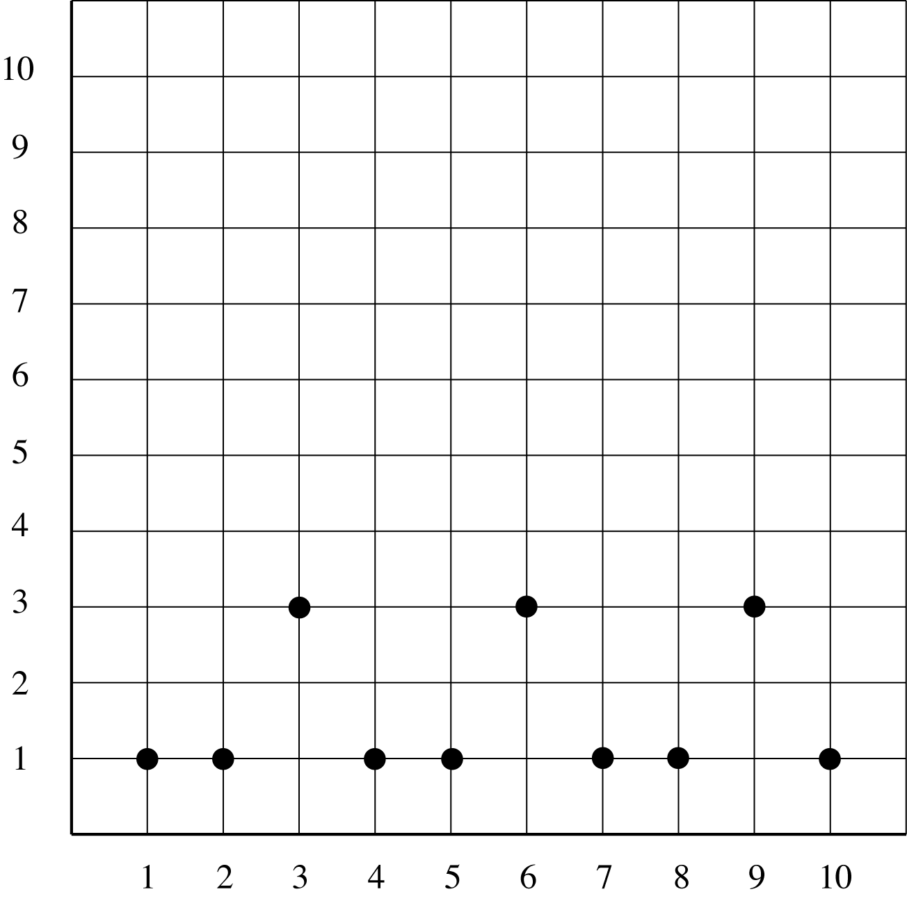

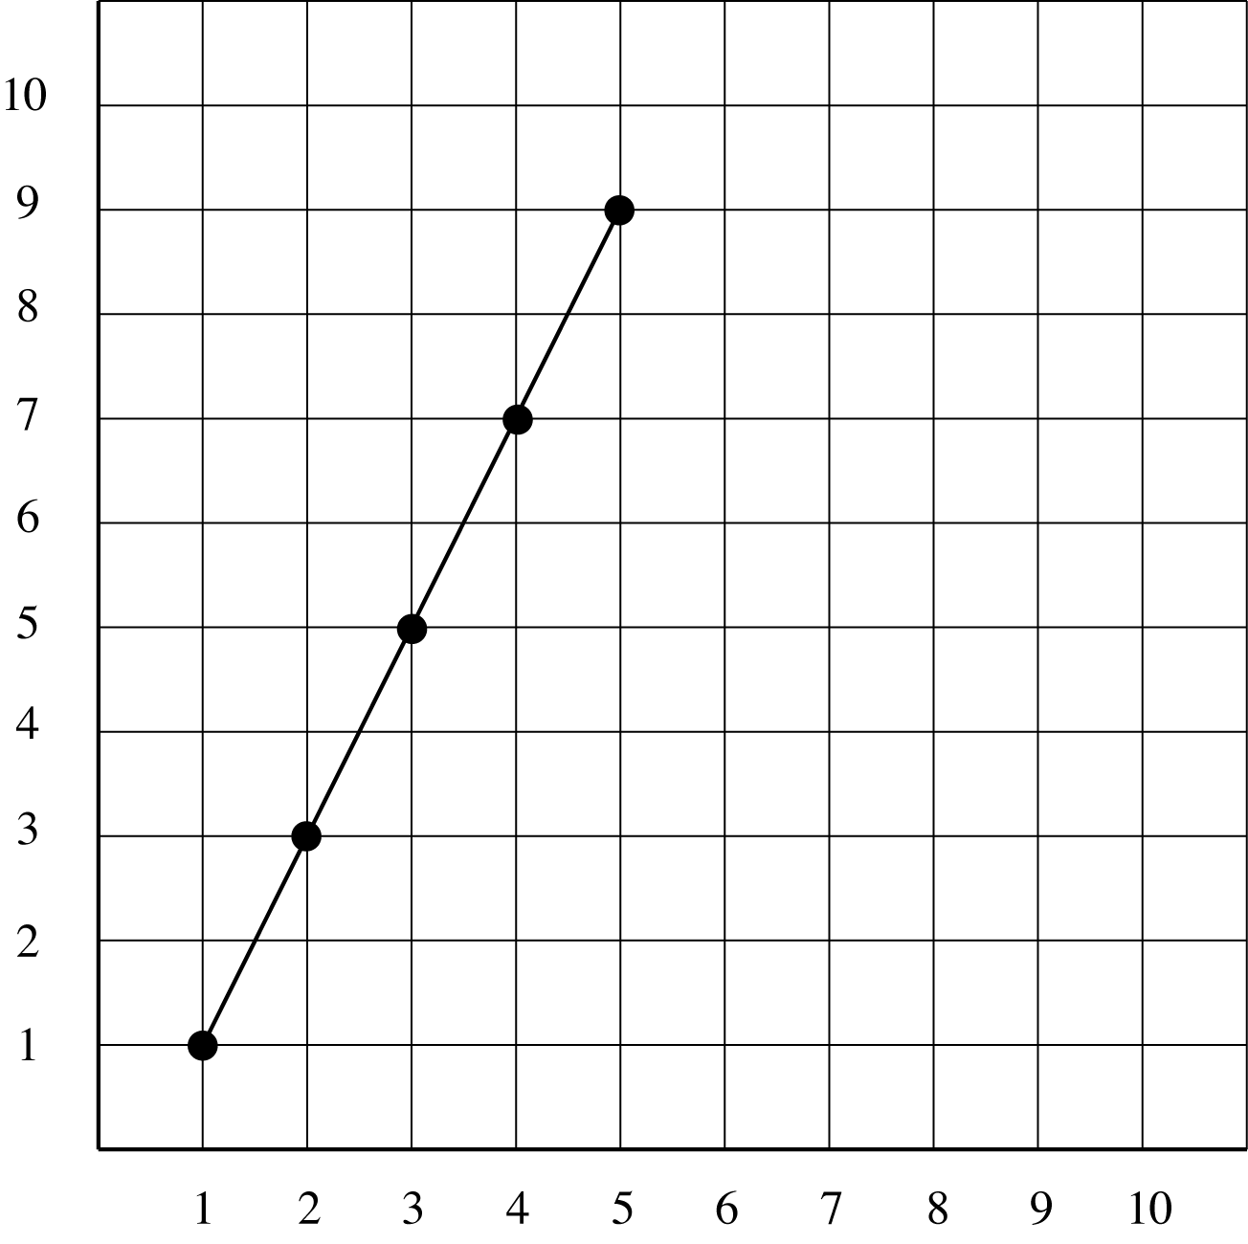
Growing, linear pattern

Attachment C (continued)
Graphs of Patterns

Growing,
non-linear pattern
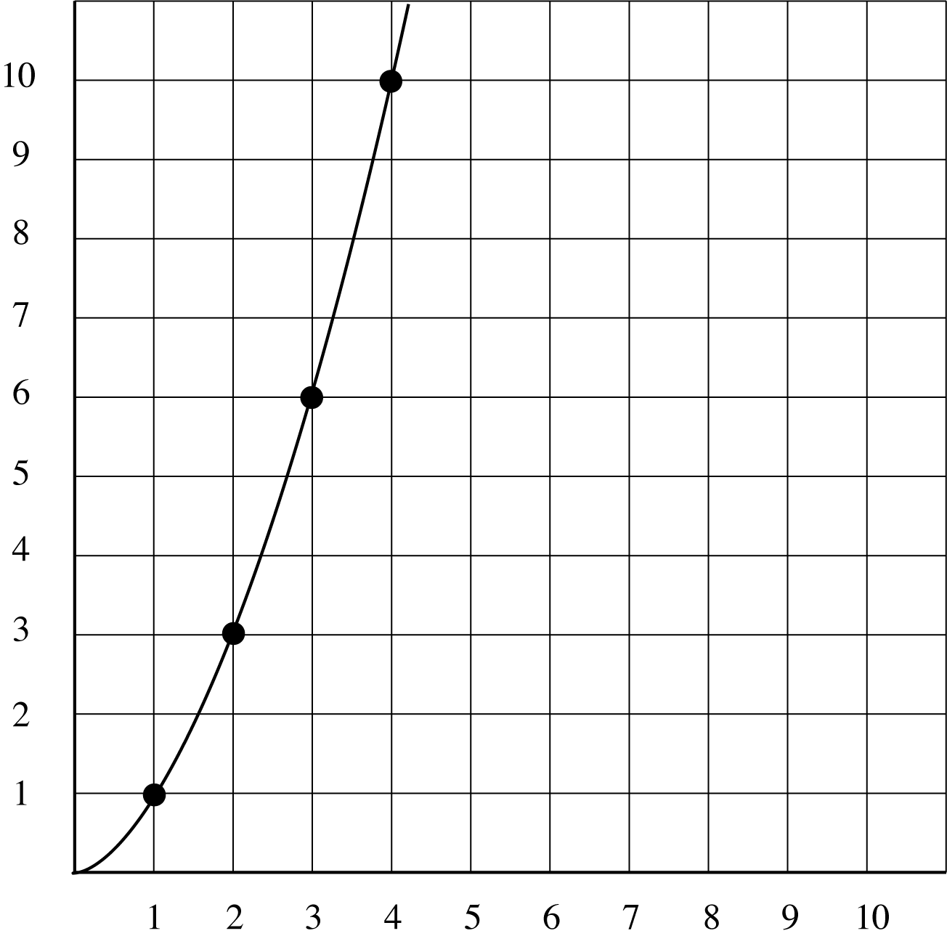
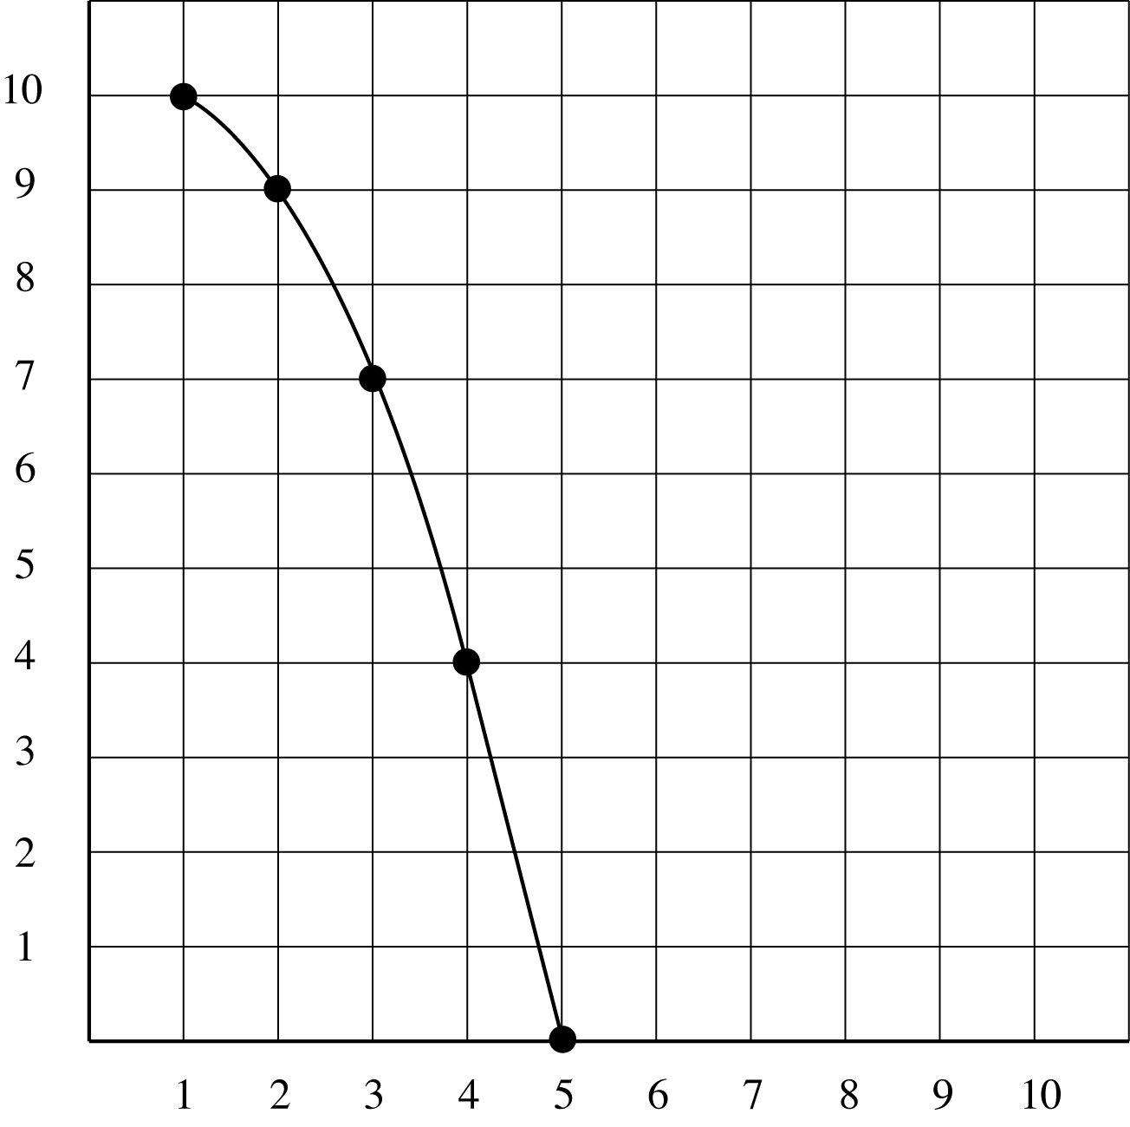
Growing (shrinking),
non-linear pattern
Lesson 4 - Guess My Rule
Commentary:
Developing the skill and understanding of representing a problem situation or a set of number with a “rule” expression or equation begins in the elementary grades and is refined as students advance through high school. The process and the way students look at data now affects how they deal with more complex situations and data later. The simple difference between the statements, “multiply by 2” and “multiply A by 2” or “increase by 2” and “starting at 3 and increase by 2,” can lead to greater understanding. Developing the connections between the term and the value of the term when an operation place on the set of number.

Lesson Summary:
In this lesson, students construct and use tables of values to solve problems associated with mathematical relationships and identify a rule/equation. By the end of the lesson, students understand the concept of input/output to determine the relationships. Although Indicator 5 includes inequalities, this lesson focuses on equations as used in tables. Additional instruction is necessary to cover the indicator completely.

Estimated Duration: Two to three hours

Ohio Standards Connection

Patterns, Functions and Algebra

Benchmark F
Construct and use a table of values to solve problems associated with mathematical relationships.

Indicator 3
Construct a table of values to solve problems associated with a mathematical relationship

Benchmark C
Write and solve open sentences and explain strategies

Indicator 5
Represent mathematical relationships with equations or inequalities

Related Benchmark D Represent an unknown quantity as a variable using a symbol, including letters.

Related Indicator 2 Represent and analyze patterns and functions using words, tables and graphs.

Mathematical Processes Benchmarks:
A. Apply and justify the use of a variety of problem-solving strategies; e.g., make an organized list, guess and check.
K. Use mathematical language to explain and justify mathematical ideas, strategies and solutions.

Instructional Procedures:
Part One
- Place the students into small groups of 3 or 4 students.
- Describe the game ‘Guess My Rule.’ to the class
- The numbers will be displayed in an input/output table.
- Students are to guess the “rule” or the mathematical operation(s) performed on the value in Column A to get the value in Column B.
- Present the chart on an overhead projector or chalkboard to the class. Copy Attachment J, Input / Output Table on to an overhead transparency.
A | B
2 | 4

- Have the groups discuss and determine rules that work for the input/output table and why the rule works. (Possible rules include; add 2 to A, add the number to itself, double the number, or multiply A by 2.)
- Add another row to the table, A=5 and B=10.

A | B
2 | 4
5 | 10

- Have the groups determine if the rules stated in step 4 apply to each row of the table.
- Ask each group to share responses. (The “add 2 to A” rule no longer works, the “multiply A by 2” rule still does.) Reinforce the idea that the same rule must work for all rows of the table.
- Add a third row of values to the table, A = 3 and B = 6. Have each group test the rule; multiply A by 2, with the additional row of values. Ask the students if the rule still applies.

A | B
2 | 4
5 | 10
3 | 6

9. Add another row to the table with the value of 6 in the A column and leave column B blank in the fourth row. Have students use the rule “multiply A by 2” to determine the value to be placed in Column B. (6 x 2, or 12)

A | B
2 | 4
5 | 10
3 | 6
6

10. Add another row to the table with the value of 16 in the Column B and leave column A blank in the fifth row. Ask students to discuss with their groups how they could apply their rule to determine the value that should be placed in Column A. (Encourage students to think about what value to multiply by 2 to get 16 or divide 16 by 2, since division is the inverse operation to multiplication.)

A | B
2 | 4
5 | 10
3 | 6
6 | 12
 | 16

11. Direct the groups to create additional values for A and B that would apply to the rule in the table. Select students to share the pairs of A and B values and ask the rest of the class if they agree or disagree with the pair of values.
12. Add another row to the table and place the variable n in Column A and leaving Column B blank in the sixth row.

A | B
2 | 4
5 | 10
3 | 6
6 | 12
8 | 16
n

13. Tell students that the n in Column A is a variable that stands for any number. Ask students,
- How can we write a rule using the variable n to show what is done to each input value in Column A to get the output value in Column B?” (Since we multiplied each number in Column A by 2, n x 2 is our rule.)
14. Ask students to write and define the word “variable,” as well as provide examples, in a mathematics journal. Have students share their entries with the class.
15. Write the rule, n x 2 (or other representation), in Column B.
A | B
2 | 4
5 | 10
3 | 6
6 | 12
8 | 16
n | n x 2

Page 3

16. Provide practice with the skill. Have additional charts ready to present to the class and continue playing the “Guess My Rule” game. (Some examples follow.)
a.
A | B
10 | 5
20 | 10
6 | 3
12 | ?
? | 4
n

The rule is n 2. ; where the value in column A is divided by 2; B=A/2; etc various forms of words and mathematical symbols is acceptable.
b.
A | B
1 | 12
20 | 31
15 | 26
6 | ?
? | 11
n
The rule is n + 11 ; the value in column A plus 11; A + 11 = B
c.
A | B
8 | 0
19 | 0
5 | 0
0 | ?
? | 0
n
The rule is n × 0; A(0)=0; 0= A times 0

17. Assign Attachment E, Homework Assignment Part One.
18. Present the following scenario.
Janet receives $4 every week for her allowance. She is saving all her money to buy a CD that costs $20. Determine the number of weeks Janet will need to save her money to have enough money to buy the CD.
Page 4

a. Have students construct a table of values to represent the situation. Ask the students to determine titles for the columns and explain their reasoning.
b. Model the construction of the table on the board. Direct the students to construct the table in their journals.
Blank table:
Week | $ Earned
c. Ask students to complete the table and check their answers with a partner. Discuss the responses as a class and complete the table. Have students correct any errors in their tables.
Completed table:
Week | $ Earned
1 | 4
2 | 8
3 | 12
4 | 16
5 | 20

19. Ask the students to work in pairs to create an expression using a variable to represent the “rule” for the table. Select several students to share their “rule” and record the expressions or equations on the board. Some possible solutions include: 204 = 5, 4 × d = 20 or 4 + 4 + 4 + 4 + 4 = 20. If the students decide the rule is to add 4, rather than to multiply by 4, remind them to create an equation that describes the relationship between the first and second columns (also known as the input and the output).

20. Discuss how to write the rule as an equation using the variable, n, for the number of weeks Janet worked to determine the amount of money she earned. (n x 4 = money earned, n ● 4 = money earned, or 4n = money earned.)
21. Tell students that sometimes rules are more challenging than simply multiplying or subtracting. Sometimes rules include multiple operations or steps. Ask students to give an example of an expression that has two different operations (n × 3 + 2 or 4n -3).
22. Present a new input/output table to students.

A | B
2 | 12

a. Ask groups to think of rule that can be used for the input/output table and have them explain why it works. Ask each group for a rule and place it on the board or overhead. (Some possible solutions are “multiply A by 6”, or “add 10 to A.”).
Page 5
b. Add a second row to the table where A = 5 and B = 27. Have students test the rules with the added number.

A | B
2 | 12
5 | 27

c. Apply the rules stated for the first row of values to the second row. Identify which rules still apply to the table and cross out those that do not.

23. Have the groups discuss and think about possible rules for the relationship. Remind students that, in some cases, one operation is not enough. Sometimes, the rule must use two operations to get the correct output.
a. Brainstorm with students and model thinking processes to determine ways to get from 5 to 27 if student are having difficulty in identifying additional rules. Record all of suggestions. Remind students that the rule must work for both sets of numbers.
b. Ask questions to help guide thinking such as:
- What could you multiply the values in column A by to get close to the values in column B? (5, 6 or 7)
- Do any of these appear to lead to a second step that can be used in both rows? (If the values in column A are multiplied by 5, then add 2 to that product to get the values in column B.)
c. Have the students test each of the suggested rules to determine which can be applied to both rows of values. (For example, some may suggest adding 22, but that does not work with the first set of numbers, nor is it a two-step rule.)
24. Add a third row of values to the table, where A = 3 and B = 17.

A | B
2 | 12
5 | 27
3 | 17

a. Ask the class to test the rule(s) to determine which still works. The rule “multiply A by 5, add 2” still works.
b. Have students use the rule to find values in column B when given values in column A. Add rows to the table, where A= 4 (22), 8 (42) or 11 (57).

A | B
2 | 12
5 | 27
3 | 17
4

Page 6

25. Add a row to the table where the value in column B is 37. Have students determine the value for column A.

A | B
2 | 12
5 | 27
3 | 17
4 | 22
 | 37

a. Ask students to determine the value for Column A. (Encourage students to think about what to multiply by 5 and add 2 to get to 37. Or, subtract 2 from 37 then divide by 5 since subtraction is the opposite operation of addition and division is the opposite operation of multiplication.)
b. Select students to share the value for column A and explain their reasoning.
27. Instruct students to record a process for identifying a rule using an input/output table in their mathematics journals.

Research Connections:
Daniels, Harvey and Marilyn Bizar. Methods that Matter: Six Structures for Best Practice Classrooms. Me: Stenhouse Publishers, 2000.

Head, M. H., & Readence, J. E. “Anticipation Guides: Meaning through prediction.” In E. K. Dishner, T. W. Bean, J. E. Readence, D. W. Moore (Eds.), Reading in the Content Areas, 2nd ed., pp. 229-234, Dubuque, IA: Kendall/Hunt, 1986.

Name: ___________________________________

Patterns Post Assessment

1. The table below shows the number of cans of paint Manndale use to paint birdhouses.
Number of cans | Number of birdhouses
1 | 3
2 | 6
3 | 9
4

A. How many birdhouses can he paint with 8 cans of paint? _______________

B. Use words and numbers to explain how you found the number of benches.

2. Mrs. Crawford described a number pattern as “start with 21 and subtract 5 to get the next number”.

Complete Mrs. Crawford’s number pattern: 21, ____, ____, ____, _____

3. Cianna made this pattern: 43, 48, 53, 58.
Write the rule for Cianna’s pattern.

_________________________________________________________________

4. Kayla and Mark’s total savings at the end of the week are shown in the table.
WEEK | KAYLA | MARK
1 | $5 | $2
2 | $10 | $8
3 | $15 | $14

Which statement about their savings is true?

A. Kayla will have $1 less than Mark at the end of week 4.
B. Mark will have saved more than Kayla at the end of week 4.
C. Kayla will have saved more than Mark at the end of week 4.
D. Mark and Kayla will have saved the same amount at the end of week 4.
Page 2

5. Marcus recorded the number of pennies he has saved at the end of each week in the table shown.
WEEK | NUMBER OF PENNIES
1 | 4
2
3 | 16
4
5 | 64

Each week, Marcus doubles the number of pennies he has saved. He forgot to record the total number of pennies in week 2 and week 4.
How many pennies did he have saved for week 2 _____________

How many pennies die he have saved for week 4? ____________

6. Autumn made the pattern shown.

1, 2, 4, 8, 16, ____, ____

A. What are the next two numbers?

B. Describe the pattern using words.

7. Derek starts with 12 birdhouses. He makes three new birdhouses each week.

Which pattern shows the number of birdhouses he has at the end of each week?

A. 3, 6, 9, 12
B. 12, 9, 6, 3
C. 12, 15, 28, 21
D. 12, 24, 26, 48

Page 3

9. Lyn and Kris were picking up pine cones. Every 30 minutes, they counted to check the total number of pine cones they had picked up. The chart shows their results.
Time | Lyn’s pine cones | Kris’ pine cones
1:00 p.m. | 7 | 12
1:30 p.m. | 14 | 24
2:00 p.m. | 21 | 36
2:30 p.m. | 30 | 48

Which statement is true according to the data in the chart?

A. Kris always picked up 5 more pine cones than Lyn.
B. Kris and Lyn picked up the same number of pine cones every 30 minutes.
C. Kris picked up fewer pine cones than Lyn.
D. Kris picked up 12 pine cones every 30 minutes.

10. The numbers in column A have been changed to the numbers in column B by using a specific rule.
A | B
21 | 7
24 | 8
12 | 4
15 | 5

Which number sentence shows that rule?

A. A x 3 = B
B. A – 14 = B
C. A ÷ 3 = B
D. A – 10 = B

Complete the number sequence. Fill in the missing number.
12.
6 | 12 | 18 | 24 | 30 | 36 | 42 | 48 | 54 |  | 66 | 72

Explain sequence:

13.
  3 | 12 | 21 | 30 | 39 | 48 | 57 | 66 | 75 | 84 | 93
  Explain sequence:

14.
  47 | 44 | 41 | 38 |  | 32 | 29 | 26 | 23 | 20 | 17 | 14
  Explain sequence:

15.
   | 101 | 93 | 85 | 77 | 69 | 61 | 53 | 45 | 37 | 29 | 21
  Explain sequence:

16.
  1 | 2 | 4 | 8 | 16 | 32 | ____ | ____ | ____
  Explain sequence:

17.
  67 | 62 |  | 52 | 47 | 42 | 37 | 32 | 27 | 22 | 17 | 12
  Explain sequence:

