B>L: (Humans clear the forest to be used for infrastructure – roads, logging & mining sites, etc)
Road construction gives developers and ranchers access to previously inaccessible forest lands in the Amazon. Road construction in the Amazon leads to deforestation. Roads provide access to logging and mining sites while opening forest frontier land to exploitation by poor landless farmers (MB-1).
B>B>E (Humans build roads that affect migrations and result in more deforestation)
The pavement is bound to boost migration and is expected to lead to deforestation, prompting warnings from environmentalists of possible ecological disaster (MB-2).
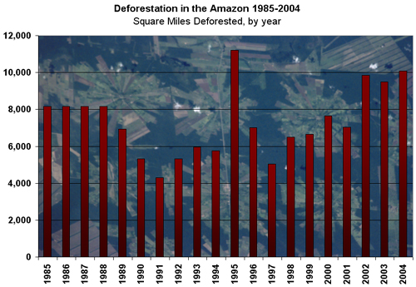
Satellite data from 2004 shows a marked increase in deforestation along the BR-163 road, a highway the government has been paving in an effort to help soy farmers from Mato Grosso get their crops to export markets. Typically, roads encourage settlement by rural poor who look to the rainforest as free land for subsistence agriculture.
B>H>E: (Humans build dams that cause flooding that increases deforestation)
Historically, hydroelectric projects have flooded vast areas of Amazon rainforest. The Balbina dam flooded some 2,400 square kilometers (920 square miles) of rainforest when it was completed. Phillip Fearnside, a leading expert on the Amazon, calculated that in the first three years of its existence, the Balbina Reservoir emitted 23,750,000 tons of carbon dioxide and 140,000 tons of methane, both potent greenhouse gases which contribute to global climate change. (MB-3).

B>E (Human mining endeavors lead to Deforestation)
Mining has impacted some parts of the Amazon Basin. During the 1980s, over 100,000 prospectors invaded the state of Para when a large gold deposit was discovered, while wildcat miners are still active in the state of Roraima near the Venezuelan border. Typically, miners clear forest for building material, fuelwood collection, and subsistence agriculture (MB-3).

