Instructional Design- If You Give A Mouse A Cookie
By Laura Numeroff
Julia Doubrva
Bowling Green State University

Rationale
A special education classroom varies slightly from a regular education classroom. The students in the class will have different goals that will help them succeed in their academics if those particular goals are met. Many times students with disabilities are taught in a pull out or inclusion environment. This lesson is designed to work with a whole classroom of students or one student in particular to meet the goals of the Individual Education Plan.
The first section of the unit would be language arts to allow the student to become familiar with the story and do a picture walk through to make predictions of the story line. Within the languages arts sections students will also learn new vocabulary, rhyming words, be exposed to other texts that incorporate the same theme, comprehend the text itself, and learn the sequence of the story. The second section would be the science lessons. Students will learn about mice and other animals. Nutrition such as the food pyramids and compares it to where cookies fit into the pyramid. Lastly scientific inquiry by forming hypothesis and making predictions such as what would happen to a cookie if it was in milk for too long. While writing the students will understand cause and effect which will coincide with sequencing and allow students to use their creativity and create a new version of the story. Lastly the text will be incorporated into math and the students will be exposed to graphing the class or school’s favorite cookie. The students will bake cookies together and measure and use fractions to correct make the recipe.
To wrap up the lesson the students will complete graphic organizers to pull the lesson together and learn the skills to incorporate different lessons together into a unit and bridge connections from the text to other aspects of their schools curriculum.

Learning Outcomes
Content Literacy
- Students will be able to make predictions of the book’s content
- Students will be able to identify the parts of the story
- Students will be able to sequence the events of the story
- Students will be able to compare and contrast the events of the story to that of another story by the same author.
Science
- Students will be able to understand the contents of the food pyramid
- Students will be able to compare and contrast different animals that are associated with mice
- Students will be able to compare their predictions to the events in the story with a graphic organize.
Writing
- Students will be able to create their own version of the story as if they were the mouse.
- Students will understand cause and effect
- Student’s will be able to be creative and imaginative while making their own story.
Math
- Students will be able to collect data by graphing how many different types of cookies their peers prefer as a class
- Students will be able to measure with basic cookie utientisel
- Students will work on counting, numbers, and number placement
- Students will be able to estimate by looking at chocolate chips in a cookie.

Pre-Test
Working one-on-one with students in a special education setting is not out of the norm for intervention specialists. For this lesson one student will work with me to work on reading comprehension, predications, story recall, and the use of graphic organizers. To begin this lesson a pre-test will be taken based on the K-W-L chart. It will help identify the students prior knowledge of what is known, what is going to be learned, and what the student wants to learn based on the subject.
I large teacher book will be placed in the classroom and the student will have their own version of the book. By flipping through the pictures the student will complete the K-W-L chart with the assistance of the teacher. The student will be asked three questions. What he knows about the book, what does he believe he will learn from the book, and what does he want to learn from the book.
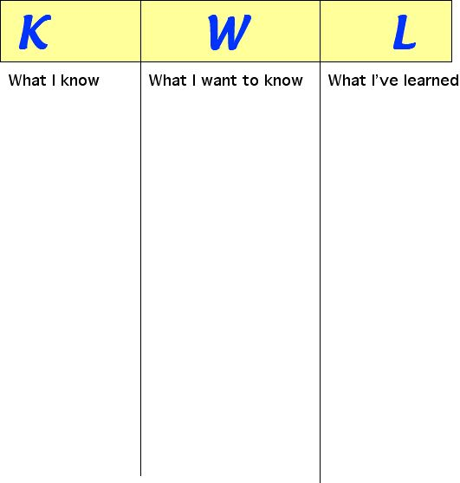

Lesson One
Materials needed: Worksheet and pencil
Procedure:
Students will fill in the blanks with the words provided in the word bank.

Moustache Crayons Mirror Thirsty Drawing
Pillow Blanket Hair Mop Broom Scotch Tape

- The Mouse used ________________________________________________to draw a picture.

- The Mouse had a milk ____________________________________________________________

- The cookie made the mouse ______________________________________________________.

- The Mouse asked for a __________________________________to see his new milk moustache.

- The mouse put his ______________________________________________ on the refrigerator.

- The Mouse noticed his _______________________________________________needed a trim.

- The mouse needed a _____________________________________________ to sweep the floor.

- The Mouse needed a ______________________________________________ to wash the floor.

- The boy got the mouse ________________ ______________________ to hang his picture.

- The Mouse needed a ______________________ and a ______________________ to take a nap.

Lesson Two
Materials: Worksheet, pencil, and crayons
Procedure:
Students will write their own story by filling in the blanks of the sample. The sentences will be “If you give me a _________________ then I will probable want _____________________. The students will then create an illustration to help imagine the story as their own.
The students will then complete the cause and effect chart for the story by Laura Numeroff as well as their version of the story.

If you Give _________a
(Students Name)

_____________________

If you give me a

______________________ then I’ll probably going to ask for

___________________.

If you give me a

______________________ then I’ll probably going to ask for

___________________.

If you give me a

______________________ then I’ll probably going to ask for

___________________.

If you give me a

______________________ then I’ll probably going to ask for

___________________.

If you give me a

______________________ then I’ll probably going to ask for

___________________.

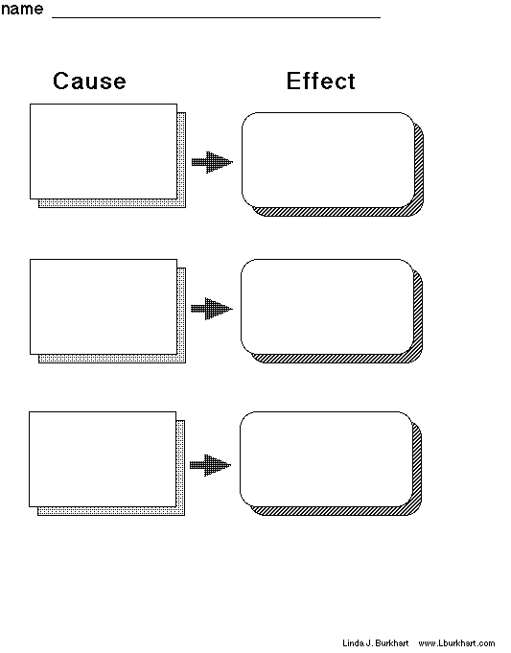
Lesson Three
Materials: Copy of the food pyramid, pencil, worksheet
Procedure:
The students will begin the lesson by going over the food pyramid. Then they will use the school’s lunch menu and deiced what food items belong on the food pyramid. After that they will then create their own week’s lunch menu for the school in small groups and present them to the class. The class will then vote, and use the data to graph in the Math lesson, to choose one week menu to submit to the school cafeteria as a possible menu in the future.
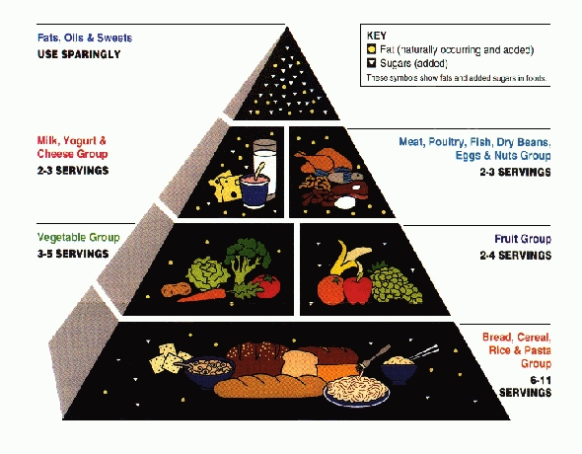

LUNCH MENU
Monday:
Grain:
Fruit:
Veggie:
Meat:
Dairy:
Fats, Oils, and Sweets

Tuesday:
Grain:
Fruit:
Veggie:
Meat:
Dairy:
Fats, Oils, and Sweets

Wednesday:
Grain:
Fruit:
Veggie:
Meat:
Dairy:
Fats, Oils, and Sweets

Thursday:
Grain:
Fruit:
Veggie:
Meat:
Dairy:
Fats, Oils, and Sweets

Friday:
Grain:
Fruit:
Veggie:
Meat:
Dairy:
Fats, Oils, and Sweets

Lesson Four
Materials: Pencil and Venn Diagram
Procedure: Students will use a Venn diagram to compare and contrast mice to another animal of their choice 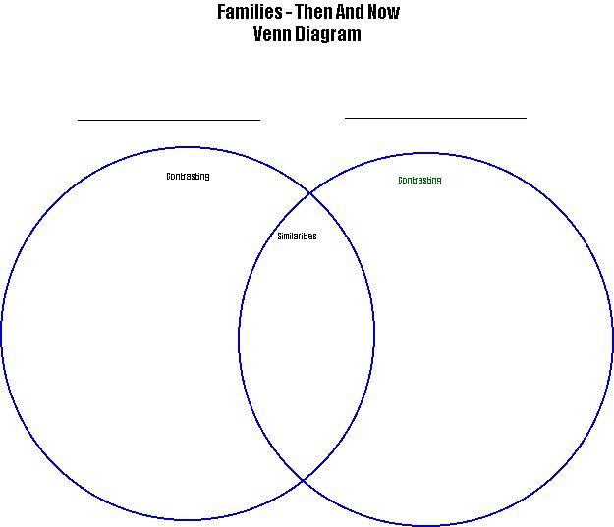

Lesson Five
Materials: Votes, graph paper, chalk, and chalk board
Procedure: Students will graph the votes of the lunch menu’s as a class and create a bar graph on the chalk board to find out whose menu will be submitted to the school cafeteria.
Lesson Six
Materials: recipe, cooking materials, paper, pencil, apron, soap (to wash hands)
Procedure: Students will take a recipe for baking cookies and use it bake cookies as a class. Students will then count out the number of chocolate chips to put into each cookie. The teacher will then bake one LARGE cookie herself and keep the number of chocolate chips a secret from the students. After the cookie has been baked each student will observe the cookie make an estimate of number of chocolate chips in the large cookie. The winner gets to eat the cookie themselves!

Post Assessment
The post assessment will allow the teacher or intervention specialist on the knowledge of the content of the book. It will be a multiple choice assessment that will give the teacher an idea if the student understood and comprehended the story of the book, If You Give A Mouse A Cookie by Laura Numeroff.

If You Give A Mouse A Cookie Post-Test
- Circle what the mouse asked the boy for.
  - Juice
  - Movie
  - Straw
- Why did the Mouse want a mirror?
  - To brush his teeth
  - To see if he had a milk moustache.
  - To wash his hands
- What did the mouse want to do with his picture?
  - Hang it on the refrigerator
  - Mail it to his mom
  - Put it in the boys room.
- What did the story take place?
  - At the mouse’s house
  - At the boys hours
  - At school
- How many characters are in the story?
  - One
  - Two
  - Three

