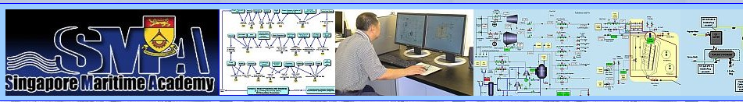

Steam Certificate of Competency Course for LNG Vessels

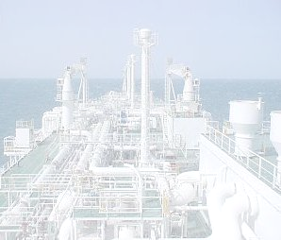

With the emergence of increasing numbers of LNG tonnage, steam turbine propulsion has again become a viable means of propulsion at sea. The Singapore Maritime Academy provides a specialized Certificate of Competency Course, specially tailored for this emerging sector.

Course Objective: The Steam Certificate of Competency Course at the Singapore Maritime Academy is a course to equip management level marine engineers to acquire the additional knowledge and proficiency to be competent and safe operators on steam propelled LNG vessels.

Scope: The course will introduce to the students the LNG-based steam propulsion system, its safe operational procedures, containment and usage of LNG boil-off gas for propulsion as well as maintenance & troubleshooting of steam machinery. The course delivery and assessment will be through a computer-mediated interactive system & LNG-based Steam Propulsion Simulator.

Entry Requirements: Either Second Class Certificate of Competency (Motorship) or First Class Certificate of Competency (Motorship) from Maritime Port Authorities (MPA), Singapore or an equivalent qualification recognized by MPA, Singapore.

Duration: Four weeks (full time: 9am to 5pm, Monday to Friday).

Progression: Progression is shown in the following flow chart

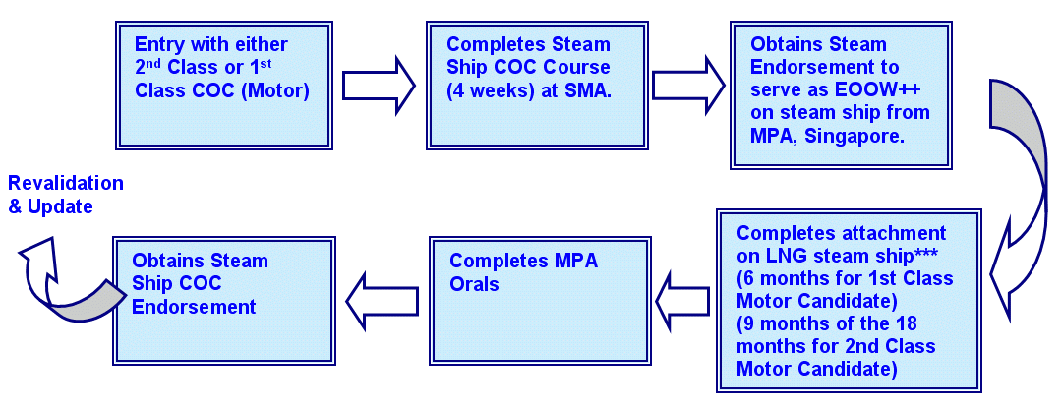

++EOOW: Engineer Officer Of the Watch

Course Dates in 2006: Course will commence on these dates: 3rd July 2006, 1st August 2006, 2nd October 2006, 1st November 2006
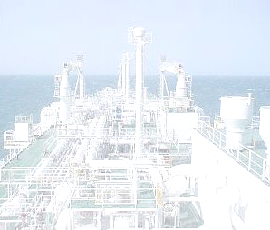

Fees: Fees are made flexible depending on the number of participants, see example below.

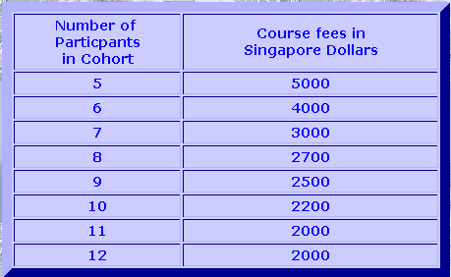

Course Fees: Steam COC for LNG Propulsion

How to apply: For application to enrol in the course, please contact Singapore Maritime Academy (SMA) {Email: Kalyan@sp.edu.sg } with the date when you want to join the course.

For Sea Service Requirements & Eligibility: Please contact Maritime Port Authority (MPA){ Email: Zulfiqur_HUSAIN@mpa.gov.sg } with the details of your qualifications and sea service experience.

Visit our website at: http://www.sma.sp.edu.sg/

