A la edad de 40 años, King Gillette era un inventor frustrado, un anticapitalista amargo, y un vendedor de tapas de botellas forradas de corcho. Era 1895, ya pesar de las ideas, la energía, y los padres ricos, que había poco que mostrar por su trabajo. Culpó a los males de la competencia en el mercado. De hecho, el año anterior había publicado un libro, La Deriva Humanos, que argumentó que toda la industria debería ser asumida por una sola corporación de propiedad por parte del público y que millones de estadounidenses que viven en una ciudad gigante llamado Metropolis, alimentado por las cataratas del Niágara. Su jefe en la empresa tapa de la botella, mientras tanto, había sólo un pequeño consejo: la gente inventa algo usar y tirar.
Un día, mientras él se afeitaba con una navaja de afeitar que fue llevada por lo que ya no podía ser afilada, la idea vino a él. ¿Qué pasa si la hoja se podría hacer de una tira delgada de metal? En lugar de pasar el tiempo el mantenimiento de las cuchillas, los hombres sólo podían desprenderse de ellos cuando se convirtió en aburrido. Unos años más tarde la metalurgia de la experimentación, la maquinilla de afeitar desechables, hoja nació. Pero no se quitó de inmediato. En su primer año, 1903, Gillette vendió un total de 51 máquinas de afeitar y hojas de 168. Durante las próximas dos décadas, trató de cada truco de marketing que se le ocurrió. Él puso su propio rostro en el paquete, por lo tanto lo legendario y, algunas personas creen, de ficción. Vendió millones de maquinillas de afeitar al Ejército con un gran descuento, con la esperanza de los soldados hábitos desarrollados en guerra podrían llegar a tiempo de paz. Vendió maquinillas de afeitar en la mayor parte de los bancos para que pudieran dar a la basura con los nuevos depósitos ("afeitado y salvar" las campañas). Maquinillas de afeitar se viene con todo lo de la goma de Wrigley a los paquetes de café, té, especias, y los malvaviscos. Los regalos ayudado a vender esos productos, pero la táctica ayudó a Gillette aún más. Al regalar las maquinillas de afeitar, que eran inútiles por sí mismos, fue la creación de demanda de cuchillas desechables. Unos pocos millones de hojas más tarde, este modelo de negocio es ahora el fundamento de las industrias de todo: Regala el teléfono móvil, vende el plan mensual, que la consola de videojuegos barato y vender caro juegos, instala cafeteras de lujo en las oficinas sin costo para que pueda vender gerentes sobres de café caro.
WIRED MAGAZINE: 16.03
Tech Biz : IT

Free! Why $0.00 Is the Future of Business
By Chris Anderson 02.25.08
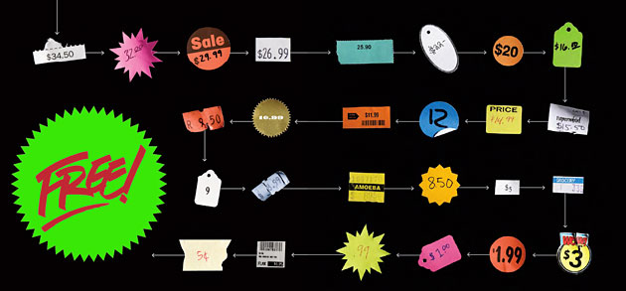
FEATURE
Webmail Windfall
How Can Air Travel Be Free?
How Can a CD Be Free?
How Can a DVR Be Free?
How Can Directory Assitance Be Free?
How-To Wiki
How To Make Money Around Free Content
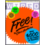The March 2008 "issue for free" offer is now closed.
At the age of 40, King Gillette was a frustrated inventor, a bitter anticapitalist, and a salesman of cork-lined bottle caps. It was 1895, and despite ideas, energy, and wealthy parents, he had little to show for his work. He blamed the evils of market competition. Indeed, the previous year he had published a book, The Human Drift, which argued that all industry should be taken over by a single corporation owned by the public and that millions of Americans should live in a giant city called Metropolis powered by Niagara Falls. His boss at the bottle cap company, meanwhile, had just one piece of advice: Invent something people use and throw away.
One day, while he was shaving with a straight razor that was so worn it could no longer be sharpened, the idea came to him. What if the blade could be made of a thin metal strip? Rather than spending time maintaining the blades, men could simply discard them when they became dull. A few years of metallurgy experimentation later, the disposable-blade safety razor was born. But it didn't take off immediately. In its first year, 1903, Gillette sold a total of 51 razors and 168 blades. Over the next two decades, he tried every marketing gimmick he could think of. He put his own face on the package, making him both legendary and, some people believed, fictional. He sold millions of razors to the Army at a steep discount, hoping the habits soldiers developed at war would carry over to peacetime. He sold razors in bulk to banks so they could give them away with new deposits ("shave and save" campaigns). Razors were bundled with everything from Wrigley's gum to packets of coffee, tea, spices, and marshmallows. The freebies helped to sell those products, but the tactic helped Gillette even more. By giving away the razors, which were useless by themselves, he was creating demand for disposable blades. A few billion blades later, this business model is now the foundation of entire industries: Give away the cell phone, sell the monthly plan; make the videogame console cheap and sell expensive games; install fancy coffeemakers in offices at no charge so you can sell managers expensive coffee sachets.
Chris Anderson discusses "Free."
Video produced by Annaliza Savage and edited by Michael Lennon.
For more, visit wired.com/video.
Thanks to Gillette, the idea that you can make money by giving something away is no longer radical. But until recently, practically everything "free" was really just the result of what economists would call a cross-subsidy: You'd get one thing free if you bought another, or you'd get a product free only if you paid for a service.
Over the past decade, however, a different sort of free has emerged. The new model is based not on cross-subsidies — the shifting of costs from one product to another — but on the fact that the cost of products themselves is falling fast. It's as if the price of steel had dropped so close to zero that King Gillette could give away both razor and blade, and make his money on something else entirely. (Shaving cream?)
You know this freaky land of free as the Web. A decade and a half into the great online experiment, the last debates over free versus pay online are ending. In 2007 The New York Times went free; this year, so will much of The Wall Street Journal. (The remaining fee-based parts, new owner Rupert Murdoch announced, will be "really special ... and, sorry to tell you, probably more expensive." This calls to mind one version of Stewart Brand's original aphorism from 1984: "Information wants to be free. Information also wants to be expensive ... That tension will not go away.")
Scenario 1: Low-cost digital distribution will make the summer blockbuster free. Theaters will make their money from concessions — and by selling the premium moviegoing experience at a high price.
Once a marketing gimmick, free has emerged as a full-fledged economy. Offering free music proved successful for Radiohead, Trent Reznor of Nine Inch Nails, and a swarm of other bands on MySpace that grasped the audience-building merits of zero. The fastest-growing parts of the gaming industry are ad-supported casual games online and free-to-try massively multiplayer online games. Virtually everything Google does is free to consumers, from Gmail to Picasa to GOOG-411.
The rise of "freeconomics" is being driven by the underlying technologies that power the Web. Just as Moore's law dictates that a unit of processing power halves in price every 18 months, the price of bandwidth and storage is dropping even faster. Which is to say, the trend lines that determine the cost of doing business online all point the same way: to zero.
But tell that to the poor CIO who just shelled out six figures to buy another rack of servers. Technology sure doesn't feel free when you're buying it by the gross. Yet if you look at it from the other side of the fat pipe, the economics change. That expensive bank of hard drives (fixed costs) can serve tens of thousands of users (marginal costs). The Web is all about scale, finding ways to attract the most users for centralized resources, spreading those costs over larger and larger audiences as the technology gets more and more capable. It's not about the cost of the equipment in the racks at the data center; it's about what that equipment can do. And every year, like some sort of magic clockwork, it does more and more for less and less, bringing the marginal costs of technology in the units that we individuals consume closer to zero.
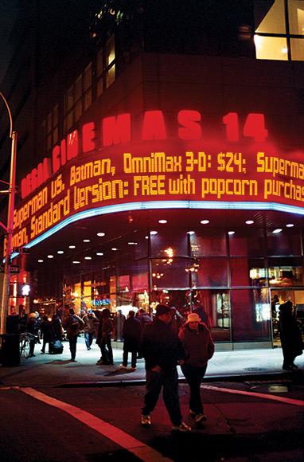
Photo Illustration: Jeff Mermelstein
As much as we complain about how expensive things are getting, we're surrounded by forces that are making them cheaper. Forty years ago, the principal nutritional problem in America was hunger; now it's obesity, for which we have the Green Revolution to thank. Forty years ago, charity was dominated by clothing drives for the poor. Now you can get a T-shirt for less than the price of a cup of coffee, thanks to China and global sourcing. So too for toys, gadgets, and commodities of every sort. Even cocaine has pretty much never been cheaper (globalization works in mysterious ways).
Digital technology benefits from these dynamics and from something else even more powerful: the 20th-century shift from Newtonian to quantum machines. We're still just beginning to exploit atomic-scale effects in revolutionary new materials — semiconductors (processing power), ferromagnetic compounds (storage), and fiber optics (bandwidth). In the arc of history, all three substances are still new, and we have a lot to learn about them. We are just a few decades into the discovery of a new world.
What does this mean for the notion of free? Well, just take one example. Last year, Yahoo announced that Yahoo Mail, its free webmail service, would provide unlimited storage. Just in case that wasn't totally clear, that's "unlimited" as in "infinite." So the market price of online storage, at least for email, has now fallen to zero (see "Webmail Windfall"). And the stunning thing is that nobody was surprised; many had assumed infinite free storage was already the case.
For good reason: It's now clear that practically everything Web technology touches starts down the path to gratis, at least as far as we consumers are concerned. Storage now joins bandwidth (YouTube: free) and processing power (Google: free) in the race to the bottom. Basic economics tells us that in a competitive market, price falls to the marginal cost. There's never been a more competitive market than the Internet, and every day the marginal cost of digital information comes closer to nothing.
One of the old jokes from the late-'90s bubble was that there are only two numbers on the Internet: infinity and zero. The first, at least as it applied to stock market valuations, proved false. But the second is alive and well. The Web has become the land of the free.
The result is that we now have not one but two trends driving the spread of free business models across the economy. The first is the extension of King Gillette's cross-subsidy to more and more industries. Technology is giving companies greater flexibility in how broadly they can define their markets, allowing them more freedom to give away products or services to one set of customers while selling to another set. Ryanair, for instance, has disrupted its industry by defining itself more as a full-service travel agency than a seller of airline seats (see "How Can Air Travel Be Free?").
The second trend is simply that anything that touches digital networks quickly feels the effect of falling costs. There's nothing new about technology's deflationary force, but what is new is the speed at which industries of all sorts are becoming digital businesses and thus able to exploit those economics. When Google turned advertising into a software application, a classic services business formerly based on human economics (things get more expensive each year) switched to software economics (things get cheaper). So, too, for everything from banking to gambling. The moment a company's primary expenses become things based in silicon, free becomes not just an option but the inevitable destination.
WASTE AND WASTE AGAIN
Forty years ago, Caltech professor Carver Mead identified the corollary to Moore's law of ever-increasing computing power. Every 18 months, Mead observed, the price of a transistor would halve. And so it did, going from tens of dollars in the 1960s to approximately 0.000001 cent today for each of the transistors in Intel's latest quad-core. This, Mead realized, meant that we should start to "waste" transistors.
Scenario 2: Ads on the subway? That's so 20th century. By sponsoring the whole line and making trips free, the local merchants association brings grateful commuters to neighborhood shops.
Waste is a dirty word, and that was especially true in the IT world of the 1970s. An entire generation of computer professionals had been taught that their job was to dole out expensive computer resources sparingly. In the glass-walled facilities of the mainframe era, these systems operators exercised their power by choosing whose programs should be allowed to run on the costly computing machines. Their role was to conserve transistors, and they not only decided what was worthy but also encouraged programmers to make the most economical use of their computer time. As a result, early developers devoted as much code as possible to running their core algorithms efficiently and gave little thought to user interface. This was the era of the command line, and the only conceivable reason someone might have wanted to use a computer at home was to organize recipe files. In fact, the world's first personal computer, a stylish kitchen appliance offered by Honeywell in 1969, came with integrated counter space.
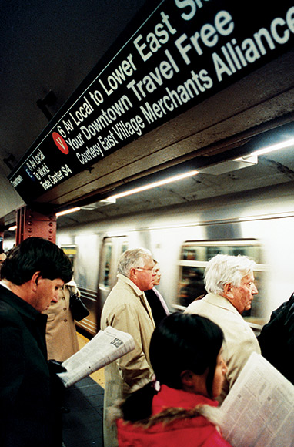
Photo Illustration: Jeff Mermelstein
And here was Mead, telling programmers to embrace waste. They scratched their heads — how do you waste computer power? It took Alan Kay, an engineer working at Xerox's Palo Alto Research Center, to show them. Rather than conserve transistors for core processing functions, he developed a computer concept — the Dynabook — that would frivolously deploy silicon to do silly things: draw icons, windows, pointers, and even animations on the screen. The purpose of this profligate eye candy? Ease of use for regular folks, including children. Kay's work on the graphical user interface became the inspiration for the Xerox Alto, and then the Apple Macintosh, which changed the world by opening computing to the rest of us. (We, in turn, found no shortage of things to do with it; tellingly, organizing recipes was not high on the list.)
Of course, computers were not free then, and they are not free today. But what Mead and Kay understood was that the transistors in them — the atomic units of computation — would become so numerous that on an individual basis, they'd be close enough to costless that they might as well be free. That meant software writers, liberated from worrying about scarce computational resources like memory and CPU cycles, could become more and more ambitious, focusing on higher-order functions such as user interfaces and new markets such as entertainment. And that meant software of broader appeal, which brought in more users, who in turn found even more uses for computers. Thanks to that wasteful throwing of transistors against the wall, the world was changed.
What's interesting is that transistors (or storage, or bandwidth) don't have to be completely free to invoke this effect. At a certain point, they're cheap enough to be safely disregarded. The Greek philosopher Zeno wrestled with this concept in a slightly different context. In Zeno's dichotomy paradox, you run toward a wall. As you run, you halve the distance to the wall, then halve it again, and so on. But if you continue to subdivide space forever, how can you ever actually reach the wall? (The answer is that you can't: Once you're within a few nanometers, atomic repulsion forces become too strong for you to get any closer.)
In economics, the parallel is this: If the unitary cost of technology ("per megabyte" or "per megabit per second" or "per thousand floating-point operations per second") is halving every 18 months, when does it come close enough to zero to say that you've arrived and can safely round down to nothing? The answer: almost always sooner than you think.
What Mead understood is that a psychological switch should flip as things head toward zero. Even though they may never become entirely free, as the price drops there is great advantage to be had in treating them as if they were free. Not too cheap to meter, as Atomic Energy Commission chief Lewis Strauss said in a different context, but too cheap to matter. Indeed, the history of technological innovation has been marked by people spotting such price and performance trends and getting ahead of them.
From the consumer's perspective, though, there is a huge difference between cheap and free. Give a product away and it can go viral. Charge a single cent for it and you're in an entirely different business, one of clawing and scratching for every customer. The psychology of "free" is powerful indeed, as any marketer will tell you.
This difference between cheap and free is what venture capitalist Josh Kopelman calls the "penny gap." People think demand is elastic and that volume falls in a straight line as price rises, but the truth is that zero is one market and any other price is another. In many cases, that's the difference between a great market and none at all.
The huge psychological gap between "almost zero" and "zero" is why micropayments failed. It's why Google doesn't show up on your credit card. It's why modern Web companies don't charge their users anything. And it's why Yahoo gives away disk drive space. The question of infinite storage was not if but when. The winners made their stuff free first.
Traditionalists wring their hands about the "vaporization of value" and "demonetization" of entire industries. The success of craigslist's free listings, for instance, has hurt the newspaper classified ad business. But that lost newspaper revenue is certainly not ending up in the craigslist coffers. In 2006, the site earned an estimated $40 million from the few things it charges for. That's about 12 percent of the $326 million by which classified ad revenue declined that year.
But free is not quite as simple — or as stupid — as it sounds. Just because products are free doesn't mean that someone, somewhere, isn't making huge gobs of money. Google is the prime example of this. The monetary benefits of craigslist are enormous as well, but they're distributed among its tens of thousands of users rather than funneled straight to Craig Newmark Inc. To follow the money, you have to shift from a basic view of a market as a matching of two parties — buyers and sellers — to a broader sense of an ecosystem with many parties, only some of which exchange cash.
The most common of the economies built around free is the three-party system. Here a third party pays to participate in a market created by a free exchange between the first two parties. Sound complicated? You're probably experiencing it right now. It's the basis of virtually all media.
In the traditional media model, a publisher provides a product free (or nearly free) to consumers, and advertisers pay to ride along. Radio is "free to air," and so is much of television. Likewise, newspaper and magazine publishers don't charge readers anything close to the actual cost of creating, printing, and distributing their products. They're not selling papers and magazines to readers, they're selling readers to advertisers. It's a three-way market.
In a sense, what the Web represents is the extension of the media business model to industries of all sorts. This is not simply the notion that advertising will pay for everything. There are dozens of ways that media companies make money around free content, from selling information about consumers to brand licensing, "value-added" subscriptions, and direct ecommerce (see How-To Wiki for a complete list). Now an entire ecosystem of Web companies is growing up around the same set of models.
A TAXONOMY OF FREE
Between new ways companies have found to subsidize products and the falling cost of doing business in a digital age, the opportunities to adopt a free business model of some sort have never been greater. But which one? And how many are there? Probably hundreds, but the priceless economy can be broken down into six broad categories:
· "Freemium"
What's free: Web software and services, some content. Free to whom: users of the basic version.
This term, coined by venture capitalist Fred Wilson, is the basis of the subscription model of media and is one of the most common Web business models. It can take a range of forms: varying tiers of content, from free to expensive, or a premium "pro" version of some site or software with more features than the free version (think Flickr and the $25-a-year Flickr Pro).
Again, this sounds familiar. Isn't it just the free sample model found everywhere from perfume counters to street corners? Yes, but with a pretty significant twist. The traditional free sample is the promotional candy bar handout or the diapers mailed to a new mother. Since these samples have real costs, the manufacturer gives away only a tiny quantity — hoping to hook consumers and stimulate demand for many more.
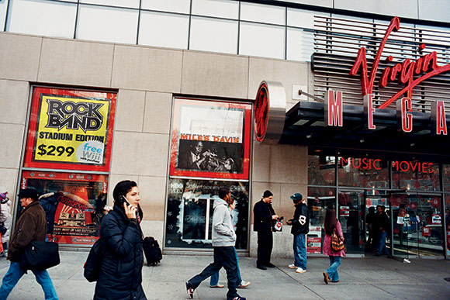
Photo Illustration: Jeff Mermelstein
But for digital products, this ratio of free to paid is reversed. A typical online site follows the 1 Percent Rule — 1 percent of users support all the rest. In the freemium model, that means for every user who pays for the premium version of the site, 99 others get the basic free version. The reason this works is that the cost of serving the 99 percent is close enough to zero to call it nothing.
· Advertising
What's free: content, services, software, and more. Free to whom: everyone.
Broadcast commercials and print display ads have given way to a blizzard of new Web-based ad formats: Yahoo's pay-per-pageview banners, Google's pay-per-click text ads, Amazon's pay-per-transaction "affiliate ads," and site sponsorships were just the start. Then came the next wave: paid inclusion in search results, paid listing in information services, and lead generation, where a third party pays for the names of people interested in a certain subject. Now companies are trying everything from product placement (PayPerPost) to pay-per-connection on social networks like Facebook. All of these approaches are based on the principle that free offerings build audiences with distinct interests and expressed needs that advertisers will pay to reach.
· Cross-subsidies
What's free: any product that entices you to pay for something else. Free to whom: everyone willing to pay eventually, one way or another.
Scenario 3: It's a free second-gen Wiii! But only if you buy the deluxe version of Rock Band.
When Wal-Mart charges $15 for a new hit DVD, it's a loss leader. The company is offering the DVD below cost to lure you into the store, where it hopes to sell you a washing machine at a profit. Expensive wine subsidizes food in a restaurant, and the original "free lunch" was a gratis meal for anyone who ordered at least one beer in San Francisco saloons in the late 1800s. In any package of products and services, from banking to mobile calling plans, the price of each individual component is often determined by psychology, not cost. Your cell phone company may not make money on your monthly minutes — it keeps that fee low because it knows that's the first thing you look at when picking a carrier — but your monthly voicemail fee is pure profit.
On a busy corner in São Paulo, Brazil, street vendors pitch the latest "tecnobrega" CDs, including one by a hot band called Banda Calypso. Like CDs from most street vendors, these did not come from a record label. But neither are they illicit. They came directly from the band. Calypso distributes masters of its CDs and CD liner art to street vendor networks in towns it plans to tour, with full agreement that the vendors will copy the CDs, sell them, and keep all the money. That's OK, because selling discs isn't Calypso's main source of income. The band is really in the performance business — and business is good. Traveling from town to town this way, preceded by a wave of supercheap CDs, Calypso has filled its shows and paid for a private jet.
The vendors generate literal street cred in each town Calypso visits, and its omnipresence in the urban soundscape means that it gets huge crowds to its rave/dj/concert events. Free music is just publicity for a far more lucrative tour business. Nobody thinks of this as piracy.
· Zero marginal cost
What's free: things that can be distributed without an appreciable cost to anyone. Free to whom: everyone.
This describes nothing so well as online music. Between digital reproduction and peer-to-peer distribution, the real cost of distributing music has truly hit bottom. This is a case where the product has become free because of sheer economic gravity, with or without a business model. That force is so powerful that laws, guilt trips, DRM, and every other barrier to piracy the labels can think of have failed. Some artists give away their music online as a way of marketing concerts, merchandise, licensing, and other paid fare. But others have simply accepted that, for them, music is not a moneymaking business. It's something they do for other reasons, from fun to creative expression. Which, of course, has always been true for most musicians anyway.
· Labor exchange
What's free: Web sites and services. Free to whom: all users, since the act of using these sites and services actually creates something of value.
You can get free porn if you solve a few captchas, those scrambled text boxes used to block bots. What you're actually doing is giving answers to a bot used by spammers to gain access to other sites — which is worth more to them than the bandwidth you'll consume browsing images. Likewise for rating stories on Digg, voting on Yahoo Answers, or using Google's 411 service (see "How Can Directory Assistance Be Free?"). In each case, the act of using the service creates something of value, either improving the service itself or creating information that can be useful somewhere else.
· Gift economy
What's free: the whole enchilada, be it open source software or user-generated content. Free to whom: everyone.
From Freecycle (free secondhand goods for anyone who will take them away) to Wikipedia, we are discovering that money isn't the only motivator. Altruism has always existed, but the Web gives it a platform where the actions of individuals can have global impact. In a sense, zero-cost distribution has turned sharing into an industry. In the monetary economy it all looks free — indeed, in the monetary economy it looks like unfair competition — but that says more about our shortsighted ways of measuring value than it does about the worth of what's created.
THE ECONOMICS OF ABUNDANCE
Enabled by the miracle of abundance, digital economics has turned traditional economics upside down. Read your college textbook and it's likely to define economics as "the social science of choice under scarcity." The entire field is built on studying trade-offs and how they're made. Milton Friedman himself reminded us time and time again that "there's no such thing as a free lunch.
"But Friedman was wrong in two ways. First, a free lunch doesn't necessarily mean the food is being given away or that you'll pay for it later — it could just mean someone else is picking up the tab. Second, in the digital realm, as we've seen, the main feedstocks of the information economy — storage, processing power, and bandwidth — are getting cheaper by the day. Two of the main scarcity functions of traditional economics — the marginal costs of manufacturing and distribution — are rushing headlong to zip. It's as if the restaurant suddenly didn't have to pay any food or labor costs for that lunch.
Surely economics has something to say about that?
It does. The word is externalities, a concept that holds that money is not the only scarcity in the world. Chief among the others are your time and respect, two factors that we've always known about but have only recently been able to measure properly. The "attention economy" and "reputation economy" are too fuzzy to merit an academic department, but there's something real at the heart of both. Thanks to Google, we now have a handy way to convert from reputation (PageRank) to attention (traffic) to money (ads). Anything you can consistently convert to cash is a form of currency itself, and Google plays the role of central banker for these new economies.
There is, presumably, a limited supply of reputation and attention in the world at any point in time. These are the new scarcities — and the world of free exists mostly to acquire these valuable assets for the sake of a business model to be identified later. Free shifts the economy from a focus on only that which can be quantified in dollars and cents to a more realistic accounting of all the things we truly value today.
FREE CHANGES EVERYTHING
Between digital economics and the wholesale embrace of King's Gillette's experiment in price shifting, we are entering an era when free will be seen as the norm, not an anomaly. How big a deal is that? Well, consider this analogy: In 1954, at the dawn of nuclear power, Lewis Strauss, head of the Atomic Energy Commission, promised that we were entering an age when electricity would be "too cheap to meter." Needless to say, that didn't happen, mostly because the risks of nuclear energy hugely increased its costs. But what if he'd been right? What if electricity had in fact become virtually free?The answer is that everything electricity touched — which is to say just about everything — would have been transformed. Rather than balance electricity against other energy sources, we'd use electricity for as many things as we could — we'd waste it, in fact, because it would be too cheap to worry about.
All buildings would be electrically heated, never mind the thermal conversion rate. We'd all be driving electric cars (free electricity would be incentive enough to develop the efficient battery technology to store it). Massive desalination plants would turn seawater into all the freshwater anyone could want, irrigating vast inland swaths and turning deserts into fertile acres, many of them making biofuels as a cheaper store of energy than batteries. Relative to free electrons, fossil fuels would be seen as ludicrously expensive and dirty, and so carbon emissions would plummet. The phrase "global warming" would have never entered the language.
Today it's digital technologies, not electricity, that have become too cheap to meter. It took decades to shake off the assumption that computing was supposed to be rationed for the few, and we're only now starting to liberate bandwidth and storage from the same poverty of imagination. But a generation raised on the free Web is coming of age, and they will find entirely new ways to embrace waste, transforming the world in the process. Because free is what you want — and free, increasingly, is what you're going to get.
Chris Anderson (canderson@wired.com) is the editor in chief of Wired and author of The Long Tail. His next book, FREE, will be published in 2009 by Hyperion.
Read More http://www.wired.com/techbiz/it/magazine/16-03/ff_free?currentPage=all#ixzz12I1bXH4e

