Kelsey Rankin
Artifact Box

Maya, Inca and Aztec Civilizations

Grade Level Band: 6-8
Grade Level: 6
Benchmark: History: The First Global Age
Grade Level lndicator: Describe the characteristics of Maya, Inca, Aztec and Mississippian civilizations including: a. Location; b. Government; c. Religion; d. Agriculture; e. Cultural and scientific contributions.

The Maya, Inca and Aztec Civilizations are some of the most advanced and intricate civilizations in the Pre-Columbian era. Each civilization has its own unique characteristics and practices but also share many of the same rituals and traditions. These civilizations can help students better understand the ways in which groups and people function as a society and students can engage in many activities to further their learning. These include, comparing and contrasting civilizations, research and exploration, writing, poetry, group work as well as project based learning, to name a few. These activities will allow students to learn and apply their knowledge in relation to the Maya, Inca and Aztec civilizations.
The Maya, Inca and Aztec artifact box is a unique and creative way to introduce students to the content. This activity gives students the opportunity to sort through a collection of information pertaining to the societies and learn what each is known for as well as things they have in common. Through this act of research students are also gaining knowledge regarding how to decipher information that is fact vs fiction, an important skill that can be used throughout their education. My artifact box includes: a Mayan glyph, Mayan pyramid, the Inca Sun God, Inti, Inca road, human sacrifice and an Aztec Warrior.

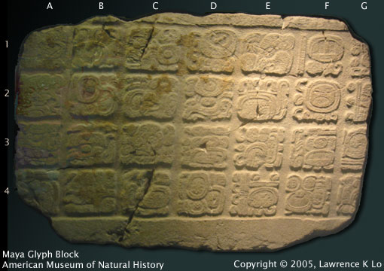
Mayan Glyph: The Mayans had the only fully developed language of the pre-Columbian cultures. Their writing system was the only system of the pre-Columbian New World that represented the language of the community, making it a complex and intricate system. The Mayans had hundreds of signs or glyphs that made up their writing system. These glyphs came in the forms of animals, humans, symbols and even abstract designs. The picture above is a Maya glyph block. Each square contains one to five glyphs often making an entire word or phrase within one block. These glyph blocks are not read as straightforward as it may seem. Maya glyph blocks are read in paired columns. The first block is on the top left, the second is to the right of the first block and the third is under the first block, the fourth under the second block. This means you read them in a zigzagging order. Using the number and letter system in the picture the reading order is A1, B1, A2, B2 until you hit the bottom and then you would start at C1 and continue in that pattern.

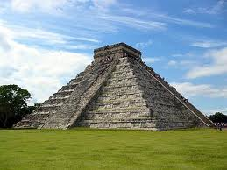

Mayan Pyramids: The ancient Mayans built pyramids for multiple purposes. Some pyramids were used for sacrificial rituals. During the rituals priests would climb the pyramid in order to be closer to the gods. In addition to their religious function, Mayan pyramids were also built to serve as landmarks for the Mayan people. Some pyramids were built so that their tops could be seen from the jungle, serving as point of reference for the people. These high pyramids also were meant to remind the people that the gods were always present in their lives. In the picture above, the Mayan pyramid, El Castillo, in Yucatan Mexico was used as a calendar. There are four stairways, each with 91 steps to make a total of 365, equal to the number of days in a calendar year. These complex pyramids served many purposes and displayed the complexity of the Mayan civilizations.

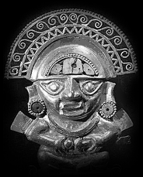

Inca Sun God, Inti: The Incas were polytheistic people and one of the most respected Gods is Inti, the God of Sun. Although there is little written record of the Inca civilization, oral records have been passed from generation to generation through the many centuries of their existence. Viracocha is the Inca God of creation, responsible for the creation of all things, including Inti. Inti was revered for his ability to enable life and was worshipped by farmers who relied on the sun for its production. Incan rulers were known as the “son of the sun” and Inti is celebrated each year at the Inti Raymi festival, the largest Inca religious event. During the festival, which is still held today, the people line up according to their tribe and give thanks to their creator, feasting on food that is provided by local priests.

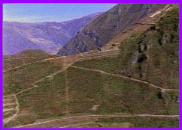
Inca Roads: The Inca road system was essential for the success of the empire. The Inca Empire stretched approximately 2,500 miles along the Andes mountain range and within this geography over 14,000 miles of roads were built. These intricate roads had great importance for the Inca people. The roads allowed for trade to occur and in turn the development of the Inca economy. They also linked forts and religious sites as well as aided in civilian and military communications. Without these skillfully built roads the Inca culture and empire would not have expanded so rapidly and become so strong.

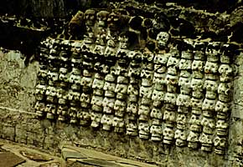

Sacrifice: The Aztecs, along with the Mayans and Inca’s all performed sacrifices of both humans and animals for various reasons. The Aztec Empire greatly honored their Gods and as a citizen it was ones duty to provide nourishment for the earth and the sun through the form of blood. They believed that in order to keep the sun on its course and prevent evil from taking over the world it was necessary to sacrifice a human. The human sacrifice was thought of as a messenger to the Gods and a way to feed them and keep them happy, putting them one step closer to the Gods. Sacrifice was very important during the agricultural seasons to ensure good crops. Temples were built to celebrate the offerings during a sacrifice and often the hearts of the human sacrifice were placed on the temples to offer up to the Gods. Templo Mayor, a temple located in today’s Mexico City, was a temple dedicated to the two most important Aztec Gods, Huitzilopoctli and Tlaloc. Atop the two temples is where the human sacrifice would occur. The temple was almost entirely destroyed by the Spaniards when they conquered their lands but the photo above displays some of the lost temple and skulls excavated in Mexico City in 1978.
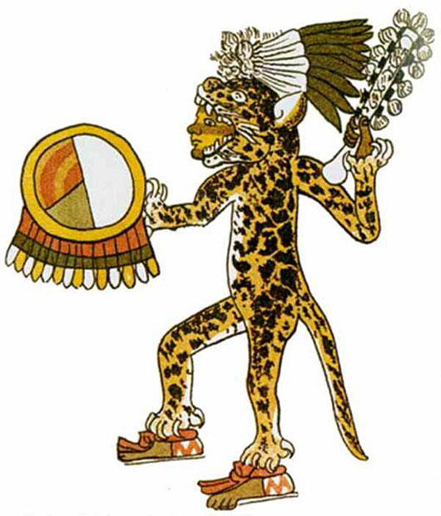

Aztec Warriors: Aztec Warriors were a major part of the Aztec culture and helped to expand and control the power and size of the Aztec Empire. The main purposes for these warriors were to take prisoners to sacrifice to the Gods, expand the size and power of the empire and protect the government. Both free citizens and noble people underwent military training and engaged in warfare; even new rulers were required to prove themselves in battle before stepping into leadership. The warriors had divisions within their military and each of these sections had different dress and duties. Two of the most well known Aztec warriors were the Eagle and Jaguar Warrior Societies. These men dressed as their animal counterparts and in order to be eligible to join the ranks of these warriors one had to capture at least four prisoners in battle. Another division of Aztec Warriors was The Shorn Ones. These warriors were considered the most prestigious in society, much like the Navy Seals are to the United States today. The Shorn Ones shaved their heads with one braid left over their left ear. Before entering battle The Shorn Ones took a vow to never move backwards during a battle and if they did their own men could kill them.

Resources:

Ancient scripts: maya. (1996). Retrieved from http://www.ancientscripts.com/maya.html

Aztec warriors. (2010). Retrieved from

http://www.ancientmilitary.com/aztec-warriors.htm

Aztec warriors. (n.d.). Retrieved from http://www.aztec-history.net/aztec_warrior

Aztec warriors. (2010). Retrieved from http://www.aztec-indians.com/aztec-warriors.html

Highway of an empire. (2011). Retrieved from

http://www.amnh.org/exhibitions/incaroad/

Inca civilization. (n.d.). Retrieved from

http://www.lost-civilizations.net/inca-civilization.html

Inca religion. (2009). Retrieved from http://mayaincaaztec.com/incareligion.html

Inti the sun god. (2006, June 22). Retrieved from

http://www.ancientsites.com/aw/Article/780496

Moore, C. (n.d.). Mayan pyramids. Retrieved from

https://www.courses.psu.edu/anth/anth008_cmg149/pyr.html

Sacrifice. (n.d.). Retrieved from http://www.plu.edu/~arnoldwp/sacrifice/home.html

The zocalo. (1997). Retrieved from

http://www.differentworld.com/mexico/areas/mexico-city/guide-zocalo.htm

