**Subject:**

Implementation of the South Slough Trail Master Plan adopted in 1990.

**Issue:**

The staff and the board of directors of the Friends of South Slough Inc. seek Commission approval to construct an over water pier, gangway and floating platform that is identified in the 1990 trail master plan. The structure will provide access to a tidewater channel at the base of the Estuary Study trail system.

**Background:**

In 2005 the Friends of South Slough (FOSS) embarked on a special initiative called *“FOSS Floats!”.* The goal of the *“FOSS Floats!”* initiative is to support and cultivate a more intimate understanding of estuaries by creating new opportunities to experience the water of the estuary first hand.

The partnership between the Friends of South Slough and the Reserve has accomplished two major *“FOSS Floats!”* projects since the initiative began. The first project involved designing, constructing and installing a 75’ long foot bridge across a tidal inlet at the base of the estuary study trail system at the Reserve. The most recent project of the *“FOSS Floats!”* initiative involved the purchase and donation of a 24’ long, 8 passenger canoe christened “Chmoosh” after a Native American term meaning *“floats with the tide”.*

The Friends of South Slough board of directors and SSNERR staff members worked during the past several months to outline the next two phases of the *“FOSS Floats!”* initiative. The projects include a blend of elements from the two previous *“FOSS Floats!”* projects and build on the experience gained by the Friends from the bridge and canoe projects. The boat shed project involves creating a floating platform that can serve as an educational waypoint along the South Slough Trail system, reflecting the longstanding relationships between people and estuaries;

The floating mobile boat shed structure is envisioned to mirror the design of the simple, log supported floating structures that served as dwellings and boat houses for people living on the shore of estuaries in the Pacific Northwest.

The newly built mobile boat shed structure will be moored alongside a floating dock/platform (see illustration above) at the base of the sloughside pilings on the Reserve’s estuary study trail system. Log flotation under the mobile boat shed structure will enable it to rise and fall alongside the floating dock/platform with the coming and going of the tides. The wooden decked exterior of the floating dock will be accessible to South Slough Visitors via a pier and gangway that span the tideflats between the shore and the floating structure and will provide 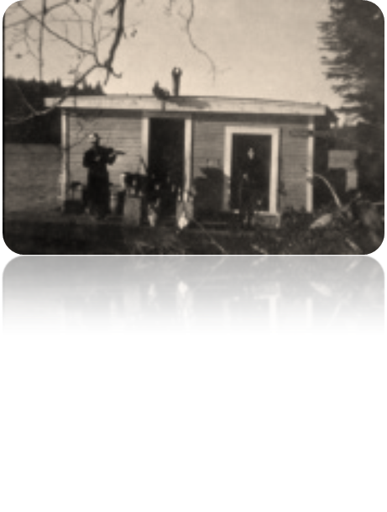visitors without boats with the first ever on-water access to the estuary in the Reserve.

A wood framed enclosed shed, sufficiently large to accommodate the 24”long canoe *“Chmoosh”*, other paddle craft, and associated paddle equipment will sit atop the mobile log float structure. The architecture of the mobile floating boat shed will reflect the simple, utilitarian designs and construction methods of former South Slough float houses. (See Photo at left)

On special occasions, the *“FOSS Floats!”* boat shed will be detached from the mooring at the dock and gangway in the South Slough and towed to other locations in the estuary; serving as a mobile interpretive center and iconic “flagship” of the South Slough Reserve. We envision moving the *“FOSS Floats!”* boat shed to downtown waterfront locations in Empire, Coos Bay, and North Bend for special events and festivals offering interpretive experiences for participants in those events to learn about their estuary.

**Staff Recommendation:**

The Commission should authorize the “FOSS Floats!” partnership to seek necessary permits to allow for the construction of the pier, gangway and floating dock structure outlined in the 1990 trail master plan for the Reserve.