Historiography Authentic Activities Assignment
Sarah Taylor and Lisa Dunham

Summary of Lesson:
This lesson would be included in part of a unit on government. This particular lesson will focus on the government of dictatorship, while other lessons within the unit would focus on governments like monarchies, theocracies, democracies, and overlapping categories. This lesson follows a lesson within the unit where students discovered that some governments have overlapping characteristics. For instance, the United Kingdom has the royal family (monarchy) but a constitutional monarchy in place (similar to a democracy).
In this lesson, students will learn about dictatorships through looking at historic and contemporary resources on the dictatorship of a particular country, North Korea, ultimately composing an essay that synthesizes research to create new conclusions. Students must use the sources given to determine, through the use of support, the type of government in North Korea.

Essential Unit Question(s):
- How do you determine the type of government used in a country?
- Can a country’s government be defined in multiple ways? Can governments have overlapping characteristics?

Objectives:
- Given historic and contemporary resources regarding North Korea, students will analyze these resources and their perspectives through the government handout to determine the type of government in place in North Korea, sharing their ideas through discussion with group members.
- Given historic and contemporary resources regarding North Korea, students will synthesize their understandings to compose an essay that meets the criteria outlined in the corresponding rubric.

OACS Content and CC Standards:
Grade: Six
Theme: Regions and People of the Eastern Hemisphere
Strand: Government
Topic: Civic Participation and Skills
Civic participation embraces the ideal that an individual actively engages in his or her community, state or nation for the common good. Students need to practice effective communication skills including negotiation, compromise and collaboration. Skills in accessing and analyzing information are essential for citizens in a democracy.
Content Statement: 9. Different perspectives on a topic can be obtained from a variety of historic and contemporary sources. Sources can be examined for accuracy.

Grade: Six
Theme: Regions and People of the Eastern Hemisphere
Strand: Government
Topic: Roles and Systems of Government
The purpose of government in the United States is to establish order, protect the rights of individuals and promote the common good. Governments may be organized in different ways and have limited or unlimited powers.
Content Statement: 10. Governments can be categorized as monarchies, theocracies, dictatorships or democracies, but categories may overlap and labels may not accurately represent how governments function. The extent of citizens’ liberties and responsibilities varies according to limits on governmental authority.

Common Core State Standards for Literacy in History
Reading Standard- Integration of Knowledge and Ideas:
9. Analyze the relationship between a primary and secondary source on the same topic
Writing Standards- Text Types and Purposes:
1. Write arguments focused on discipline-specific content.
a. Introduce claim(s) about a topic or issue, acknowledge and distinguish the claim(s) from alternate or opposing claims, and organize the reasons and evidence logically.
b. Support claim(s) with logical reasoning and relevant, accurate data and evidence that demonstrate an understanding of the topic or text, using credible sources.
c. Use words, phrases, and clauses to create cohesion and clarify the relationships among claim(s), counterclaims, reasons, and evidence.
d. Establish and maintain a formal style.
e. Provide a concluding statement or section that follows from and supports the information or explanation presented.

Information to Understand:
Japan annexed Korea in 1910. Upon the end of World War II, Korea was divided into two occupation zones, split upon the 38th parallel. The United States administered to South Korea and the Soviet Union North Korea. In December of 1945, a conference was held to determine the future of Korea. When a decision was unable to be reached, the United States asked the UN General Assembly to intervene. Due to the Cold War, a united Korea was not developed and instead, two separate nations were created in Korea. The UN oversaw elections in South Korea and the Republic of Korea (R.O.K.) was established. In the North, the Democratic People’s Republic of Korea (D.P.R.K.) was established and a leader who had been influenced by the Soviet Union was put in place. The Korean War (1950-1953), which began when battles took place and North Korea invaded South Korea, ended with an armistice agreement.
North Korea has a central government controlled by the communist Korean Workers’ Party (KWP). Minor political parties exist but lack real power. Kim Il-sung ruled North Korea from 1948-1994. Kim Jong-il took over from his father, Kim Il-sung, inheriting “supreme power” (U.S. Department of State, 2012). In December of 2011, Kim Jong-il died and power was passed to his son, Kim Jong-un, the current ruler of North Korea.
There are three entities of the North Korean government. A cabinet administers ministries and implements policies, the NDC is in charge of external and internal security and influences policy, and the Politburo of the Central People’s Committee is most in charge of making policy and “also plays a role as the dominant social institution in North Korea” (U.S. Department of State, 2012). The legislature of North Korea, the Supreme People’s Assembly (SPA), has elected members but “serves only to ratify decisions made by the ruling KWP [and] North Korea’s judiciary is ‘accountable’ to the SPA and the President” (U.S. Department of State, 2012). North Korea has often violated human rights, including: “torture and degrading treatment,...forced labor, public executions,...denial of the right of citizens to change their government, and suppression of workers’ rights. All sources of media...are controlled by the government and heavily censored” (U.S. Department of State, 2012). The official name of North Korea is: Democratic People’s Republic of Korea. The U.S. Department of State identifies the government of North Korea as a: highly centralized communist state. The Central Intelligence Agency further expands that the government is a: communist state one-man dictatorship.

Reference:
Central Intelligence Agency. (2012). Korea, North. The World Factbook. Retrieved from
https://www.cia.gov/library/publications/the-world-factbook/geos/kn.html
U.S. Department of State. (2012). Background Note: North Korea. Bureau of East Asian
and Pacific Affairs. Retrieved from http://www.state.gov/r/pa/ei/bgn/2792.htm

Resources Used in Lesson:
- Smart Board or projector system (to project opening question and government definitions)
- Map of North Korea
- Government handout and writing utensils for students
- Multiple sources from different perspectives regarding North Korea (see attachments for these sources and their individual references)
- Technology for students to record and print their writing
- Rubric for historiography essay assignment
- Exit slip handout

Introduction to the lesson (warm-up with teacher):
1. Students will enter the classroom and begin responding in writing to the following question, which should be projected on the screen/board. The teacher should also project a map of North Korea so students can see its location (see attachments near the end of this lesson).
- The official name of North Korea is: Democratic People’s Republic of Korea. Based on this name, what would you expect the government of North Korea to be like? Create a list of characteristics/ideas.
2. The teacher will allow students to discuss their answers within small groups and then with the entire class. The discussion will focus on what it means to be democratic. The teacher will ask the question:
- Does a name define the type of government a country uses? For instance, since North Korea is called the Democratic People’s Republic of Korea, does this mean their government absolutely fits our ideas of a democracy?
3. After discussing this idea, the teacher will present the lesson focus of the day: “Today, you will be analyzing several different sources from different perspectives about North Korea and its government. By the end of class today, you will write a historiography essay that compiles your analysis and synthesis of these sources, proving the type of government in North Korea and explaining the importance (or lack of importance) of a government’s title or name. This is an example of historiography. Historiography means: ‘the study of how history has been written and how social change has influenced the way that people perceive historical events’ (Ward, 2012). By analyzing various sources, you will see that certain concepts, like government, are open to interpretation and must be analyzed in light of perspective and bias. You will be analyzing sources of historical and contemporary importance about North Korea.”
Reference:
Ward, K. (2012). Using historiography to analyze the Mexican-American War.
Teachinghistory.org: National history education clearinghouse. Retrieved from
http://teachinghistory.org/best-practices/teaching-with-textbooks/20424

Lesson (guided practice and strategies also):
1. To begin the lesson, the teacher will remind students of the major types of governments. The following information should be projected on the screen for students to reference:
- In a democracy, the power of those in authority is limited because the people retain the supreme power.
- In a dictatorship, a ruler or small group with absolute power over the people holds power, often through force.
- Monarchy is a government in which authority over the people is retained through a tradition of allegiance.
- Theocracy is a government in which religious leaders who represent divine power and retain authority through religious beliefs hold authority over the people.
Reference for government definitions:
ODE. (2012). Sixth Grade content elaborations. OACS. Retrieved from
http://www.ode.state.oh.us/GD/Templates/Pages/ODE/ODEDetail.aspx?page=3&TopicRelationID=1706&ContentID=126270
2. The teacher should pass out copies of the sources students will use and the government handout, and explain the directions: “View the different sources provided on North Korea. Compare and contrast these sources. As you work, take notes within the government handout, writing notes beneath each form of government you see represented in North Korea in the sources. Don’t forget to answer the thinking questions below the chart to help you analyze these sources from a historiographical perspective.” Students should work in pairs or groups of 3.
3. The teacher should walk around the classroom as students work to monitor student understanding and correct misconceptions when discovered.
4. Once students have finished analyzing the sources and completing the government handout, the teacher should assemble the class again and explain the directions for the historiography essay. The teacher will introduce the rubric and criteria for this assignment, and students should complete the essay portion of this lesson, using their notes on the government handout and the sources to complete the essay. If technology is available, students should type their essays (1 per group/pair).

Closure:
1. Students should check their essays for grammatical errors, print their documents, and turn in their essays.
2. To debrief this lesson, students will engage in a whole class discussion on the following questions that relate to this assignment and the overall unit essential questions:
- How did you determine the type of government in North Korea?
- How did the history of North Korea influence your decision?
- Can a country’s government be defined in multiple ways? Can governments have overlapping characteristics?
- Why is it important to analyze a source based on perspective and bias?
3. Students will complete the exit slip to individually reflect on their understanding of the day’s lesson and turn this in before leaving class.

Assessments Used: Informal and formal assessment will be used in this lesson. The teacher should informally assess students by listening to their comments in whole class and group discussions, monitoring student answers (e.g., on the government handout and critical thinking questions), and generally observing student actions and thought processes. If the teacher sees that students hold misconceptions, some information may need retaught in small groups or to the whole class. Formally, students will write an essay (based on historiography) that will be assessed with the rubric for this assignment (see the end of this document for this rubric). Rubric criteria is based on the objectives and OACS and Common Core content for this lesson.

Differentiation and Additional Lesson Ideas: The teacher may group students according to their needs. For instance, two students who excel in this content may be paired together so that they may extend their knowledge, perhaps going beyond the assignment to find an additional source to prove their points in the essay. If time constraints exist or students are struggling with this content, the teacher should extend this lesson so that it takes place over 2 days instead of 1 lesson. For students with special needs, the teacher may need to provide a scribe or technology that allows students to talk as the computer records their essay into a Word document. To further ensure all students are involved in the synthesis of the resources, the teacher could add on to this assignment, perhaps asking groups to also create a visual representation of their conclusions and asking students to take on roles: one person could be the writer and another the artist if pairs of students are working together. If students lack the writing skills to form an argument, a writing lesson on argument writing may need taught and could provide an opportunity to connect to the language arts subject area.

Materials for Lesson:
Map of North Korea
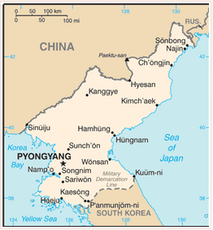
Reference:
Central Intelligence Agency. (2012). Korea, North. The World Factbook.
Retrieved from https://www.cia.gov/library/publications/the-world-factbook/geos/kn.html

Government Handout

Directions: As you view each of the different sources regarding North Korea, take notes in the chart below about the characteristics of the government. List democratic characteristics you discover in the democracy column, dictatorship characteristics in the dictatorship column, and so on. Be sure to answer the thinking questions as you work to ensure your critical analysis of these sources.

Democracy Characteristics:  - Power of authority is limited  - People retain supreme power | Dictatorship Characteristics:  - A ruler or small group holds absolute power over the people  - Force may be used to retain power  - Limits on citizen liberties | Monarchy Characteristics:  - Authority is held through a tradition of allegiance  - Typically involves the use of kings and queens with heirs receiving power | Theocracy Characteristics:  - Authority over the people is held by religious leaders  - Authority is held through religious beliefs

Thinking Questions:
1. Explain how at least 1 (if not more) of these sources demonstrates bias.

2. Compare and contrast the viewpoints of 2 of the different sources below in the Venn diagram. List characteristics that show the various perspectives represented.

Source: ____________________________ Source: ____________________________
3. Answer the following 2 questions using bullet points. These notes will become the basis for your essay.
Which type of government do you believe North Korea has? Defend your answer. | Why is it possible for a country to have characteristics of multiple types of government?
Reference for government definitions:
ODE. (2012). Sixth Grade content elaborations. OACS. Retrieved from
http://www.ode.state.oh.us/GD/Templates/Pages/ODE/ODEDetail.aspx?page=3&TopicRelationID=1706&ContentID=126270
Source 1
Summary: These posters were produced in North Korea by the government between 2000-2010 to represent the values of the country. In the third poster, Kim Jong-il, the father of the current ruler of North Korea and the previous ruler, is shown overseeing a movie production.
Reference: Lai, L. (2011). North Korean propaganda posters. ABC news. Retrieved from http://abcnews.go.com/blogs/headlines/2011/12/north-korean-propaganda-posters/

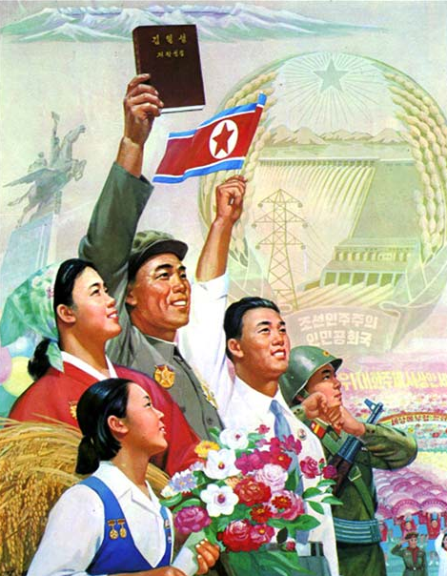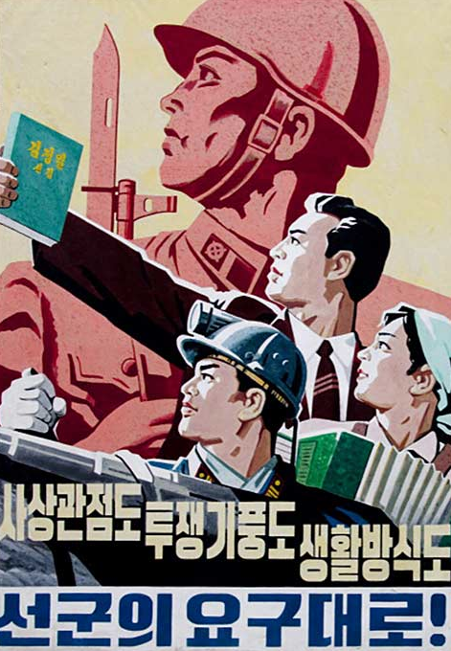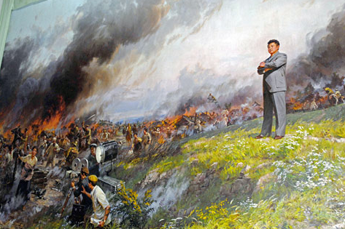

Source 2
Summary: This article is from the Korean Central News Agency. This article depicts views of the U.S. through a North Korean perspective.
Reference: Korean Central News Agency. (2012). Masterminds of terrorism bound to face punishment by history. Retrieved from www.kcna.kp/goHome.do?lang=eng

Excerpt(s): “It was recently disclosed that the United States and south Korea’s Lee Myung Bak regime let human dregs form a ‘statue demolition society’ in a bid to undermine the socialist system in the Democratic People’s Republic of Korea...But the DPRK army and people are advancing toward their final victory, rallied closer around the dear respected Kim Jong Un...The recently disclosed terrorist case aimed at demolition of statue fully revealed the true colors of the U.S., which had asserted it has no intention to antagonize the DPRK...However, such sinister plots will only harden the single-minded unity between the leader and people in the DPRK and fan up their hatred toward the anti-DPRK forces. The U.S., mastermind of terrorism, and the confrontation fanatics of south Korea are bound to face a stern punishment by history for their crimes.”

Source 3
Summary: This article, written from Seoul, South Korea, describes the transition of Kim Jong-un as leader of North Korea.
Reference: Sang-hun, C. (2012). To sell a new leader, North Korea finds a mirror is handy. The New York Times. Retrieved from http://www.nytimes.com/2012/02/02/world/asia/packaging-of-Kim-Jong-un-in-north-korea.html?_r=1&ref=kimjongun

Excerpt(s): “When Kim Jong-un made his debut as the North Korean heir apparent in September 2010, he looked so much like his grandfather, the closest thing North Koreans had to a god, that South Korean intelligence officials noted that many North Koreans who saw the young man for the first time on television broke down in tears...The packaging of Mr. Kim as the embodiment of the North’s widely revered founding president suggests that a well-oiled machine is at work to create a new leader. The strategy of having Mr. Kim assume his grandfather’s persona, and relying on nostalgia for the “Great Leader” to justify and consolidate his dynastic succession, reflects the slightness of the young leader’s own résumé, as well as the length of his grandfather’s and father’s shadows, under which he must rule. It also suggests a note of desperation among the nomenklatura, who know that their own privileged positions depend on the survival of the Kim dynasty. Whether it will work or not remains an open question...‘When North Koreans see Kim Jong-un, they think of Kim Il-sung when he was 33,’ said An Chan-il, a former North Korean Army officer. Mr. An, 57, was referring to 1945, when Kim Il-sung, a guerrilla leader fighting for Korean independence, entered Pyongyang at the end of Japanese colonial rule, casting himself as the smiling liberator. In reality, it was the Americans and the Soviets who liberated Korea from Japan and divided it between them...Kim Jong-il was a master propagandist who directed several movies. His last work may have been casting Kim Jong-un as a successor who inherited his father’s policy but his grandfather’s face. It was a role that Kim Jong-il knew he could never play. He indicated that his homely, pear-shaped looks were loathed by many North Koreans (he once called himself “an ugly midget”), according to South Koreans who met him...In the hybrid Stalinist-Confucian dynasty that his grandfather and father created, he is presented as having a divine right to rule because of his blood ties to Kim Il-sung.”

Source 4
Summary: These statistics are directly from a list of statistics about North Korea from the Central Intelligence Agency.
Reference: Central Intelligence Agency. (2012). Korea, North. The World Factbook. Retrieved from https://www.cia.gov/library/publications/the-world-factbook/geos/kn.html

Excerpt(s):
Government
- “Executive branch: chief of state: Kim Jong Un
- elections: last election held in September 2003
- election results: KIM Jong Il and KIM Yong Nam were only nominees for positions and ran unopposed
- Legislative branch: election results: ruling party approves a list of candidates who are elected without opposition; a token number of seats are reserved for minor parties
- Judicial branch: Central Court (judges are elected by the Supreme People’s Assembly)
- Political parties and leaders: major party- Korean Workers’ Party or KWP [KIM Jong Il]; minor parties- Chondoist Chongu Party [RYU Mi Yong] (under KWP control), Social Democratic Party [KIM Yong Dae] (under KWP control)”
Economy
- “no independent media; radios and TVs are pre-tuned to government stations; 4 government-owned TV stations; the Korean Workers’ Party owns and operates the Korean Central Broadcasting Station, and the state-run Voice of Korea operates an external broadcast service; the government prohibits listening to and jams foreign broadcasts”

Exit Slip
Briefly explain below how your understanding of government has changed or been enhanced after completing this historiography assignment. If your understanding has not changed or if you believe you hold confusion about this topic, please note this below instead.
________________________________________________________________________________________________________________________________________________________________________________________________________________________________________________________________________________________________

Rubric:

Historiography Essay Rubric

Directions: In essay format, defend the type of government you have decided is in place in North Korea using the sources (from various perspectives) provided. You do not need to support this government personally, just prove why the evidence suggests this is the type of government of North Korea. Explain why government systems are not easily categorized, including examples from your study of North Korea and other lessons within this unit. (This essay might be composed as 2 extensive paragraphs that transition to one another).

 | 5- Exemplary | 3- Acceptable | 1- Unacceptable | 0- Incomplete
Government  Argument | Essay accurately argues the form of government of North Korea and thoroughly defends this argument. | Essay accurately argues the form of government of North Korea and defends this argument. | Essay accurately identifies the form of government of North Korea but does not defend this topic. If government form is incorrectly identified, some logical support was included. | Essay incorrectly identifies the form of government in place in North Korea, and/or has an insufficient argument for the correct form of government, or is missing from the essay.
Government Characterization | The difficulty of characterizing a country’s government (due to overlapping features and characteristics) is thoroughly explained. | The difficulty of characterizing a country’s government (due to overlapping features and characteristics) is explained. | The difficulty of characterizing a country’s government is explained, though insufficiently or partially incorrect. | The difficulty of characterizing a country’s government is explained using incorrect information or is missing from the essay.
Synthesis of Sources | Multiple examples of support are used from various sources. Examples are from multiple perspectives and include references to this lesson and other lessons within this unit. | 2-3 examples of support are used. Examples are from multiple perspectives and may include references to only this lesson. | Little support is included throughout. | Sources are not used to defend the argument(s) made in this essay.
Writing | Essay is written in complete sentences and demonstrates an understanding of grammatical conventions. Writing is clear and understandable in terms of its structure and development. | Essay is written in complete sentences and mostly demonstrates an understanding of grammatical conventions. Writing is clear and understandable. | Essay is mostly written in complete sentences and somewhat demonstrates an understanding of grammatical conventions. Parts of the essay are difficult to understand. | Essay is incomplete and difficult to understand in terms of its structure and development.

