Antibiotic overuse: Stop the killing of beneficial bacteria
Martin Blaser
Nature 476, 393–394 (25 August 2011) doi:10.1038/476393a
Published online 24 August 2011
Concerns about antibiotics focus on bacterial resistance — but permanent changes to our protective flora could have more serious consequences, says Martin Blaser.
The average child in the United States and other developed countries has received 10–20 courses of antibiotics by the time he or she is 18 years old¹. In many respects, this is a life-saving development. The average US citizen born in 1940 was expected to live to the age of 63; a baby born today should reach 78, in part because of antibiotics. But the assumption that antibiotics are generally safe has fostered overuse and led to an increase in bacterial resistance to treatments.
Other, equally serious, long-term consequences of our love of antibiotics have received far less attention. Antibiotics kill the bacteria we do want, as well as those we don't. Early evidence from my lab and others hints that, sometimes, our friendly flora never fully recover. These long-term changes to the beneficial bacteria within people's bodies may even increase our susceptibility to infections and disease. Overuse of antibiotics could be fuelling the dramatic increase in conditions such as obesity, type 1 diabetes, inflammatory bowel disease, allergies and asthma, which have more than doubled in many populations (see graph).
We urgently need to investigate this possibility. And, even before we understand the full scope, there is action we should take.
Bacteria have lived in and on animals — constituting their microbiome — since multicellular life evolved about 1 billion years ago. Hosts derive many benefits from their bacterial guests2: the Bacteroides species that dwell in the colon synthesize our required vitamin K; gut bacteria help us to resist invading organisms.
An oral or injectable antibiotic diffuses through the bloodstream and affects targeted pathogen and residential microbiota alike. And evidence is accumulating that our welcome residents do not, in fact, recover completely³ or are replaced in the long term by resistant organisms⁴.
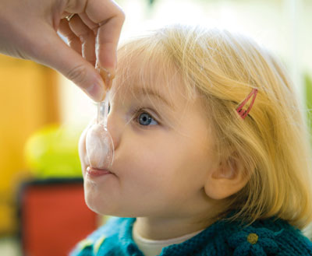
Ilustración 1. Dosed up: could excessive prescription of antibiotics be hampering children's ability to fight disease?

Collateral damage
In the early twentieth century, Helicobacter pylori was the dominant microbe in the stomachs of almost all people. By the turn of the twenty-first century, fewer than 6% of children in the United States, Sweden and Germany were carrying the organism. Other factors may be at play in this disappearance5, but antibiotics may be a culprit. For example, a single course of amoxicillin or a macrolide antibiotic, most commonly used to treat middle-ear or respiratory infections in children, may also eradicate H. pylori in 20–50% of cases.
In humans, eradicating H. pylori affects the regulation of two hormones produced in the stomach and involved in energy balance, ghrelin and leptin. And as H. pylori has disappeared from people's stomachs, there has been an increase in gastroesophageal reflux, and its attendant problems such as Barrett's oesophagus and oesophageal cancer. Could the trends be linked?
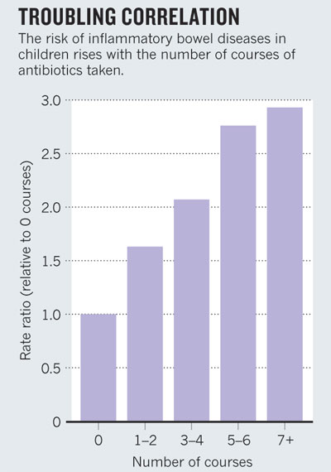
Ilustración 2. SOURCE: A. HVIID, H. SVANSTRÖM & M. FRISCH GUT60, 49–54; 2011
H. pylori is a risk factor for peptic ulcers and stomach cancer, but a microbe probably wouldn't have been so pervasive if it didn't carry some benefit to its host. Indeed, large studies we performed have found that people without the bacterium are more likely to develop asthma, hay fever or skin allergies in childhood6. Stomachs that lack H. pylori seem immunologically quite different from those that do not, and infection of young mice with H. pylori protects against experimental asthma⁷.
There is other evidence that antibiotics cause shifts in microbial composition that may bring long-term physiological changes. For instance, as farmers have discovered, continuous, sub-therapeutic doses of many different antibacterial agents cause animals to gain weight with less food. And the earlier that antibiotics are started, the more profound the effects. In my laboratory, we have preliminary evidence in a mouse model that changes in body fat and tissue composition are associated both with low-dose antibiotic treatment that mimics farm use, and with high-dose treatment similar to those used to treat childhood infections.
The changes in our microbiome may even be fuelling the transmission of deadly organisms such as methicillin-resistant Staphylococcus aureus⁵ and Clostridium difficile⁸. This is not an enormous surprise, because one of the important roles of an intact microbial ecosystem is to resist intrusions by pathogenic organisms.
To better understand the long-term effects of antibiotic use, we need to compare the microbiomes of antibiotic-using and antibiotic-free populations. We are working with Maria Gloria Dominguez Bello at the University of Puerto Rico in San Juan and her colleagues to study people living in remote regions in the Amazon who either have never received antibiotics or who have had very limited recent exposures.
If antibiotics do cause long-term physiological changes, we may not be able to wait until we fully understand the problem before changing our approaches. Knowledge gleaned from farms indicates that early life is most crucial, triggering physiological changes that are difficult to reverse later on.
Consequently, we should reduce the use of antibiotics during pregnancy and childhood. Antibiotics — particularly penicillins — are now given routinely to between one-third and one-half of all women during pregnancy or nearing childbirth in the United States and other developed countries. Babies acquire their founding bacterial populations from their mothers while passing through the vagina at birth. So each generation — particularly the 30% or so of infants born via Caesarian⁹ — could be beginning life with a smaller endowment of ancient microbes than the last⁵.
When antibiotics seem warranted — such as in the 30% of pregnant women with group B Streptococcus, which causes serious infection in about 1 in 200 newborns — we must better assess which mothers need to be treated, or whether a vaccine might be preferable.

Targeted attack
Another precautionary step would be to develop specific agents to stabilize at-risk residential microbial populations, such as effective probiotics. We also need new, narrow-spectrum antibacterial agents to minimize collateral effects on the microbiota. This is an admittedly huge task, which will require providing incentives for the pharmaceutical industry to develop targeted classes of antibacterial agents and, importantly, better diagnostics that rapidly identify the problematic agent.
We may also need to start replacing what has been lost over the past 70 years. Along with receiving standard vaccinations, for instance, one day, children whose microbiome has been genotyped could be given inoculations of specific strains of H. pylori to reduce their chance of later developing allergies or asthma, then receive narrow-spectrum antibiotics later in life to eliminate the bacterium and lower the risks of peptic ulceration and gastric cancer.
The ease of worldwide travel is increasing our global vulnerability to pathogens, just as our ancient microbial defences are eroding. We must make use of the available technology to protect and study our bacterial benefactors before it is too late.

References
- Sharland, M. J. Antimicrob. Chemoth. 60 (suppl. 1), i15–i26 (2007).
- Ley, R. E., Lozupone, C. A., Hamady, M., Knight, R. & Gordon, J. I. Nature Rev. Microbiol. 6, 776–788 (2008).
- Dethlefsen, L. & Relman, D. A. Proc. Natl Acad. Sci. USA 108 (suppl. 1), 4554–4561 (2011).
- Sjölund, M., Wreiber, K., Andersson, D. I., Blaser, M. J. & Engstrand, L. Ann. Intern. Med. 139, 483–487 (2003).
- Blaser, M. J. & Falkow, S. Nature Rev. Microbiol. 7, 887–894 (2009).
- Chen. Y. & Blaser, M. J. Arch. Intern. Med. 167, 821–827 (2007).
- Arnold, I. C. et al. J. Clin. Invest. 121, 3088–3093 (2011).
- Chang, J. Y. et al. J. Infect. Dis. 197, 435–438 (2008).
- Dominguez-Bello, M. G. et al. Proc. Natl Acad. Sci. USA 107, 11971–11975 (2010).

