Mystery Lesson – Consumer Reports
OACS
Standard: 6th Grade Social Studies
Strand: Economics
Topic: Financial Literacy
Content Statement: 16 – When selecting items to buy, individuals can compare the price and quality of available goods and services.
Standard: 6th Grade Social Studies
Strand: Economics
Topic: Economic Decision Making and Skills
Content Statement: 1 – The choices people make have both present and future consequences. The evaluation of choices is relative and may differ across individuals and societies.

Objectives
The students will be able to research and evaluate the value of products.

The students will be able to determine if a certain choice is better for someone or not.

Materials
Computers
Internet

Bike photo and information (in appendix)

Intro
Show students images of different products their parents or they might buy and have them write down in pairs how people decide how and what to buy. How can they make better choices? Why do some people make some choices that are not the best?

Lesson
Start off by giving each group of 4 students a folder with an image of a bicycle and information about the bike. Tell them that this is the bike that their friend’s parents want to get him for his birthday. His parents went to the local bicycle store and got the information about it last week and want your advice since you’re best friends. The question the students need to answer is, “Was this the best bike for their friend? If not, what should his parents buy and from where?”

Tell them that the parents have a price limit of $350. They need to think about if the bike store is the best place to buy this bike, if they think this bike is the best place to get it, and if this isn’t the best bike for their friend, what kind of bike would be better and where should the parents get the bike from?

Start off by giving students time to discuss if this is the best bike store to buy from. Instead of giving them clues, let them research online to answer this question.

Once they have evidence, they should “write a quick email to his parents” explaining why this is or is not the best place to buy the bike.

Now it’s time to explore some other options. Tell the kids to think about their friend and what they think he would like in a bike and explore some other options for his parents. Think about type of bike, features, etc. but also remind them to look within the price range and to look for options of where they can buy the bike to get the best value. However, don’t forget to remind them that they need to consider all factors and if the best-priced bike is shipped for $100 or is only at a shop in Montana, that they need to consider these factors.

At the end, students should create a report of their choosing (act out what they would say to parents, write a report, make a poster, write another email, etc.) to demonstrate that they were able to consider the variety of options and consider their friend’s point of view and his parents’ in their decision making.

Students will share their thoughts and hypotheses about the best bike and best place to buy it together as a class. They should be able to back up their opinions with data and evidence. Students will give feedback to each other on what they thought was good and what factors the group could have better considered.
Conclusion
After, students should do a self-reflection on the process. They should consider how they determined which bike was the best value (quality of bike versus price, location to pick up the bike, shipping and handling costs, used versus new, etc.), and how they determined which bike would be the best for their friend. They should consider what the hardest part was, what factors really helped them make a decision, how this process would be different if they were looking for a bike for themselves instead or for their little sister, and what they thought of the other groups’ hypotheses on the best purchase.

Appendix
Bike Information sheet (see next page)

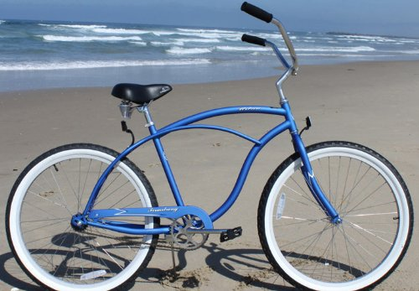
Bob’s Bike Shop
This bike is a single-speed bike that is great for cruising around the neighborhood, by the beach, or anywhere else when you are looking for a casual ride.
It fits most adult men 5’5” and taller, with a 19” frame and 26” wheels.
No worries about stopping with a hand brake – this bike comes equipped with simple reverse pedal braking. But just as easy is the coasting feature to allow for times when you want to stop pedaling and just enjoy the wind in your hair!
The seat has extra padding and springs for the ultimate comfort ride, along with the upright seating position.
Comes in a variety of colors!

Only $299.00!

Firmstrong Urban Man Single Speed Men's 26" Beach Cruiser Bike

