Yellow River Valley Civilization (Huang Ho/Huang He) – China

Standard: 6th Grade Social Studies
Strand: History
Topic: Early Civilizations
Content Statement: 2 – Early civilizations (India, Egypt, China and Mesopotamia) with unique governments, economic systems, social structures, religions, technologies and agricultural practices and products flourished as a result of favorable geographic characteristics. The cultural practices and products of these early civilizations can be used to help understand the Eastern Hemisphere today.
Standard: 6th Grade Social Studies
Strand: History
Topic: Historical Thinking and Skills
Content Statement: 1 – Events can be arranged in order of occurrence using the conventions of B.C. and A.D. or B.C.E. and C.E.
Standard: 6th Grade Social Studies
Strand: Geography
Topic: Human Systems
Content Statement: 6 – Variations among physical environments within the Eastern Hemisphere influence human activities. Human activities also alter the physical environment.
Standard: 6th Grade Social Studies
Strand: Geography
Topic: Spatial Thinking and Skills
Content Statement: 4 – Latitude and longitude can be used to identify absolute location.
Standard: 6^{-8th} Grade English Language Arts (Common Core)
Strand: History/Social Studies
Topic: Integration of Knowledge and Ideas
Content Statement: 6-8.8 – Distinguish among fact, opinion, and reasoned judgment in a text.
Standard: 6^{-8th} Grade English Language Arts (Common Core)
Strand: History/Social Studies
Topic: Integration of Knowledge and Ideas
Content Statement: 6-8.7 – Integrate visual information (e.g., in charts, graphs, photographs, videos, or maps) with other information in print and digital texts.
Standard: 6^{-8th} Grade English Language Arts (Common Core)
Strand: History/Social Studies
Topic: Craft and Structure
Content Statement: 6-8.4 – Determine the meaning of words and phrases as they are used in a text, including vocabulary specific to domains related to history/social studies.

Intro: Huang Ho/Huang He/ Yellow River – China
China is one of the oldest civilizations and has flourished for anywhere from 5-7,000 years. Much of the culture derived around the Yellow River, in northern China. This river is the second largest river in China, after the Yangtze, traveling almost 3,400 miles across China, starting to the west and flowing toward the east. Its name originates from its unique color caused by loess silt. Unfortunately, this river is also referred to as “China’s Sorrow” because of its constant flooding and rerouting that has resulted in the death of millions, damage to farms, and destruction of villages that need to be rebuilt almost annually in some places. This area is unique in its isolation, allowing for the development of a culture nearly uninfluenced by other cultures. To the southwest are mountain ranges, including the Himalayas, the Gobi Desert to the north, and the Pacific Ocean to the east. They called themselves “Zhong Guo” or “Middle Kingdom” because of this, believing to be the middle of the world.
Originally, small groups or tribes occupied areas near the Huang Ho/Huange He/Yellow River in China, due to fertile lands. In Neolithic China, there was some combining of groups and eventually a time considered the Age of Five Rulers, where the best candidate for ruler was bestowed with power. Around 2,000 B.C.E. was the beginning of a new type of rule, dynastic rule, where power was passed through families. There were three main dynasties that dominated early Chinese history, the Xia(Shia), Shang, and Zhou(Chou) dynasties. Most believed the Xia to be a legendary dynasty until recend archaeological findings showed otherwise. In the Zhou dynasty, a new idea was proposed, the idea of the Mandate of Heaven, where the gods would show disfavor for a ruler/ruling group with natural disasters. At this point, revolts and uprisings would occur and a new ruler would claim power, beginning a new dynasty. Despite the changing of hands of power, China still prospered in a variety of ways. They lay claim to many inventions and technological advancements, had a social system, though it changed with time, laid the foundations for many modern religions with ancestor worship and the introduction of influential thinkers and philosophies, and eventually opened up the Silk Road, opening their culture and ideas to the Western world.

Artifacts:
Government/Social Structures: Deck of Cards
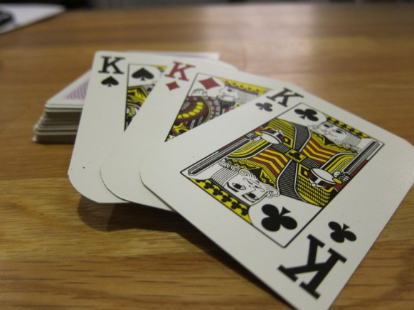
In China, men were dominant with women treated as inferiors. They were leaders and warriors and heads of families. A very important point about social structure is that family comes before the individual. Additionally, there was a hierarchy in society with upper and lower classes. The king/emperor was at the top, officials and military nobility would also be classified as upper class. Lower class citizens would be merchants, then farmers, and finally slaves. At different times in China’s history were different ruling families, or dynasties. This began early in China’s history, dating to about 2,000 B.C.E., where the Xia dynasty began. This has just been verified through evidence recently, but many people thought the Xia dynasty was just legend. The next dynasty was the Shang and then the Zhou. Passed from father to son, the dynasties lasted until problems arose and their power was usurped. In the Zhou dynasty, the idea of Mandate from Heaven became the dominant thinking, where the gods could demonstrate their disapproval with the ruling family with natural disasters and other problems. The dynasty would then be overthrown and a new dynasty would begin. In the Zhou dynasty also began feudalism, in which nobility shared power with the emperor and paid for land and titles. This lasted the majority of Chinese history.

Teaching Idea: The deck of cards represents the hierarchy of people in ancient China. To help students understand the idea of dynasties, cards can be given out and students who have the same suit (families) create a dynasty. The king is the highest in power and position. Each card type could represent a type of job or a specific person. Each “dynasty” can represent a real dynasty in ancient China and students can do research to learn more about what life during that time would be like for the different people during that time period. What would they be doing? What kinds of jobs are there? What kinds of technology would they experience? What things are happening in China? Students can brainstorm together and help each other research and then put together a book of journal entries, create a play, or make a movie about what life would be like.

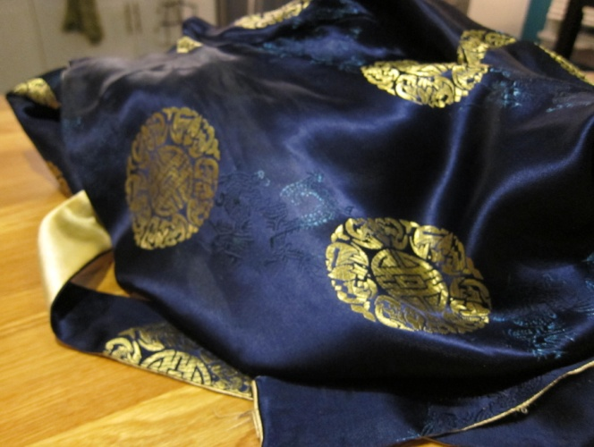
Economic System (+ movement): Silk Robe
China was very isolated in its early history, which did not give it the opportunity to trade with other people outside of China. Not too much is known about the economic systems of very early ancient China because of the lack of writing system. However, later goods were traded within China and eventually outside of China, with the creation of roadways. Northern China farmed more wheat while southern China farmed more rice. Aside from farming, mining was also an important industry in ancient China. Salt was one thing that was mined in China. Silk, cattle, iron, fish, and salt were items that were often traded internally in China. By the Ch’in dynasty, right after the Zhou dynasty, a standard system of weights and measurements was established. Silk became a major item traded, though it wasn’t the only thing. Gold was a prevalent traded item they imported from their trading along the Silk Road (multiple caravan routes and eventually sea routes). In as early as the Shang dynasty, people used cowrie shells as currency, which led to metal version of the shells, and finally metal beads instead. Eventually, by the Zhou dynasty, bronze coins were used. About 1,500 years later paper money began to be used.

Teaching Idea: Students can take roles as merchants on the Silk Road. The goal is to bring back new things to China. Some students will play the role of people in India, Greece, or others along the road; some students will play Chinese merchants. Also, some will be trading goods, some will be trading ideas, and some will be trading the bubonic plague (though talk about how this was much later in history but represents a major issue with breaking China’s isolation)and other illnesses only introduced through exposure to new people in new places. After role playing, students can come together and discuss in small groups. Why did different people have different things to share? What about where they lived affected what they were contributing? What effect did this have on the people of China? What effect did this have on people around the world? What was most important result in the opening of the Silk Road: new goods, new ideas, or new diseases? Why? What would China be like without the Silk Road.

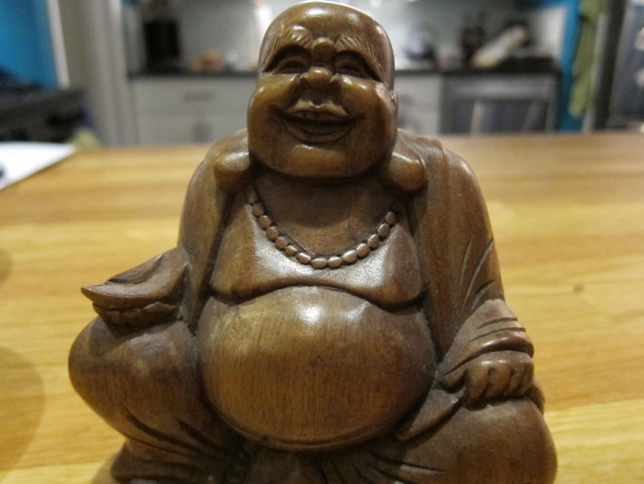
Religions (+ places and how humans relate to places): Buddha Figurine
Religion has changed in China, but mostly with the addition of beliefs and philosophies instead of the replacement of beliefs. Originally, many people believed in folk religions, specifically focusing on the appeasement of ancestral spirits. In the Shang dynasty (the first dynasty with a written history, dating back to around 1,700 B.C.E. to 1,100 B.C.E.), there was a common high deity known as Shang Ti, meaning “lord on high,” although there were other deities, making their religion polytheistic. Ancestor worship was the way to interact with and appease the gods, and by not appeasing one’s ancestors could result in natural disasters and general bad luck. Rulers would be buried in pit tombs, with many things they would need, including people who were sacrificed to be included in the tomb. Creation stories were not a major part of religion but instead were myths centered on humans dealing with challenges of life. For example, one leader, Yu, was said to have spoken to the gods and with the help of a dragon brought a special type of soil to help prevent the river from flooding. Further in history was the introduction of a great thinker, Confucius, and other philosophies, which led to Taoism and Confucianism, as well as the introduction of ideas leading to the practice of Buddhism, Christianity, and Islam.

Teaching Idea: This Buddha figure represents one religion that was introduced to China in the first century C.E. during the Han dynasty. This can lead to a discussion about how ancestor worship is still common and was the main form of religion starting back in early Chinese history. When a relative died, tablets were believed to house their spirits and were placed on an altar. Items that were needed to live a comfortable afterlife were placed at the alters to help make sure that the spirits were happy. To show that they understand what ancestor worship means, students can create a short history about a child living during that time, their family, the ancestors they worship, and what they might bring and why. What are the consequences? What do they worry about? What kinds of things would be relevant to bring and why?

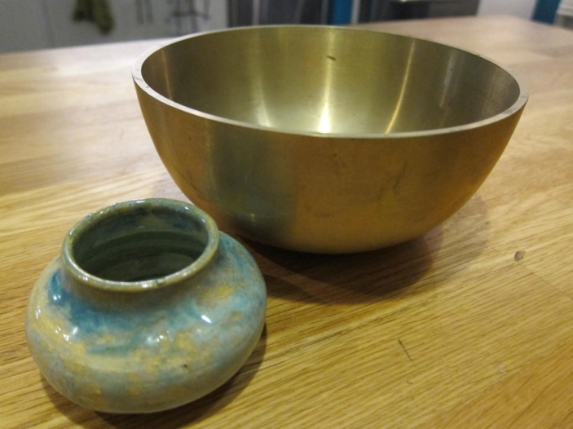
Technologies (Movement of ideas, goods, and people): Ceramic Bowl and “Bronze” Bowl
The ancient Chinese began developing technologically with the first pottery and tools made from stone or bones. Later, they created a writing system, which not only allowed for record keeping of the civilizations, but was a technological development in and of itself, which progressed from inscriptions on bronze and oracle bones to the complex writing system we see today. Early in China’s history they harnessed the power of metallurgy and began working extensively in bronze. So much so that the Shang dynasty was called “The Bronze Age.” Tools, artwork, chariots, and weapons were made in bronze. The chariot itself was an invention the Chinese created. Eventually iron was introduced in the Zhou dynasty and made for better tools/weapons/artwork/etc. The Chinese also can be credited for inventing paper, almost 1,000 years before it was seen elsewhere in the world, and the compass. Starting in the Zhou dynasty was the building of the Great Wall of China, to be renovated and enlarged in the Han Dynasty. In the Han dynasty porcelain and wheelbarrows were also invented. The Chinese also used silkworms to create silk fabrics for clothing and artwork. Aside from physical innovations, the early Chinese were masters of cosmology, studying the universe as a part of their religion. They created a calendar of 30 day months and a 360 day year. The list continues and is extensive, in part to the isolation from other cultures and needing to be self-reliant and because of the natural resources available where they were located. In the Han dynasty the Silk Road opened to allow for goods to be exchanged and traded, spreading Chinese technology to the world and obtaining new ideas, goods, and people to China.

Teaching Idea: Students can research technological advances made in ancient China and see which are still relevant today. They can create a song, poem, or commercial about what was created or what the early Chinese did to improve life, and connect it to: how the Chinese influenced other cultures then with the Silk road, how their technologies are related to what we see today in the world (How did their advancements help us created the things we have today and what Chinese culture use today?); and to how their resources they had available to them helped them create these improvements (What kinds of materials did they need or did they have? How could they use them or what did they have to create?).

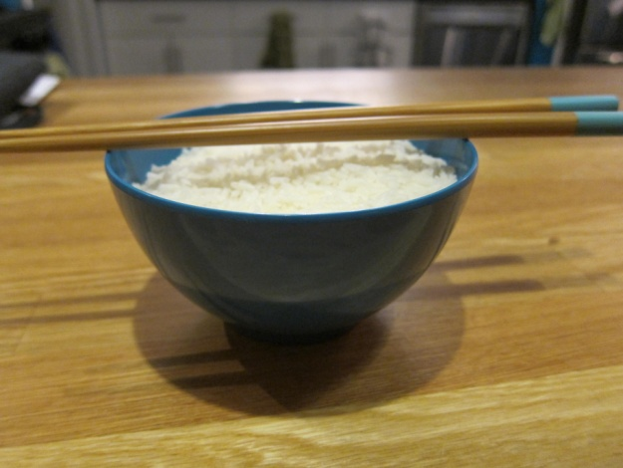
Agricultural Practices/Products (+ Places and Regions): Bowl of Rice
Though they still hunted and gathered, the Chinese used the fertile land near the banks of the Yellow river to farm. Early on, the early rulers and people chose plants that they wanted to farm. This included, but was not limited to, rice, millet, wheat, barley, chestnuts, and soy. They also domesticated animals like pigs, chickens, dogs, sheep, oxen, and silkworms. The use of irrigation was an early practice as well as flood control techniques. This was vital to their survival because the river, though slow flowing, would severely flood often and change its course, causing massive damages and deaths. Later this led to the use of hydraulics to dig riverbeds deeper to reduce flooding. Chinese farmers farmed for day to day food, not in mass harvests like we have in America, for example.

Teaching Idea: Students will create a pretend village on the river (drawing or modeling), finding a real location using latitude and longitude. They will compare what the climate is like to Ohio, based on its latitude and longitude (to help them see what it is like with a concrete example). Then, students will play the role of a son who wants to start his own farm after his poor father died (since ancient China was patriarchal). He is trying to convince someone to help give him money to start his farm. They will choose up to 3 crops from either personal research or information from the teacher that they will “grow” and explain in a letter to a benefactor why it would be a good crop for growing along the Yellow River (considering temperature, water needed, how often it can be harvested, rain amounts, natural habitat). They will then be introduced to a flood and have to adjust their model to show the devastation and write a letter to their benefactor explaining what happened and its consequence and what they plan to do next.

Geographic Characteristics (+regions): Water from the “Yellow River” in a Jar
Many Chinese people today recognize the importance of the Yellow River. It helped begin a civilization that has not only existed consistently but has prospered for anywhere from 5-7,000 years. Located in the north of China, this river extended from the west to the east, emptying into the Yellow Sea. This gave fertile lands available for people to farm successfully. China was also isolated from other places in the world that were developing because of mountains, steppes, deserts, and ocean. China had the unique situation to be virtually untouched by other cultures as it developed. This affected how it developed and changed.

Teaching Ideas: First, this should open a discussion with students in small groups to consider why this item would be important to people in China. What is good about it? What is bad about it? How can it be used? What do you notice about a lot of civilizations and where they originate in relation to this item? Are there any other important geographic considerations that help civilizations succeed? Students should use maps and research materials to identify important geographic features of China that would affect those living in the Yellow River valley. They can make an advertisement or a newspaper editorial article for China and why it’s the best place to live, as if they were people living in the Yellow River Valley and wanted to invite more people to live there. They should consider what they found in their research and even talk about some of the negative things that people might have to deal with.

Resources
Ancient China economy. (2010, March 29). Globerove.com. Retrieved July 14, 2013, from http://globerove.com/china/ancient-china-economy/2411
Ancient Chinese economy. (n.d.). Historyforkids.org. Retrieved July 14, 2013, from http://www.historyforkids.org/learn/china/economy/
Cassel, S. (2006). The Silk Road linking Asia, the Middle East, Northern Africa, and Europe as evident by the spread of the Black Death. Flamingnet.com. Retrieved July 14, 2013, from http://www.flamingnet.com/bookreviews/resources/essays_bookreviews/silk.cfm
China. (n.d.). Ancient Civilizations. Retrieved July 14, 2013, from http://www.ushistory.org/civ/9.asp
China silk. (n.d.). TravelChinaGuide.com. Retrieved July 14, 2013, from http://www.travelchinaguide.com/intro/arts/silk.htm
Chinese ancestor worship. (n.d.). Religionfacts.com. Retrieved July 14, 2013, from http://www.religionfacts.com/chinese_religion/practices/ancestor_worship.htm
Civilization: Ancient China. (n.d.). TimeMaps.com. Retrieved July 14, 2013, from http://www.timemaps.com/civilization/Ancient-China
Early river valley civilizations. (n.d.). old.clevelandstatecc.edu. Retrieved July 14, 2013, from http://old.clevelandstatecc.edu/courses/ngreenwood/history 1110/online_presentations/first_river_valley_civilizations.htm
Formation of the Chinese civilization. (n.d.). China.org.cn. Retrieved July 14, 2013, from http://www.china.org.cn/e-gudai/1.htm
Gill, N.S. (n.d.). Trade and economy in ancient China. Ancient China in pictures. Retrieved July 14, 2013, from http://ancienthistory.about.com/od/china/ss/082208china_5.htm
History of Chinese religion. (n.d.). Religionfacts.com. Retrieved July 14, 2013, from http://www.religionfacts.com/chinese_religion/history.htm
History timeline. (n.d.). History of China. Retrieved July 14, 2013, from http://www.chaos.umd.edu/history/time_line.html
McGill, S.A. (2002). Ancient China timeline. In Events of ancient civilization (p.51). Retrieved from http://blue.butler.edu/~jfmcgrat/china/timeline.htmPopov, I.V. (n.d.). Huang He. Britannica.com. Retrieved July 14, 2013, from http://www.britannica.com/EBchecked/topic/274303/Huang-He
Religions & beliefs in China. (n.d.). TravelChinaGuide.com. Retrieved July 14, 2013, from http://www.travelchinaguide.com/intro/religion/
Silk Road. (n.d.). TravelChinaGuide.com. Retrieved July 14, 2013, from http://www.travelchinaguide.com/silk-road/
The rise and spread of civilization in India and China, c. 2500 BC – AD 535. (n.d.). The University of North Carolina at Pembroke. Retrieved July 14, 2013, from http://www.uncp.edu/home/rwb/lecture_asian_civ.htm
Yangshao culture. (n.d.). TravelChinaGuide.com. Retrieved July 14, 2013, from http://www.travelchinaguide.com/intro/history/prehistoric/yangshao_culture.htm
Yellow River Valley Civilization. (n.d.). The River Valley Civilization Guide. Retrieved July 14, 2013, from http://www.rivervalleycivilizations.com/yellow.php
Yellow River Civilization. (n.d.). TravelChinaGuide.com. Retrieved July 14, 2013, from http://www.travelchinaguide.com/river/yellow/civilization.htm

