Huang Ho River: China
Grade Level: Sixth Grade
Topic: Early Civilizations
Strand: History
Content Statement: #2 – Early civilizations (India, Egypt, China, and Mesopotamia) with unique governments, economic systems, social structures, religions, technologies, and agricultural practices and products flourished as a result of favorable geographic characteristics. The cultural practices and products of these early civilizations can be used to help understand the Eastern Hemisphere today.

The ancient Chinese began settlements along the Huang Ho River, also known as the Yellow River. The settled here because they were able to transport things and communicate better. The first documented history of ancient China begins with the Shang dynasty, which is what I have focused on for this project. It is unclear when the Shang dynasty began but it is assumed to be between 1800 and 1000 BC. During this time period the Chinese discovered and produced silk and bronze. Their written language also began to develop, and their first writings have been found on animal bones and shells. It was also apparent that family was extremely important to the ancient Chinese and social rankings began to form. In my artifact box, I have represented each of the above things.

Huang Ho River
Artifact: Picture of the Huang Ho River
My Representation: “Yellow Silt”

The Huang Ho River is one of the longest rivers in
China, stretching for nearly 3,000 miles. In early
civilization the Huang Ho River caused several
problems for the Chinese. The river flooded often,
and would often times destroy whole villages. The
ancient Chinese were often rebuilding their
settlements. When the floods came so did the yellow silt, which was blown in from the desert. This silt would cover everything along with the water and cause issues with fertilization of the land. This is also where the river gets its nickname “The Yellow River.” When learning about The Huang Ho River and how it would affect the ancient Chinese I would show the students the yellow silt I have in my artifact box. Before teaching them how the silt affected the land and where it came from, I would have them brainstorm their beliefs to both.

Silk and Bronze
Artifact: Silk Material and a Bronze Pot
My Representation: Silk Tie and Bronze Metal

Discovering new things that you can create in any early
civilization would help one to live well and prosper by
contributing to society. During the Shang dynasty the
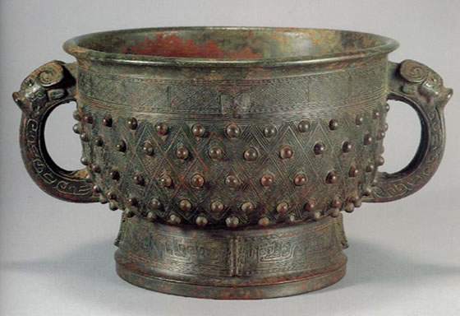
Chinese learned how to make silk cloth, which is one of
China’s greatest contributions to the world. They also
became very skilled in casting bronze. They created jugs,
chopsticks, vessels, statues, and much more out of bronze.
When learning about ancient contributions to society, I
would use these artifacts. I would show the students that this
is what the ancient Chinese contributed to society. Then,
they could decide if this would be something that would be a good contribution to our society today. After discussing this, the students would then think of things that they could contribute to society today that would be beneficial, and create an example.

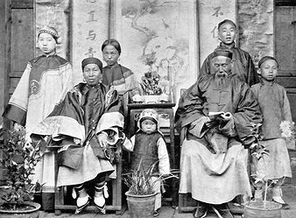
Family
Artifact: Ancient Chinese Family Portrait
My Representation: Picture of my family

In ancient China, family was very important.
The father is the head of the family, and has
authority over all other members. If there were
no father, than authority belonged to the oldest
male. The father or oldest male made all
decisions and controlled the property. Men
were superior to women regardless of age. Women were expected to obey all men, including their sons. If a family had any daughters, the father or oldest male would arrange their marriage for them as early as thirteen years old. When we discuss family traditions, values, etc. of the ancient Chinese I will bring in the picture of my family that I have in my box. I will then encourage to have the students bring in a portrait of their family and they can discuss the similarities and differences between an ancient Chinese family and their family today.
Social Pyramid
Artifact Picture of a Divided Pyramid
My Representation: Paper Pyramid

In ancient China, people were separated into one of
two categories. There were nobles, and peasants.
The nobles were the people who owned the land of
ancient China, and governed it as well. They were in
charge of the peasants. In fact, nobles owned
everything on their land, including the peasants
that worked for them. This makes peasants, very
similar to slaves in the early United States. Peasants
worked hard every day and could be sold or traded at any time. There was one more category that only one person could be a part of. The king ruled all of ancient China, and sat atop the social pyramid. When we talk about the social division of people in ancient China, I would have my students create a paper pyramid like the one I created in my box. Then would then divide it into sections based on how they think the classroom or school is ruled. This would help them see how people are viewed at different ranks in all types of places.

Language
Artifact: Picture of an Oracle Bone with Inscriptions
My Representation: A Dog Bone
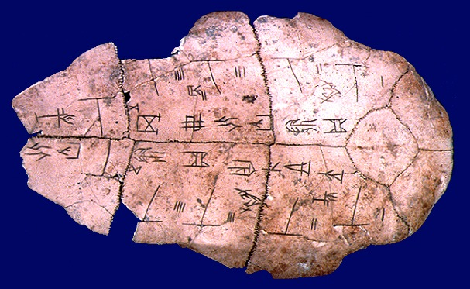
The Shang dynasty is the first recorded history
of ancient China. This is because this dynasty
lasted from approximately 1766-1122 BC, and
the form of writing they used was developed
around 2000 BC, shortly before this dynasty
began. The early Chinese used animal bones
and turtle shells to record their writings. In
ancient China these were used to keep records
and fortune telling. When we are learning about
ancient China and the language that developed, the students can use this dog bone and inscribe messages in it to see what it was like for the ancient Chinese to record data this way.

VIDEO LINK: http://www.youtube.com/watch?v=GCvEH4hZhAs
Resources:

Halsall, P. (n.d.). Retrieved from http://acc6.its.brooklyn.cuny.edu/~phalsall/texts/chinhist.html

History of china. (n.d.). Retrieved from http://www.historyworld.net/wrldhis/PlainTextHistories.asp?groupid=151&HistoryID=aa21>rack=pthc

N/A. (n.d.). Retrieved from http://www.rivervalleycivilizations.com/yellow.php

(n.d.). Retrieved from http://www.education.com/study-help/article/ancient-history-china-shang-dynasty/?page=2

Retrieved from http://www.slideshare.net/Gregman215/shang-dynasty-presentation

ushistory.org. (n.d.). Retrieved from http://www.ushistory.org/civ/9b.asp

