Joseph Breisch
TLT 403

How to remember the unit circle

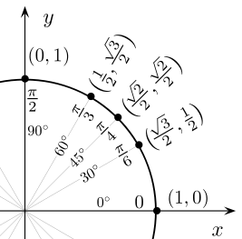

- Use your left hand. (Your index finger is your y axis and your thumb is your x axis) The L shape of the first quadrant is the same as the L with your index and thumb. images/visualization

- Every value is over 2. “Bottom” Ben ordered two tomatoes on Monday. acrostic mnemonics

- Every top value is always a square root because “The fans are high in the bleachers rooting for their team” associations/connections

- There are 5 spots you have to fill in on the unit circle. With your left hand put one finger down. The finger down refers to the location of the values(90°, 60°, 45°, 30°, and 0°). The number of fingers to the left is the numerator value under the square root in the “x” ordered pair(cos) value(x,y). The number of fingers to the right is the numerator value under the square root in the “y” ordered pair(sin) value(x,y). mnemonic

