Clinical signs of GI problems

The most common signs of digestive disorders are soft stools or diarrhea, some or all of the following signs may also be observed.
- Vomiting
- Regurgitation
- Flatulence
- Weakness
- Diarrhea/Constipation
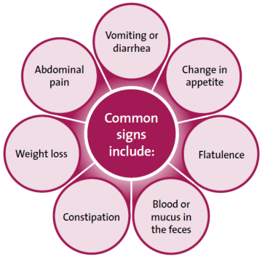
Chronic GI disease can be a debilitating problem and requires testing and a thorough diagnosis.

