**Bovine Iritis (Syn: "silage eye")**

Bovine iritis, colloquially known as "silage eye" in the UK, is a common cause of uveitis in cattle of all ages fed winter rations of baled silage/haylage.

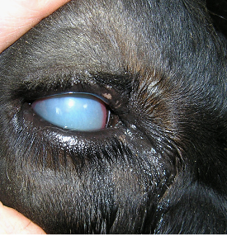

***Fig 5: With silage eye there is a bluish-white opacity of the surface of the eye within two to three days.***

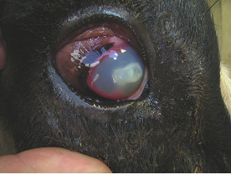

***Fig 6: Bulges often appear in the iris with white discolouration***

**Clinical presentation**

The initial presenting signs are excessive tear-staining, blinking and forced closure of the eyelids, and pain from direct sunlight. Within two to three days there is a bluish-white opacity of the surface of the eye (cornea). Regression of ocular lesions takes several weeks without treatment.

* excessive tear-staining, initially clear, becoming sticky and purulent
* blinking
* forced closure of the eyelids
* bluish-white opacity of the surface of the eye which can become yellow as pus develops
* Bulges in the iris, with white discolouration.
* Very painful particularly in direct sunlight

**Treatment**

There is a good response to combined subconjunctival injection of oxytetracycline and dexamethasone (2-3ml of 5 or 10% oxytetracycline mixed with 0.5-1ml soluble dexamethasone) in acute cases administered by the veterinary practitioner.

**Management/Prevention/Control measures**

Big-bale silage can be rolled out rather than placing in ring feeders to prevent cows burrowing their heads into the bale but this is impractical in most situations. Attention to detail when baling and wrapping silage and ensuring appropriate fermentation conditions should limit contamination with *L. monocytogenes* the cause of this problem. However, exposure to air for several days before the large bale is eventually eaten provides an ideal environment for *L. monocytogenes* multiplication.

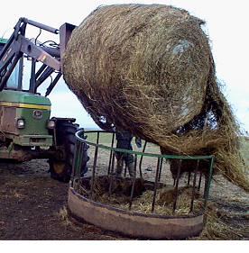

***Fig 7: Poor quality silage fed in ring feeders is the major risk factor for silage eye.***

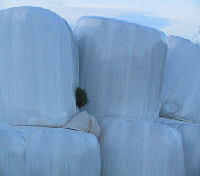

***Fig 8: Perforations to the plastic wrap should be repaired immediately.***