**Infectious Bovine Keratoconjunctivitis (IBK, "Pink eye", New Forest Disease")**

IBK is a highly contagious disease caused by *Moraxella bovis* that can spread rapidly during the summer months. It is more commonly seen in young stock than adults.

Head and nuisance flies can act as mechanical vectors for *M. bovis* and and dust can be a risk factor. The pain associated with this condition is more intense in strong sunlight.

Most cases are selected for treatment on the basis of obvious tear-staining of the face which becomes increasingly purulent matting the lashes and hair of the face. There is marked pain when the eye is exposed to direct sunlight. The ocular lesions are very painful and disrupt grazing patterns causing poor performance and even weight loss. Bilateral lesions cause temporary blindness and the affected animals tend to wander aimlessly about.

* tear-staining of the face
* pus matting the lashes and hair of the face
* conjunctivitis
* corneal ulceration
* pain when the eye is exposed to direct sunlight

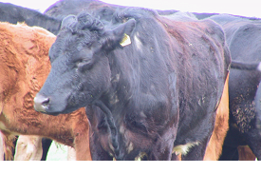

***Fig 1: IBK lesions are very painful and disrupt grazing patterns causing poor performance and even weight loss.***

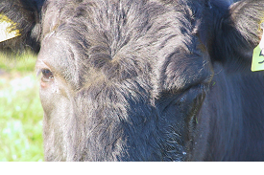

***Fig 2: There is marked pain when the eye is exposed to direct sunlight. Note the obvious tear-staining of the face.***

Spontaneous recovery may occur in mild cases three to five days after clinical signs are first observed, and is complete two weeks later. In severe cases, ulceration may progress to corneal perforation but this is uncommon.

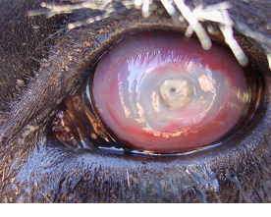

***Fig 3: Advanced case of IBK showing deep corneal ulceration***

The main differential diagnoses your veterinary practitioner will consider include

* foreign bodies (e.g. grass awns) within the conjunctival sac,
* bovine iritis
* infectious bovine rhinotracheitis (IBR).

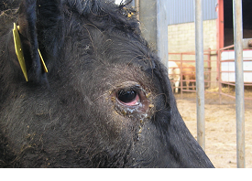

***Fig 4: IBR is one of the main differential diagnoses your veterinary practitioner will consider.***

Prompt treatment is essential. Topical ophthalmic antibiotic cream containing cloxacillin is commonly used. Antibiotic injection (penicillin, oxytetracycline or ceftiofur) into the dorsal bulbar conjunctiva is the best treatment but can be difficult to achieve in fractious cattle and requires good restraint. Injection into the upper palpebral conjunctiva is commonly used but it should be noted that this technique will not give residual antibiotic levels in the eye and relies on leakage onto the cornea from the injection site. This technique has no advantage over systemic injection except the much lower cost because of the smaller antibiotic dose.

When subconjunctival or topical treatment is not practical then single dose long acting oxytetracycline, florfenicol, tilmicosin or tulathromycin have all been reported to be effective but will prove expensive.

In severe cases suturing the eyelids together using mattress sutures can be undertaken under local anaesthesia together with an auriculopalpebral block. The sutures must not contact the cornea and are removed after - two weeks. Temporary adhesive eye patches can also be used to provide protection from environmental conditions. Severely affected cattle should be housed with ready access to food and water.

Metaphylactic injection of all at-risk cattle with a single intramuscular injection of long-acting oxytetracycline or tilmicosin could be considered in severe epidemics but there are no supporting field data.

**Management/Prevention/Control measures**

Outbreaks of IBK may occur after the introduction of purchased stock therefore, whenever possible, all new stock should be managed separately as one group away from the main herd. Fly control using ear tags and pour-on insecticides is never absolute and repeated treatments prove costly. Development of immunity following infection is variable.

* All new stock should be managed separately
* Fly control using ear tags and pour-on insecticides

Source: <http://www.nadis.org.uk/bulletins/eye-conditions-in-cattle.aspx>