**Resection & Anastomosis: Enterotomy technique**

**Procedure**

* Enter abdomen via a midline incision.
* Identify and exteriorize the affected segment of bowel, along with 15 to 20 cm of normal bowel orad and aborad to the segment to be resected.
* Use several layers of moist laparotomy sponges to isolate (“pack off ”) this bowel from the rest of the abdomen.
* Milk bowel contents away from the preposed sugery site.
* Place non-crushing sugery forceps (or have an assistant’s fingers) across the bowel to minimize spillage (and possible contamination of the sugery site).
* Make a full thickness stab incision into the lumen, incision enlarged with scisors
* Perform the enterotomy over healthy bowel distal to the foreign body
* Close the enterotomy incision with 3/0 or **4/0** (which is more commonly used) synthetic absorbable suture material or mono filament non-absorable suture material.
* Appositional suture pattern is performed as follows
  + A single-layer, snug, appositional suture technique is the preferred method.
  + Suture bites should be taken 2mm apart.
  + 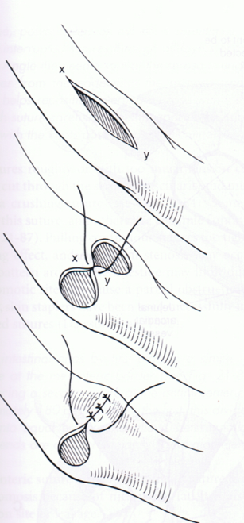This can be either an interrupted or continuous pattern, and it is essential that all bites engage the strength-holding layer, the submucosa, thus for safety all layers are incorporated.
  + Follow the guide as given in the photo below.
* Rinse the enteroctomy site throughly with warm saline
* Check for leakage by injecting sterile saline near the suture line and applying some force, leakage indicates an insufficiently closed suture line and can be corrected with a few simple interrupted sutures.
* Use of omentum or jejunal onlay patch to reinforce the suture line (even in relatively healthy tissue)
* Perform routine abdominal closure.