The General Examination
The general examination should start with the observation of the horse from a distance in order to detect abnormalities that might be obscured by handling and restraint. Horses' stance and general behavior in the stall will reflect their general mentation, which is frequently affected by systemic illness, neurologic disease, and pain in various organs (P). The respiratory rate and effort should be noted prior to handling, as well as a general evaluation of body condition (P).
Examining the horse from nose to tail along the left side and then tail to nose along the right side is one way of ensuring a complete general examination. Again, there are no strict rules regarding the proper physical examination procedures. It is recommended that a consistent approach be adopted. The mucous membranes are first examined by raising the upper lip as shown.
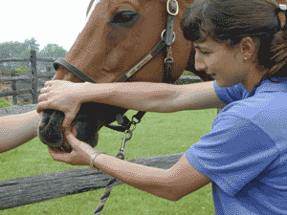
Mucous membranes are examined for moistness, icterus, hyperemia, cyanosis, pallor, ulceration, and petechia. Capillary refill time is also evaluated at this time by blanching the mucous membranes.
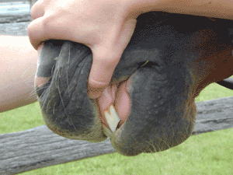
The tongue can also be grasped through the interdental space at this time to evaluate for oral ulceration (P). The sclera are then examined for icterus, petechia, vesicles, or injection by placing the thumb over the upper lid and grasping the bottom of the halter and rotating the horse's head away to expose the sclera .
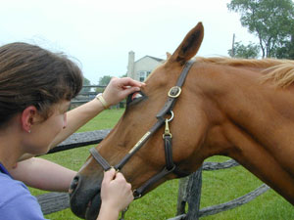 | 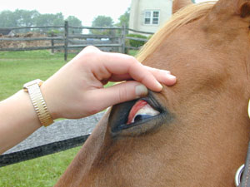
Although many horses do not like their ears touched, one can slowly and gently palpate the ear for temperature if there is a suspicion that the horse may be in cardiovascular shock and experiencing poor peripheral perfusion. The intramandibular space is then palpated for submandibular lymphadenopathy.
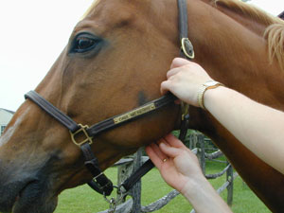
The retropharyngeal lymph nodes are not readily palpated in the normal animal but may be if enlarged. The facial artery is palpated at the ventral aspect of the mandible.
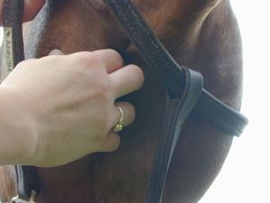
The thyroid gland is frequently palpable in older horses and should not be confused for a lymph node (P). The left jugular vein is then occluded and palpated to evaluate jugular fill and to examine for thrombophlebitis.
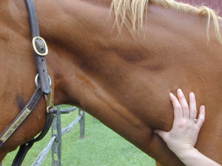
The heart is then ausculted in three locations on the left cranial ventral thorax: over the pulmonic, aortic, and mitral valves. The normal resting heart rate of the horse is 28-42 BPM. The hand is then run down the forelimb to evaluate temperature of the distal extremities if cardiovascular shock is a concern and also to palpate temperature of the hoof and evaluate digital pulses if laminitis is a concern.
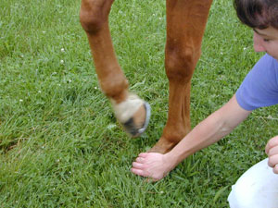 | 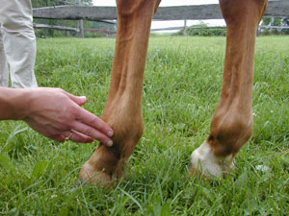
Firm, upward pressure is then placed on the ventral thorax on midline to evaluate for ventral edema.

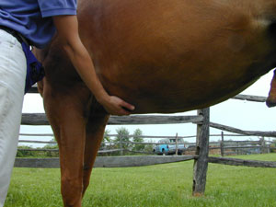
A discussion of auscultation of the thorax and abdomen is included in the focused examination of the respiratory and gastrointestinal tracts respectively. The inguinal area is then carefully palpated to evaluate testicles in stallions, scrotal remnants in geldings, and the mammary gland in mares. The distal hind limbs are visually inspected for joint effusion or distal limb edema. If edema is present, it should be determined if it is warm or painful to palpation. The tail is then carefully raised from the side and a thermometer is inserted in the rectum, noticing tail tone and anal reflexes.
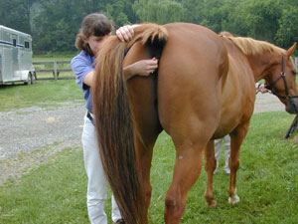
Most resting horses have rectal temperatures of 98.0°-101.5° F. Examination is then continued on the left side for visual inspection of the integument and auscultation of the abdomen and thorax, as noted in the focused physical examination. In the general examination, the right side of the heart is then ausculted, the right jugular vein is occluded, and the right side of the head and neck are visually examined. As one can see, this general physical examination can be easily performed in just a few minutes, yet it can provide important information that would otherwise be easily missed.

