Post Op Complications of Calf #196 at UWI Field Station
1 day Post op
RR= 88
T=40.5 degrees Celsius
HR=108
Wound site on scrotum was swollen and tissue was seen protruding out. The animal showed no signs of pain when scrotum was palpated. Supervising surgeon was consulted and advised the group to monitor the animal and to contact him if signs of infection were observed.
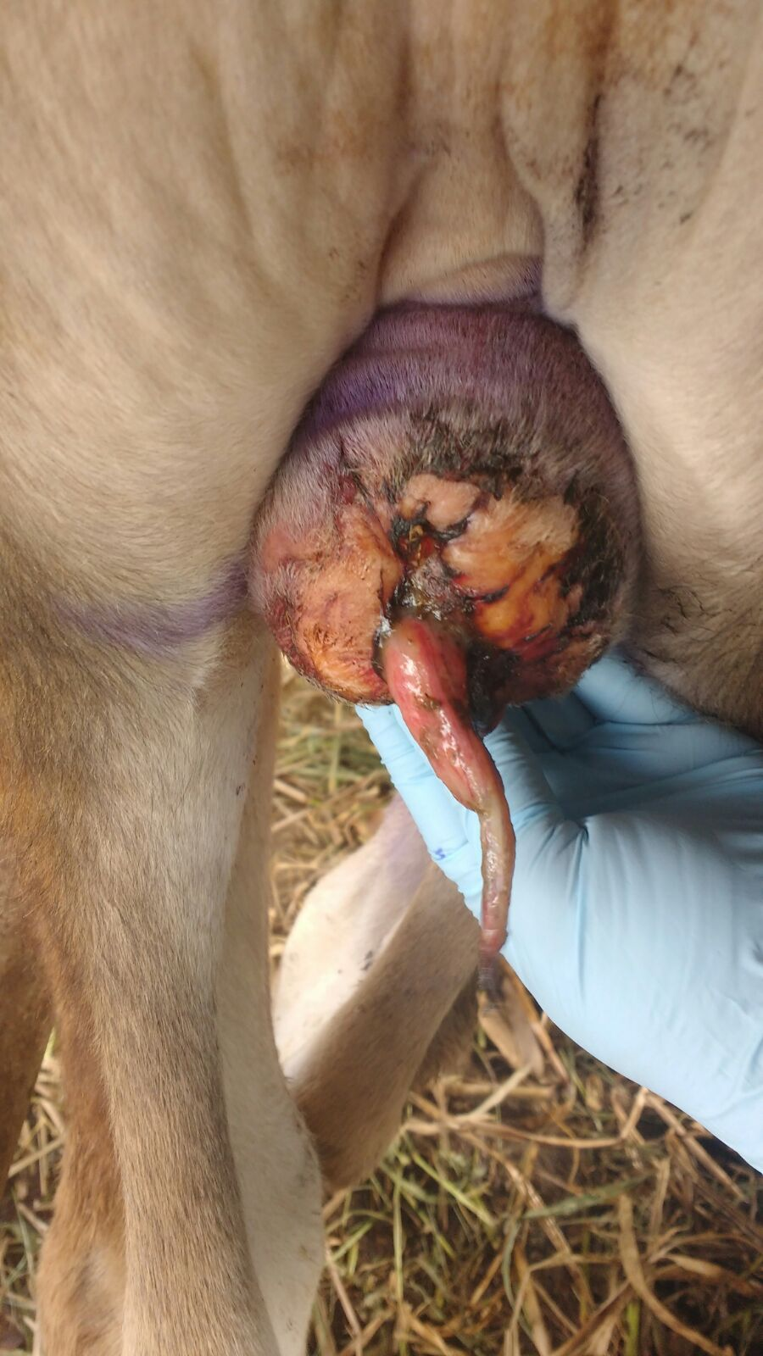
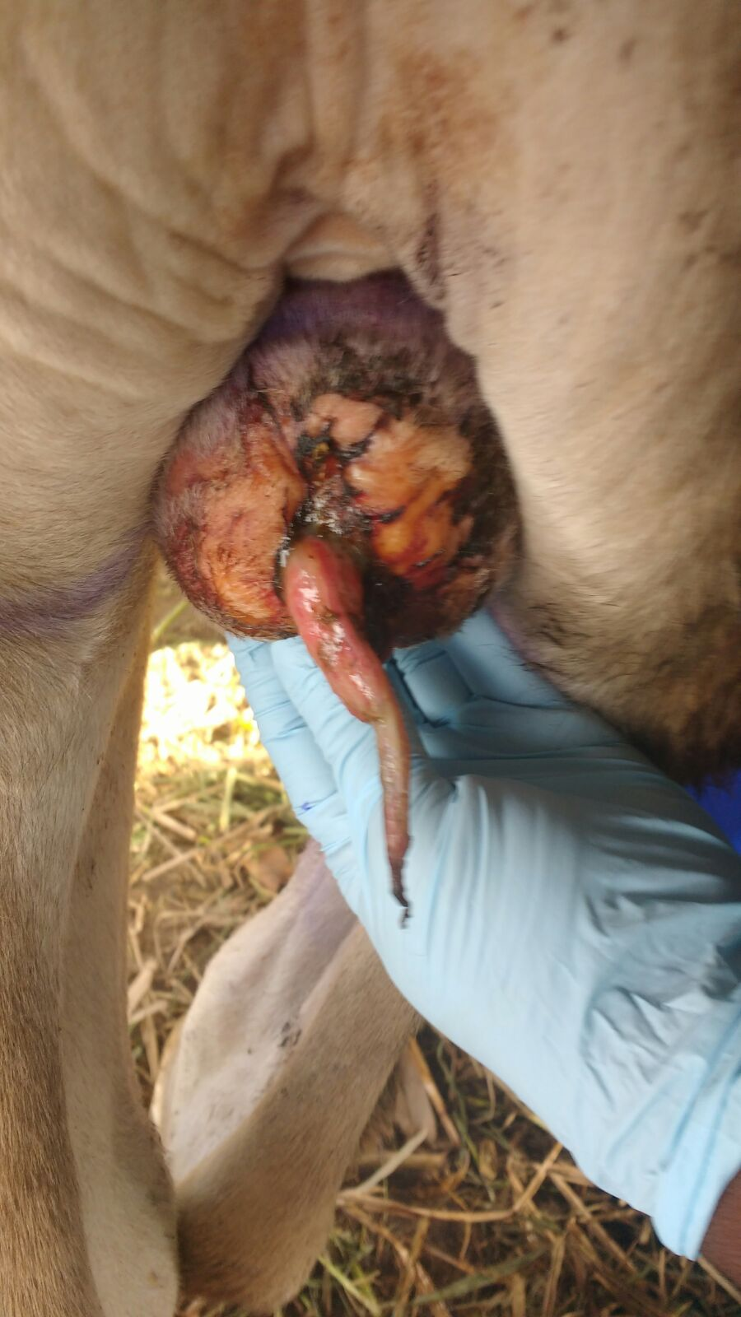

3 days post op
RR=88
T=40.5
HR=112
Protruding tissue had reduced in length and showing signs of drying up nicely. There was no sign of infection. Swelling was reduced. Animal was BAR, and showed no reluctance to move.
