WEANING

ANTI-SUCKLING DEVICE

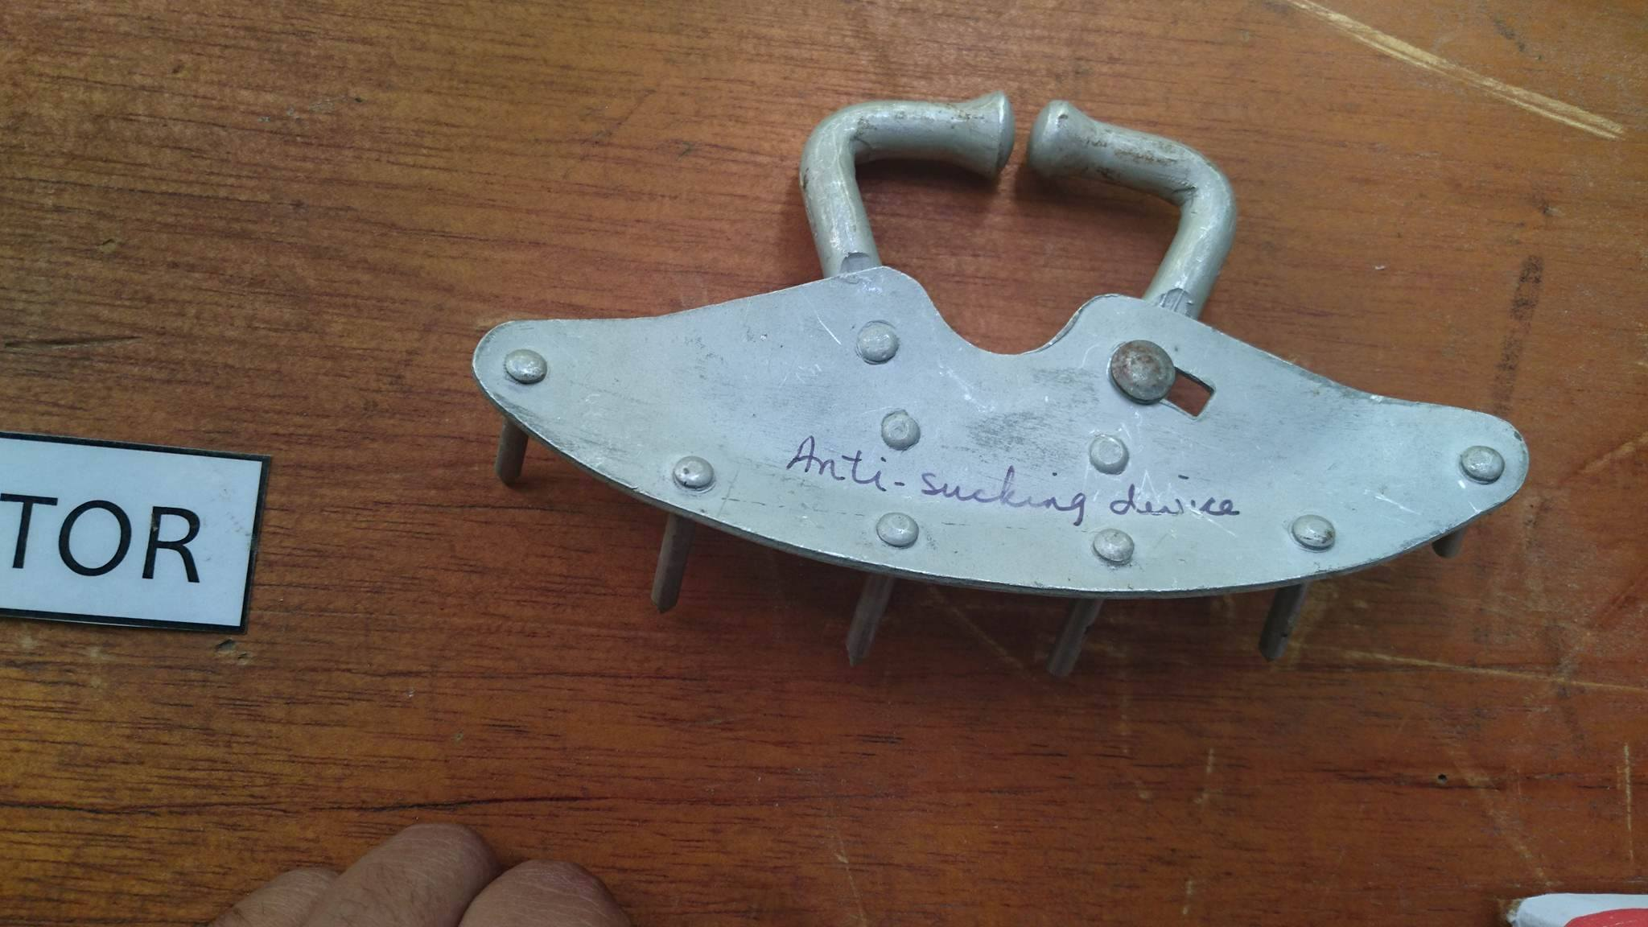

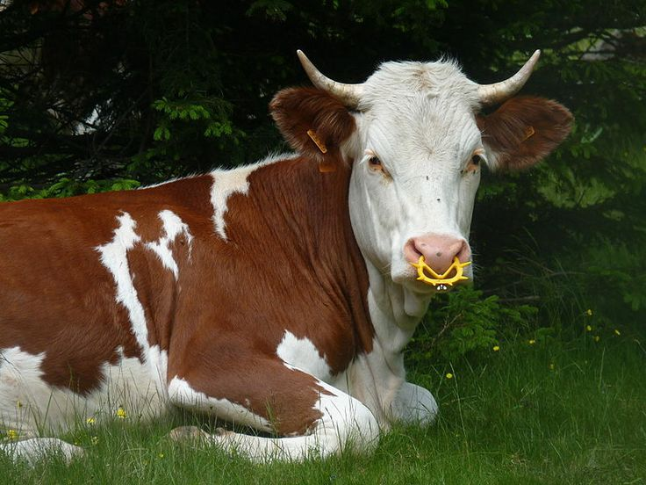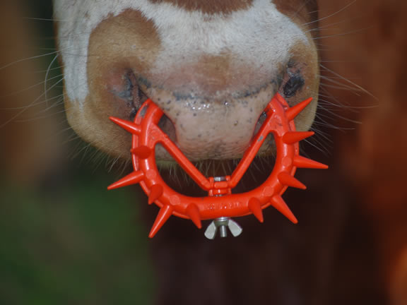

**USE:** A flap that attaches to the nostrils of the calf so that the calf cannot get the teat into its mouth to nurse. This device prevents calves from suckling but allow them to graze and drink.

**BENEFIT:** Prevents calves from nursing while allowing the calf and cow to remain together.

**APPLICATION:** <https://www.youtube.com/watch?v=1K7Mzd1RAc4>

**PUBLICATION ON TWO STAGE WEANING:** <http://aces.nmsu.edu/pubs/_circulars/CR648/welcome.html>