**DEHORNING AND DISBUDDING**

DEHORNER AND DISBUDDER

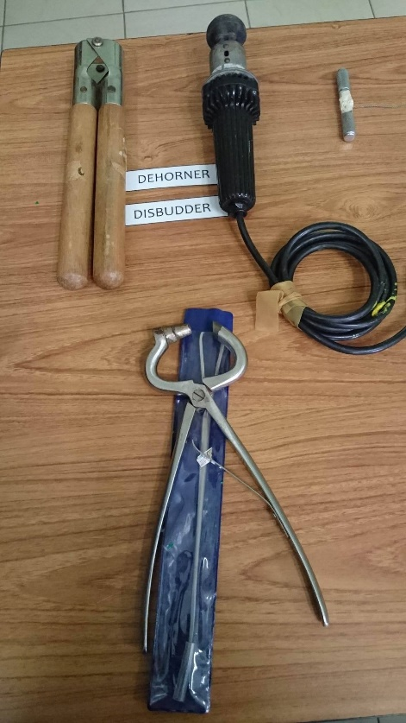

**USE:** To remove horns or to prevent their growth.

**USEFUL INFORMATION:** <http://www.thebeefsite.com/articles/2261/dehorning-of-calves/>

**APPLICATION**: <https://www.youtube.com/watch?v=x0o37E9bHGQ>

GIGLI WIRE AND HANDLES

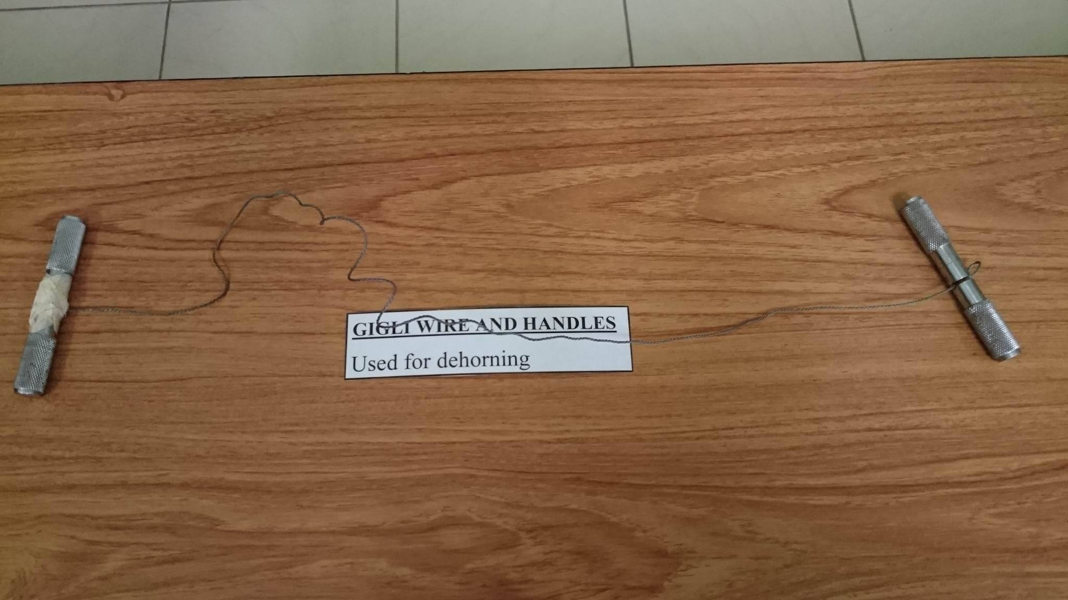

**USE:** To remove horns

**APPLICATION:** <https://www.youtube.com/watch?v=GxV35EZ1px4>