ELECTRIC CATTLE PROD, ROPE AND HALTER

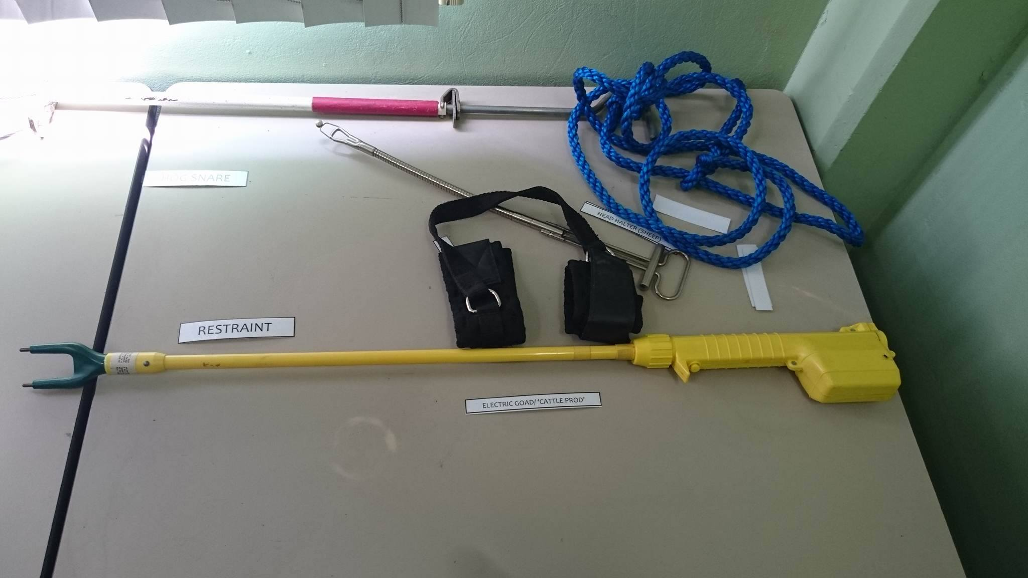

**USE:** Aids in proper restraint and control of animals. A cattle prod is used to make cattle move by receiving a ‘shock’ of electricity.

HOG SNARE

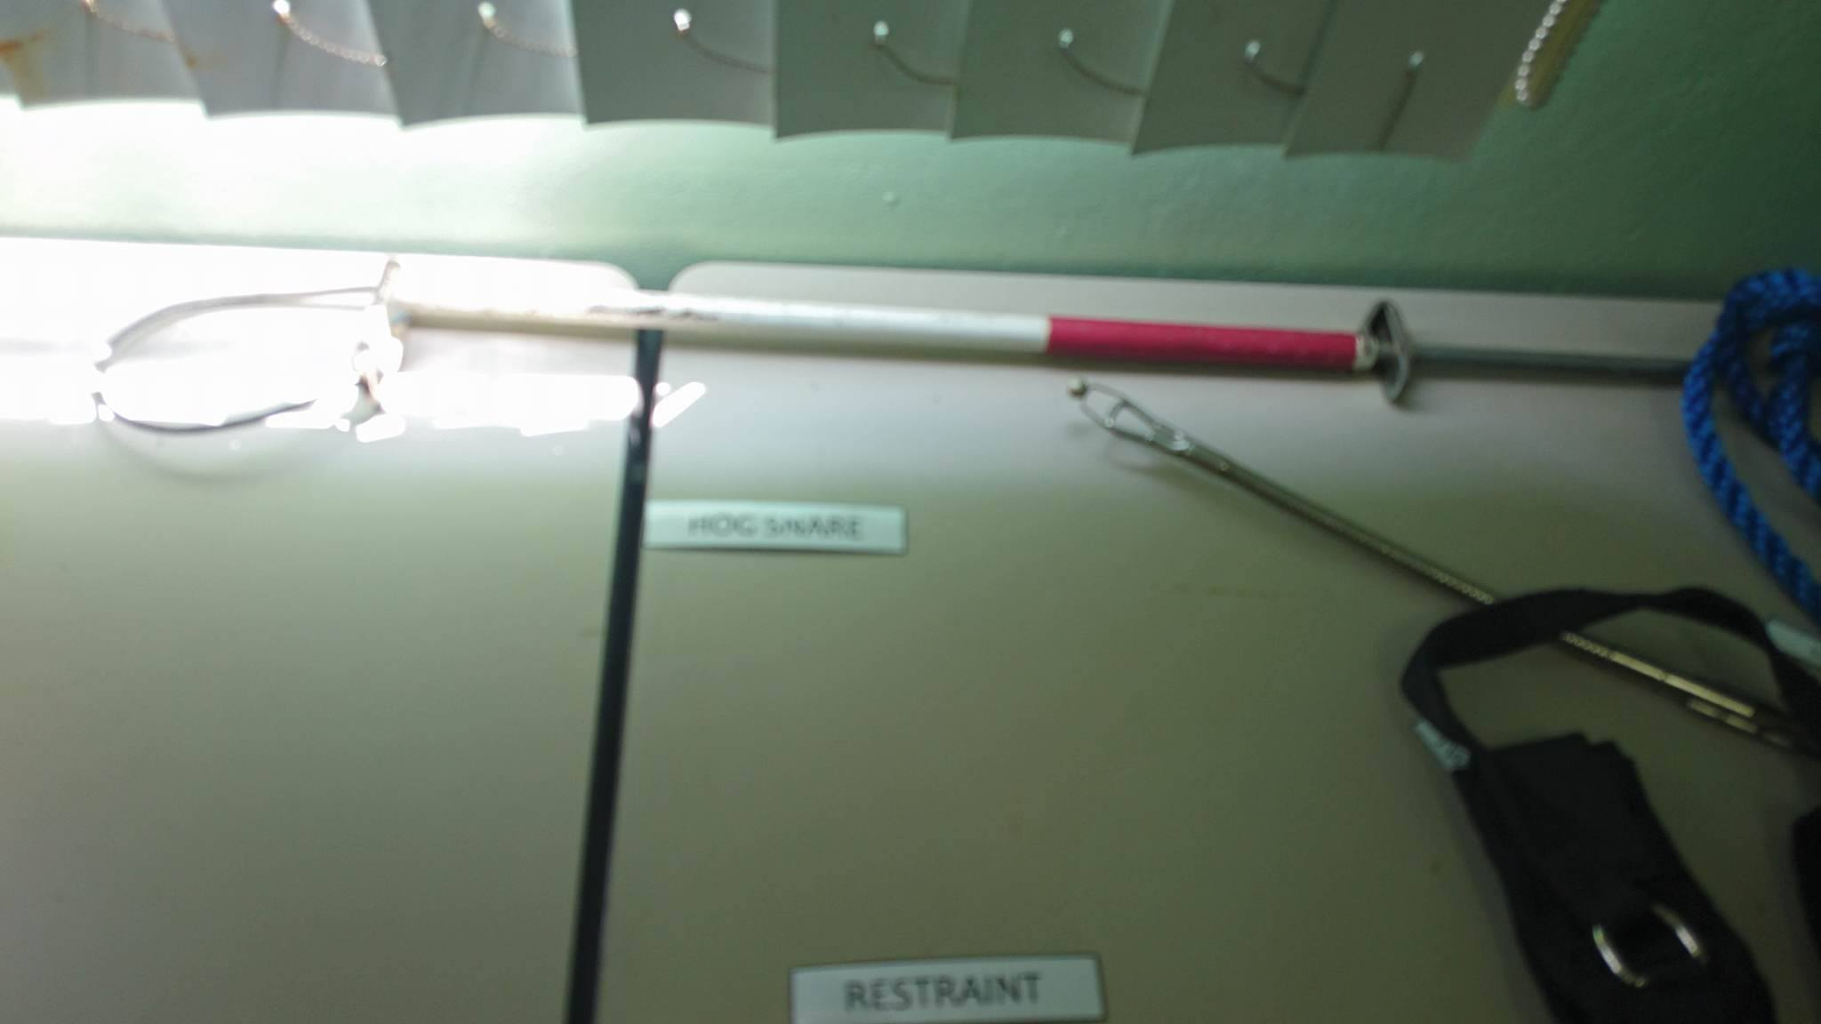

**USE:** A hog snare is placed onto a pig’s mouth behind the incisors. The snare acts as a halter and provides pressure to the snout when handling.

**APPLICATION:** <https://www.youtube.com/watch?v=FFYpJDjjmA4>

HAUSSEAN MOUTH GAG FOR HORSES

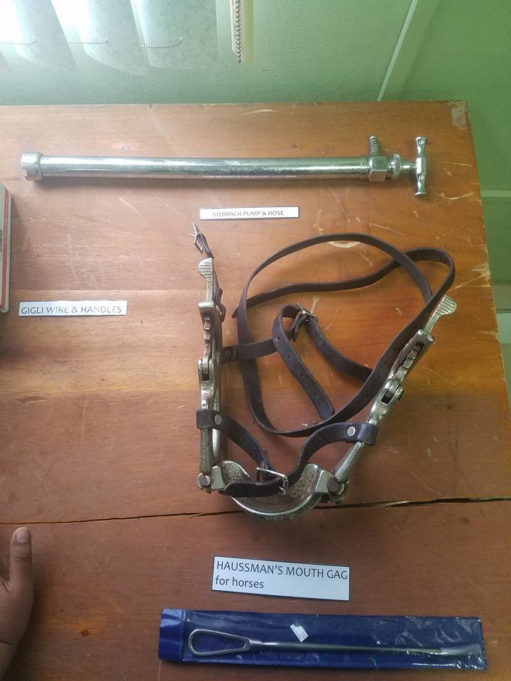

**USE:** In restraint of horses when oral examinations or procedures are disered to be done e.g. endoscopy, dental work