Common nerve block drugs used in horse | Picture of drug | Duration of action
2% Mepivacaine hydrochloride | 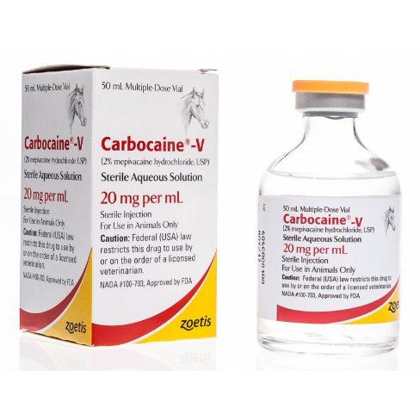 | 90 to 120 min
2 % Lidocaine | 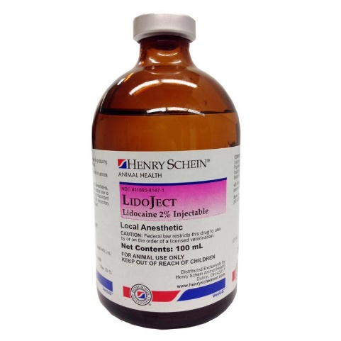 | 30 to 45 min
0.5% Bupivacaine | 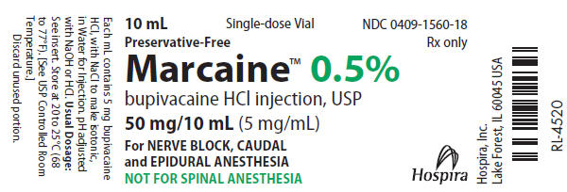 | 4-8 hours

