**POST OPERATIVE CARE FOLLOWING DEHORNING OF CATTLE**

Complications, after-care and advice to the farmer:

* Haemorrhage- this is the most common complication of dehorning. If bleeding persists, the source of the bleeding must be found and ligated. To give the clot a matrix on which to form, padding like cotton can be pressed on the wound and left until it falls off. Dressings should be avoided as they may irritate the sinus and delay wound healing.
* Infection (often *A. pyogenes*)
* Serious complication although rare if correct technique is used.
* Clinical signs that the farmer should observe the animals for:
* Febrile
* Lethargy
* Inappetent
* Malodorous discharge from the site
* Fever
* Foul smelling nasal discharge
* Extending the head forward and tilting the head slightly toward the affected side (if unilateral)
* If chronic, clinical signs include:
* Swelling of the frontal bone in the region of the post orbital diverticulum
* Occasionally exophthalmos, usually unilateral
* Possible central nervous system disturbances in both acute and chronic sinusitis and empyema syndromes
* To prevent infection, systemic antibiotics was given (PenStrep) as well as topical application of nitrofurazone and oxytetracycline spray and continued until the wound was healed

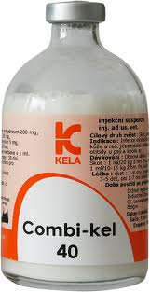 **PenStrep (Anti-Biotic)**

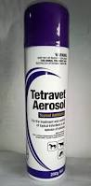**Antibiotic (Oxytetracycline) Spray**

* Treatment of this condition includes Trephination of the frontal sinus as explained below:

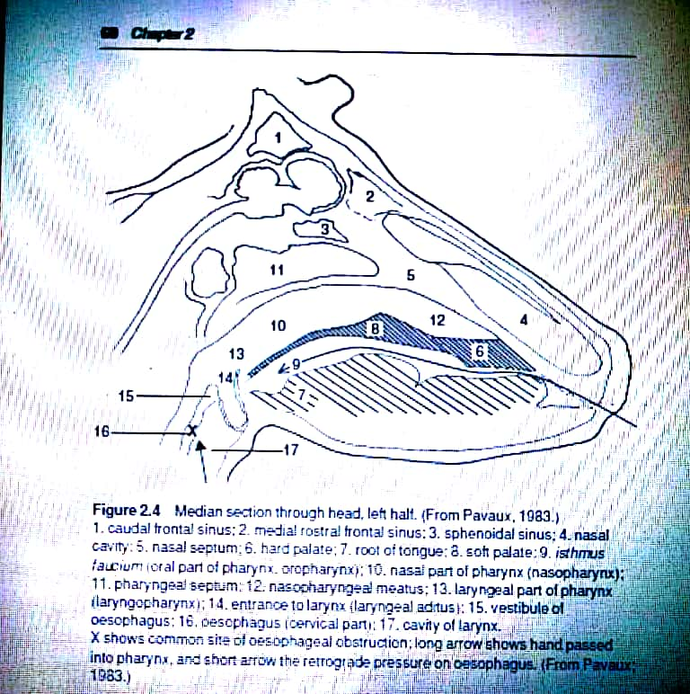

**The above diagram shows the anatomy of the sinuses in cattle**

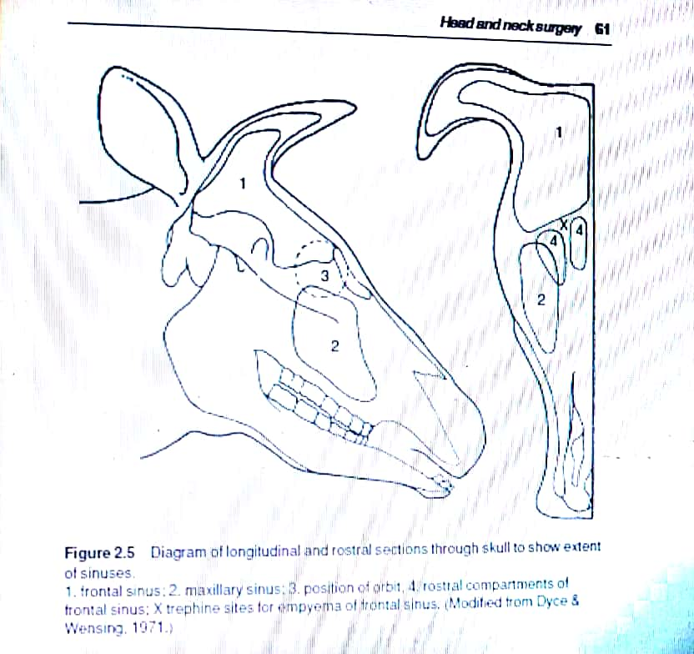

**The above diagram shows the Trephination site for empyema of the frontal sinus**

* Technique:
* Restrain animal adequately in crush/ chute and give sedative
* Clip hair around horn base and over whole frontal region, cleanse and disinfect
* Produce local analgesia by supra-orbital block or infiltration over site of proposed trephine opening (5 cm dorsal to the line joining the 2 supra-orbital processes and about 5cm from the midline. Further landmark: 2-3cm abaxial at the level of the horizontal line joining the axial parts of both orbits. Sometimes a soft area of bone presents as a suitable site. Avoid the supraorbital foramen and vein)
* Remove circular area of skin, subcutaneous tissue and cutaneous muscle 3cm in diameter by scalpel and forceps
* Elevate periosteum with periosteal elevator and remove it with the scalpel
* Trephine bone over sinus using 2.5cm diameter Galt or Horsley pattern trephine
* Flush sinus cavity initially with warm water using enema pump then with hydrogen peroxide
* Insert enema pump to direct the mixture into the various compartments
* Continue irrigation through the horn sinus orifice
* Irrigate finally with dilute chlorhexidine hydrochloride solution, flushing from top to bottom
* The wound usually heals in 3-4 weeks
* Parenteral broad-spectrum antibiotics for 5-10 days is indicated in animals with systemic signs
* Prognosis favourable (acute) to guarded (chronic)
* Complications:
* In consideration of the possible safe sites of trephination, note that the site for euthanasia using a captive bolt gun is midline at the junction of diagonal lines joining the medial canthus of the orbit to the ventral border of the opposite horn base
* Myiasis- Screw worm spray was applied topically at the site as well as Silver sulfadiazine which act as a larvicide
* Fractured skull- To prevent this from occurring all equipment must be sharpened thoroughly before use
* Regrowth of scurs- Scurs can regrow when horn-producing cells are left at the site. This can be eliminated by burning all the cells adjacent to the horns thoroughly
* Side effects caused by inadvertent IV injection of analgesic solution in young calves (excessive salivation, mild ataxia and temporary collapse)
* Tetanus- Tetanus can affect cattle as well as goats and sheep. However, goats are more prone to getting tetanus hence a tetanus antitoxin should be administered before and procedure in goats.
* For disbudding- the only complication is the regrowth of scurs
* In small ruminant, complications include overdosing with anaesthetic since it involves 4 nerve blocks in which the anaesthetic must be diluted

Resources used in this document includes:

