Lateral abdominal wall in Male Pig

In this case the hernial ring was under the prepuce

1. A 4-6cm straight line incision was made between the left lateral aspect of the nipple and prepuce using a scalpel

2. The peritoneum layer was reached using a curved scissors doing a blunt dissection. Some ligatures and clamps were used to stop excessive bleeding during this step. Also splash block of lidocane was used during incidences of the patient moving.

3. A small incision was made, and then a finger was inserted into the incision to feel around to establish the borders of the hernia

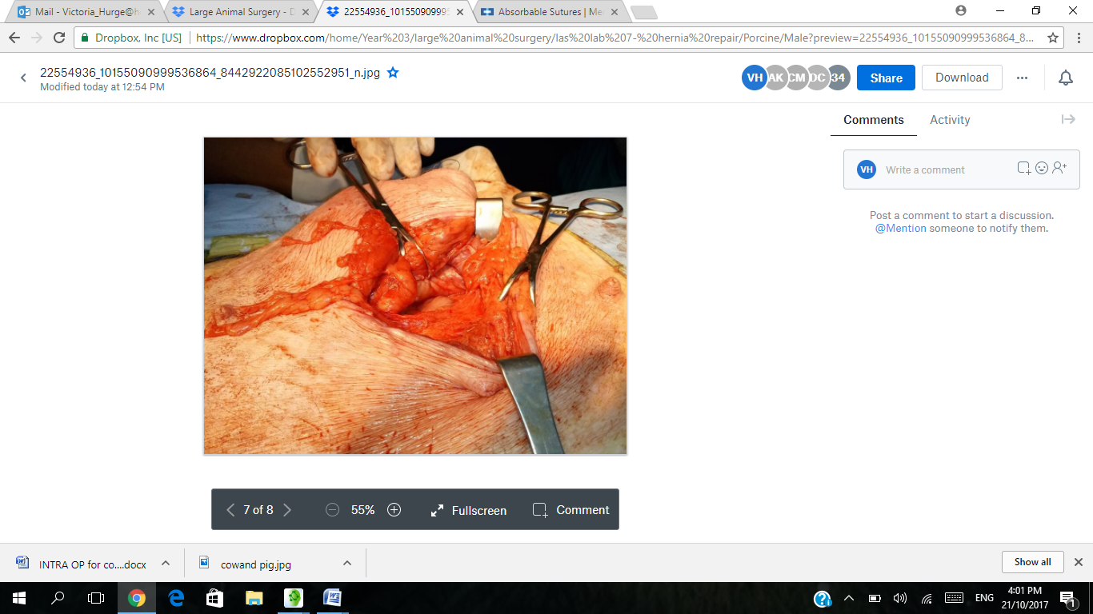*Pic 1 showing hernia ring*

4. Fat and muscle were moved out of the way and the hernia ring was identified

5. The hernia ring was closed up doing a vest over pants suture pattern on the muscular layer ( 5-6 sutures) using 2-0 Nylon Supraminde

6. The subcutaneous layer was closed with 2.0 lactomere polysorb doing simple continuous suture pattern.

7. The skin was closed with 2-0 Nylon Supraminde absorbable using crucitate suture

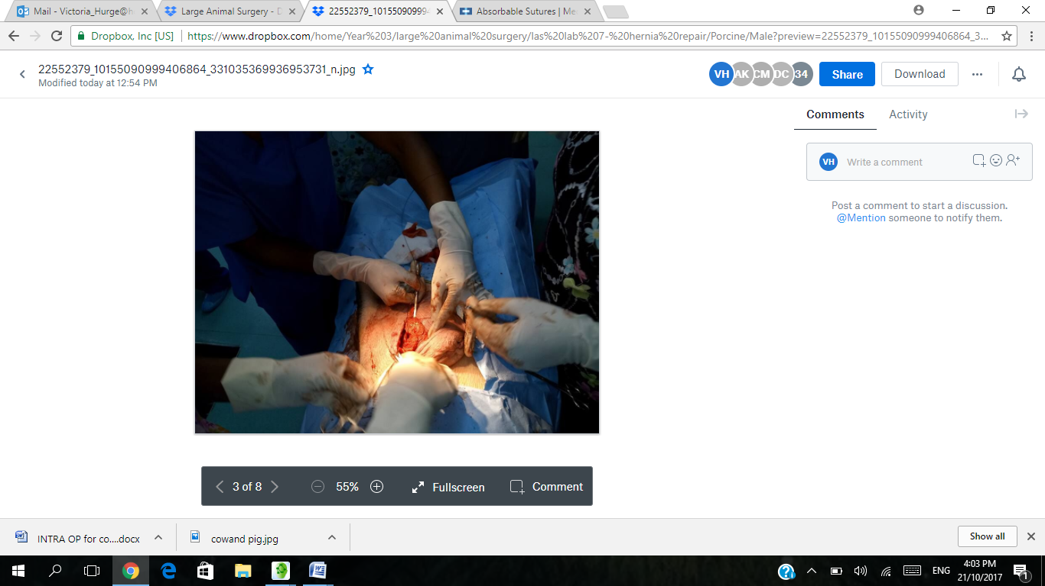Pic 2 showing closing of surgical site

8. The stitched wound was cleaned with distilled water and swabs to remove any blood from the site. Tetravet and an antibiotic spray was used to cover the top of the wound/ on the wound.

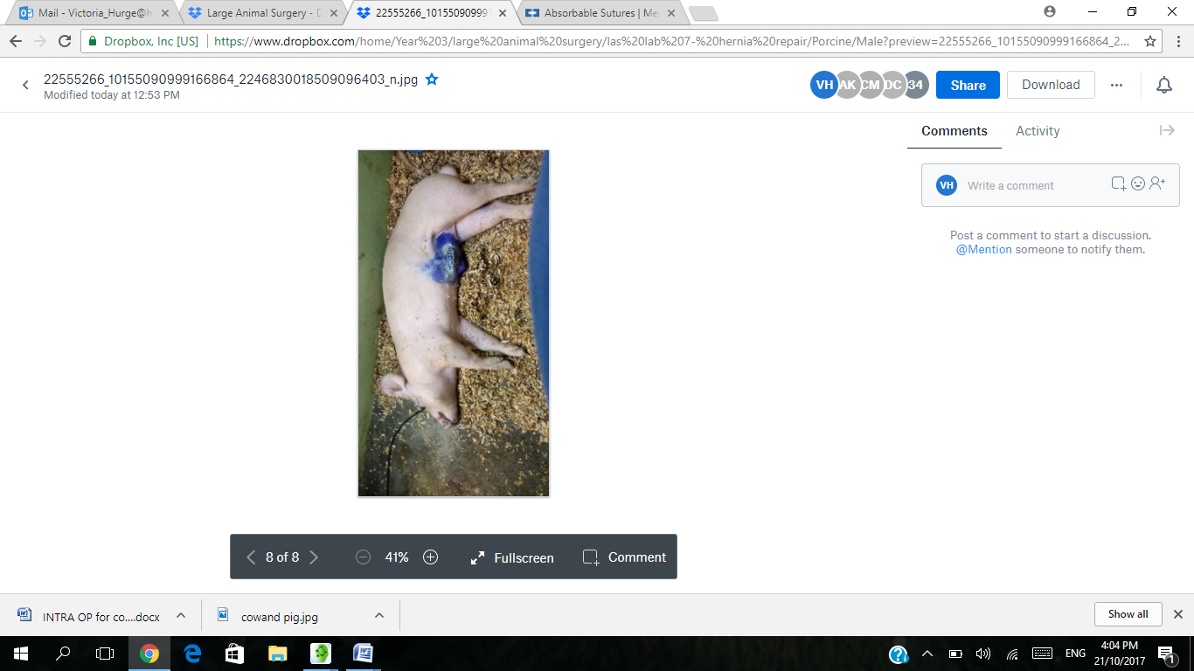 *Pic 3 showing patient in recovery minutes after surgery*