COMPLICATED UMBILICAL HERNIA in Female Pig

In this case, there were remnants of the umbilicus

1. An elliptical incision was made starting from 4cm cranial from the mass then passing along the lateral sides of the mass while staying within the medial side of the teats, and connecting 3 cm caudally to the mass using a scalpel.

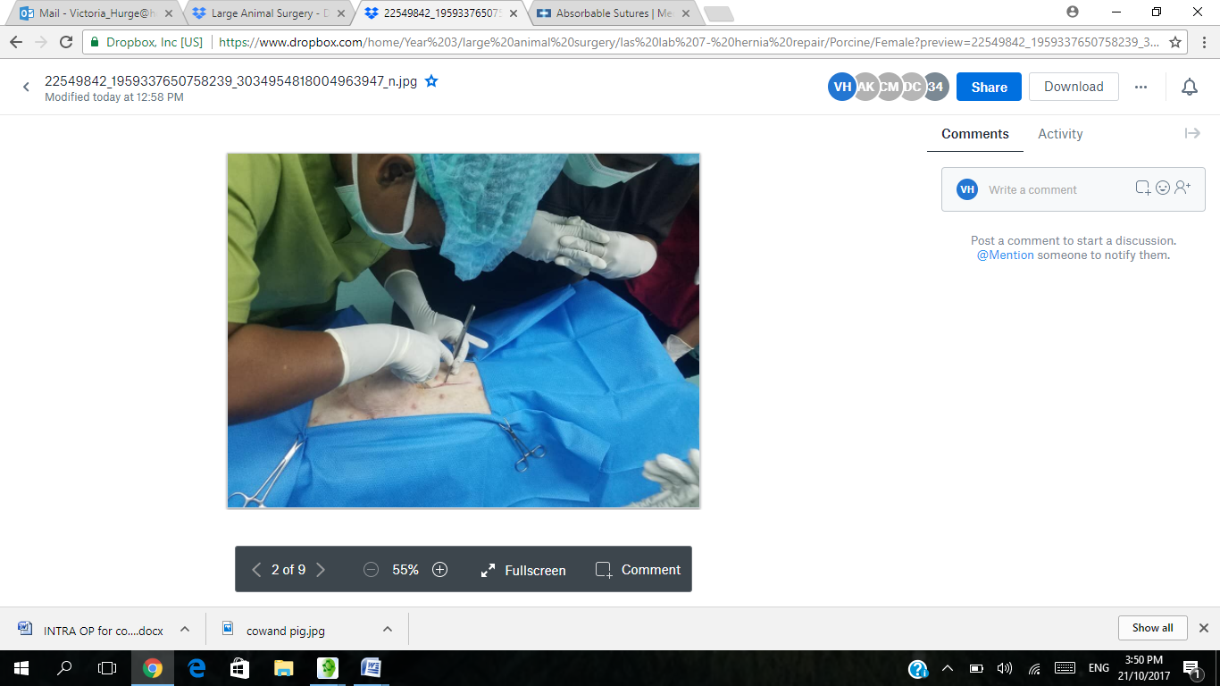 *Pic 1 showing incision being made*

2. The skin flap was removed followed by detachment of the tissue adhesions around the mass using a blunt scissors and fingers until the muscle layer covering the peritoneum. Some ligatures and clamps were used to stop excessive bleeding during this step. Also splash block of lidocane was used during incidences of the patient moving.

3. A small cut was made into the peritoneum.

4. A finger was placed into the peritoneum sac to feel any attachments under and at the side of the mass. Once the entirety of the mass was felt, the mass was cut from the body and placed on an awaiting steel tray.

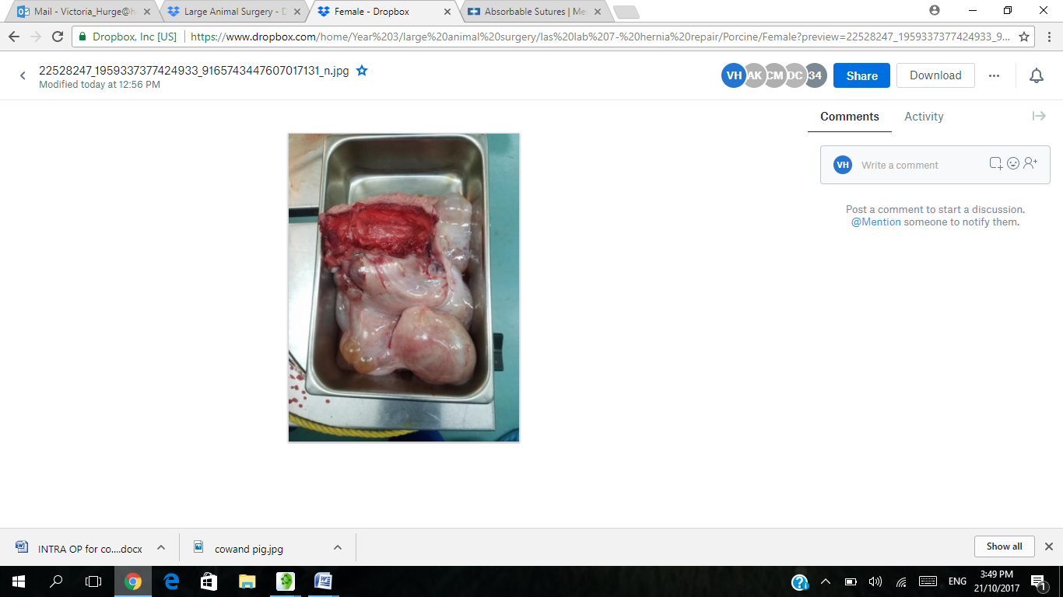 *Pic 2 showing remnants of umbilicus( Mass)*

5. Swabs were used to soak up any bleeding encounter when the mass was removed.

6. The hernia ring was identified and the abdominal layers and muscles were sutured with Non-absorable 2-0 Nylon Supramide doing six (6) vest over pants suture for this layer.

7. The subcutaneous layer was sutured using 2.0 lactomere polysorb Absorbable suture with a simple continuous stitch.

8. The skin was sutured using Non-absorable 2-0 Nylon Supraminde with an interrupted horizontal mattress suture pattern. It was also followed up with a simple continuous stitch to re assure non-exposure of the inner layer of the epidermins and the dermis.

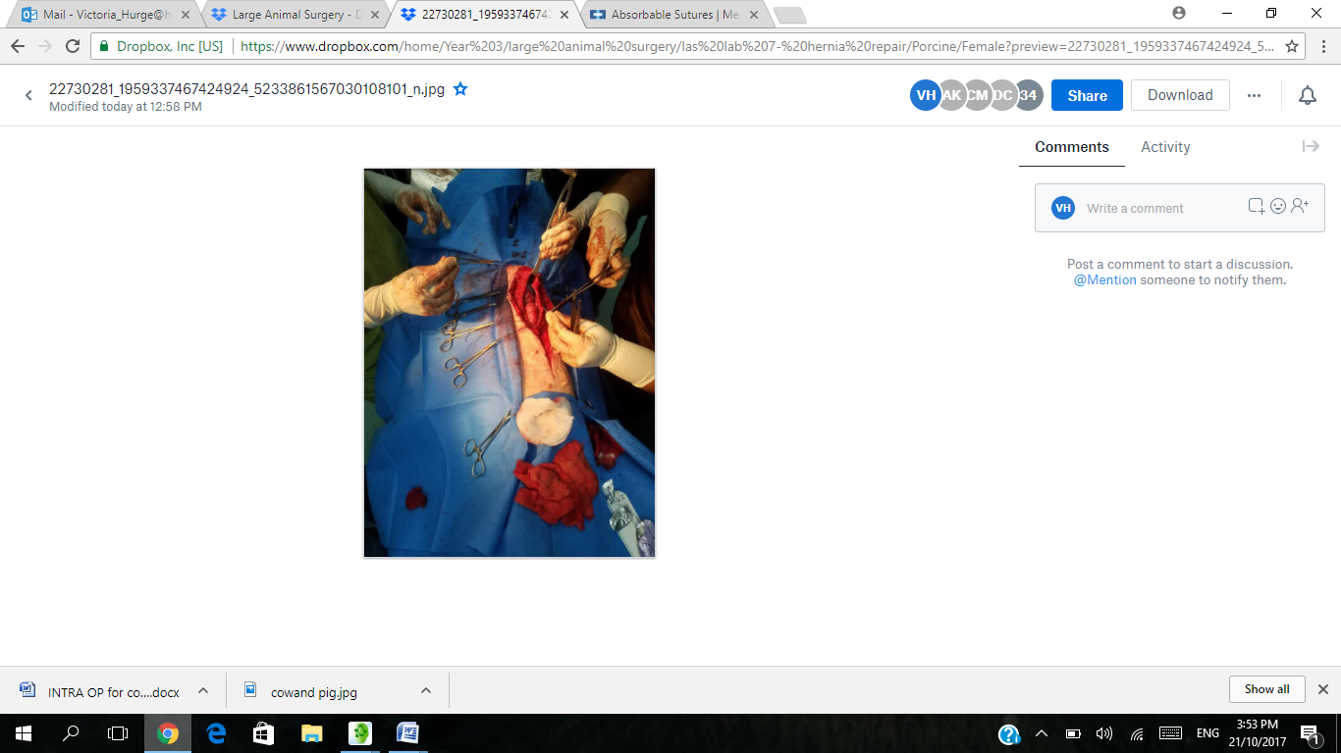*Pic 3 showing closing of surgical site*

9. The stitched wound was cleaned with distilled water and swabs to remove any blood from the site. Tetravet and an antibiotic spray was used to cover the top of the wound/ on the wound.

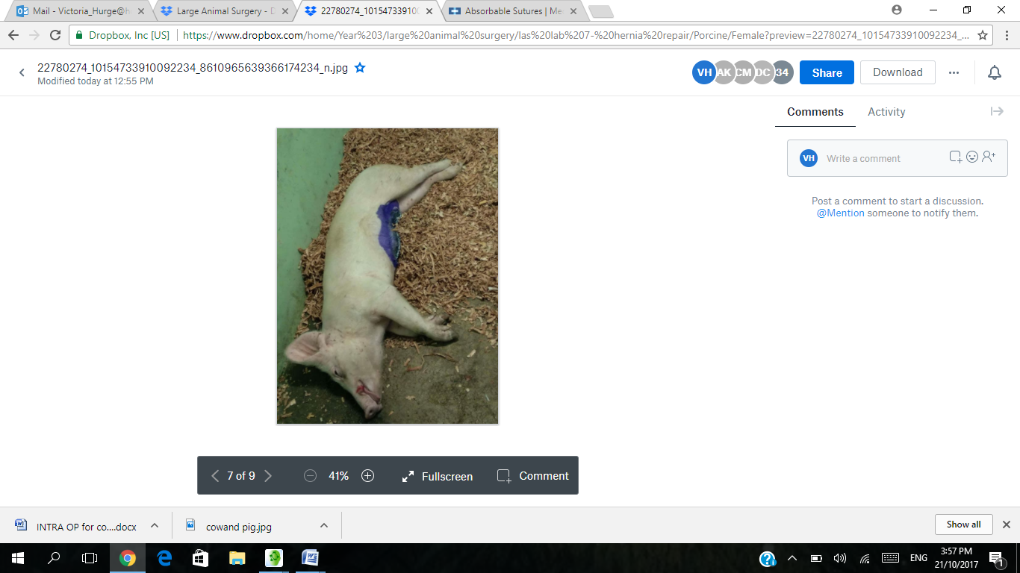 Pic 4 showing pig in recovery ward minutes after surgery