Drug name | Active ingredient | Time given/onset/ duration | Indication | Contraindication | route of administration/Withdrawal time | Direction for use/ Withdrawal time
Tetravet aerosol  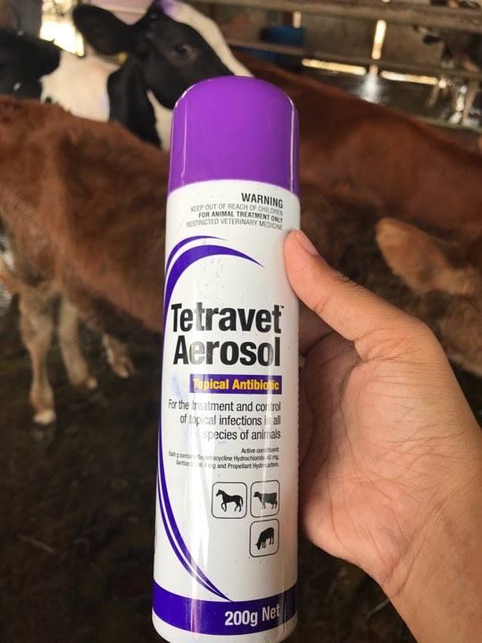 | Oxytetracycline HCI 2.5% and Gentian Violet 0.2%. |  | For the treatment and control of topical infections in all species of animals. | NOT FOR USE IN FIBRE PRODUCING ANIMALS | Route : topical | SHAKE WELL BEFORE USE. For topical use only.  Remove any dead tissue, dried serum or secretions and debris from infection site.  Hold pack upright approximately 15 – 20cm from the surface and cover affected area completely once or twice a day and repeat for 3 – 5 days or as required.
Agropharm Screwworm aerosol  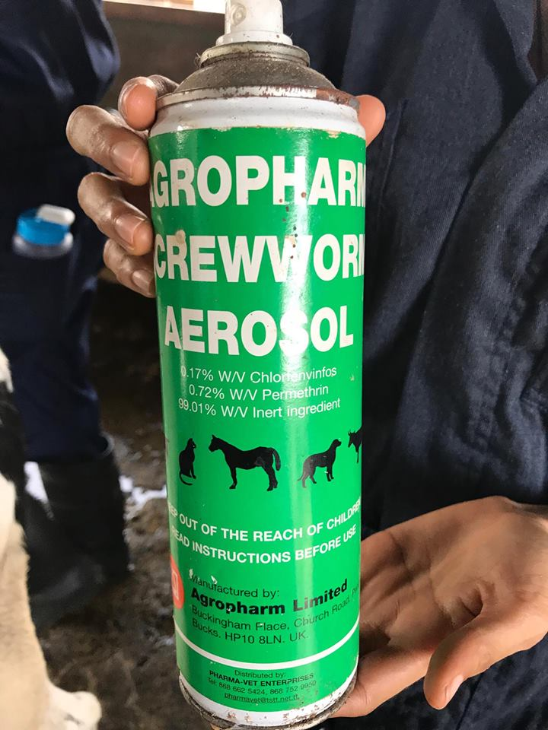 | Permethrin  0.5% | Given at 3:29pm | Kills flies and fly maggots on wounds.  For Use On:  Beef and Dairy Cattle, Sheep, Goats, Swine and Horses. | Harmful if swallowed, absorbed through the skin or inhaled. Causes moderate eye irritation. Avoid breathing spray mist. Avoid contact with skin, eyes or clothing. Wash thoroughly with soap and water after handling and before smoking or eating. Remove contaminated clothing and wash before reuse. Avoid contamination of feed and foodstuffs | Route : topical | Remove protective cap, hold container upright and spray from a distance of 12 to 15 inches.
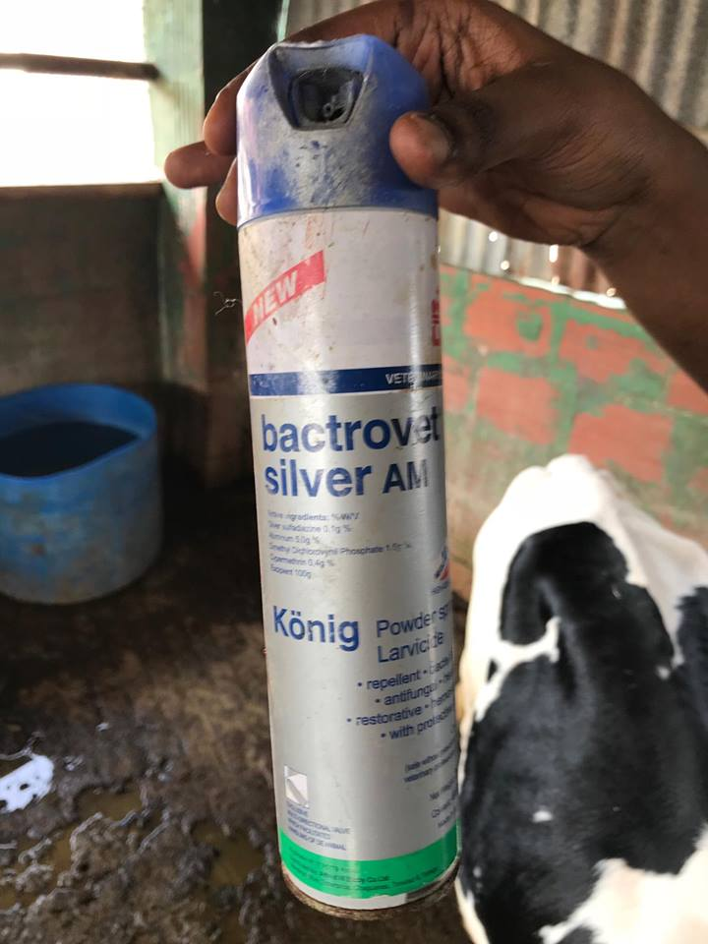 | Silver sulfadiazine 0.1%  Aluminum 5.0g%  Dimethyl Dichlorovynil Phospahte  Cypermethrin 0.4g%  Dosage:  Preventive: a single application  Healing: a daily application usually for 4 to 5 days. | Given at 3:3opm | Bactrovet Silver AM is indicated for cattle of all ages, including for newborns: It  acts as larvicide on infested wounds, with rapid healing;  Routinely applied to accidental or surgical wounds (castration, dehorning), it eliminates bleeding from them (astringent and haemostatic effects), forming a protective film that prevents infection;  Its repellent effect prevents the treated wounds from being attacked by the flies that cause the myiasis;  Due to its high penetration and grip, Bactrovet Silver AM is excellent in curing navels;  The multi-directional valve of Bactrovet Silver AM allows to treat wounds of difficult access, by the maneuver of the packaging in any desired direction. |  | Route: topical | Shake the bottle well before each application. Place the vial at a distance of approximately 10 cm from the wound or infested area.  - Treatment of myiasis: carefully introduce the product into the cavities where the larvae are housed. In cases of very serious myiasis, it is advisable to remove the larvae from the affected areas and clean it before applying the product.  - Prevention of myiasis and scarring: apply directly on all recent injury caused by accident or by castration, dehorning, etc.
Furacin  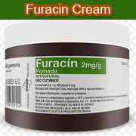 | 0.2% nitrofurazone in a water-soluble base. |  | Nitrofurazone Ointment is a water-soluble antibacterial ointment for the prevention or treatment of surface bacterial infections of wounds, burns, and cutaneous ulcers | Sensitization to Furacin occasionally occurs and treatment should be stopped if pruritus, irritation, erythema, local edema | Route: topical | Apply directly on the lesion with a spatula or first place on a piece of gauze. Application of a bandage is optional.  This preparation should be in contact with the lesion for at least 24 hours. The dressing may be changed several times daily or left on the lesion for a longer period.
Banamine  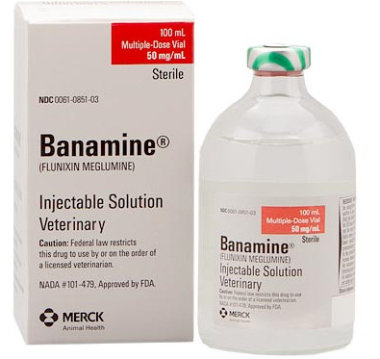 | FLUNIXIN MEGLUMINE)  50 mg/ml | Given at 2:38pm  ONSET- 2hrs  Duration – 30hrs | For the control of pyrexia associated with bovine respiratory disease, endotoxemia and acute bovine mastitis. BANAMINE Injectable Solution is also indicated for the control of inflammation in endotoxemia. | NSAIDs inhibit production of prostaglandins which are important in signaling the initiation of parturition. The use of flunixin can delay parturition and prolong labor which may increase the risk of stillbirth. Do not use BANAMINE Injectable Solution within 48 hours of expected parturition. Do not use in animals showing hypersensitivity to flunixin meglumine. Use judiciously when renal impairment or gastric ulceration are suspected. | The recommended dose for control of pyrexia associated with bovine respiratory disease and endotoxemia and control of inflammation in endotoxemia, is 1.1 to 2.2 mg/kg (0.5 to 1 mg/lb; 1 to 2 mL per 100 lbs) of body weight given by slow intravenous administration either once a day as a single dose or divided into two doses administered at 12-hour intervals for up to 3 days. The total daily dose should not exceed 2.2 mg/kg (1.0 mg/lb) of body weight. Avoid rapid intravenous administration of the drug. | Cattle must not be slaughtered for human consumption within 4 days of the last treatment. Milk that has been taken during treatment and for 36 hours after the last treatment must not be used for food
Combikel 40 LA  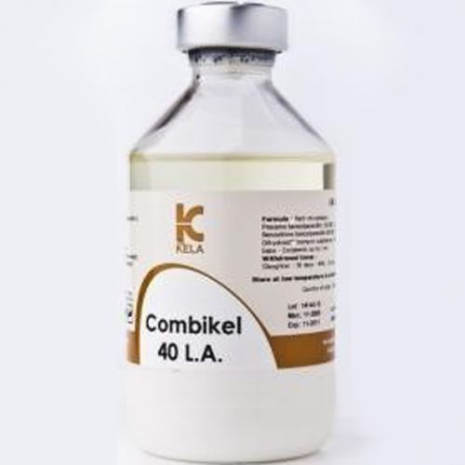 | Procaine benzylpenicillin eq.120 000 I.U. –  Benzathine benzylpenicillin eq.80 000 I.U. - Dihydrostreptomycin sulphate eq. 200 mg base - Excipients up to 1 ml | Given at 2:45pm  3 day duration of activity with minimum adverse effects | Prevention and treatment of infections caused by penicillin G and/or DHS susceptible microorganisms such as respiratory tract infections (shipping fever, bronchopneumonias, upper respiratory tract infections), uro-genital tract infections, necrobacillosis in calves and piglets, anaerobe infections (clostridial infections, tetanus, anthrax), polyarthritis (navel ill), mastitis, septicaemia, bacterial infections secondary to viral ones.  The drug also can be used in postoperative prevention of infections | With the administration of the drug, rapidly developing allergic reactions sometimes appear. Treatment of allergic reactions: glucocorticosteroids or / and antihistamines. Possible neural phenomena, neuromuscular blockade, vomiting, febrile state, abortions in pigs. Prolonged use of the drug may lead to deafness, vestibulotoxic and nephrotoxic symptoms.  Contraindications.  Do not use the drug with individual hypersensitivity to one of the components. Do not use lactating animal if milk is used for food purposes. Do not use intravenously.  Do not administer to animals with kidney failure | Route: IM | Dose –  Give a dose of 20,000I.U/kg (conc. 200,000I.U/ml) IM before the surgical procedure so the animal is protected for possible intra-operative infections.  Cattle, horses - 1 ml of the drug for 10-20 kg of animal weight once a day.

