**How to trim:**

**Dutch 5- step method**

1. **Cut the overgrown toe back to its correct length**, approximately 60 – 80mm from the coronary band to the toe. The thickness of the toe is to be left 5-7 mm

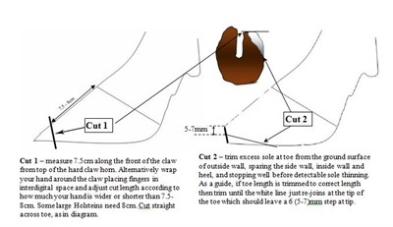

1. **Trim the partner claw to match length and balance to first claw (if correct).**

The sole should be trimmed flat from front to back and should be .25 inch thick at the toe. Avoid removing the horn from the heel of the inside hind claw. When trimming front feet, start with outer claw first.

Step 2 correct any obvious imbalances in weight bearing between inner and outer claws.

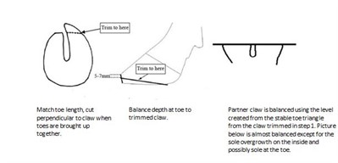

1. **'Model' (Dishing out, hollow out) the** **ulcer site.**

**This step transfers weight from center of the sole onto the harder wall, toe triangle and more cushioned heel**

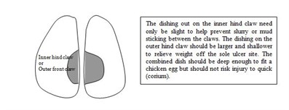

1. **Relieve weight off a painful claw - trim down the back 2/3 of painful claw and/or fix a block to the healthy claw**

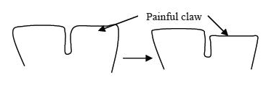

1. **Remove loose or under-run horn and hard ridges**

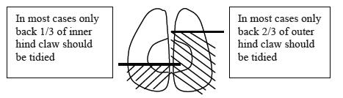

As little serious disease occurs in the front 2/3rds of the inner hind claw, and front 1/3rd in the outer claw, then tracts or under-run horn should be ignored in these regions. Loose horn around the base of the sole ulcer, in the heel or around white line lesions should be removed (red arrows below). However, cutting into the "quick" should be avoided to prevent unnecessary pain, scarring or risk of severe infections spreading to the deeper tissues. The final stage is to ensure there are no sharp ridges that could injure the teats or legs, checked by running the hand over the claw

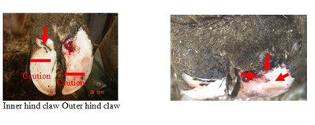

1. **Locating, identifying and treating for lesions.**