Drug | Species | Indications | Therapeutic Dose | Lethal Dose/ Toxicity | Contraindications | Pharmacology | Adverse Effects
Xylazin 2%  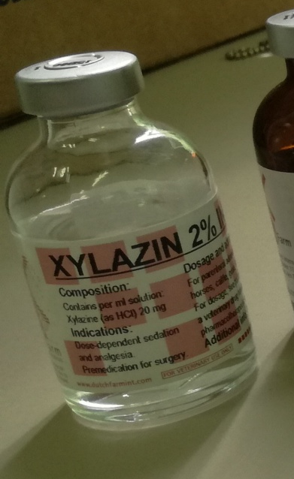 | Cattle, Horses, Sheep, Goats | A tranquilizing agent characterized in the horse by a rapid onset, good to excellent sedation, excellent analgesia of 15 to 30 minutes duration and a smooth recovery. Xylazine is particularly potent as a short- acting analgesic in horses with colic. The duration of sedation in ruminants is longer than in horses.  In cattle, it is given as an epidural analgesic as well as in horses. | Horses:  0.2- 1.0 mg/kg intravenously  1.0-2.2 mg/kg intramuscularly  Cattle:  0.10-0.33 mg/kg intramuscularly  0.05-0.15 mg/kg intravenously | Horses: 15- 27 mg/kg intravenously; 60-70 mg/kg intramuscularly  Cattle: 0.9 mg/kg | Animals receiving epinephrine or those with ventricular arrhythmias. It should be used with caution in animals with heart disease, hypotension, shock, respiratory dysfunction, severe hepatic or renal disease, a history of seizure activity, or those severely debilitated. | Xylazin Injection (xylazin), a non-narcotic compound, is a sedative and analgesic as well as muscle relaxant. Its sedative and analgesic activity is related to central nervous system depression. Its muscle relaxant effect is based on inhibition of the intraneural transmission of impulses in the central nervous system. The principal pharmacological activities develop within 10 to 15 minutes after intramuscular injection in horses and Cervidae, and within 3 to 5 minutes following intravenous administration in horses.  Following treatment with Xylazin Injection (xylazin), the heart rate is decreased and a transient change in the conductivity of the cardiac muscle may occur, as evidenced by a partial atrioventricular block. When given intravenously in horses, the incidence of partial A-V block is higher. Intravenous administration causes a transient rise in blood pressure in horses, followed by a slight decrease.  . | At recommended dosage levels may occasionally cause slight muscle tremors, bradycardia with partial A-V heart block and a reduced respiratory rate. Movement in response to sharp auditory stimuli may be observed.  In horses, sweating, rarely profuse, has been reported following administration.

