Drug | Species | Indications | Therapeutic Dose | Contraindications | Pharmacology | Adverse Effects
VEDCO Atropine Sulfate  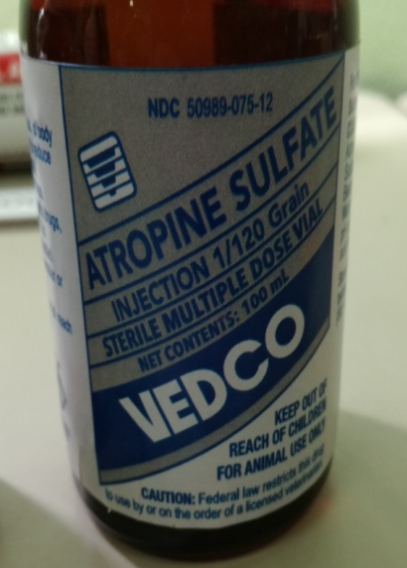 | Cattle, Horses, Swine, Sheep, Goats | - Preanesthetic to prevent or reduce secretions of the respiratory tract.  - Treat sinus bradycardia, sinoatrial arrest, incomplete AV block.  - As an antidote for overdoses of cholinergic agents (e.g., physostigmine, etc.)  - As an antidote for organophosphate or muscarinic mushroom intoxication  - Hypersialism  - Treatment of bronchoconstrictive disease | Cattle:  For adjunctive treatment of bovine hypersensitivity disease:  a) 1 gram per cow once daily followed by 0.5 gram/cow in 2 - 3 days  For treatment of cholinergic toxicity (organophosphates):  a) 0.5 mg/kg (average dose); give 1/4th of the dose IV and the remainder SC or IM; may  repeat q3-4h for 1-2 days  b) 0.2 mg/kg give 1/4th of the dose IV and the remainder SC or IM  Horses:  For treatment of bradyarrhythmias due to increased parasympathetic tone:  a) 0.01 - 0.02 mg/kg IV  b) 0.045 mg/kg parenterally  As a bronchodilator:  a) 5 mg IV for a 400-500 kg animal  For organophosphate poisoning:  a) Approximately 1 mg/kg given to effect IV (use mydriasis and absence of salivation as  therapy endpoints), may repeat every 1.5 - 2 hours as required subcutaneously  b) 0.22 mg/kg, 1/4th of the dose administered IV and the remainder SC or IM  Swine:  The equine dose (above) may be used to initially treat organophosphate toxicity in  swine.  As an adjunctive preanesthetic agent:  a) 0.04 mg/kg IM | Atropine is contraindicated in patients with narrow-angle glaucoma, synechiae (adhesions) between the iris and lens, hypersensitivity to anticholinergic drugs, tachycardias secondary to thyrotoxicosis or cardiac insufficiency, myocardial ischemia, unstable cardiac status during acute hemorrhage, GI obstructive disease, paralytic ileus, severe ulcerative colitis, obstructive uropathy, and myasthenia gravis (unless used to reverse adverse muscarinic effects secondary to therapy). Atropine may aggravate some signs seen with amitraz  toxicity; leading to hypertension and further inhibition of peristalsis.  Antimuscarinic agents should be used with extreme caution in patients with known or suspected GI infections. Atropine or other antimuscarinic agents can decrease GI motility and prolong retention of the causative agent(s) or toxin(s) resulting in prolonged symptoms. Antimuscarinic agents must also be used with extreme caution in patients with autonomic neuropathy.  Antimuscarinic agents should be used with caution in patients with hepatic or renal disease, geriatric or pediatric patients, hyperthyroidism, hypertension, CHF, tachyarrhythmias, prostatic  hypertrophy, or esophageal reflux. Systemic atropine should be used cautiously in horses as it may decrease gut motility and induce colic in susceptible animals. It may also reduce the arrhythmogenic doses of epinephrine. Use of atropine in cattle may result in inappetence and rumen stasis which may persist for several days. | Atropine, like other antimuscarinic agents, competitively inhibits acetylcholine or other cholinergic stimulants at postganglionic parasympathetic neuroeffector sites. High doses may block nicotinic receptors at the autonomic ganglia and at the neuromuscular junction.  Pharmacologic effects are dose related. At low doses salivation, bronchial secretions, and sweating (not horses) are inhibited. At moderate systemic doses, atropine dilates and inhibits accommodation of the pupil, and increases heart rate. High doses will decrease GI and urinary tract motility. Very high doses will inhibit gastric secretion. | Adverse effects are basically extensions of the drug’s  pharmacologic effects and are generally dose related. At usual doses effects tend to be mild in relatively healthy patients. The more severe effects listed tend to occur with high or toxic doses.  GI effects can include dry mouth (xerostomia), dysphagia, constipation, vomiting, and thirst. GU effects may include urinary retention or hesitancy. CNS effects may include stimulation, drowsiness, ataxia, seizures, respiratory depression, etc. Ophthalmic effects include blurred  vision, pupil dilation, cycloplegia, and photophobia. Cardiovascular effects include sinus tachycardia (at higher doses), bradycardia (initially or at very low doses), hypertension,  hypotension, arrhythmias (ectopic complexes), and circulatory failure.

