Physical Evaluation
Listed below are brief explanations to guide a producer in evaluating a healthy animal. Any question about the condition or health status of an animal should be referred to a veterinarian; if in doubt, consult a veterinarian.

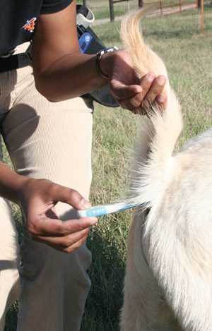
Taking rectal temperature.

Rectal Temperature
The first step in evaluating whether an animal is healthy is to take its temperature; in goats, this is done rectally. A digital thermometer works well; a plastic digital thermometer is very safe and will not break like a glass thermometer. A small amount of lubricant, such as petroleum jelly, can be put on the thermometer. Insert the thermometer with a twisting motion. A goat’s normal temperature should be 103° to 104°F (39° to 40°C).

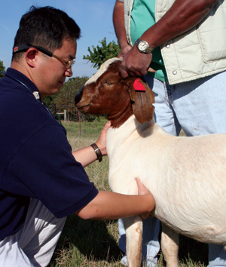
Taking heart rate.

Pulse or Heart Rate
The pulse or heartbeat can be felt and measured on several places on a goat. Heartbeat can be felt by placing one’s fingertips between the ribs behind the elbow. The pulse can be measured using the femoral artery on the inside of the goat’s rear leg roughly one-third of the way down the thigh. Pulse may also be detected by placing the index and middle fingers on the artery located below and slightly inside the jaw roughly two-thirds to the rear of the muzzle. A normal range is 70 to 90 beats per minute.

Respiration
Respiration is detected by watching the movement of the flank or chest. A normal range is 12 to 20 breaths per minute.

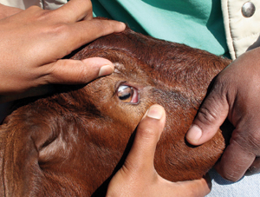
Assessing mucous membrane.

Checking Mucous Membranes
Paleness of the mucous membranes in the mouth (gums), vagina, and prepuce can be an indicator that the animal is in hypovolemic shock, meaning that there is a decrease in the blood volume circulating in the animal. The color of the conjunctiva around the eyes can be an indicator of anemia that could be caused by a heavy internal parasite burden.
Roll down the lower eyelid to look at the color. A pale, whitish color indicates anemia. This color can be scored using the FAMACHA system http://www.acsrpc.org/, which is described in the section on "Parasites of Goats." Remember that irritation of any type causes membranes to turn red. This means that an anemic goat with pinkeye may still have red membranes.

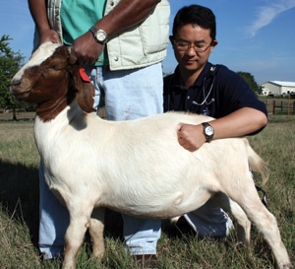
Assessing rumen movement.

Rumen Movements
Normal rumen function is essential for the goats health. One sign of normal function is regular contractions that mix the rumen contents in the digestion process. Normal movements can be detected by placing the hand on the left flank of the animal. If the rumen feels soft and water-filled this should be noted and reported to your veterinarian. Rumen contractions occur 1 to 2 times per minute.

