Abdominal wall closure = Vest over Pants Suture https://www.youtube.com/watch?v=GtQ_JV68tCk
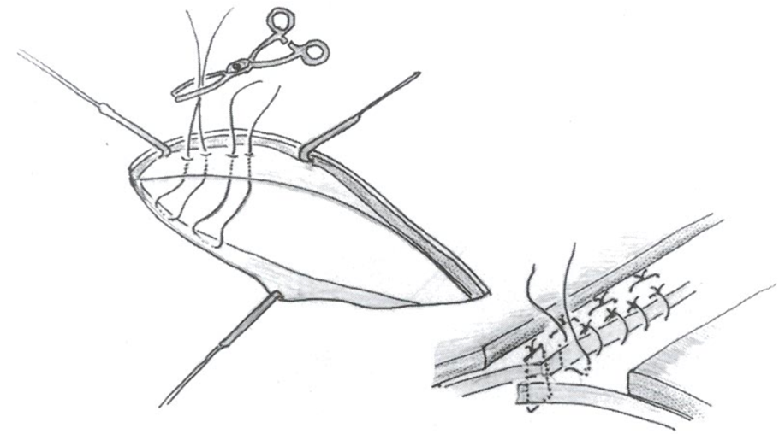
Vest-over-Pants suture. Very important. Best for adhesion forming but any tension suture – horizontal mattress etc will work. Do not use simple or continuous suture.
Abdominal wall closure = Vertical mattress to close example
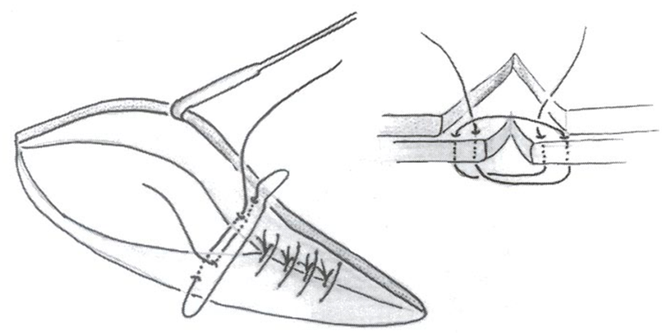
Abdominal wall closure
Pre-placing sutures – clamp the end then when you have put all in, pull them all up together and tighten them one by one. This works for all species.
