Drugs | Dosage mg/kg | Concentration mg/ml | Calculations (WxD)/C | Dose  ml | Route of admin. | Contraindications & Withdrawal Period
Ketamine 10%  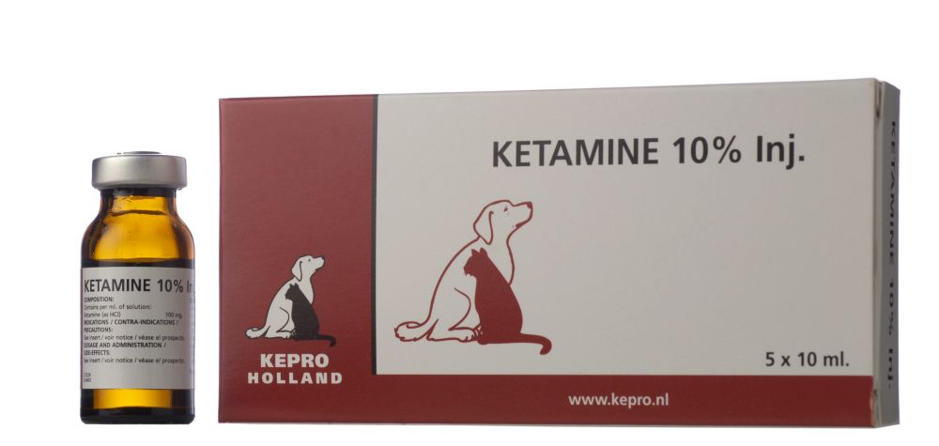 | 0.10 | 100 | 170x0.10  100 | 0.17 | IM | - Do not use in animals presenting with: - severe hypertension, - cardio-respiratory deficiency, - hepatic or renal dysfunction.  - Do not use in animals with glaucoma.  - Do not use in cases of hypersensitivity to the active substance or any of the excipients.  - Do not use the product as a sole anaesthetic agent in any of the target species.  - Do not use in ocular surgical intervention  - Cattle, sheep, goats: Meat and offal : 1 day.  - Milk : zero days.
Xylazine 2%  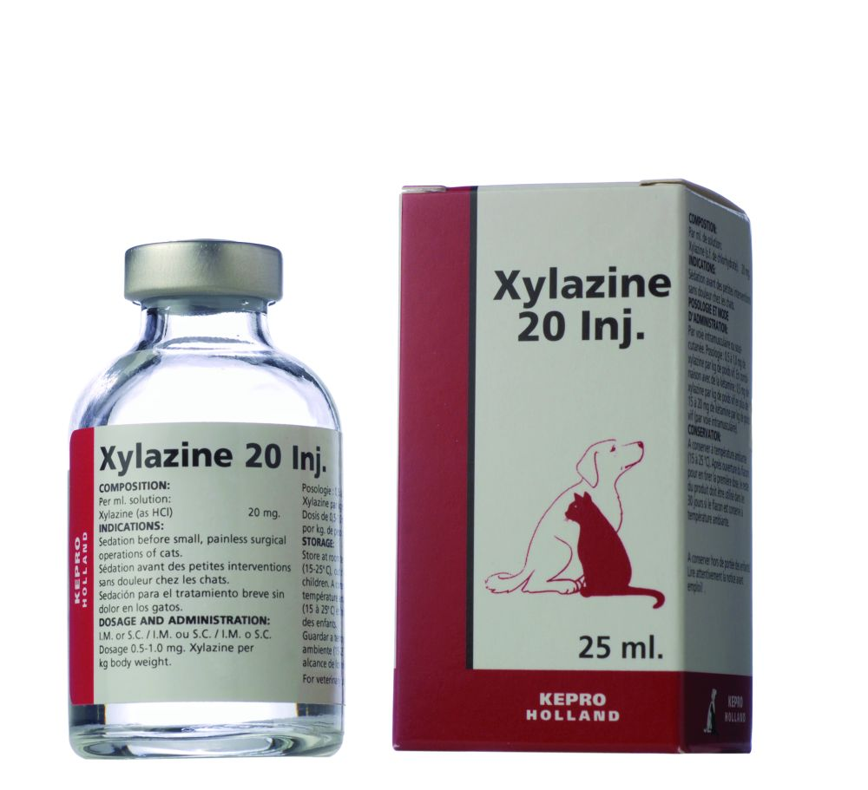 | 0.05 | 20 | 170x0.05  20 | 0.425 | IM | - Xylazine should not be used in combination with sympathomimetic drugs such as epinephrine as ventricular arrhythmia may follow.  - Do not use in the later stages of pregnancy (particularly in cattle and cats), because xylazine causes uterine contractions and it may induce premature labour.  - Do not use in cattle receiving ovum transplants as the increased uterine tone may reduce the chance of implantation of the ovum.  - Cattle (meat and offal ):1 day.  - Cattle (milk): Zero days.
Flunixin meglumine  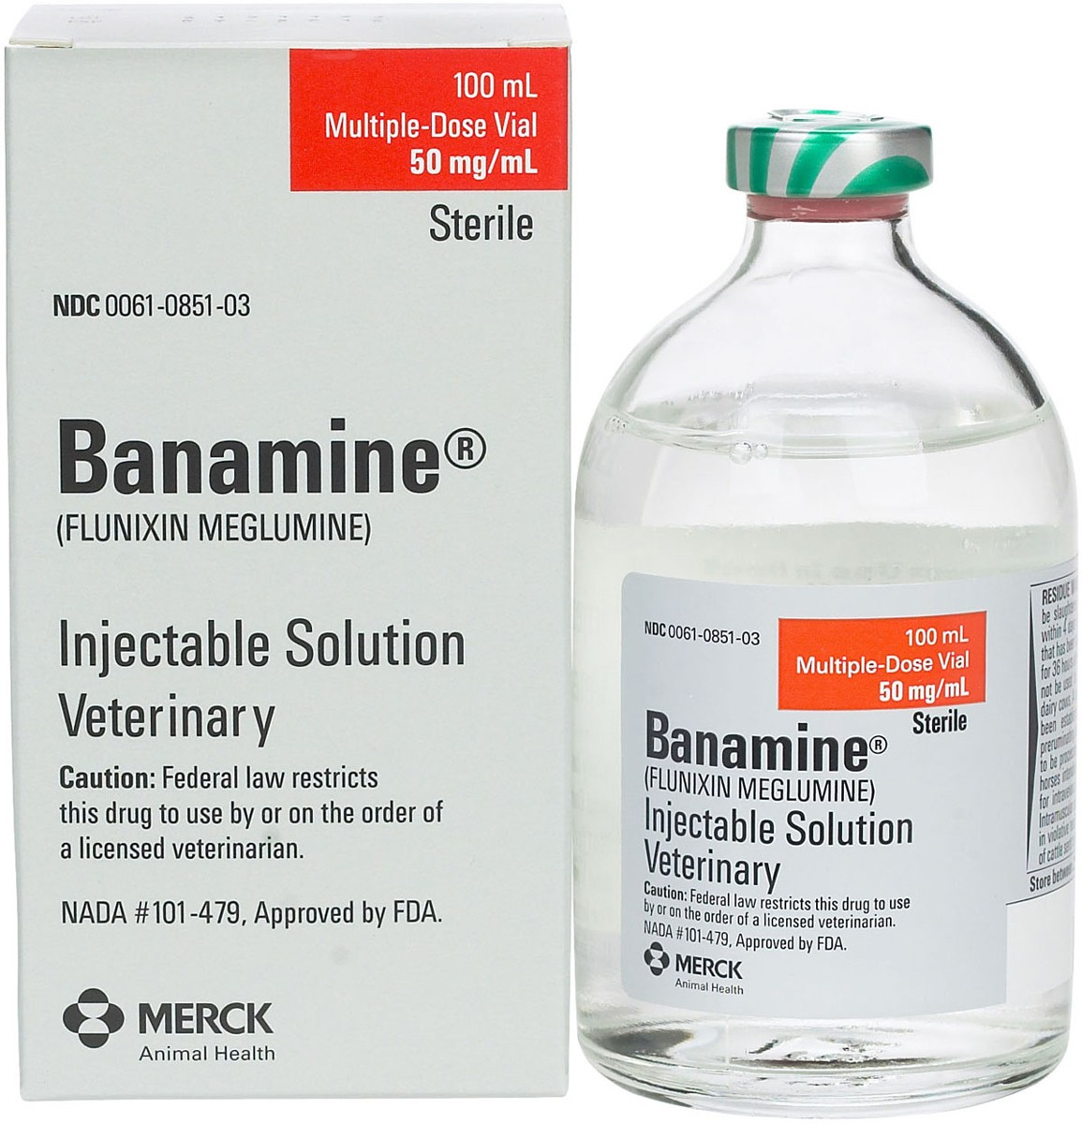 | 1.1 | 50 | 170x1.1  50 | 3.74 | IV | - Flunixin meglumine is contraindicated in animals with a known hypersensitivity to the drug.
Penicillin-streptomycin  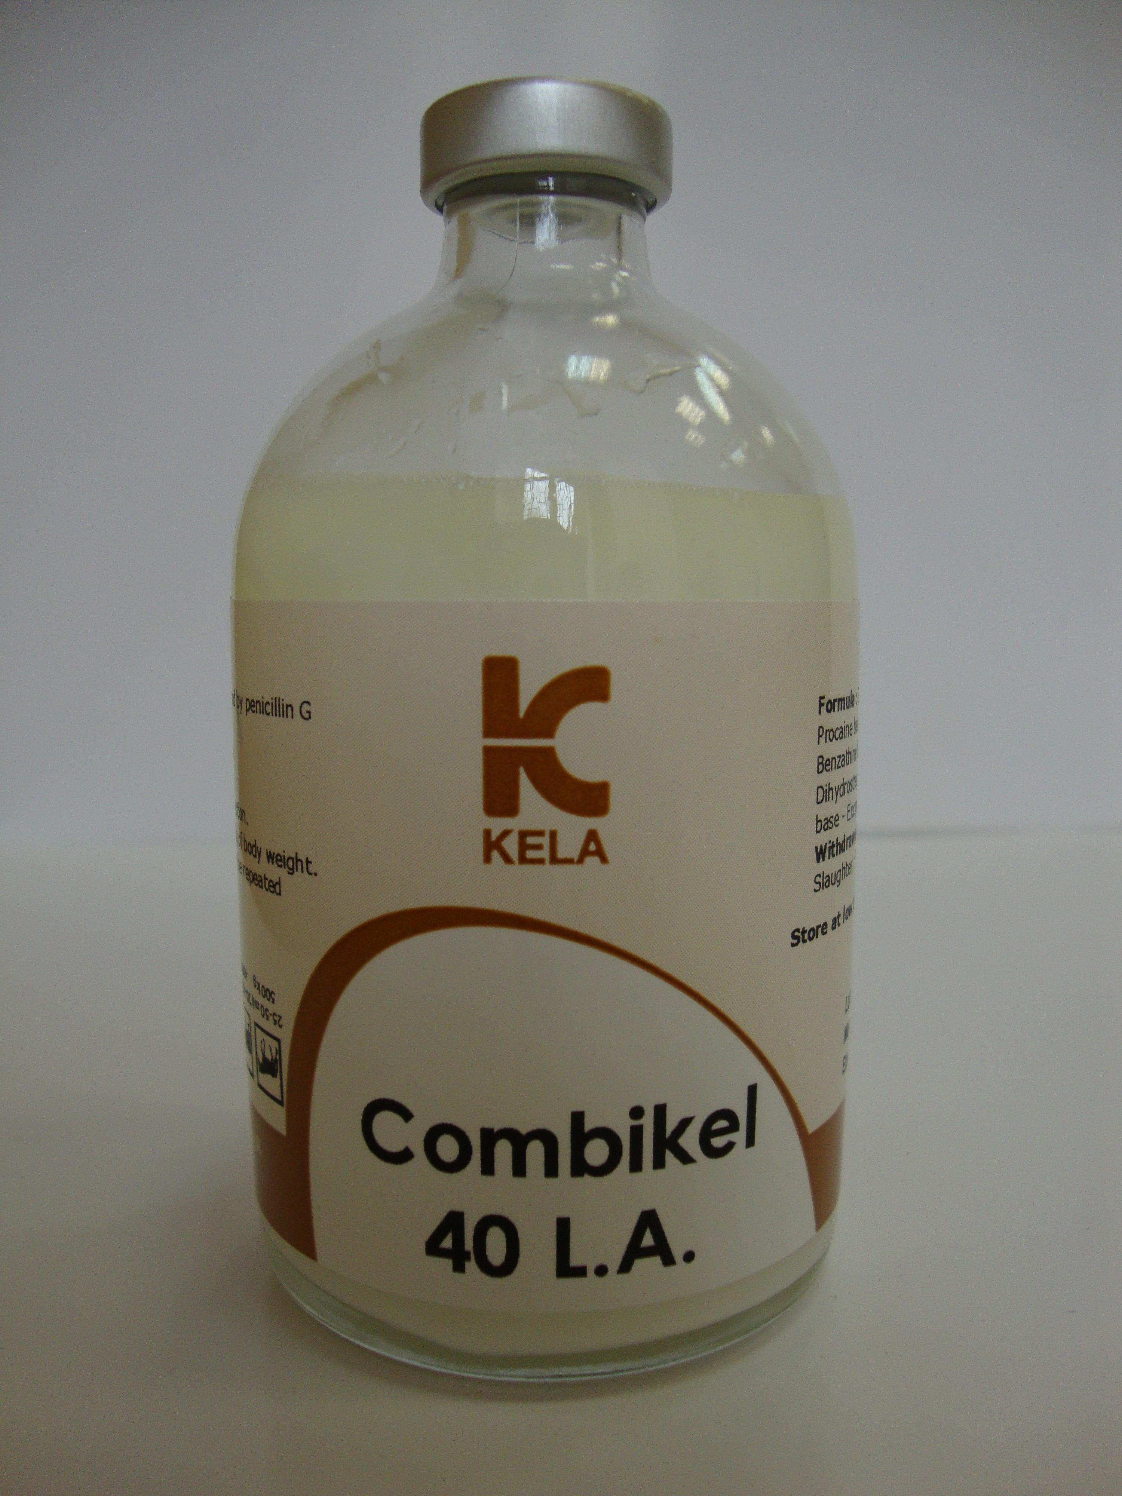 | 20,000 | 200,000IU | 170x20,000  200,000 | 17 | IM | - Do not administer to animals hypersensitive to penicillins, aminoglycosides and/or procaine.  - Do not administer to animals with an impaired renal function, disturbances of auditory or vestibular organs.
Lidocaine TD 2%  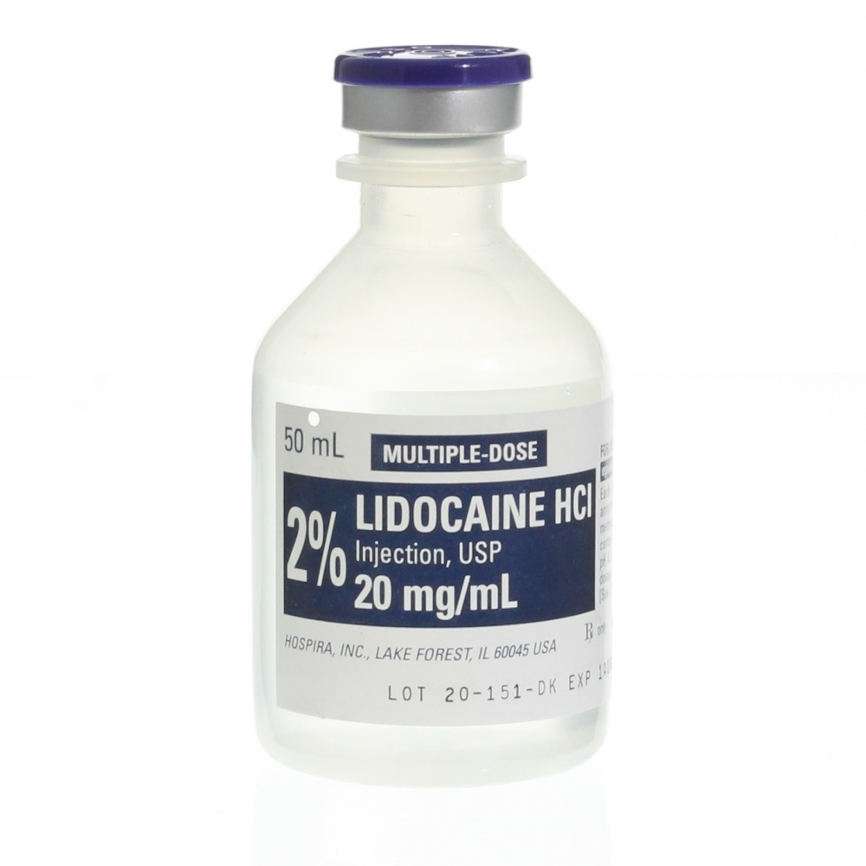 | 5 | 20 | 170x5  20 | 42.5 | IM&  SC | - Lidocaine is contraindicated in animals with a known hypersensitivity to the drug.
EMERGENCY DRUGS
Epinephrine  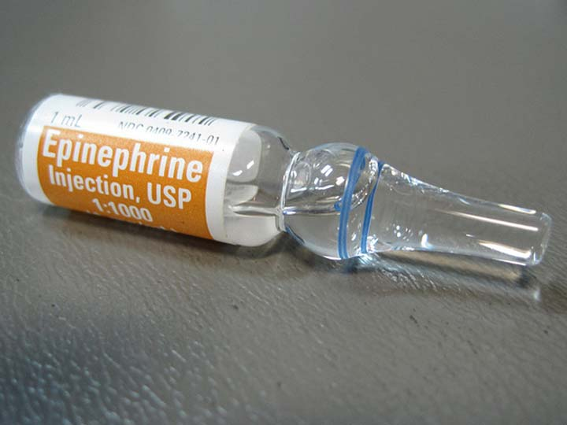 | 0.02 | 1 | 170x0.02  1 | 3.4 | IV |  | - This is used for anaphylactic reactions, and intravenous administration is not recommended for routine clinical cases.  - Epinephrine is contraindicated in patients with narrow-angle glaucoma, hypersensitivity to epinephrine, shock due to non-anaphylactoid causes, during general anesthesia with halogenated hydrocarbons or cyclopropane, during labor and in cardiac dilatation or coronary insufficiency.  - Epinephrine should not be used in cases where vasopressor drugs are contraindicated. It should not be injected with local anesthetics into small appendages of the body (toes, ears, etc.) because of the chance of necrosis.
Tolazine  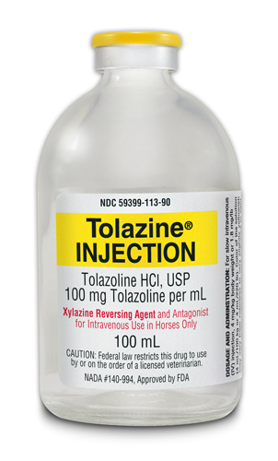 | 0.020 | 50 | 170x0.02  50 | 0.68 | IV |  | - This is used for Xylazine reversal, if large doses of tolazoline are given with either norepinephrine or epinephrine, a paradoxical drop in blood pressure can occur followed by a precipitous increase in blood pressure.  - Do not administer if xylazine was not administered.  - Slaughter withdrawal: 30 days

