Haemonchus conturtus (Barberpole worm)

Haemonchus contortus is a gastrointestinal nematode known widely for its detrimental effects in small ruminants. Its pathological effects result in marked decrease in growth rates and sexual performance in breeding herds, as well as increased morbidity and mortality rates.

Life Cycle
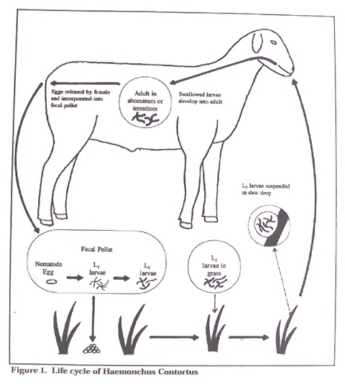

Clinical Signs

- Pale mucous membranes
- Low PCV/Anaemia
- Dehydration
- Diarrhea
- Reduced growth and performance
- Unthriftiness and lethargy
- Rough hair coat
- Depression
- Fluid accumulation in sub-mandibular tissues, gut wall, thoracic cavity and abdomen

Treatment
Use of anthelminthics have proven effects against Haemonchus contortus infections in young and adult goats and sheep. Ivermectin, Albendazole and Fenbendazole is routinely used orally to clear the adult forms from the digestive tract. It must be noted that resistance is likely to be an occurrence so treatment may not be effective in some cases.

Management

Proper feeding management
- Clean water must be supplied to the goats/sheep. The provision of water must of optimum quality and availability. It must allowed be free from the risk of faecal contamination.
- Forage must originate from reliable sources where faecal contamination is not a concern. Forage to be fed to the herd should also be stored off the ground prior to feeding.
- If there is a feedlot area on the farm, the flooring should be made of concrete to prevent proliferation of the parasite in the early stages.

Improved herd and pasture management
- After parturition, the doe/ewe should be dewormed. Progesterone has been found to decrease the mother’s ability to fight of worm infestations by supressing the immune system to some degree. So post-partum deworming would aid in preventing this.
- Good nutrition needs to be implemented prior to and throughout gestation, especially in the last trimester of pregnancy. This helps to build the immune system of the dam and the foetus in order to fight off worm infestations.
- Pastures should be rotated to reduce exposure of the herd to the parasite.
- Selective breeding can also be done to pass on traits that allow for resilience against Haemonchus contortus if they do arise. This progressively limits the chance of the nematode from successfully integrating itself into the herd.

