# DISTANCE AND PHYSICAL EXAMINATION

Picture: Patient – Kid rock and her obvious umbilical hernia

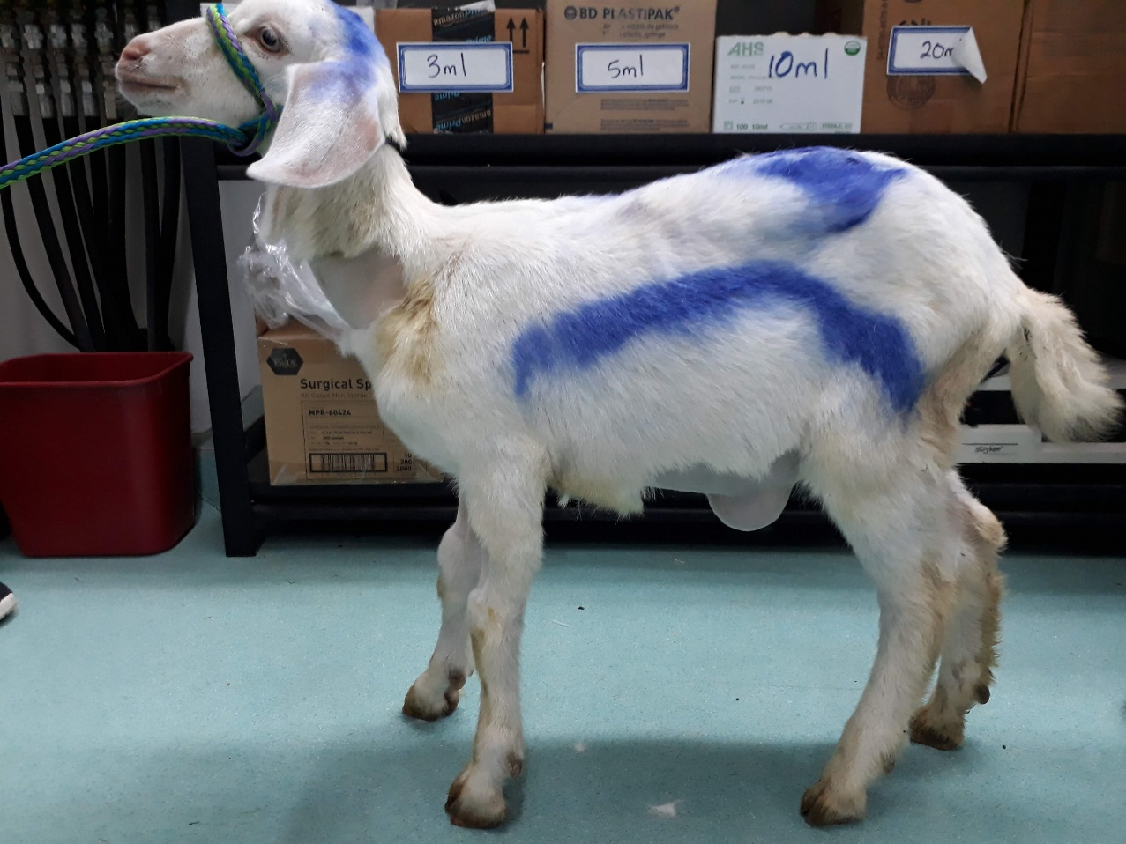

DISTANCE EXAM

* Observing the animal
* Stance
* Gait
* Posture
* Signs of pain
* Any abnormal skin lesions
* Respiratory rate – 28bpm
* Discharges – severe bilateral mucopurulent nasal discharge with coughing
* Body condition of animal – poor – 2/5

PHYSICAL EXAM

* Temperature – 39.5 degrees Celsius
* Heart rate – 136 bpm
* Mucous membrane colour – pale pink
* ASA grade – 2/5
* CRT - <2 seconds
* Palpation of hernia – the contents were reducible and soft

Picture: BCS of animal – prominent hip bones can be seen after shaving the animal for epidural

