DEEP DIGITAL FLEXOR TENOTOMY

PROCEDURE

In the standing horse,

* A proximal metacarpal palmar nerve block is performed
* A 2-3cm skin incision is made over the lateral aspect of the DDFT in the middle of the 3rd metacarpal bone.

This approach provides good exposure of the tendon and allows the surgeon to perform the procedure quickly and safely.

* The fascia is separated, the limb flexed.
* The superficial digital flexor tendon is separated from the deep digital flexor tendon.
* The DDFT is brought to the surface of the wound using a small, curved retractor and incised/transected with a scalpel
* Following tenotomy, the skin is sutured with non-absorbable material or a few skin staples.
* The limb can be bandaged and changed at weekly intervals.

N.B An extended heel shoe or egg bar shoe is indicated following surgery. It prevents the toe lift that may accompany a DDFT tenotomy and will support the posterior aspect of the foot as the horse’s weight shifts towards the heels.

Shoeing also prevents stretching of the palmar joint capsule, which results when the distal phalanx is returned to a more normal angle.

Diagram: The relation of the DDFT with respect to the coffin bone/distal phalanx. Note other structures e.g. The lamina and sole corium.

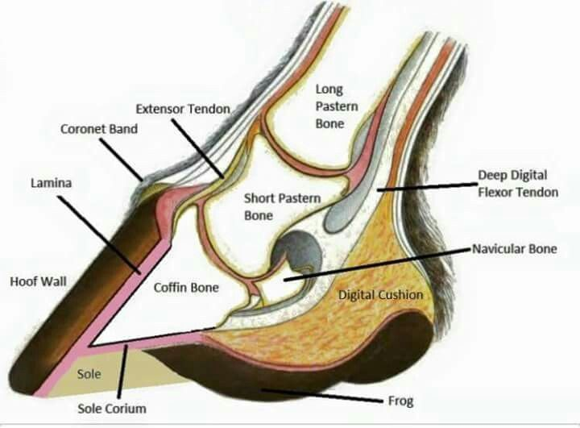

Diagram: The effect the DDFT has on the coffin bone when there is laminitis (inflammation of the lamina).

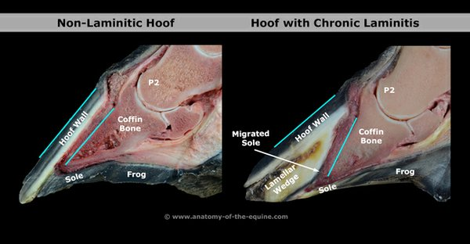

Following tenotomy,

* the distractive forces exerted by the DDFT are eliminated and
* the tension of the apex of the distal phalanx is relieved thus allowing increased blood flow to the laminae and solar corium.
* increase in depth of the sole, resulting in immediate improvement in most cases (e.g. decreased pain, resolution of abscesses, seromas and new growth in the sole and horn wall).

N.B The long-term effects of tenotomy can be extended if the procedure, in addition to therapeutic shoeing is performed before evidence of bone disease (osteomyelitis or osteoporosis).

Proper hoof care should be provided which entails realignment of the distal phalanx within the hoof capsule (de-rotation) and post-op support of the heel area.